SPACESUIT THERMAL SHIELDING KIT
Team Engineering Report for the SPHERE Initiative
Piyath Vithanage, Elio Krollpfeiffer, Dilan Fernando, and Nuhansee Migelhewage
Professorship of Human Spaceflight Technology
TUM School of Engineering and Design
Abstract—The SPHERE team designed a classroom experiment that compares four insulation arrangements around a 100 mL warm-water core. Students record 16 temperatures, generate a Newtonian cooling reference curve, and evaluate the difference between measurement and prediction. The worked test ranked the full cotton–bubble-wrap–Mylar package first for heat retention. The report also explains why the water-bath test is not a vacuum or spacesuit qualification test.
Keywords—heat transfer, Newtonian cooling, insulation, classroom experiment, data logging, model validation

Executive Summary and Project Definition
This report presents our SPHERE thermal-insulation classroom kit. We built the project around one engineering question: how much does a chosen layer arrangement reduce the cooling rate of the same 100 mL water-filled core under the same cold-water boundary? The kit combines four physical test articles, a browser-based Mission Control page, manual temperature logging, and a Newtonian cooling model. Our aim was to make heat transfer measurable in one school lesson without requiring specialist data-acquisition hardware.
The four conditions are a bare control, two layers of bubble wrap, a Mylar-only wrap, and a full multilayer package made from cotton, bubble wrap, and Mylar. Students record the core temperature once per minute from 0 to 15 minutes. The website plots the recorded values against a reference curve and calculates residuals and mean absolute error. In the worked data, the full multilayer package retained the most heat. Mylar alone performed poorly in the water-bath setup, which showed why a reflective material cannot be judged without considering contact, convection, wetting, gaps, and closure quality.

Main outcome
We produced a reusable experiment that links construction, measurement, modelling, and evaluation. The activity does not reproduce vacuum and does not test materials for real spacesuit use. It is a controlled teaching model for comparing cooling behaviour. The final design uses identical glass jars, a target start temperature near 80 °C, a measured ice-water bath, a centred probe, and a 16-point temperature record.
Item | Final project setting
Thermal core | 100 mL water in matched glass jars
Boundary | Measured ice-water bath
Sampling | Every minute from 0 to 15 min
Outputs | Measured curve, model curve, residuals, MAE
Lesson length | About 55-70 min including setup and review

Project scope
The team developed the thermal model, experimental method, physical test articles, browser application, telemetry workflow, assessment activities, classroom documentation, safety guidance, and final learning resources as one integrated engineering package.

1 Project Context and Requirements

1.1 Context
SPHERE uses human-spaceflight engineering as the setting for classroom activities. Thermal protection was selected because students can see the construction, measure a temperature change, and compare a real curve with a mathematical prediction. The spacesuit story gives the task a clear purpose, but the measured system is a jar in a water bath. This distinction remains visible throughout the manuals and website.

1.2 Engineering requirements
- Produce a visible difference between configurations within a 15-minute test.
- Use parts that a school can replace locally.
- Keep the procedure understandable without prior differential-equation study.
- Run on ordinary laptops and tablets without accounts, pairing, or a native app.
- Keep hot water, cold bath water, and electronic displays separated.
- Use the same variables and test settings in the website, manuals, worksheet, and report.

1.3 Learning requirements
Students should be able to distinguish conduction, convection, and radiation; explain the meaning of an effective cooling constant; collect an ordered time series; compare measurement with prediction; and discuss uncertainty. We also wanted them to see that an unexpected result is useful evidence. A disagreement should lead to checks of the setup and assumptions, not to editing the data until it matches the model.
Requirement | Design response | Check
Comparable cores | Matched 100 mL jars | Same geometry and fill
Repeatable boundary | Shared ice-water bath | Measure bath temperature
Safe handling | Adult pours hot water | Pre-run safety checklist
Accessible software | Static browser app | No login or driver
Traceable result | 16 raw readings retained | Table and graph agree

1.4 Decisions made during development
The team first considered automatic sensors and wireless transfer. That option was rejected because it would shift attention from the thermal problem to pairing, drivers, and battery faults. Manual entry makes the observation step explicit and is easier for a teacher to recover when something goes wrong. The design question was also changed from a general spacesuit demonstration to a controlled comparison of cooling rate. This change produced measurable inputs, a fair-test procedure, and a result that students could defend.

2 Thermodynamic Model

2.1 Lumped cooling model
We model the water as one thermal mass with a uniform temperature. This is an approximation, but it gives a useful reference for a short classroom test. The stored sensible energy change is
Q = m cₚ ΔT.
For 100 mL of water, the mass is approximately 0.10 kg. With a water heat capacity of about 4184 J kg⁻¹ K⁻¹, a 10 K drop represents about 4.18 kJ leaving the water. The jar, probe, and insulation also store energy, so this value is an estimate rather than a complete energy balance.
For a body losing heat to an environment at approximately constant temperature, we use
m cₚ dT/dt = −hA(T − Tenv),
which gives the reference curve
T(t) = Tenv + (T₀ − Tenv)e⁻ᵏᵗ.
The website uses minutes, so the effective cooling constant k is in min⁻¹. It combines geometry, boundary conditions, thermal mass, and all heat-loss paths. It is not the material conductivity of cotton, bubble wrap, or Mylar.

2.2 Model coefficients
Condition | Reference k (min^-1) | Model T15 for 80/0 °C
Bare control | 0.150 | 8.4 °C
Bubble wrap | 0.040 | 43.9 °C
Mylar only | 0.121 | 13.0 °C
Full MLI | 0.015 | 63.9 °C

2.3 Interpretation
Cotton and bubble wrap reduce direct solid contact and trap low-density regions. Mylar mainly changes radiative exchange when a suitable air gap exists. In a water bath, conduction and convection can dominate, especially if water touches the wrap or enters through the neck. This is why the Mylar-only condition should not be treated as a direct test of spacecraft multilayer insulation.
For runs with different starting temperatures, we compare the dimensionless temperature above the boundary:
θ(t) = [T(t) − Tenv] / [T₀ − Tenv].

3 Hardware and Test Configurations

3.1 Apparatus
The physical system uses four matched 100 mL glass jars, four digital probe thermometers, a separate bath thermometer, one stable bucket or deep container, insulation materials, a timer, towels, and heat-resistant handling tools. Each probe is suspended near the centre of the water volume. The display and cable connector stay dry and outside the bath.
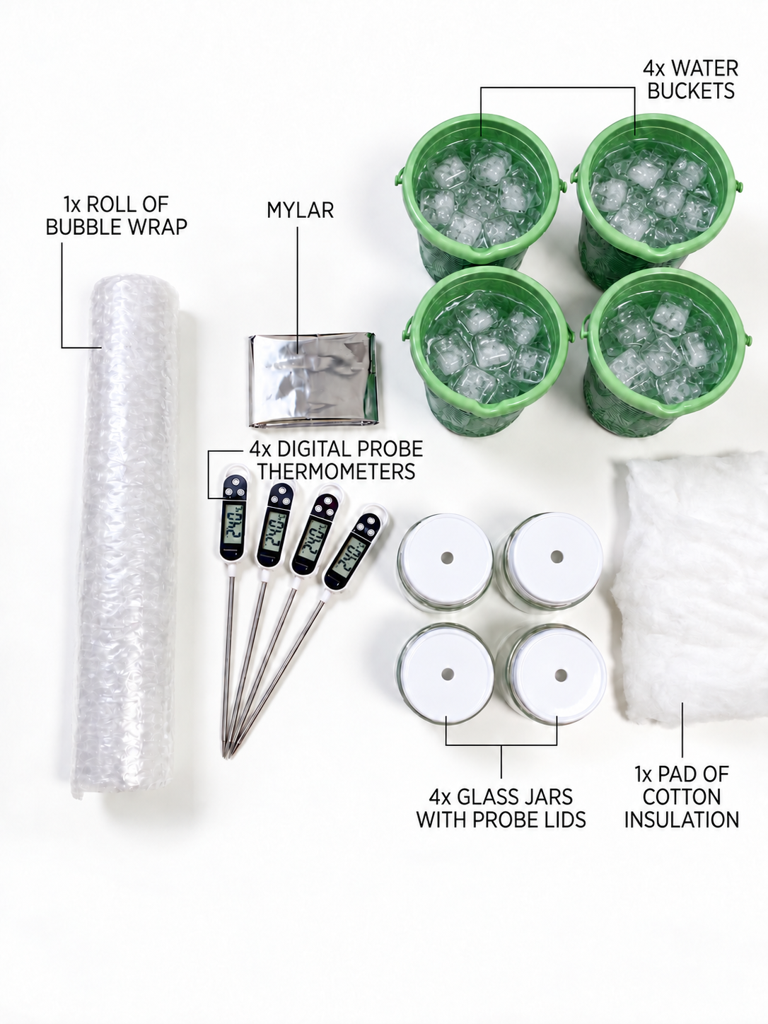
Image A. Complete apparatus set used for the four-condition classroom experiment.
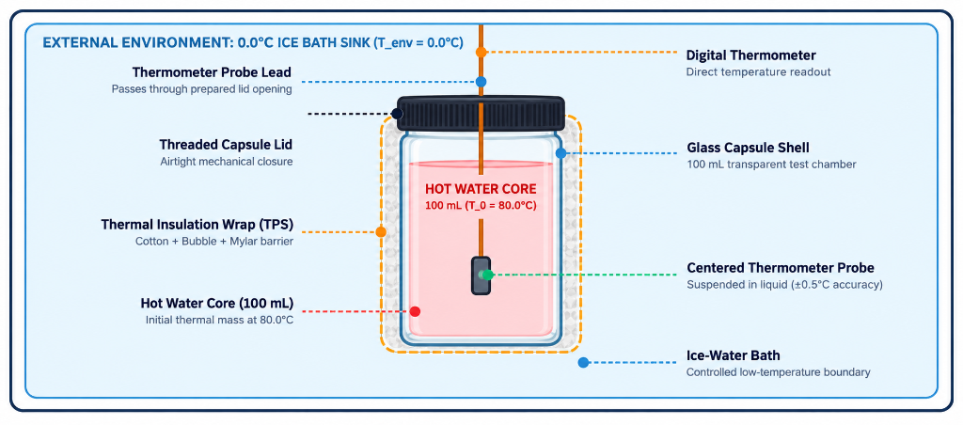
Image B. Capsule arrangement showing the warm-water core, centred probe, insulation wrap, and ice-water boundary.
Condition | Construction | Purpose
Bare control | Jar with no added insulation | Reference heat-loss path
Bubble wrap | Two even layers with cells uncrushed | Trapped-air layer
Mylar only | One reflective layer, neck closed | Reflective layer by itself
Full MLI | Cotton, bubble wrap, outer Mylar | Combined mechanisms

3.2 Construction controls
Small assembly differences changed the response during development. A probe touching the glass did not represent the bulk water. Tight tape flattened bubble cells. A loose opening around the probe created a direct heat-loss path and could let bath water enter. We therefore treated probe position, layer compression, closure, and immersion depth as controlled variables.
- Use jars with the same diameter, wall thickness, and fill height.
- Cut insulation pieces to the same nominal size for repeated trials.
- Secure each layer only tightly enough to stop movement.
- Keep the jar neck and probe opening as consistent as possible.
- Record any wetting, gap, leak, or probe movement with the run data.
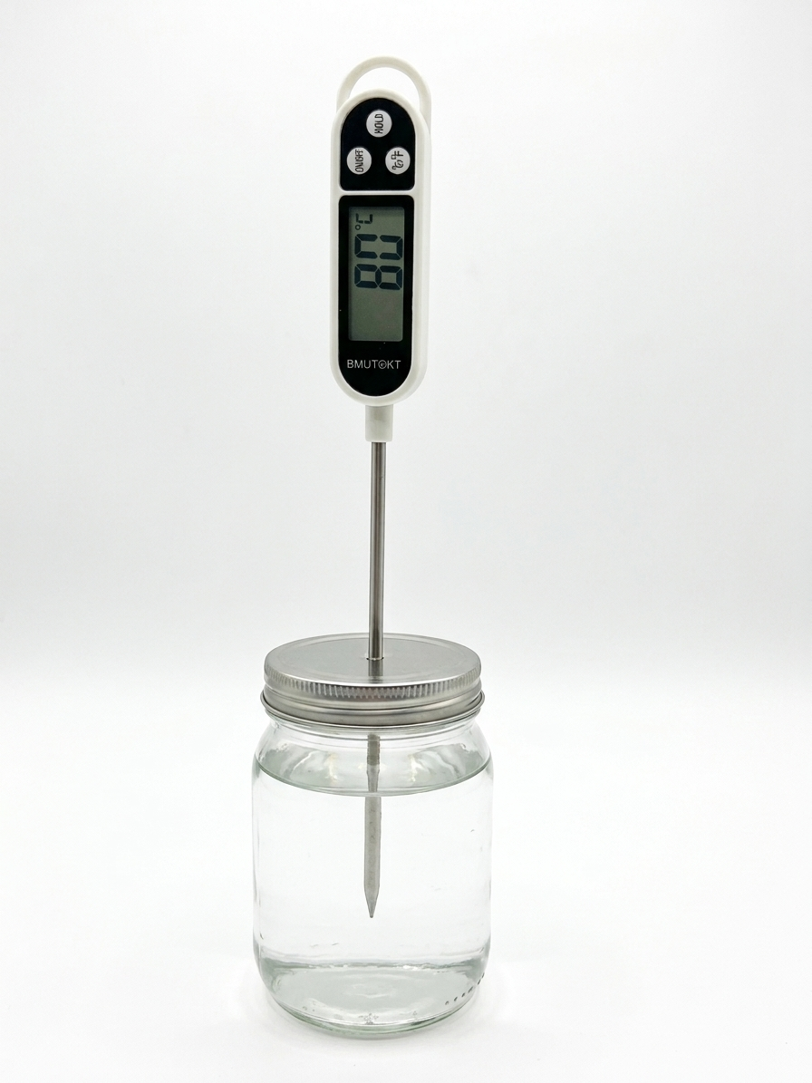
Image C. Bare control capsule with the probe centred through the lid.

3.3 Full multilayer package
The full package is built from the core outward: cotton next to the jar, two layers of bubble wrap around the cotton, and Mylar on the outside. The order was chosen so the soft inner layer follows the jar, the bubble layer provides trapped air, and the reflective sheet forms the outer surface. This arrangement is a classroom analogue only. Real spacecraft multilayer insulation uses carefully controlled low-emittance films, spacers, vacuum conditions, and qualification tests.
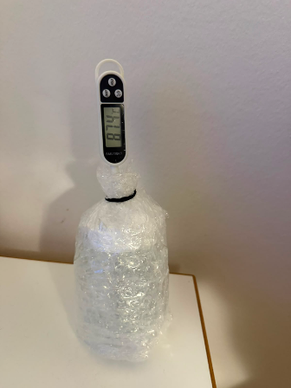
Image D. Bubble-wrap test article with two uncrushed layers and a closed probe opening.
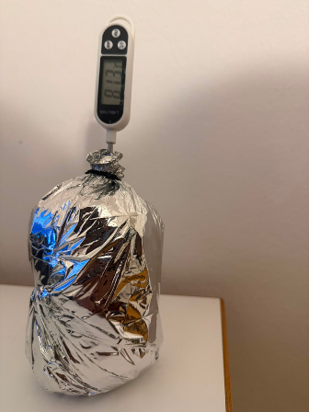
Image E. Completed multilayer test article with the external reflective layer and digital probe.

3.4 Integration with the learning kit
The hardware labels match the configuration names in Mission Control. This prevents a group from choosing one model coefficient while testing another construction. The same four names appear in the manuals, worksheet, result table, and assessment questions.

4 Experimental Method and Safety

4.1 Controlled procedure
- Prepare a stable dry work area. Keep laptops and displays away from the bath.
- Build the assigned insulation and check the jar with cool water.
- Prepare the ice-water bath and record its actual temperature.
- Add 100 mL of water near 80 °C and record the actual starting temperature.
- Centre the probe, close the neck, immerse the jar to the agreed depth, and start the timer.
- Record the core temperature at t = 0 and once per minute through t = 15 min.
- Enter the readings without smoothing them. Calculate drop, residuals, MAE, and an effective k.
- Compare conditions and list the factors that limit the conclusion.

4.2 Fair-test criteria
Every condition should use the same jar geometry, water volume, probe depth, immersion depth, bath location, and timing method. The bath temperature must be measured rather than assumed. If a reading is late, the actual time should be recorded. A complete run contains 16 ordered time-temperature pairs or a written reason for each missing point.

4.3 Safety controls
Hazard | Control
Hot water | Adult or trained supervisor pours; use gloves or tongs
Glass breakage | Inspect jars; use stable secondary containment
Water near electronics | Keep displays, laptops, and connectors dry
Leak or unstable jar | Stop the run immediately
Wet floor | Use towels and clean spills at once

4.4 Data quality
We kept the original readings, including the unexpected Mylar-only curve. The purpose of the model is to support a comparison, not to force a match. Repeating each configuration at least three times and randomising the run order would improve the evidence. Future trials should also record water mass, bath temperature, probe depth, immersion depth, and construction notes for every run.

5 Software and Data Workflow

5.1 Architecture
Mission Control is a browser-based single-page application built with HTML, CSS, and JavaScript. Chart.js draws prediction and telemetry curves, while KaTeX renders the mathematical notation. Local browser storage keeps the selected model, generated prediction, measurements, quiz state, and fallback leaderboard results. The core laboratory runs without a native installation, Bluetooth link, or device driver. The current project also supports an optional Supabase connection for a shared classroom quiz leaderboard; when it is not configured or cannot be reached, the leaderboard falls back to local storage.

5.2 Workflow
Stage | Website action | Student action
Prediction | Calculates T(t) from T0, Tenv, k, and time | Choose a condition and record assumptions
Measurement | Provides timer and 16-point log | Read and enter one value per minute
Comparison | Overlays measured and predicted curves | Inspect curve shape and residuals
Evaluation | Calculates MAE and feedback score | Explain the disagreement physically
Assessment | Runs a timed ten-question challenge | Review answers and compare team score

5.3 Graphing choices
The prediction and telemetry use the same time axis and configuration colours. Axes include units, and the plotted interval matches the 15-minute procedure. The data table keeps the measured value separate from the predicted value. This makes it clear which numbers came from the physical test and which came from the model.
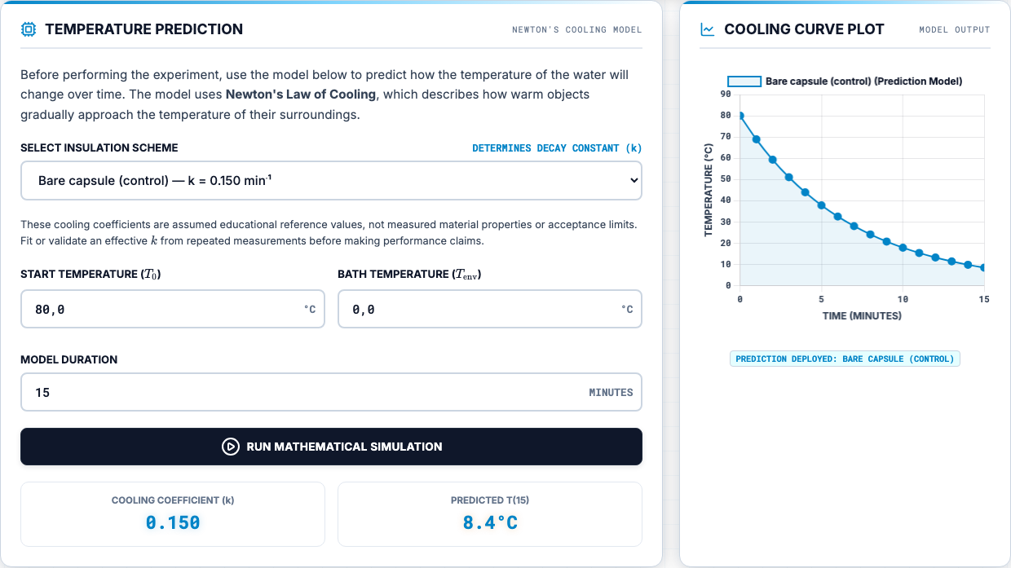
Image F. Current Mission Control prediction interface and 15-minute cooling curve.
The residual at each time is the measured value minus the model value. We use mean absolute error as a simple summary:
MAE = (1/n) Σᵢ₌₁ⁿ |Tmeas,i − Tmodel,i|.

5.4 Reliability and limitations
The site is easy to publish with GitHub Pages and can be opened from a local web server. The current build still loads several browser libraries and fonts from public content-delivery networks, so complete offline use requires those dependencies to be bundled locally. The optional shared leaderboard needs the supplied Supabase configuration and database setup; otherwise the application clearly reports local mode. CSV export and structured run metadata remain useful future additions. The dashboard score is classroom feedback, not a formal statistical validation result.

6 Experimental Results

6.1 Recorded endpoints
The worked dataset contains 16 readings for each condition. The endpoint summary is shown below. Because starting temperatures were not identical, final temperature alone is not enough for a fair comparison; the temperature drop and full curve are more useful.
Condition | T0 | T15 | Drop | Dashboard score
Full MLI | 77.6 °C | 62.7 °C | 14.9 °C | 93%
Bubble wrap | 82.6 °C | 52.6 °C | 30.0 °C | 83%
Bare control | 80.1 °C | 35.2 °C | 44.9 °C | 94%
Mylar only | 80.5 °C | 33.3 °C | 47.2 °C | 3%

6.2 Main result
The full multilayer package had the smallest 15-minute temperature drop and therefore retained the most heat in this run. Bubble wrap ranked second. The bare control and Mylar-only condition cooled much faster. The Mylar-only result does not show that reflective insulation is generally ineffective. It shows that the selected reference coefficient and the physical water-bath construction did not agree for that run.

6.3 Representative telemetry
Time | Full MLI | Bubble | Mylar | Bare
0 min | 77.6 | 82.6 | 80.5 | 80.1
3 min | 75.6 | 72.5 | 55.8 | 59.9
6 min | 73.9 | 65.6 | 44.9 | 47.1
9 min | 70.6 | 60.6 | 38.9 | 40.9
12 min | 67.4 | 56.1 | 35.5 | 37.3
15 min | 62.7 | 52.6 | 33.3 | 35.2

6.4 Fitted cooling constant
A point estimate of k can be calculated when T(t), T0, and Tenv are known:
k = −(1/t) ln([T(t) − Tenv] / [T₀ − Tenv]).
A fit using all usable points is better than a one-point estimate because it uses the curve shape and reduces the influence of one reading. Repeated trials are still needed before reporting material rankings as stable results.

7 Analysis and Model Limitations

7.1 Comparison with the model
The full multilayer package and bare control followed their selected reference curves more closely than the Mylar-only case. The model is useful because it gives the class a common baseline, but k is an effective system value. It changes when the jar, fill, bath, probe, closure, or layer contact changes. A coefficient chosen for one setup should not be presented as a fixed property of a material.

7.2 Likely error sources
Source | Effect on result | Control
Probe touches glass | Biased core reading | Centre probe with a guide
Bath warms | Changing boundary | Measure before and during run
Different start temperatures | Unfair final-temperature ranking | Use drop, theta, or fitted k
Compressed layers | Higher solid conduction | Use repeatable light fastening
Water reaches wrap | Extra conductive path | Improve closure and log wetting
Timing delay | Shifted data point | Record actual timestamp

7.3 Limits of the analogy
A spacesuit operates in vacuum outside the garment, where there is no external air convection. The classroom jar is surrounded by water, so convection and conduction are strong. Real spacesuits also use an active liquid-cooling and ventilation garment. The activity therefore teaches the method of thermal testing and model checking; it does not reproduce the full physics or certify the materials.

7.4 Confidence in the result
The recorded ordering is valid as a description of the worked runs: full MLI, bubble wrap, bare control, then Mylar-only by 15-minute temperature drop. Confidence in a general ranking is limited because the available dataset contains one series per condition and incomplete metadata for some construction details. We would not claim that the same ordering will always occur until repeated trials show the variation.

7.5 Changes for the next campaign
- Run at least three repeats per condition and randomise the order.
- Use a simple probe-position jig and a fixed immersion-depth mark.
- Record bath temperature at the start and end of every run.
- Weigh the water instead of relying only on nominal volume.
- Store construction notes and export all telemetry as CSV.

8 Educational Delivery and Feasibility

8.1 Classroom sequence
The lesson starts with a short briefing on heat transfer and the limits of the spacesuit analogy. Groups then predict which condition will retain the most heat, assemble or inspect their test article, run the 15-minute measurement, and compare the recorded curve with the model. The final discussion asks students to defend a ranking and explain at least one source of disagreement.

8.2 Supporting materials
The current project includes the Mission Control website, student manual, teacher manual and marking guide, task sheet, printable flashcards, illustrated procedure, leaderboard setup guide, and final presentation material. The learning materials use one aligned ten-question framework: written-response questions in the printable set, multiple-choice questions online, and complete solution guidance for students and instructors. We used the same configuration names, variables, test duration, and core volume throughout.

8.3 Assessment
Evidence | What it checks
Prediction | Reasoning from heat-transfer mechanisms
Raw data table | Careful measurement and units
Model comparison | Use of k, residuals, and MAE
Evaluation paragraph | Limits, uncertainty, and fair testing
Open response | Explanation in the student's own words

8.4 Practical feasibility
The equipment is reusable, and the core laboratory does not require a paid account. Shared multi-device leaderboard synchronisation is optional and depends on a configured Supabase project; local scoring remains available without it. The item estimate is EUR 11 for jars and cable glands, EUR 16 for four digital probe thermometers, EUR 8 for insulation materials, and EUR 5 for the test tub. The EUR 40 total remains a planning value until checked against final receipts.
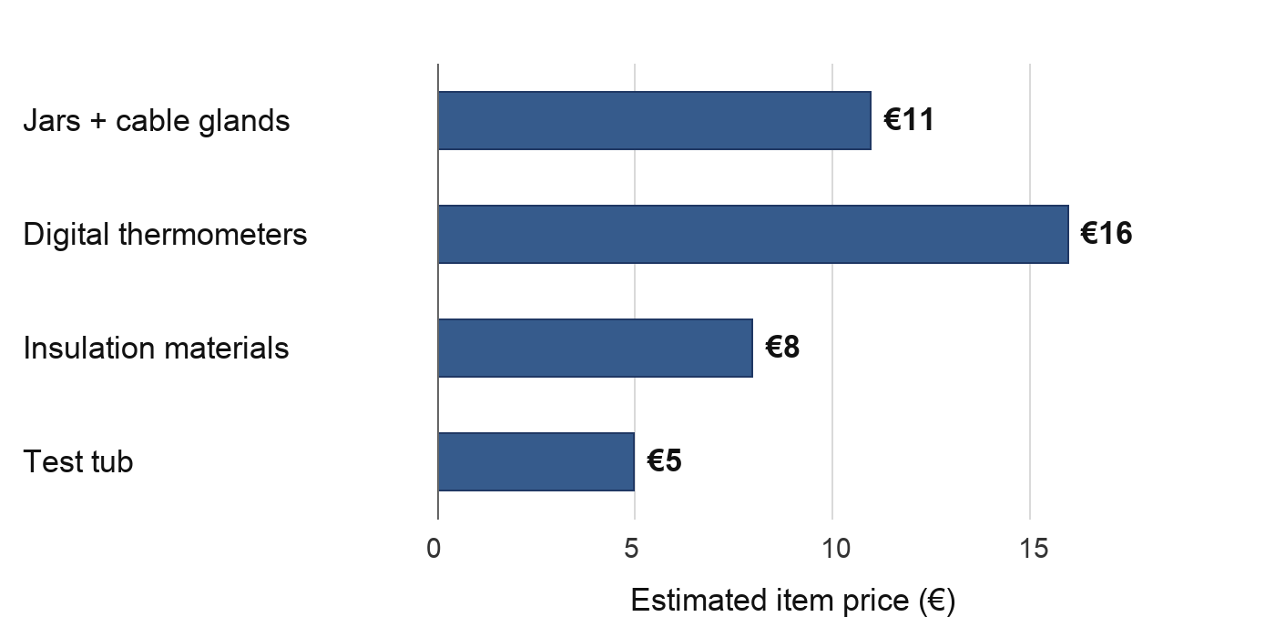
Budget graph. Item-level planning estimate: EUR 40 total, below the EUR 50 course target.

8.5 Handover
A teacher should receive the full kit, printed safety checklist, spare insulation, towels, and a local copy of the website. The handover notes should state the measured jar volume, probe type, reference coefficients, and known limits. This information is more useful than a polished demonstration alone because it lets another class repeat the test and compare results.

9 Conclusions, Responsibilities, and References

9.1 Conclusion
We developed a complete classroom engineering activity that connects a physical thermal test with a simple mathematical model. The full multilayer package retained the most heat in the worked data, while the Mylar-only result showed the importance of boundary conditions and construction. The strongest part of the project is the full workflow: students make a prediction, control a test, keep raw data, compare the result with a model, and explain the mismatch.

9.2 Final recommendations
- Repeat all four conditions and report the variation, not only one curve.
- Bundle Chart.js and KaTeX locally for offline use.
- Add CSV export, run identifiers, and metadata fields.
- Use a probe guide and fixed immersion mark.
- Verify the final cost from current supplier quotes.
- Keep the vacuum-versus-water-bath limitation in every student briefing.

9.3 Project deliverables
The submitted engineering package contains the website, classroom documentation, assessment material, experimental procedure, and presentation resources listed below.
Deliverable | Purpose and report connection
Mission Control website | Prediction, telemetry, model comparison, quiz, and leaderboard
Student manual | Student-facing theory, construction, procedure, and analysis guidance
Teacher manual and marking guide | Preparation, safety, solutions, and assessment criteria
Task sheet | Prediction, raw data, calculations, evaluation, and open response
Printable flashcards | Ten aligned revision and discussion topics
Illustrated procedure | Assembly sequence and experimental controls
Final presentation | Team overview, method, findings, and classroom delivery
README and setup guides | Deployment, resource links, and optional leaderboard configuration

References
[1] NASA, "Spacewalk Spacesuit Basics," Johnson Space Center, accessed 9 Sep. 2026.
[2] NIST, "Water Liquid Phase Heat Capacity," Chemistry WebBook SRD 69, accessed 9 Sep. 2026.
[3] M. M. Finckenor and D. Dooling, Multilayer Insulation Material Guidelines, NASA/TP-1999-209263, 1999.
[4] NASA, Passive Thermal Control Engineering Guidebook, Rev. 4.0, 2023.

Individual Contribution
Piyath Vithanage
Piyath Vithanage completed the current Mission Control application and the final integration of the project resources. The browser workflow connects the briefing, assembly instructions, prediction model, 15-minute measurement sequence, study materials, and assessment. The implementation uses HTML for structure, CSS for the responsive interface, and JavaScript for the thermal model, timer, telemetry, quiz, and leaderboard.
The application state links the selected configuration, initial temperature, bath temperature, duration, and reference cooling constant. The telemetry system stores physical readings separately from the predicted series, restores active data from browser storage, overlays both curves, calculates mean absolute error, and generates a printable experiment record. Defensive checks and responsive layouts improve reliability across classroom laptops and tablets.
Piyath also developed the timed ten-question challenge, scoring workflow, answer review, podium display, and leaderboard. Results remain available through local storage when the optional Supabase connection is unavailable. Final integration covered the student manual, teacher manual, task sheet, flashcards, README, presentation material, regenerated PDFs, and consistency checks across the complete resource set.
The graphing workflow uses one time axis and consistent configuration colours for the measured and predicted series. Residuals and mean absolute error are calculated from the entered readings, while the printed telemetry record preserves the selected configuration, model settings, chart, measurement count, and error result for classroom assessment.
The application was structured so the thermal model and telemetry remain available when optional services fail. Browser storage preserves the active session, and leaderboard results fall back to local storage when the shared connection is unavailable. Responsive layouts and defensive interface checks support use on classroom laptops and tablets.

Individual Contribution
Elio Krollpfeiffer
Elio Krollpfeiffer contributed the early website and interface development that established the project structure. Repository history records 78 commits from the associated development account, including 34 changes to index.html together with updates to styles.css, student documentation, teacher documentation, and project media. These iterations organised the project introduction, thermal content, experiment instructions, and supporting visuals into one browser-based learning sequence.
The student and teacher manuals were developed alongside the website. The student material introduced the activity and task order, while the teacher material supported preparation and classroom delivery. This early separation of learner and instructor guidance created a documentation structure that could later be aligned with the final model, telemetry, assessment, and safety requirements.
Elio's work provided the documented implementation foundation for later development. The combination of interface structure, visual styling, manuals, PDFs, and media assets allowed new functionality to be added within an established educational workflow rather than as isolated features.
The early interface revisions combined the project introduction, heat-transfer theory, experiment instructions, and supporting visuals in one location. This structure created a clear sequence from scientific context to practical activity and remained the basis for the later prediction, telemetry, study, and assessment sections.
Repeated revisions improved the navigation, terminology, instructional order, and visual presentation. Developing the learner and instructor materials alongside the website helped keep preparation guidance, operational instructions, and scientific explanations directed at the correct classroom audience.

Individual Contribution
Dilan Fernando
Dilan Fernando held the main technical responsibility for the thermodynamic model and the interpretation of the experimental results. The lumped Newtonian cooling model was selected to preserve the relationship between thermal mass, environmental temperature, and cooling rate while remaining understandable to students. The effective cooling constant was defined as a system coefficient in min⁻¹ and kept separate from material thermal conductivity.
Dilan established the 100 mL water core, starting temperature near 80 °C, measured ice-water boundary, and one-minute readings over 15 minutes. The four-condition comparison was analysed using temperature drop, normalised temperature, residuals, mean absolute error, and a fitted cooling constant. The unexpected Mylar-only response was retained as evidence of model or construction mismatch rather than adjusted to fit the reference curve.
The contribution also covered the safety controls for hot water, glass, spills, and electronics; the interpretation of probe position, closure, wetting, compression, and bath temperature; and the alignment of the model, experiment, manuals, website, and report. This technical work kept the conclusion limited to the tested system and supported the recommendation for repeated trials.
The original measurement series was retained without smoothing. This preserved the unexpected Mylar-only response and allowed the discussion to distinguish measurement variation from model limitations. Recommended improvements included repeated trials, randomised run order, measured bath temperature, fixed probe depth, and construction notes for every run.
The model was also checked through its physical behaviour. The calculated curve begins at the entered initial temperature, approaches the environmental temperature over time, and becomes steeper when the effective cooling constant increases. These relationships provided practical acceptance limits for the simulator and supporting documents.

Individual Contribution
Nuhansee Migelhewage
Nuhansee Migelhewage contributed the scientific principles, theory, experimental setup, and practical preparation. The theory work explained conduction, convection, radiation, thermal capacity, and transient cooling at the level required for the activity. It also connected the water-bath experiment to spacesuit thermal protection while maintaining the limitation that the classroom system does not reproduce vacuum heat transfer.
The experimental setup contribution covered the glass water core, centred probe, insulation layers, ice-water bath, and measurement sequence. Fair-test controls included equal water volume, comparable jars, repeatable probe depth, consistent immersion depth, one-minute sampling, and a recorded boundary temperature. Layer-order checks also addressed compressed bubble cells, reflective-film placement, and the opening around the probe.
Practical preparation included safe handling of hot water, stable bath placement, leak checks, dry thermometer displays, and separation of electronics from water. By linking each setup control to a thermal variable, the contribution helped students understand how experimental errors change the curve and why deviations must be documented during evaluation.
A pre-run inspection sequence covered jar condition, room-temperature probe response, insulation order, closure quality, bath position, and cable routing before hot water was introduced. The same preparation sequence informed the student manual, teacher guide, task sheet, illustrated procedure, and classroom safety briefing.
The theory contribution connected the curve shape with the physical setup. A steep curve indicates rapid approach to the bath temperature, while a shallow curve indicates greater heat retention in the tested system. Probe placement, water volume, insulation contact, layer compression, and bath condition were used to explain why measured and predicted values may differ.

