Additional File 1: Supplementary Materials

GRAD: A Two-Stage Algorithm for Resolving Diagnostic
Uncertainty in the Plasma phospho-tau217 Gray Zone

Harthik Parankusham, Casey Vanderlip, Colin Birkenbihl, Eashwar Krishna,
Chizobam Ugboaja, Andrew Budson, Brandon Frank,
and for the Alzheimer's Disease Neuroimaging Initiative

Journal of Prevention of Alzheimer's Disease

Contents:
Supplementary Figures S1–S2
Supplementary Tables S1–S7

Figure S1. ADNI LOOCV calibration analysis. (A) Calibration curve comparing GRAD predicted probabilities against observed Aβ positivity fraction across decile bins. Dashed line indicates perfect calibration. Expected Calibration Error (ECE) = 0.060. Hosmer–Lemeshow test: χ² = 17.69, df = 8, p = 0.024. (B) Prediction density distributions by true Aβ status, with Gatekeeper probability thresholds (P = 0.25, P = 0.75) indicated by dashed vertical lines.
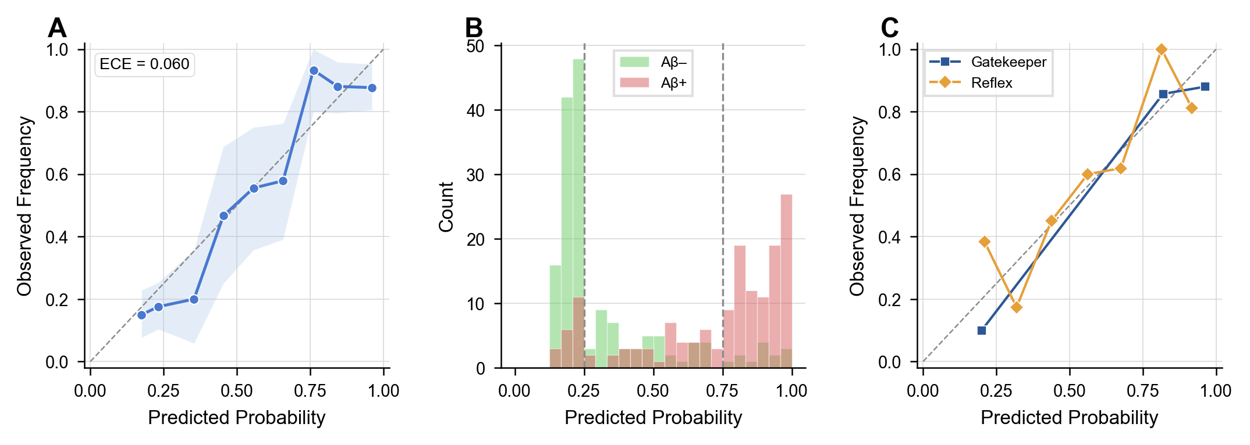

Figure S2. Supplementary model characterization. (A) Subgroup AUC forest plot stratified by cognitive status, APOE ε4 status, sex, and age tertiles; dashed line indicates overall AUC (0.857). (B) Threshold–performance tradeoff showing sensitivity, specificity, PPV, NPV, and accuracy across classification thresholds, with 90% sensitivity (threshold = 0.240) and 90% specificity (threshold = 0.674) operating points annotated. (C) Gatekeeper threshold sensitivity heatmap across 25 low/high threshold combinations. Each cell shows resolution rate (top) and resolved accuracy (bottom). Gold border indicates the selected 0.25/0.75 operating point. (D) Per-stage confusion matrices for Stage 1 Gatekeeper (N = 178, accuracy 88.8%) and Stage 2 Reflex (N = 142, accuracy 70.4%).
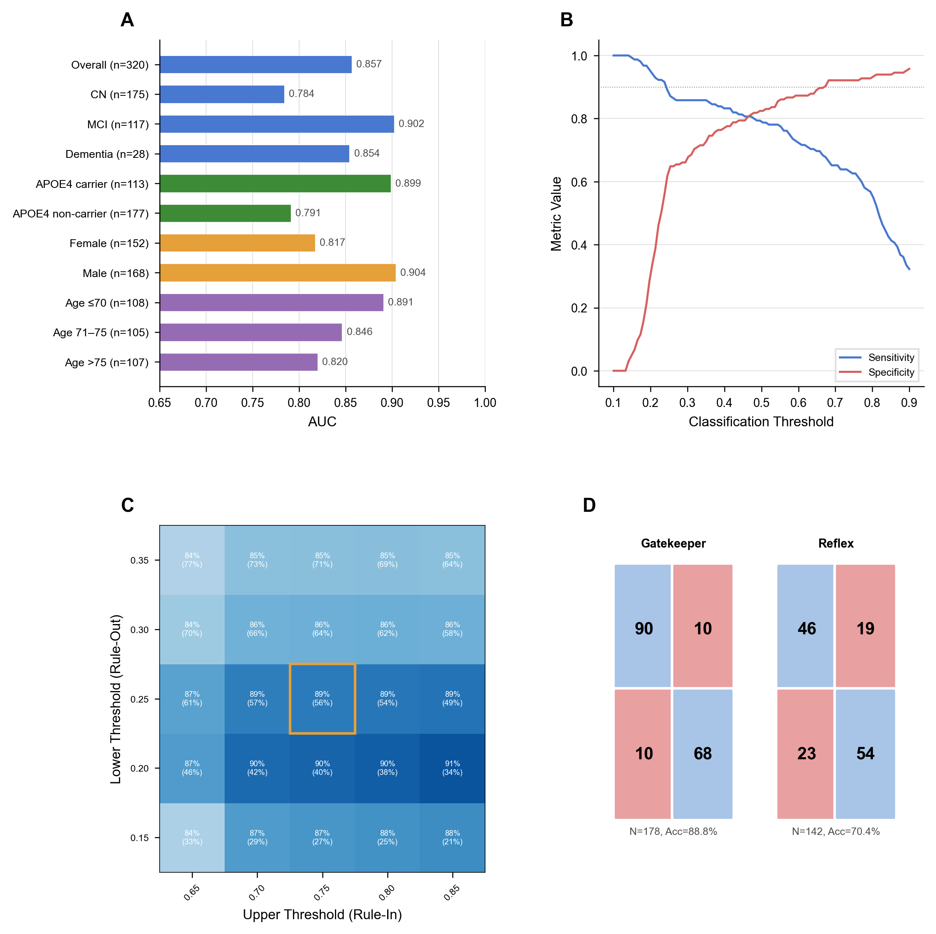

Table S1. Complete Model Performance Metrics. Full GRAD model performance in the ADNI development cohort (N = 320) under leave-one-out cross-validation. 95% confidence intervals for AUC, accuracy, sensitivity, and specificity derived from 2,000 bootstrap resamples of the LOOCV predictions; CIs for PPV, NPV, and likelihood ratios computed analytically. Discrimination, calibration, and likelihood ratio metrics reported per STARD 2015 diagnostic accuracy guidelines. AUC, area under the receiver operating characteristic curve; AUPRC, area under the precision-recall curve; PPV, positive predictive value; NPV, negative predictive value; LR+, positive likelihood ratio; LR−, negative likelihood ratio.
Metric | Value | 95% CI
AUC | 0.857 | 0.813–0.897
AUPRC | 0.827 | 0.757–0.897
Accuracy | 80.6% | 76.2%–84.7%
Sensitivity | 78.7% | 72.3%–84.8%
Specificity | 82.4% | 76.4%–88.0%
PPV | 80.8% | 74.5%–86.7%
NPV | 80.5% | 74.6%–86.2%
LR+ | 4.48 | 3.28–6.50
LR− | 0.26 | 0.18–0.35
Brier Score | 0.148 | —

Table S2. Subgroup Performance Analysis. GRAD model performance stratified by demographic and clinical subgroups. All metrics computed from ADNI LOOCV predictions. Age tertiles defined within the ADNI cohort.
Category | Subgroup | N | N+ | AUC | Accuracy | Sensitivity | Specificity
Cognitive Status | CN | 175 | 70 | 0.784 | 0.749 | 0.629 | 0.829
Cognitive Status | MCI | 117 | 61 | 0.902 | 0.863 | 0.902 | 0.821
Cognitive Status | Dementia | 28 | 24 | 0.854 | 0.929 | 0.958 | 0.750
APOE4 Status | APOE4 carrier | 113 | 81 | 0.899 | 0.850 | 0.889 | 0.750
APOE4 Status | APOE4 non-carrier | 177 | 66 | 0.791 | 0.780 | 0.682 | 0.838
Sex | Female | 152 | 77 | 0.817 | 0.789 | 0.727 | 0.853
Sex | Male | 168 | 78 | 0.904 | 0.821 | 0.846 | 0.800
Age Tertile | Age ≤70 | 108 | 40 | 0.891 | 0.852 | 0.750 | 0.912
Age Tertile | Age 70–75 | 105 | 53 | 0.846 | 0.781 | 0.774 | 0.788
Age Tertile | Age >75 | 107 | 62 | 0.820 | 0.785 | 0.823 | 0.733

Table S3. Per-Stage Performance Metrics. Performance metrics for each stage of the GRAD algorithm. Stage 1 (Gatekeeper): univariate p-Tau217 logistic regression. Stage 2 (Reflex): 6-feature Random Forest classifier applied to gray zone cases (0.25 ≤ P ≤ 0.75). Sens = sensitivity, Spec = specificity, Acc = accuracy.
Stage | N | TP | TN | FP | FN | Sens | Spec | PPV | NPV | Acc | AUC
Gatekeeper | 178 | 68 | 90 | 10 | 10 | 0.872 | 0.900 | 0.872 | 0.900 | 0.888 | 0.912
Reflex | 142 | 54 | 46 | 19 | 23 | 0.701 | 0.708 | 0.740 | 0.667 | 0.704 | 0.751

Table S4. Clinical Operating Points. Model performance at clinically relevant operating points. The 90% sensitivity threshold (rule-out, P < 0.240) and 90% specificity threshold (rule-in, P > 0.674) define the clinical decision boundaries. Youden's J index identifies the threshold maximizing sensitivity + specificity − 1.
Operating Point | Sens | Spec | PPV | NPV | Acc | LR+ | LR−
50% Standard | 0.787 | 0.824 | 0.808 | 0.805 | 0.806 | 4.48 | 0.258
90% Spec (Rule-In) | 0.677 | 0.903 | 0.868 | 0.749 | 0.794 | 6.99 | 0.357
90% Sens (Rule-Out) | 0.903 | 0.576 | 0.667 | 0.864 | 0.734 | 2.13 | 0.168
Youden's J | 0.781 | 0.861 | 0.840 | 0.807 | 0.822 | 5.60 | 0.255

Table S5. Gatekeeper Threshold Sensitivity Analysis. Each row represents a combination of lower (rule-out) and upper (rule-in) probability thresholds. Resol. Rate = proportion of patients classified without Stage 2 or PET. Resol. Acc = accuracy among resolved cases. GZ = gray zone. The selected operating point is 0.25/0.75.
Low Thr | High Thr | Resolved N | Resol. Rate | Resol. Acc | GZ N | GZ AUC | Overall AUC
0.15 | 0.65 | 105 | 32.8% | 83.8% | 215 | 0.819 | 0.862
0.15 | 0.70 | 93 | 29.1% | 87.1% | 227 | 0.820 | 0.863
0.15 | 0.75 | 87 | 27.2% | 87.4% | 233 | 0.835 | 0.869
0.15 | 0.80 | 81 | 25.3% | 87.6% | 239 | 0.827 | 0.861
0.15 | 0.85 | 66 | 20.6% | 87.9% | 254 | 0.836 | 0.858
0.20 | 0.65 | 147 | 45.9% | 87.1% | 173 | 0.781 | 0.860
0.20 | 0.70 | 135 | 42.2% | 89.6% | 185 | 0.783 | 0.861
0.20 | 0.75 | 129 | 40.3% | 89.9% | 191 | 0.796 | 0.863
0.20 | 0.80 | 123 | 38.4% | 90.2% | 197 | 0.797 | 0.861
0.20 | 0.85 | 108 | 33.8% | 90.7% | 212 | 0.800 | 0.856
0.25 | 0.65 | 196 | 61.3% | 86.7% | 124 | 0.740 | 0.860
0.25 | 0.70 | 184 | 57.5% | 88.6% | 136 | 0.733 | 0.858
0.25 | 0.75 | 178 | 55.6% | 88.8% | 142 | 0.751 | 0.857
0.25 | 0.80 | 172 | 53.8% | 88.9% | 148 | 0.753 | 0.859
0.25 | 0.85 | 157 | 49.1% | 89.2% | 163 | 0.766 | 0.858
0.30 | 0.65 | 224 | 70.0% | 84.4% | 96 | 0.788 | 0.864
0.30 | 0.70 | 212 | 66.2% | 85.9% | 108 | 0.776 | 0.867
0.30 | 0.75 | 206 | 64.4% | 85.9% | 114 | 0.779 | 0.864
0.30 | 0.80 | 200 | 62.5% | 86.0% | 120 | 0.770 | 0.866
0.30 | 0.85 | 185 | 57.8% | 86.0% | 135 | 0.756 | 0.862
0.35 | 0.65 | 245 | 76.6% | 83.7% | 75 | 0.752 | 0.866
0.35 | 0.70 | 233 | 72.8% | 85.0% | 87 | 0.723 | 0.871
0.35 | 0.75 | 227 | 70.9% | 85.0% | 93 | 0.734 | 0.869
0.35 | 0.80 | 221 | 69.1% | 85.1% | 99 | 0.714 | 0.866
0.35 | 0.85 | 206 | 64.4% | 85.0% | 114 | 0.661 | 0.855

Table S6. Cost Impact Simulation. Cost impact simulation for a projected 10,000-patient cohort. Unit costs reflect differentiated plasma pricing: single-analyte p-Tau217 ($350, CMS 2024 CLFS) versus the full GRAD panel (p-Tau217, GFAP, Aβ42/40; $600). PET: $3,000/scan (CMS 2024 PFS). MRI assumed already obtained for the Staged + MRI strategy.
Strategy | Total | Per Capita | PET Scans | Plasma | Plasma $ | Savings
Universal PET | $30.0M | $3,000 | 10,000 | 0 | — | Ref
p-Tau217 + PET for Gray Zone | $16.8M | $1,682 | 4,440 | 10,000 | $350 | 43.9%
Staged Algorithm (GRAD) | $10.0M | $999 | 1,331 | 10,000 | $600 | 66.7%
Staged + MRI (if MRI already available) | $8.7M | $866 | 887 | 10,000 | $600 | 71.1%

Table S7. NfL Feature Ablation Analysis. Feature ablation analysis evaluating the contribution of neurofilament light (NfL) to the Reflex model. Base model includes the 6 selected features (p-Tau217, GFAP, Tau–Aβ42/40 divergence ratio, GFAP × p-Tau217 interaction, age, APOE ε4). Adding NfL improved AUC by 0.011, deemed insufficient to justify additional complexity. All metrics from ADNI LOOCV.
Model | N | AUC | Accuracy | Sensitivity | Specificity | Brier | ΔAUC
Base (6 features) | 6 | 0.857 | 0.806 | 0.787 | 0.824 | 0.148 | 0.000
+ NfL | 7 | 0.865 | 0.809 | 0.800 | 0.818 | 0.146 | 0.009
+ NfL + NfL×Age | 8 | 0.864 | 0.812 | 0.806 | 0.818 | 0.147 | 0.007

