**Harsh Shaileshkumar Patel -> Customer Details Table**

**Dharam Hasmukhlal Pankhania -> Order Details Table**

**Harsh Mittal -> Employee Table**

**Overview**

This application is created to support Mall system and the focus is on the tables Customer, Order and employee details. It displays the menu of 13 options, which are 4 CRUD tasks for each table and an Exit option. The user input starts with choosing between 0-12 options which then performs Create, Read, Update or Delete operation depending on each table’s constraints and expected input. Selecting 0 in the application will quit the application.

**User guide - Table contents**

Customer Details Table

Create………………………………………………………………………………………………………………………………….. 2

Read…………………………………………………………………………………………………………………………………….. 3

Update…………………………………………………………………………………………………………………………………. 3

Delete………………………………………………………………………………………………………………………………….. 3

Order Details Table

Create………………………………………………………………………………………………………………………………….. 4

Read…………………………………………………………………………………………………………………………………….. 5

Update…………………………………………………………………………………………………………………………………. 5

Delete………………………………………………………………………………………………………………………………….. 5

Employee Table

Create………………………………………………………………………………………………………………………………….. 5

Read…………………………………………………………………………………………………………………………………….. 6

Update…………………………………………………………………………………………………………………………………. 7

Delete………………………………………………………………………………………………………………………………….. 7

**CUSTOMER DETAILS:-**

**Option 1:- Add New Customer Record:-**

As the option name suggests it let’s the user add new record for customer into the data base.

After Choosing option 1 it will prompt user to enter valid data like id, first name, last name, order number, address. If the data was added to data it displays successful message.

If the data already exists it displays that customer already exists.

**Option 2:-Update Customer Record**

This option let’s you update new address of existing customer in the data base.

It asks user to enter the id for customer to change address. It let’s you change the address as many times as you wants. If customer does not exists in data base it displays the customer does not exists.

**Option 3:-Delete Customer record**

This option let’s user delete any existing record of customer with all the details.

It prompts user to enter customer id that they want to delete and displays the message after completing the process. If the user id does not exist in data base it gives an error saying that user does not exist or if process fails due to some reason it gives error saying Record could not be deleted.

**Option 4:-Display customer record**

This option prompts user to enter the id and displays existing data present in the data base.

It prompts user to enter the customer Id that they want to see and displays their record as shown above format. If the customer id does not exist in data base it gives an Error saying customer with id … does not found.

**ORDER DETAILS( Dharam Hasmukhlal Pankhania):-**

**Option 1: - Add New Order Record:-**

As the option name suggests it let’s the user add new order record for customer into the data base, in this case the order already exists I used this to show that the data would be added regardless but if there was a conflict it would give an error.

**Option 2: -Update Order Quantity**

This option let’s you update new order quantity of existing customer in the data base.

**Option 3: -Delete Customer record.**

This option let’s user delete any existing record of customer with all the details.

**Option 4: -Display order details**

This option prompts user to enter the id and displays existing data present in the data base.

**Option 1: Insert Employee Details:**

This option allows to insert a new employee to database.It prompts for employee id, employee name,employee job,salary.If data adds successfully it show inserted successfully otherwise it gives error.

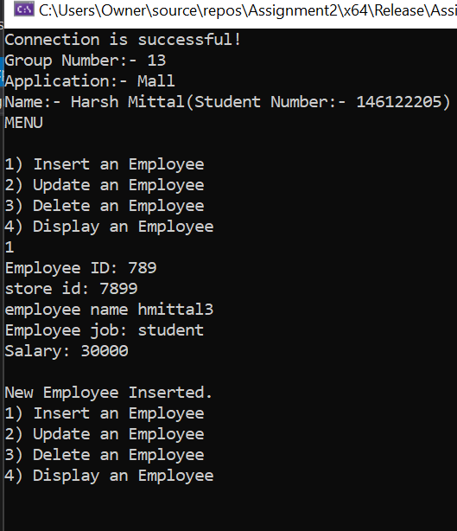

**Delete Employee Record:**

This allows us to delete any employee record by using there employee id.

