Lab 3

Haroon Popal

March 19, 2021

# Research Question

Interpersonal relationships have significant implications for perception, emotion, memory, motivation, and decision-making. Throughout the lifespan, having strong social relationships are important for personal success, health and well-being. One theory proposes that humans have a unique ability to track a large number of social relationships, which have allowed us to live in large groups and societies. As humans enjoy very diverse social lives across their family life, careers, friends, communities, and social media, the research question this project attempts to address is what is the impact of a sustained decrease in the typical number and variety of social relationships on mental health.

# Level 1 and Level 2

The level 1 unit of analysis is observations and the level 2 unit of analysis is individuals.

# Data Source

Participants were recruited from Amazon Mechnical Turk (mTurk). mTurk is hosted by Amazon and provides an online platform for individuals (mTurkers) to partake in surveys. Use of mTurk has become popular in psychology research, as it allows for larger sample sizes than what can be typically collected in a lab setting. A link to the survey was posted on mTurk using turkprime.com. The use of “bots” to pose as real participants has been an issue with mTurk, and turkprime has a system that catches and excludes some of these bots. Participants from across the United States were eligible to take the survey at three time points during the beginning of the COVID-19 pandemic, from March to May 2020. An additional eligibility criteria was that participants must have learned English as their first language. This is due to cultural differences in social relationships, which we believe exist but are unable to directly address. Data was collected at three time points. Only individuals who completed the first time point were invited to participate at the second and third time points. All of the survey data for the first time point was collected within one day. At the second and third time points, the survey was opened and participants were invite to complete the survey again. The survey remained open for one week to allow individuals to complete the survey. The second survey was opened three weeks after the first survey was completed, and the third survey was opened four weeks after the second survey was completed. In this way, the time between surveys differed for each participant. Individuals who missed the second time were still allowed to complete the third time point. In total, 767 participants completed the survey at the first time point, 501 at the second time point, and 365 at the third time point.

# Dropped Cases

Cases were dropped for two possible non-compliance reasons. The first is if participants failed attention check questions which were designed to easily reveal whether participants are attending to the survey. These questions were simple and had clear answers such as “which of the following is most likely the color red?” (e.g. strawberries). Participants who failed even one attention check question (of two) were excluded. The second way a participant might have been excluded is if they did not follow directions in how to format their responses for free response questions or did not answer all the questions. This was done so that the response coding could more easily be done by the researchers. In total 647 observations were dropped and 234 individuals were dropped because of subject noncompliance.

|  |  |  |  |
| --- | --- | --- | --- |
| Wave | Original responses | Excluding attention check failures | Excluding directions failures |
| 1 | 767 | 753 | 467 |
| 2 | 501 | 463 | 289 |
| 3 | 365 | 360 | 230 |
| Unique individuals | 767 | 754 | 533 |

# Variables

This study includes variables that can be grouped as predictors, outcomes, and nuisance variables. The outcome we measured was a latent factor of mental well-being, derived from measures of anxiety, behavioral/emotional control, depression, calm-positive affect, and happy/positive affect. These five variables were measured by asking participants whether they felt each factor much less, less, about the same, more, or much more in the past week. The predictors of interest were the number of social relationships, the variety of social relationship, and the quality of social relationships they experienced at a previous time point (lagged). Participants were asked to report each person they interacted with in the past week, and their relationship to that person, results in their number of relationships (i.e. 10 relationships), and variety of relationship (i.e. 5 unique relationships) reported. They were also asked to rate how positive or negative each relationship was on a scale of one to five indicating very negative, negative, neutral, positive, or very positive. Nuisance variables were boredom, ability to do their interests (i.e. hobbies), ability to regulate one’s emotions, their ability to do normal routine, and physical well-being, measured by a report of how they feel similar to the mental well-being questions). The observation level variables were the social relationship feature variables and the nuisance variables, which were all person-centered as we wished to know the pure within-person effects. The individual level variables were the participant means for the predictors, the outcome, and the nuisance variables. All variables were standardized.

## Aggregation and centering

The observation level variables will be aggregated as averages of the observations for each participant. Then person-centered variables were created as this is a longitudinal analysis and we wish to focus on the pure within-subject effects.

# Scatterplot Matrix

## Level 1 variables

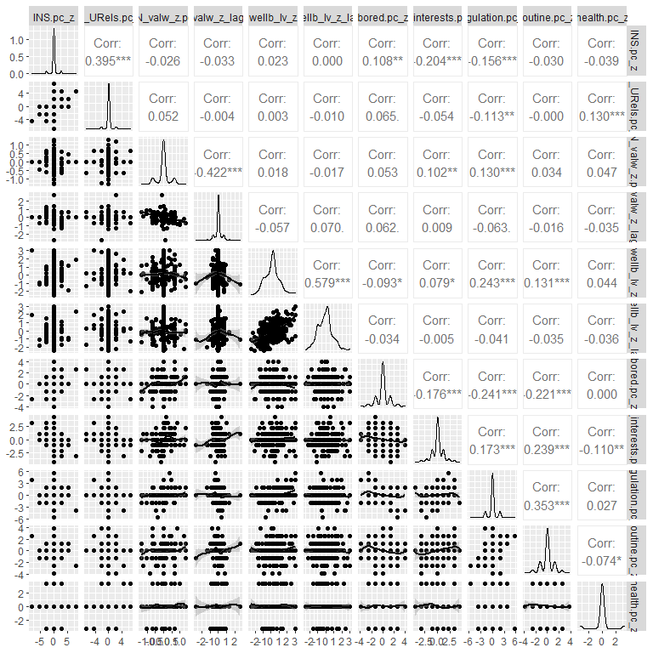

**Figure 1. Scatterplot matrix for person level outcome variable of mental well-being, social relationship features (predictors), and nuisance variables**

## Level 2 variables

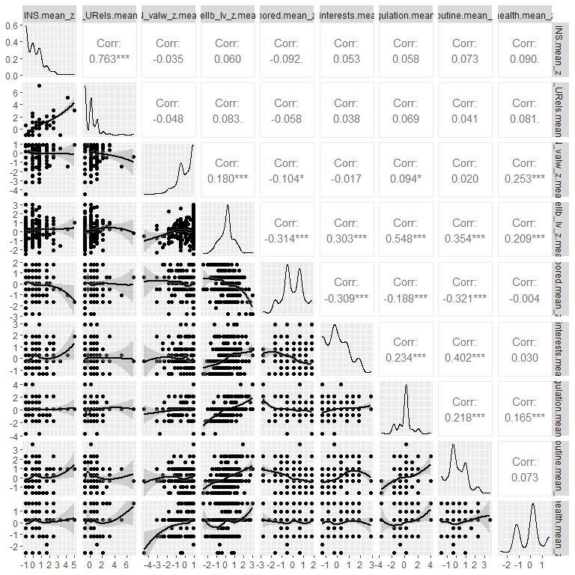

**Figure 2. Scatterplot matrix for person level outcome variable of mental well-being, social relationship features (predictors), and nuisance variables**

# Distribution of Outcome

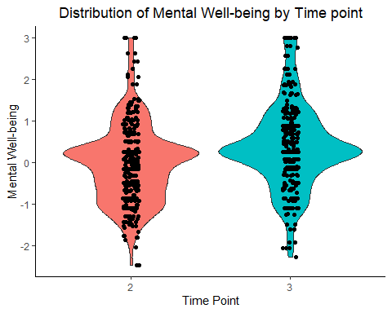

**Figure 3. Distribution of the mental well-being outcome variable for each time point. The first time point is not shown, as a lagged predictor is used in the subsequent analyses.**

# Summary Statistics

**Table 2. Summary statistics.** All variables were z-standardized. IN = Immediate network, PC = person-centered, M = person-level mean.

|  |  |  |
| --- | --- | --- |
| Measure | Mean | Standard Deviation |
| Mental well-being | 0.16 | 0.97 |
| IN size PC | 0 | 1.11 |
| IN # of unique relationships PC | 0 | 1.11 |
| IN time-weighted valence PC (lagged) | 0 | 0.39 |
| Boredom PC | 0 | 0.43 |
| Ability to do interests PC | 0 | 0.51 |
| Emotion regulation PC | 0 | 0.29 |
| Ability to do normal routine PC | 0 | 0.44 |
| General physical health PC | 0 | 0.17 |
| IN size M | 0 | 0.98 |
| IN # of unique relationships M | 0 | 0.98 |
| IN time-weighted valence M (lagged) | 0.07 | 0.87 |
| Boredom M | -0.01 | 0.98 |
| Ability to do interests M | -0.01 | 0.96 |
| Emotion regulation M | 0.01 | 0.94 |
| Ability to do normal routine M | 0.02 | 0.96 |
| General physical health M | 0.04 | 0.99 |

# Estimation Technique

Full maximum likelihood (FML) estimation will be used as there are two time points per individual.

# Regressions

# Regression Table

|  |  |  |  |
| --- | --- | --- | --- |
| **Table 3. Regression table for the empty, within and between, and the cross-level interaction models.** | | | |
|  | | | |
|  | *Dependent variable:* | | |
|  |  | | |
|  | Mental well-being | | |
|  | (1) | (2) | (3) |
|  | | | |
| IN size PC |  | 0.063*** | 0.051* |
|  |  | (0.018) | (0.018) |
|  |  |  |  |
| IN # of unique relationships PC |  | -0.003 | -0.009 |
|  |  | (0.018) | (0.018) |
|  |  |  |  |
| IN time-weighted valence PC (lagged) |  | -0.091* | -0.096* |
|  |  | (0.046) | (0.045) |
|  |  |  |  |
| Boredom PC |  | -0.024 | -0.023 |
|  |  | (0.017) | (0.017) |
|  |  |  |  |
| Ability to do interests PC |  | 0.041* | 0.039* |
|  |  | (0.017) | (0.017) |
|  |  |  |  |
| Emotion regulation PC |  | 0.192*** | 0.194*** |
|  |  | (0.018) | (0.018) |
|  |  |  |  |
| Ability to do normal routine PC |  | 0.036* | 0.040* |
|  |  | (0.018) | (0.018) |
|  |  |  |  |
| General physical health PC |  | 0.042* | 0.043* |
|  |  | (0.016) | (0.016) |
|  |  |  |  |
| IN size M |  | -0.060 | -0.060 |
|  |  | (0.059) | (0.059) |
|  |  |  |  |
| IN # of unique relationships M |  | 0.068 | 0.068 |
|  |  | (0.059) | (0.059) |
|  |  |  |  |
| IN time-weighted valence M (lagged) |  | 0.082 | 0.082 |
|  |  | (0.044) | (0.044) |
|  |  |  |  |
| Boredom M |  | -0.130** | -0.130** |
|  |  | (0.042) | (0.042) |
|  |  |  |  |
| Ability to do interests M |  | 0.071 | 0.070 |
|  |  | (0.043) | (0.043) |
|  |  |  |  |
| Emotion regulation M |  | 0.383*** | 0.383*** |
|  |  | (0.040) | (0.040) |
|  |  |  |  |
| Ability to do normal routine M |  | 0.161*** | 0.161*** |
|  |  | (0.043) | (0.043) |
|  |  |  |  |
| General physical health M |  | 0.087* | 0.087* |
|  |  | (0.040) | (0.040) |
|  |  |  |  |
| IN size PC * IN time-weighted valence M (lagged) |  |  | 0.052* |
|  |  |  | (0.021) |
|  |  |  |  |
| Constant | 0.122* | 0.127** | 0.127** |
|  | (0.051) | (0.039) | (0.039) |
|  |  |  |  |
|  | | | |
| Observations | 729 | 729 | 729 |
| Log Likelihood | -881.133 | -710.294 | -707.137 |
| Akaike Inf. Crit. | 1,768.267 | 1,458.588 | 1,454.274 |
| Bayesian Inf. Crit. | 1,782.042 | 1,545.830 | 1,546.107 |
|  | | | |
| *Note:* | *p<0.05; **p<0.005; ***p<0.001 | | |
|  | All variables are z-standardized. Standard errors in are parentheses. IN = Immediate network, PC = person-centered, M = person-level mean. | | |

# Write-Up

A latent variable of mental well-being was used as the outcome in a within- and between-subjects model with a cross-level interaction. The predictors in the model were immediate network size, number of unique relationships, lagged time-weighted immediate network valence, and the nuisance variables of boredom, ability to do interests, emotion regulation, ability to due normal routine, and general physical health. Holding all else constant, a one standard deviation increase in immediate network size was weakly predictive of a decrease 0.06 standard deviation decrease in mental well-being, when comparing two observations from the same individual. For the person-level effects, while holding all other variables constant, lagged time-weighted relationship valence was not significantly predictive of mental well-being (Table 3). The cross-level interaction revealed that for every standard deviation increase in lagged time-weighted relationship valence, the effect of immediate network size will increase by 0.05 standard deviations (Table 3, Fig. 4). These results support our hypothesis and indicate that individuals who have previously had positive social relationships at home, had an increase in their immediate network size, resulting in increases in mental well-being.

# Graph

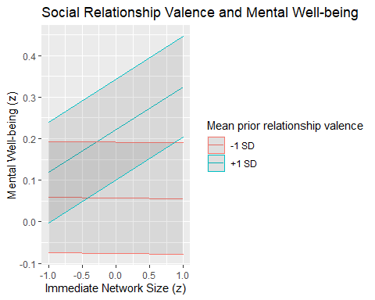

**Figure 4. Cross-level interaction of immediate network size and lagged relationship valence on mental well-being.**

# Appendix

# Data Source

# Import data  
responses_excluded <- read.csv('/Users/Administrator/Google_Drive/olson_lab/projects/social_distancing/survey_data/responses_excluded.csv')

socdist_data <- responses_excluded %>% select(AmazonIdentifier, INS, IN_URels, IN_valw, anxiety, depression, behav_emo_control, pos_affect_calm, pos_affect_happy, bored, do_interests, regulation, routine, health, wave)  
  
names(socdist_data)[names(socdist_data)=='AmazonIdentifier'] <- 'ID'

# Dropped Cases

# Drop cases that have any missing data  
socdist_data <- socdist_data[rowSums(is.na(socdist_data)) == 0,]  
socdist_data %>% group_by(wave) %>% summarise(count = n_distinct(ID))

## `summarise()` ungrouping output (override with `.groups` argument)

## # A tibble: 3 x 2  
## wave count  
## <dbl> <int>  
## 1 1 467  
## 2 2 289  
## 3 3 230

length(unique(socdist_data$ID))

## [1] 533

# Variables

## Latent variable

wellb_mod_mg <- 'Wellb =~ NA*anxiety + pos_affect_calm + depression + pos_affect_happy + behav_emo_control  
 Wellb ~~ 1*Wellb'  
  
wellb_configural_res <- sem(wellb_mod_mg, socdist_data, estimator='wlsmv')  
socdist_data$wellb_lv <- as.numeric(predict(wellb_configural_res))  
  
# Reverse score mental well-being variable so it is easier to interpret (higher score means better mental well-being)  
socdist_data$wellb_lv <- socdist_data$wellb_lv * -1  
  
  
# Set wave as a factor variable  
socdist_data$wave <- factor(socdist_data$wave)

## Z-standardization

First level variables and the outcome variable will be standardized.

socdist_data$INS_z <- scale(socdist_data$INS)  
socdist_data$IN_URels_z <- scale(socdist_data$IN_URels)  
socdist_data$IN_valw_z <- scale(socdist_data$IN_valw)  
socdist_data$anxiety_z <- scale(socdist_data$anxiety)  
socdist_data$pos_affect_calm_z <- scale(socdist_data$pos_affect_calm)  
socdist_data$depression_z <- scale(socdist_data$depression)  
socdist_data$pos_affect_happy_z <- scale(socdist_data$pos_affect_happy)  
socdist_data$behav_emo_control_z <- scale(socdist_data$behav_emo_control)  
socdist_data$wellb_lv_z <- scale(socdist_data$wellb_lv)  
socdist_data$bored_z <- scale(socdist_data$bored)  
socdist_data$do_interests_z <- scale(socdist_data$do_interests)  
socdist_data$regulation_z <- scale(socdist_data$regulation)  
socdist_data$routine_z <- scale(socdist_data$routine)  
socdist_data$health_z <- scale(socdist_data$health)

## Lagging

socdist_data<-group_by(socdist_data, ID)  
  
socdist_data <- slide(data=socdist_data, Var = 'IN_valw',   
 GroupVar = 'ID', TimeVar = 'wave',   
 NewVar = 'IN_valw_lag', slideBy=-1)

## Converting to plain data frame from tbl_df.

##   
## Lagging IN_valw by 1 time units.

## Warning: `group_by_()` is deprecated as of dplyr 0.7.0.  
## Please use `group_by()` instead.  
## See vignette('programming') for more help  
## This warning is displayed once every 8 hours.  
## Call `lifecycle::last_warnings()` to see where this warning was generated.

socdist_data <- slide(data=socdist_data, Var = 'IN_valw_z',   
 GroupVar = 'ID', TimeVar = 'wave',   
 NewVar = 'IN_valw_z_lag', slideBy=-1)

##   
## Lagging IN_valw_z by 1 time units.

socdist_data <- slide(data=socdist_data, Var = 'wellb_lv',   
 GroupVar = 'ID', TimeVar = 'wave',   
 NewVar = 'wellb_lv_lag', slideBy=-1)

##   
## Lagging wellb_lv by 1 time units.

socdist_data <- slide(data=socdist_data, Var = 'wellb_lv_z',   
 GroupVar = 'ID', TimeVar = 'wave',   
 NewVar = 'wellb_lv_z_lag', slideBy=-1)

##   
## Lagging wellb_lv_z by 1 time units.

## Subsetting due to missingness

socdist_data_ss <- subset(socdist_data, !is.na(INS) & !is.na(IN_URels) & !is.na(IN_valw_lag) & !is.na(wellb_lv_lag))  
nrow(socdist_data_ss)

## [1] 453

length(unique(socdist_data_ss$ID))

## [1] 315

## Aggregation and centering

socdist_data_ss<-group_by(socdist_data_ss, ID)  
socdist_data_ss<-mutate(socdist_data_ss,   
 INS.mean = mean(INS,na.rm=TRUE),  
 IN_URels.mean = mean(IN_URels,na.rm=TRUE),  
 IN_valw.mean = mean(IN_valw,na.rm=TRUE),  
 IN_valw_z.mean = mean(IN_valw_z,na.rm=TRUE),  
 IN_valw_z_lag.mean = mean(IN_valw_z_lag,na.rm=TRUE),  
 wellb_lv_z.mean = mean(wellb_lv_z, na.rm=TRUE),   
 wellb_lv_z_lag.mean = mean(wellb_lv_z_lag, na.rm=TRUE),   
 bored.mean = mean(bored,na.rm=TRUE),  
 do_interests.mean = mean(do_interests,na.rm=TRUE),  
 regulation.mean = mean(regulation,na.rm=TRUE),  
 routine.mean = mean(routine,na.rm=TRUE),  
 health.mean = mean(health,na.rm=TRUE),  
 coobs=n())  
  
socdist_data_ss <- ungroup(socdist_data_ss)  
socdist_data_ss$INS.pc <- socdist_data_ss$INS - socdist_data_ss$INS.mean  
socdist_data_ss$IN_URels.pc <- socdist_data_ss$IN_URels - socdist_data_ss$IN_URels.mean  
socdist_data_ss$IN_valw_z.pc <- socdist_data_ss$IN_valw_z - socdist_data_ss$IN_valw_z.mean  
socdist_data_ss$IN_valw_z_lag.pc <- socdist_data_ss$IN_valw_z_lag - socdist_data_ss$IN_valw_z_lag.mean  
socdist_data_ss$wellb_lv_z.pc <- socdist_data_ss$wellb_lv_z - socdist_data_ss$wellb_lv_z.mean  
socdist_data_ss$wellb_lv_z_lag.pc <- socdist_data_ss$wellb_lv_z_lag - socdist_data_ss$wellb_lv_z_lag.mean  
socdist_data_ss$bored.pc <- socdist_data_ss$bored - socdist_data_ss$bored.mean  
socdist_data_ss$do_interests.pc <- socdist_data_ss$do_interests - socdist_data_ss$do_interests.mean  
socdist_data_ss$regulation.pc <- socdist_data_ss$regulation - socdist_data_ss$regulation.mean  
socdist_data_ss$routine.pc <- socdist_data_ss$routine - socdist_data_ss$routine.mean  
socdist_data_ss$health.pc <- socdist_data_ss$health - socdist_data_ss$health.mean  
  
# Standardize  
socdist_data_ss$INS.pc_z <- as.numeric(scale(socdist_data_ss$INS.pc))  
socdist_data_ss$IN_URels.pc_z <- as.numeric(scale(socdist_data_ss$IN_URels.pc))  
socdist_data_ss$bored.pc_z <- as.numeric(scale(socdist_data_ss$bored.pc))  
socdist_data_ss$do_interests.pc_z <- as.numeric(scale(socdist_data_ss$do_interests.pc))  
socdist_data_ss$regulation.pc_z <- as.numeric(scale(socdist_data_ss$regulation.pc))  
socdist_data_ss$routine.pc_z <- as.numeric(scale(socdist_data_ss$routine.pc))  
socdist_data_ss$health.pc_z <- as.numeric(scale(socdist_data_ss$health.pc))  
  
  
socdist_data_ss[, 16:ncol(socdist_data_ss)] <- lapply(16:ncol(socdist_data_ss), function(x) as.numeric(socdist_data_ss[[x]]))  
  
# Create person-level dataframe  
socdist_data_pl <- group_by(socdist_data_ss, ID)  
socdist_data_pl <- filter(socdist_data_pl[c('ID','INS.mean', 'IN_URels.mean', 'IN_valw_z.mean', 'IN_valw_z_lag.mean', 'wellb_lv_z.mean', 'wellb_lv_z_lag.mean', 'bored.mean', 'do_interests.mean', 'regulation.mean', 'routine.mean', 'health.mean')])  
  
socdist_data_pl$INS.mean_z <- as.numeric(scale(socdist_data_pl$INS.mean))  
socdist_data_pl$IN_URels.mean_z <- as.numeric(scale(socdist_data_pl$IN_URels.mean))  
socdist_data_pl$bored.mean_z <- as.numeric(scale(socdist_data_pl$bored.mean))  
socdist_data_pl$do_interests.mean_z <- as.numeric(scale(socdist_data_pl$do_interests.mean))  
socdist_data_pl$regulation.mean_z <- as.numeric(scale(socdist_data_pl$regulation.mean))  
socdist_data_pl$routine.mean_z <- as.numeric(scale(socdist_data_pl$routine.mean))  
socdist_data_pl$health.mean_z <- as.numeric(scale(socdist_data_pl$health.mean))  
  
socdist_data_pl_merge <- socdist_data_pl[c('ID', 'INS.mean_z', 'IN_URels.mean_z', 'bored.mean_z', 'do_interests.mean_z', 'regulation.mean_z', 'routine.mean_z', 'health.mean_z')]  
  
socdist_data_ss<-merge(socdist_data_ss,socdist_data_pl_merge,by="ID")

# Scatterplot Matrix

## Level 1 variables

ggpairs(socdist_data_ss[c('INS.pc_z', 'IN_URels.pc_z', 'IN_valw_z.pc',  
 'IN_valw_z_lag.pc',  
 'wellb_lv_z', 'wellb_lv_z_lag', 'bored.pc_z', 'do_interests.pc_z',   
 'regulation.pc_z', 'routine.pc_z', 'health.pc_z')],   
 lower = list(continuous = wrap("smooth", method = "loess")),  
 missing='exclude')

## Level 2 variables

ggpairs(socdist_data_pl[c('INS.mean_z', 'IN_URels.mean_z', 'IN_valw_z.mean',  
 'wellb_lv_z.mean', 'bored.mean_z', 'do_interests.mean_z',   
 'regulation.mean_z', 'routine.mean_z', 'health.mean_z')],   
 lower = list(continuous = wrap("smooth", method = "loess")),  
 missing='exclude')

# Distribution of Outcome

ggplot(socdist_data_ss, aes(x = wave, y=wellb_lv_z, fill=wave)) +   
 geom_violin() +   
 geom_jitter(width=0.05) +   
 theme_classic() +   
 labs(title = "Distribution of Mental Well-being by Time point",   
 x="Time Point", y = "Mental Well-being") +   
 theme(legend.position = "none", plot.title = element_text(hjust = 0.5))

# Summary Statistics

describe(socdist_data_ss)

describe(socdist_data_pl)

# Regressions

## Empty model

model1 <- lmer(wellb_lv_z ~ 1 + (1|ID), data=socdist_data_ss)  
summary(model1)

## Linear mixed model fit by REML. t-tests use Satterthwaite's method [  
## lmerModLmerTest]  
## Formula: wellb_lv_z ~ 1 + (1 | ID)  
## Data: socdist_data_ss  
##   
## REML criterion at convergence: 1762.3  
##   
## Scaled residuals:   
## Min 1Q Median 3Q Max   
## -2.9117 -0.3687 0.0304 0.3476 3.3460   
##   
## Random effects:  
## Groups Name Variance Std.Dev.  
## ID (Intercept) 0.5910 0.7687   
## Residual 0.3486 0.5904   
## Number of obs: 729, groups: ID, 315  
##   
## Fixed effects:  
## Estimate Std. Error df t value Pr(>|t|)   
## (Intercept) 0.12221 0.05051 304.66207 2.419 0.0161 *  
## ---  
## Signif. codes: 0 '***' 0.001 '**' 0.01 '*' 0.05 '.' 0.1 ' ' 1

## Within- and Between-person model

model2 <- lmer(wellb_lv_z ~ INS.pc_z + IN_URels.pc_z + IN_valw_z_lag.pc +   
 bored.pc_z + do_interests.pc_z + regulation.pc_z +   
 routine.pc_z + health.pc_z +   
 INS.mean_z + IN_URels.mean_z + IN_valw_z_lag.mean +   
 bored.mean_z + do_interests.mean_z +   
 regulation.mean_z + routine.mean_z + health.mean_z +   
 (1 | ID),   
 data=socdist_data_ss, REML=FALSE)  
  
summary(model2)

## Linear mixed model fit by maximum likelihood . t-tests use Satterthwaite's  
## method [lmerModLmerTest]  
## Formula:   
## wellb_lv_z ~ INS.pc_z + IN_URels.pc_z + IN_valw_z_lag.pc + bored.pc_z +   
## do_interests.pc_z + regulation.pc_z + routine.pc_z + health.pc_z +   
## INS.mean_z + IN_URels.mean_z + IN_valw_z_lag.mean + bored.mean_z +   
## do_interests.mean_z + regulation.mean_z + routine.mean_z +   
## health.mean_z + (1 | ID)  
## Data: socdist_data_ss  
##   
## AIC BIC logLik deviance df.resid   
## 1458.6 1545.8 -710.3 1420.6 710   
##   
## Scaled residuals:   
## Min 1Q Median 3Q Max   
## -3.2464 -0.3765 -0.0094 0.3930 3.6168   
##   
## Random effects:  
## Groups Name Variance Std.Dev.  
## ID (Intercept) 0.3344 0.5783   
## Residual 0.2297 0.4793   
## Number of obs: 729, groups: ID, 315  
##   
## Fixed effects:  
## Estimate Std. Error df t value Pr(>|t|)   
## (Intercept) 0.126958 0.038829 309.040575 3.270 0.001198 **   
## INS.pc_z 0.063106 0.017960 429.234335 3.514 0.000489 ***  
## IN_URels.pc_z -0.002964 0.017660 429.234335 -0.168 0.866808   
## IN_valw_z_lag.pc -0.091244 0.045518 429.234335 -2.005 0.045639 *   
## bored.pc_z -0.023668 0.016785 429.234335 -1.410 0.159251   
## do_interests.pc_z 0.040674 0.017024 429.234335 2.389 0.017311 *   
## regulation.pc_z 0.191512 0.017612 429.234335 10.874 < 2e-16 ***  
## routine.pc_z 0.035582 0.017604 429.234335 2.021 0.043875 *   
## health.pc_z 0.042020 0.016365 429.234335 2.568 0.010573 *   
## INS.mean_z -0.059544 0.058886 344.523097 -1.011 0.312638   
## IN_URels.mean_z 0.068328 0.058823 340.795639 1.162 0.246219   
## IN_valw_z_lag.mean 0.082355 0.044215 333.774994 1.863 0.063394 .   
## bored.mean_z -0.130170 0.042053 333.716651 -3.095 0.002132 **   
## do_interests.mean_z 0.070527 0.042730 345.332526 1.651 0.099746 .   
## regulation.mean_z 0.383280 0.039852 358.102723 9.618 < 2e-16 ***  
## routine.mean_z 0.160842 0.043029 344.305830 3.738 0.000217 ***  
## health.mean_z 0.087004 0.040336 310.940625 2.157 0.031775 *   
## ---  
## Signif. codes: 0 '***' 0.001 '**' 0.01 '*' 0.05 '.' 0.1 ' ' 1

##   
## Correlation matrix not shown by default, as p = 17 > 12.  
## Use print(x, correlation=TRUE) or  
## vcov(x) if you need it

## Cross-level interaction model

model3 <- lmer(wellb_lv_z ~ INS.pc_z + IN_URels.pc_z + IN_valw_z_lag.pc +   
 bored.pc_z + do_interests.pc_z + regulation.pc_z +   
 routine.pc_z + health.pc_z +   
 INS.mean_z + IN_URels.mean_z + IN_valw_z_lag.mean +   
 bored.mean_z + do_interests.mean_z +   
 regulation.mean_z + routine.mean_z + health.mean_z + INS.pc_z:IN_valw_z_lag.mean +   
 (1 | ID),   
 data=socdist_data_ss, REML=FALSE)  
  
summary(model3)

## Linear mixed model fit by maximum likelihood . t-tests use Satterthwaite's  
## method [lmerModLmerTest]  
## Formula:   
## wellb_lv_z ~ INS.pc_z + IN_URels.pc_z + IN_valw_z_lag.pc + bored.pc_z +   
## do_interests.pc_z + regulation.pc_z + routine.pc_z + health.pc_z +   
## INS.mean_z + IN_URels.mean_z + IN_valw_z_lag.mean + bored.mean_z +   
## do_interests.mean_z + regulation.mean_z + routine.mean_z +   
## health.mean_z + INS.pc_z:IN_valw_z_lag.mean + (1 | ID)  
## Data: socdist_data_ss  
##   
## AIC BIC logLik deviance df.resid   
## 1454.3 1546.1 -707.1 1414.3 709   
##   
## Scaled residuals:   
## Min 1Q Median 3Q Max   
## -3.2683 -0.3876 -0.0140 0.3935 3.6352   
##   
## Random effects:  
## Groups Name Variance Std.Dev.  
## ID (Intercept) 0.3361 0.5797   
## Residual 0.2264 0.4758   
## Number of obs: 729, groups: ID, 315  
##   
## Fixed effects:  
## Estimate Std. Error df t value Pr(>|t|)  
## (Intercept) 0.126875 0.038824 308.995563 3.268 0.001205  
## INS.pc_z 0.050735 0.018491 428.649059 2.744 0.006329  
## IN_URels.pc_z -0.008606 0.017673 428.649059 -0.487 0.626540  
## IN_valw_z_lag.pc -0.095550 0.045217 428.649059 -2.113 0.035165  
## bored.pc_z -0.023353 0.016663 428.649059 -1.402 0.161778  
## do_interests.pc_z 0.039150 0.016910 428.649059 2.315 0.021070  
## regulation.pc_z 0.193880 0.017508 428.649059 11.074 < 2e-16  
## routine.pc_z 0.040426 0.017580 428.649059 2.300 0.021955  
## health.pc_z 0.042745 0.016247 428.649059 2.631 0.008821  
## INS.mean_z -0.059698 0.058856 343.996536 -1.014 0.311150  
## IN_URels.mean_z 0.068410 0.058796 340.327501 1.164 0.245433  
## IN_valw_z_lag.mean 0.082236 0.044198 333.398003 1.861 0.063673  
## bored.mean_z -0.130316 0.042037 333.348016 -3.100 0.002100  
## do_interests.mean_z 0.070452 0.042709 344.799716 1.650 0.099939  
## regulation.mean_z 0.383289 0.039826 357.371226 9.624 < 2e-16  
## routine.mean_z 0.160871 0.043007 343.786085 3.741 0.000215  
## health.mean_z 0.086957 0.040331 310.870033 2.156 0.031845  
## INS.pc_z:IN_valw_z_lag.mean 0.052171 0.020685 428.649059 2.522 0.012026  
##   
## (Intercept) **   
## INS.pc_z **   
## IN_URels.pc_z   
## IN_valw_z_lag.pc *   
## bored.pc_z   
## do_interests.pc_z *   
## regulation.pc_z ***  
## routine.pc_z *   
## health.pc_z **   
## INS.mean_z   
## IN_URels.mean_z   
## IN_valw_z_lag.mean .   
## bored.mean_z **   
## do_interests.mean_z .   
## regulation.mean_z ***  
## routine.mean_z ***  
## health.mean_z *   
## INS.pc_z:IN_valw_z_lag.mean *   
## ---  
## Signif. codes: 0 '***' 0.001 '**' 0.01 '*' 0.05 '.' 0.1 ' ' 1

##   
## Correlation matrix not shown by default, as p = 18 > 12.  
## Use print(x, correlation=TRUE) or  
## vcov(x) if you need it

# Regression Table

class(model1) <- "lmerMod"  
class(model2) <- "lmerMod"  
class(model3) <- "lmerMod"  
  
stargazer(model1, model2, model3, type="text",   
 out = "/Users/Administrator/Google_Drive/courses/Hierarchical_Linear_Modeling/labs/lab_03/regression_table.html",star.cutoffs=c(.05, .005, .001),   
 covariate.labels = c("IN size PC", "IN # of unique relationships PC",   
 "IN time-weighted valence PC (lagged)", "Boredom PC",   
 "Ability to do interests PC",   
 "Emotion regulation PC",   
 "Ability to do normal routine PC",   
 "General physical health PC",  
 "IN size M", "IN # of unique relationships M",   
 "IN time-weighted valence M (lagged)", "Boredom M",   
 "Ability to do interests M",   
 "Emotion regulation M",   
 "Ability to do normal routine M",   
 "General physical health M",  
 "IN size PC * IN time-weighted valence M (lagged)"),  
 dep.var.labels = c("Mental well-being"),   
 title = "Table 3. Regression table for the empty, within and between, and the cross-level interaction models. ",   
 notes="All variables are z-standardized. Standard errors in are parentheses. IN = Immediate network, PC = person-centered, M = person-level mean.")

# Graph

model3_eff<-effect("INS.pc_z:IN_valw_z_lag.mean",model3,  
 xlevels=list(INS.pc_z=c(-1,1), IN_valw_z_lag.mean=c(-1,1)))  
model3_eff_df <- data.frame(model3_eff)  
model3_eff_df$INS.pc_zf <- factor(model3_eff_df$INS.pc_z,   
 labels=c("-1 SD", "+1 SD"))  
model3_eff_df$IN_valw_z_lag.meanf <- factor(model3_eff_df$IN_valw_z_lag.mean,   
 labels=c("-1 SD", "+1 SD"))  
model3_eff_df

## INS.pc_z IN_valw_z_lag.mean fit se lower upper  
## 1 -1 -1 0.0587080 0.06830713 -0.075399798 0.1928158  
## 2 1 -1 0.0558353 0.06830713 -0.078272495 0.1899431  
## 3 -1 1 0.1188378 0.06178905 -0.002473055 0.2401486  
## 4 1 1 0.3246506 0.06178905 0.203339814 0.4459614  
## INS.pc_zf IN_valw_z_lag.meanf  
## 1 -1 SD -1 SD  
## 2 +1 SD -1 SD  
## 3 -1 SD +1 SD  
## 4 +1 SD +1 SD

ggplot(model3_eff_df, aes(x=INS.pc_z, y=fit, color=IN_valw_z_lag.meanf)) +   
 geom_line() +   
 geom_ribbon(aes(ymin=lower, ymax=upper), alpha=.1) +   
 ggtitle("Social Relationship Valence and Mental Well-being") +   
 xlab("Immediate Network Size (z)") +   
 ylab("Mental Well-being (z)") +   
 labs(color="Mean prior relationship valence")