When we read a novel or watch a movie, we use our database of social knowledge to understand characters and follow plot lines. For instance, knowledge about a character’s personality helps us understand how a character might act, while knowledge about their social relationships with other characters gives us the ability to predict how different characters will interact with one another. Regions of the “social brain”, which includes the ventral medial prefrontal cortex (vmPFC), precuneus (PCC), temporoparietal junction (TPJ), superior temporal sulcus (STS), and the anterior temporal lobes (ATL), have been shown to be important to representing social information (Binder & Desai, 2011; Pegado et al., 2018; Wasserman, Chakroff, Saxe, & Young, 2017), and for social processes, such as understanding other people’s mental states (Tamir, Thornton, Contreras, & Mitchell, 2016). Another region that has received less attention in its role in social cognition is the cerebellum (CB) (King, Hernandez-Castillo, Poldrack, Ivry, & Diedrichsen, 2019; Schmahmann & Sherman, 1998; Van Overwalle, D’aes, & Mariën, 2015). In my study, I hope to understand the influence of the cerebellum on regions of the social brain network. I will use structural equation modeling to understand the effective connectivity between regions of the social brain and the cerebellum. Effective connectivity refers to the correlation between the activity of brain regions during a task. This will be an exploratory analysis, as the current directional connectivity between regions of the social brain and the cerebellum are unknown. As there has been shown to be structural connectivity between regions of the cerebellum and the frontal and parietal cortices (Ito, 2008; Schmahmann, 2019), we hypothesize that there will be effective connectivity between the cerebellum and the vmPFC and TPJ.

We have scanned 28 participants while they completed a task about social relationships. In this task, participants were shown a relationship and two scenarios which are related to the relationship. Participants were instructed to choose the scenario which they thought was more likely to happen between the between in the presented relationship. Regions of interests (ROIs) will be identified using Neurosynth. The average time series for each of our ROIs will be extracted and correlated with each other to create a correlation matrix. This correlation matrix will be used to complete a path analysis to show the effectivity connectivity between regions of the social brain and the cerebellum.

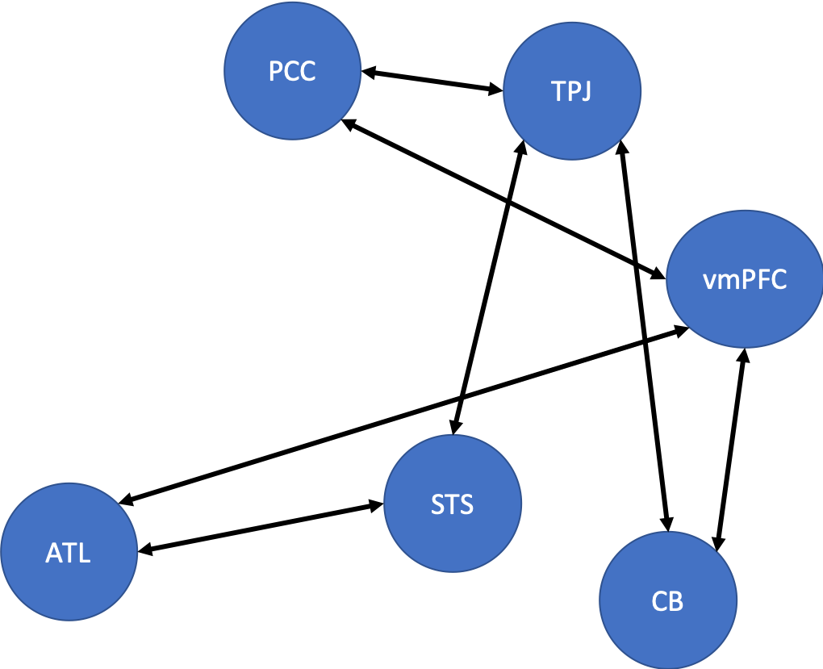

Tom, if you have the time, I’d like to talk to you in person about this proposal. Not sure if it is SEM-y enough, or hypothesis driven enough.