**Introduction**

Being social inherently means have relationships. Whether they be romantic relationships, familial, occupational, or virtual, having and maintain relationships is the basis of being social. Humans are remarkably social creatures, as we can track information about our own relationships, and the relationships of others. It has been proposed that the ability to track the relationships between different individuals allows humans to live in large social groups (Dunbar & Shultz, 2007). The importance of social relationships is highlighted theories of a need to belong, where having social connections is described as a fundamental desire of humans (Baumeister & Leary, 1995).

Having social relationships has been implicated in a variety of mental and health outcomes. Maintaining daily interactions with people has been implicated in better emotional well-being (Reis et al., 2000). Perceived social isolation can be a risk factor for depression, and a decrease in cognitive performance and executive functioning (Cacioppo & Hawkley, 2009; DiNapoli et al., 2014). Social relationships are also an important part of successful aging. Older adults who have more social relationships and engage in social activities are more likely to have better cognitive functioning (Barnes et al., 2007; Yaffe et al., 2009), and less likely to develop dementia (Fratiglioni et al., 2004) than older adults who were less social. In rodent literature, environmental enrichness (EE) is a term used to describe animal housing environments which contain either more toys or bedding, hereby referred to as physical EE, or communal housing environments in which multiple animals are kept in a single cage, hereby referred to as social EE. Social EE has been shown to lead to better task performance, compared to physical EE (Elliott & Grunberg, 2005), and an increase in neural plasticity (Branchi, 2009). Social EE is analogous to the literature in humans on greater social relationships and health outcomes.

In an effort to combat the spread of COVID-19, entire communities have had to enter into quarantines and lockdowns and practice “social distancing” from other individuals outside of their household. Interestingly, this provides for a unique opportunity to study a lack of social EE in humans. In a typical day, individuals experience a variety of relationships including with people in their family, work, local communities, and across social media. With the lockdown policies that have been enacted to decrease the spread of COVID-19, the number of possible relationships that individuals interact with on a daily basis has drastically decreased. In addition, the social relationships that individuals do still experience with social distancing, may become repetitive, leading to greater interpersonal conflicts. Some relationships, such as an individual and their in-laws, might cause more conflict than other relationships, such as an individual and their roommates.

The present study will aim to discover what impact social distancing and the exclusive increase in activity with certain relationships will have on well-being. We hypothesize that (1) individuals who report increased time with relationships that they perceive to be negative will result in worse well-being, and (2) that certain categories of relationships, such as familial relationships, will be predictive of worse well-being. Figure 1 depicts our hypothesized path analysis. Due to social distancing measures, the number of relationships individuals experience will drastically decrease. This will inherently lead to a decrease in the variety of relationships, as most individuals will only interact with individuals in their household. With an in increasing amount of time being spent with a small number of the same individuals, we predict that the quality of relationships will also decrease. Therefore, these three variables, number of relationships, variety of relationships, and quality of relationships, will have shared variance. It is hypothesized that all three will be predictive of well-being. Well-being in this model is a latent variable of mental health, comprised of anxiety, general positive affect, depression, and behavioral/emotional control. These variables are one-item questions that have collectively been shown to be detective of mental health illnesses (Berwick et al., 1991).

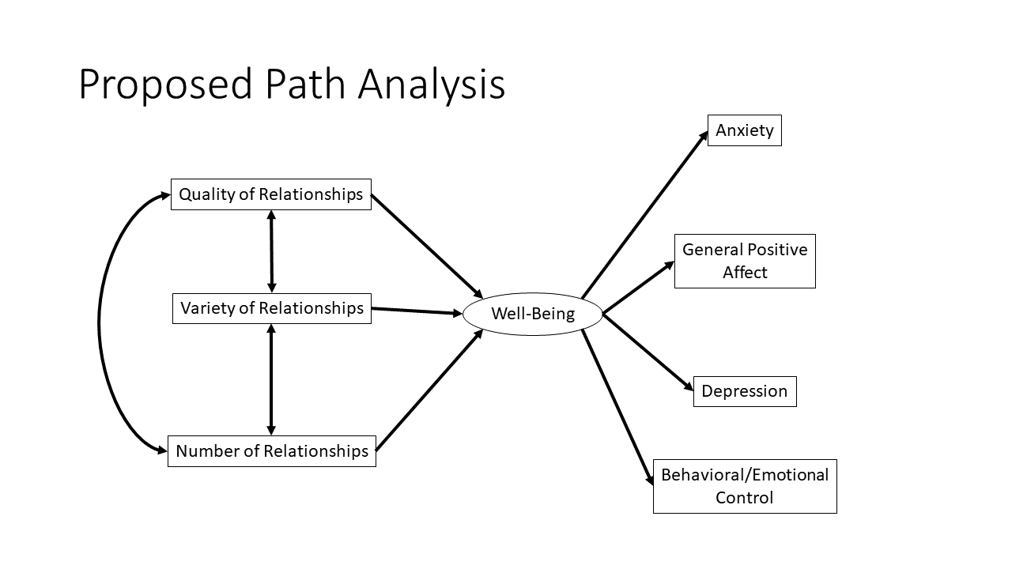

**Figure 1. Social distancing path analysis.** Social distancing measures will impact people’s number of relationships, the variety of relationships available, and the quality of relationships that people experience. These variables will have shared variance and will be predictive of well-being. Here, well-being will be a latent variable comprised of anxiety, general positive affect, depression, and behavioral/emotional control.

**Methods**

**Participants**

Amazon Mechanical Turk (MTurk) participants were recruited for this study. Participants were recruited via Turkprime, which reports that their screening processes ensures better data quality (Litman et al., 2017). Filters were used to only recruited participants based in the United States, and that were native English-speakers. In total, 768 participants were recruited, with a mean age of 38.99 (SD=12.63, 50.78% female). Attention check questions were used to ensure that participants were answering questions seriously. Six participants were excluded from analysis because of failure to accurately answer the attention check questions, and 34 participants were excluded because of missing or incomplete data, resulting in a final sample size of 728.

**Questionnaire**

A questionnaire was hosted on Qualtrics. Participants were asked a series of questions pertaining to their daily life due to COVID-19 including how long they have been practicing social distancing, questions their work situation, their general physical health, their mental health, and their social life (Table 1). To quantify the number of social relationships an individual has had in the past week, the questionnaire asked participants to list individuals in their home, which resulted in measures of their immediate network (IN), and to list individuals who they have been in contact with who do not live in their home, which results in measures of their extended network (EN). Additional questions were asked about how many hours in the past week they have spent interacting with individuals in the IN (IN time) and their EN (EN time). Participants were also asked to rate the valence (from negative to positive) of the same individuals. The questionnaire, in its entirety is available in the supplementary materials. Mental health well-being measures were used from the Mental Health Inventory (MHI-5) (Berwick et al., 1991). These comprised of five items, one each for anxiety, depression, and behavioral/emotional control. General positive affect had two questions related to how often individuals had felt calm and peaceful, and happy. These five items were edited from their original format which asked about how individuals felt in the past month, to how individuals felt in the past week (Table 1). In addition to the four answer choices in the original MHI-5, an additional answer choice was included for “much less of the time”, to match the extreme answer on the opposite side of the scale “much more of the time”.

**Table 1. Questionnaire items.** Variables come from two major domains: social and well-being. In the survey, questions were asked that probed aspects of these domains. From these questions a series of variables were derived. Multiple variables could be derived from a single question, as some item-level responses were free responses which provided rich detail.

|  |  |  |  |
| --- | --- | --- | --- |
| Domain | Question | Abbreviation(s) | Item-level responses |
| Social | How many individuals live in your household, not including yourself? | Immediate network size (INS) | Numeric response |
| Please list the relationship that each individual in your household has with you and indicate the amount of time you have spent with them (in hours), during the past week. | unique_rels, wsn | Numeric response for each relationship (i.e. mother: 40, father: 40, brother1: 60, brother2: 20) |
| Please list the relationship that each individual in your household has with you and indicate how positive or negative that relationship has been, during the past week | IN_relxn_val | Very positive: 5,  Positive: 4,  Neutral: 3,  Negative: 2,  Very negative: 1  Each relationship was given its own rating (i.e. mother: 3, father: 3, brother1: 5, brother1: 1) |
| Well-being (Wellb) | How much of the time, during the past week, have you been a nervous person? | anxiety | Much less than usual,  Less than usual,  About the same as usual,  More than usual,  Much more than usual |
| How much of the time, during the past week, have you felt calm and peaceful? | pos_affect_calm | Much less than usual,  Less than usual,  About the same as usual,  More than usual,  Much more than usual |
| How much of the time, during the past week, have you felt downhearted and blue? | depression | Much less than usual,  Less than usual,  About the same as usual,  More than usual,  Much more than usual |
| How much of the time, during the past week, have you been a happy person? | pos_affect_happy | Much less than usual,  Less than usual,  About the same as usual,  More than usual,  Much more than usual |
| How much of the time, during the past week, have you felt so down in the dumps that nothing could cheer you up? | behav_emo_control | Much less than usual,  Less than usual,  About the same as usual,  More than usual,  Much more than usual |

**Data Analysis**

Our hypothesized model has two main domains of variables; social and well-being (Table 1). Well-being (Wellb) was calculated as a latent factor of anxiety, general positive affect, depression, and emotional/behavioral control. Three social variables were used as predictors of well-being: immediate network size (INS), number of unique relationships (unique_rels), and immediate network time-weighted valence (IN_valw). Immediate network size (INS) was calculated as the number of individuals a participant was in quarantine with (i.e. in their household). Number of unique relationships was calculated as the number unique relationship types in a participant’s immediate network. For example, if a participant was quarantined with their mother, father, and two brothers, the participants number of unique relationships would be three (brothers is only counted once). Lastly, immediate network time-weighted valence was the aggregated valence rated across all individuals in a participant’s immediate network (IN_relxn_val), weighted by the proportion of time they spent with a given individual relative to the total amount of time spent with all individuals in their immediate network (wxn):

IN_valw = IN_relx1_val*wx1 + IN_relx2_val*w x2 + IN_relx3_val*wx3 ... + IN_relxn_val*wxn

Therefore, IN_valw serves as a measure of the general valence for all the social interactions in their immediate network.

Data analysis was completed in R, where the lavaan package was used to complete structural equation modeling analyses. The full information maximum likelihood option was used in lavaan to deal with missing data. To test the fit of our model, a chi-square test will be done, in addition to calculating a Comparative Fit Index (CFI), Tucker-Lewis Index (TLI), Akaike’s Information Criterion, Bayesian Information Criterion, and a root mean square error of approximation (RMSEA).

**Results**

**Immediate Network Relationship Valence Predicts Well-being**

A path analysis was done to test whether changes in social relationships due to social distancing measures was related to a latent variable of well-being. Overall, the model fit for this analysis was poor, with a significant chi-square (χ2 = 115.59, *p* < .001), low CFI (0.92), low TLI (0.88), and a high RMSEA (0.10, CI [0.08 0.12]).

The latent variable of well-being was significantly related to each of the five items in the model. Higher well-being was related to higher levels of anxiety, depression, and behavioral/emotional control issues, and lower levels of positive affect. The well-being latent variable was then used as a dependent variable for the predictors of immediate network size, number of unique relationships, and time-weighted immediate network valence. Immediate network size and number of unique relationships were not significant predictors of well-being, but time-weighted immediate network valence was (Table 2; Fig. 2).

**Table 2. Path analysis results.**

|  |  |  |  |  |  |  |
| --- | --- | --- | --- | --- | --- | --- |
| **Dependent Variable** | **Operation** | **Independent Variable** | **β** | **SE** | **z** | ***p*** |
| Wellb | =~ | anxiety | 0.64 | 0.05 | 13.67 | 0 |
| Wellb | =~ | pos_affect_calm | -0.68 | 0.04 | -16.61 | 0 |
| Wellb | =~ | depression | 0.78 | 0.04 | 21.14 | 0 |
| Wellb | =~ | pos_affect_happy | -0.60 | 0.04 | -15.72 | 0 |
| Wellb | =~ | behav_emo_control | 0.71 | 0.04 | 17.92 | 0 |
| Wellb | ~~ | Wellb | 1.00 | 0.00 | *NA* | *NA* |
| Wellb | ~ | INS | 0.02 | 0.04 | 0.48 | 0.632 |
| Wellb | ~ | IN_Urels | 0.00 | 0.51 | -0.07 | 0.941 |
| Wellb | ~ | IN_valw | -0.23 | 0.72 | -3.24 | 0.001 |

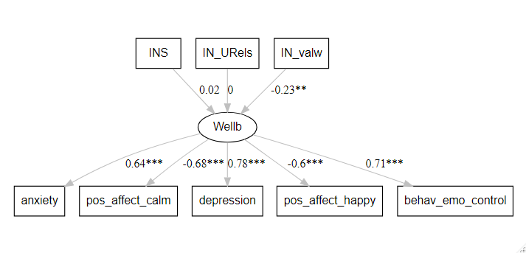

**Figure 2. Results of path analysis.**

**Immediate Network Relationship Categories Predict Well-being**

**References**

Barnes, D. E., Cauley, J. A., Lui, L. Y., Fink, H. A., McCulloch, C., Stone, K. L., & Yaffe, K. (2007). Women who maintain optimal cognitive function into old age. *Journal of the American Geriatrics Society*, *55*(2), 259–264. https://doi.org/10.1111/j.1532-5415.2007.01040.x

Baumeister, R. F., & Leary, M. R. (1995). The need to belong: Desire for interpersonal attachments as a fundamental human motivation. *Psychological Bulletin*, *117*(3), 497–529. https://doi.org/10.1109/ITME.2008.4743876

Berwick, D. M., Murphy, J. M., Goldman, P. A., Ware, J. E., Barsky, A. J., & Weinstein, M. C. (1991). Performance of a five-item mental health screening test. *Medical Care*, *29*(2), 169–176.

Branchi, I. (2009). The mouse communal nest: Investigating the epigenetic influences of the early social environment on brain and behavior development. *Neuroscience and Biobehavioral Reviews*, *33*(4), 551–559. https://doi.org/10.1016/j.neubiorev.2008.03.011

Cacioppo, J. T., & Hawkley, L. C. (2009). Perceived social isolation and cognition. *Trends in Cognitive Sciences*, *13*(10), 447–454. https://doi.org/10.1016/j.tics.2009.06.005

DiNapoli, E. A., Wu, B., & Scogin, F. (2014). Social Isolation and Cognitive Function in Appalachian Older Adults. *Research on Aging*, *36*(2), 161–179. https://doi.org/10.1177/0164027512470704

Dunbar, R. I. M., & Shultz, S. (2007). Evolution in the Social Brain. *Science*, *317*(5843), 1344–1348. https://doi.org/10.1126/science.1145463

Elliott, B. M., & Grunberg, N. E. (2005). Effects of social and physical enrichment on open field activity differ in male and female Sprague-Dawley rats. *Behavioural Brain Research*, *165*(2), 187–196. https://doi.org/10.1016/j.bbr.2005.06.025

Fratiglioni, L., Paillard-Borg, S., & Winblad, B. (2004). An active and socially integrated lifestyle in late life might protect against dementia. *Lancet Neurology*, *3*(6), 343–353. https://doi.org/10.1016/S1474-4422(04)00767-7

Litman, L., Robinson, J., & Abberbock, T. (2017). TurkPrime.com: A versatile crowdsourcing data acquisition platform for the behavioral sciences. *Behavior Research Methods*, *49*(2), 433–442. https://doi.org/10.3758/s13428-016-0727-z

Reis, H. T., Sheldon, K. M., Gable, S. L., Roscoe, J., & Ryan, R. M. (2000). Daily well-being : The role of autonomy , competence , and relatedness. *Personality and Social Psychology Bulletin*, *26*(4), 419–435. https://doi.org/https://doi.org/10.1177/0146167200266002

Yaffe, K., Fiocco, A. J., Lindquist, K., Vittinghoff, E., Simonsick, E. M., Newman, A. B., Satterfield, S., Rosano, C., Rubin, S. M., Ayonayon, H. N., & Harris, T. B. (2009). Predictors of maintaining cognitive function in older adults: The Health ABC Study. *Neurology*, *72*(23), 2029–2035. https://doi.org/10.1212/WNL.0b013e3181a92c36