Step 1: Open PowerBi

Step 2:Click on Blank report

Step 3:To load the .csv file , click on Use sample data, click on text/csv.

Fig 1:

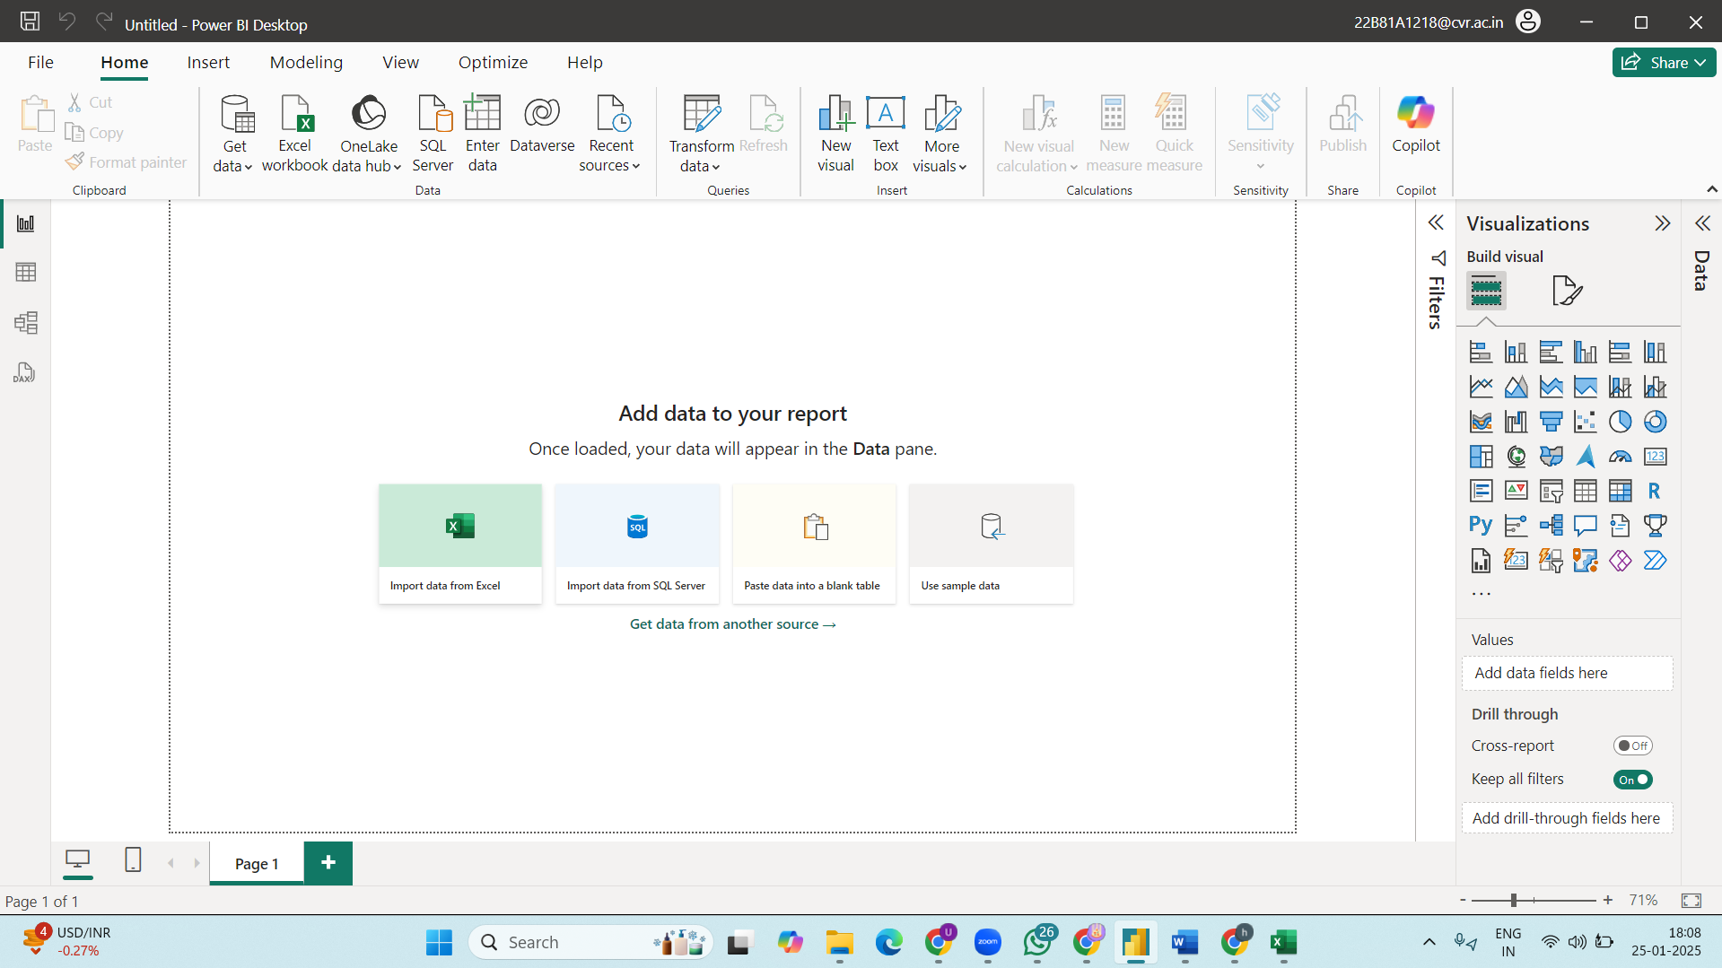

Note: If the data is clean click on load, if not click on transform if you want to process the data.

Fig 2: Under “Data” we can see the dataset

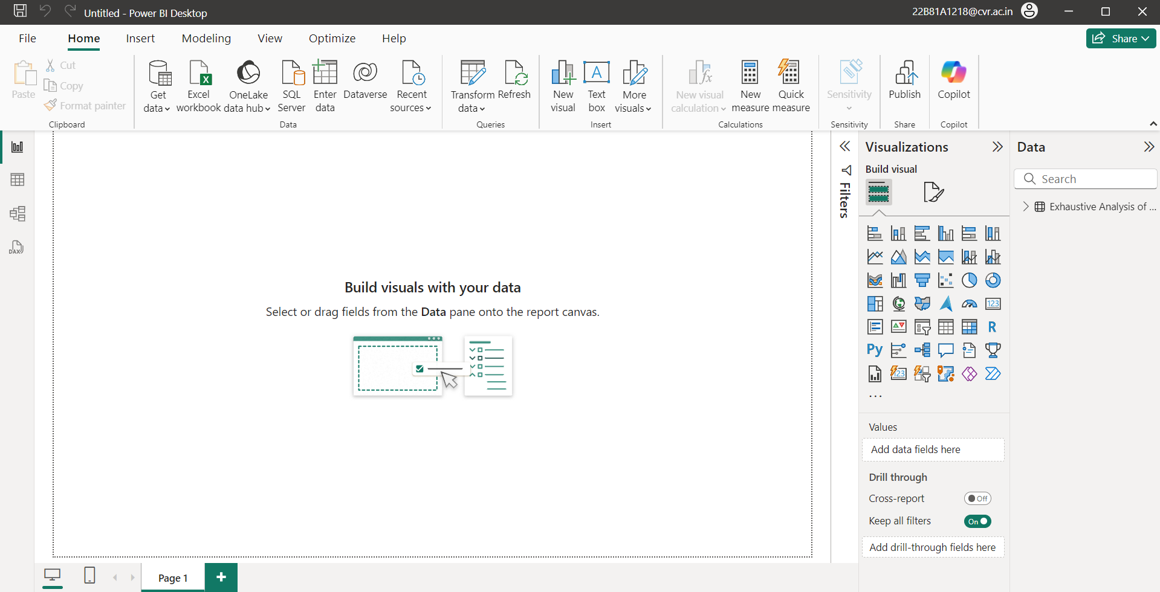

Fig 3:

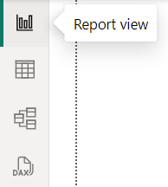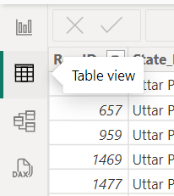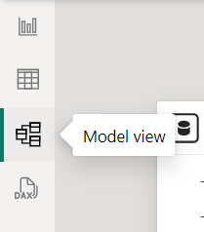

Note : In report view we can perform visualisation , in table view we can see data and in model view we can create relationship among data.

Step 5: To transform data, go to the ribbon ,

Fig 4:  
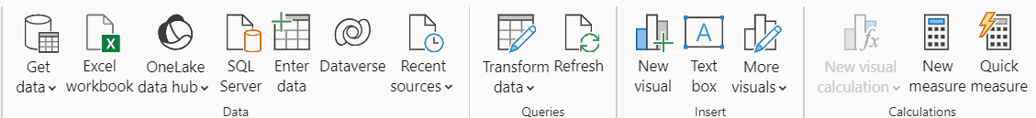

Click on transform data.

Fig 5: Power Query Editor will open in a new window

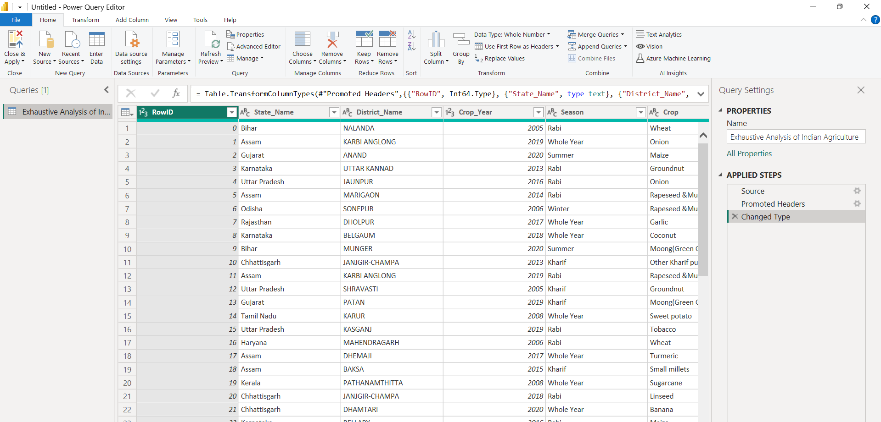

Step 6: Identify unnecessary columns in the dataset.

Step 7: To remove a column right click on it and the following pop up appears(Fig6)

Fig 6:Click on remove to remove a column

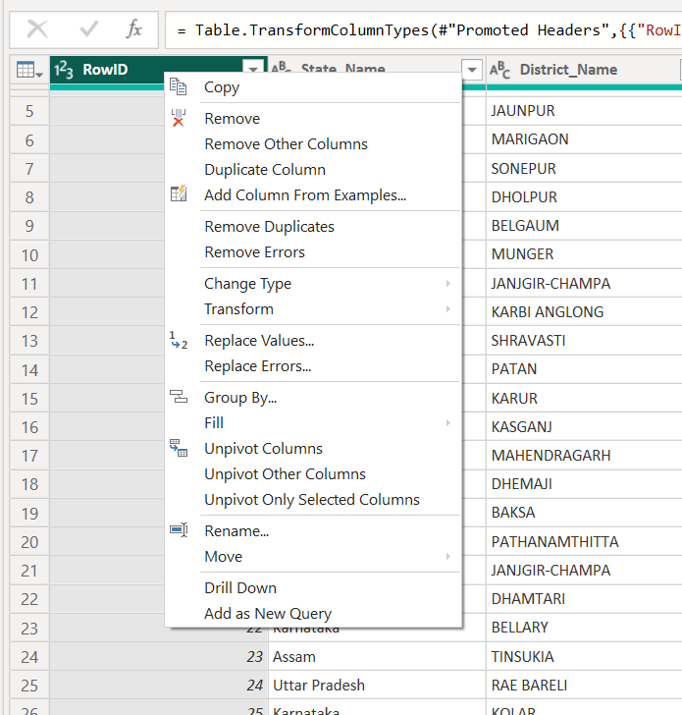

Fig 7: In order to check for null values , Click on “View” , followed by column quality on the ribbon in PQE

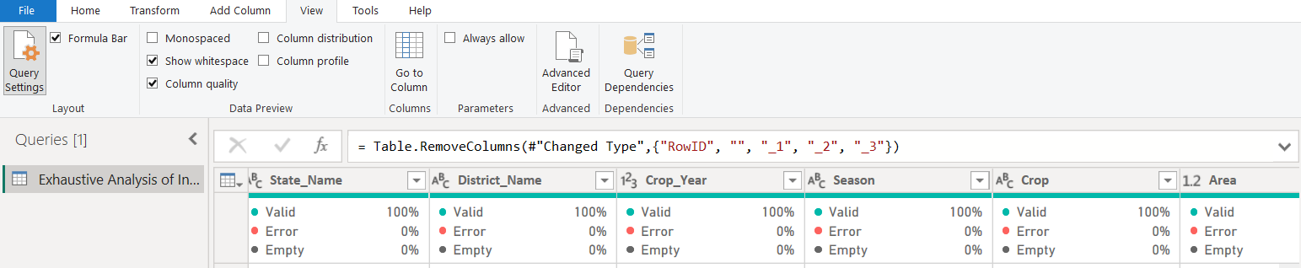

Fig 8: To remove duplicate columns , rows

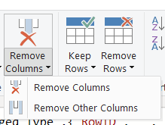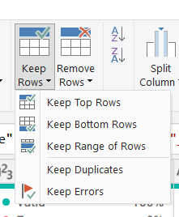

Fig9:To change datatype click on the “ABC” or “123” beside each column and choose from the options displayed.

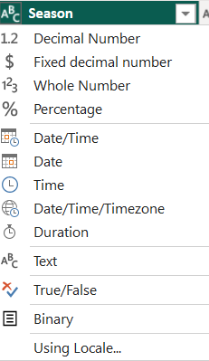

Fig 10: Click on Close and Apply to save the changes made in the PQE

