时间序列ARIMA模型

import sys  
import os  
import warnings  
warnings.filterwarnings("ignore")  
import pandas as pd  
import numpy as np  
from arch.unitroot import ADF  
import matplotlib.pylab as plt  
from matplotlib.pylab import style  
style.use('ggplot')  
import statsmodels.api as sm  
import statsmodels.formula.api as smf  
import statsmodels.tsa.api as smt  
from statsmodels.tsa.stattools import adfuller   
from statsmodels.stats.diagnostic import acorr_ljungbox   
from statsmodels.graphics.api import qqplot  
pd.set_option('display.float_format', lambda x: '%.5f' % x)   
np.set_printoptions(precision=5, suppress=True)   
"""中文显示问题"""  
plt.rcParams['font.family'] = ['sans-serif']  
plt.rcParams['font.sans-serif'] = ['SimHei']  
  
data = pd.read_excel(r"C:\Users\阿韩想养二哈\Desktop\工作簿1.xlsx",parse_dates=True)  
print(data)  
data.head()  
  
#平稳性检验

print("平稳性检验:\n")  
data["diff1"] = data["食用菌"].diff(1).dropna()  
data["diff2"] = data["diff1"].diff(1).dropna()  
data1 = data.loc[:,["食用菌","diff1","diff2"]]  
data1.plot(subplots=True, figsize=(18, 12),title="差分图")  
plt.show()

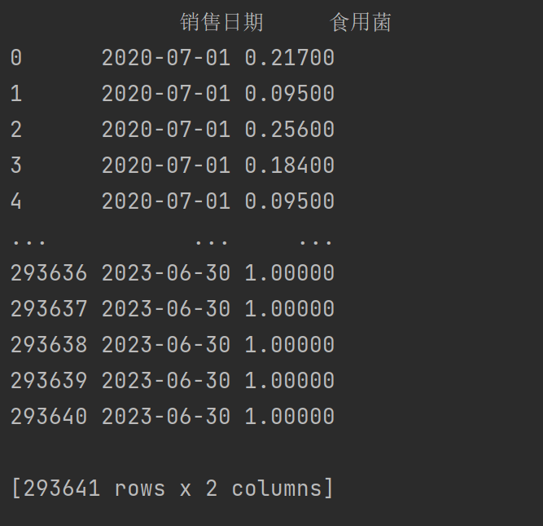

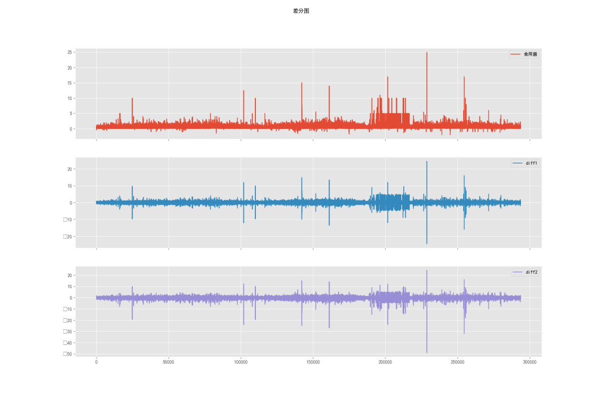

print("单位根检验:\n")  
print(ADF(data.diff1.dropna()))

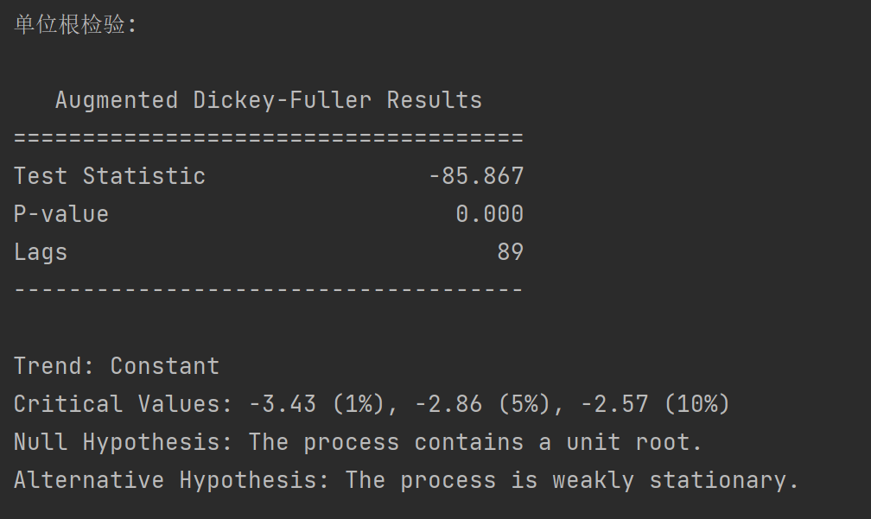

print("白噪声检验:\n")  
from statsmodels.stats.diagnostic import acorr_ljungbox  
print(acorr_ljungbox(data.diff1.dropna(), lags = [i for i in range(1,12)],boxpierce=True))

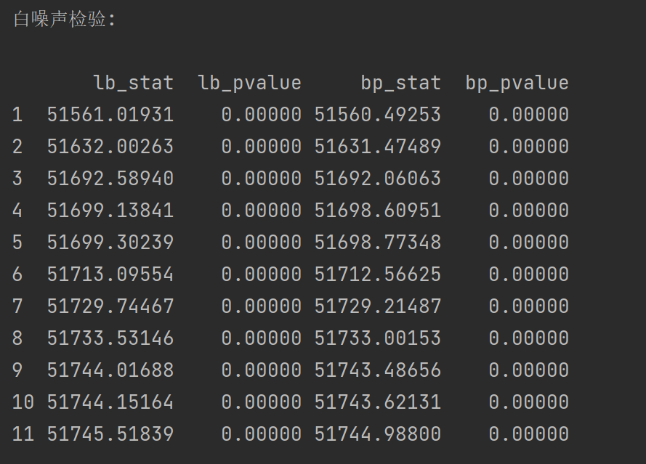

#平稳时间序列的自相关图和偏自相关图

series = data['食用菌']  
print(series)  
1697105171681

# 使用ACF函数 自相关图  
fig, ax = plt.subplots(figsize=(10, 5))  
sm.graphics.tsa.plot_acf(series, lags=40, ax=ax)  
plt.show()

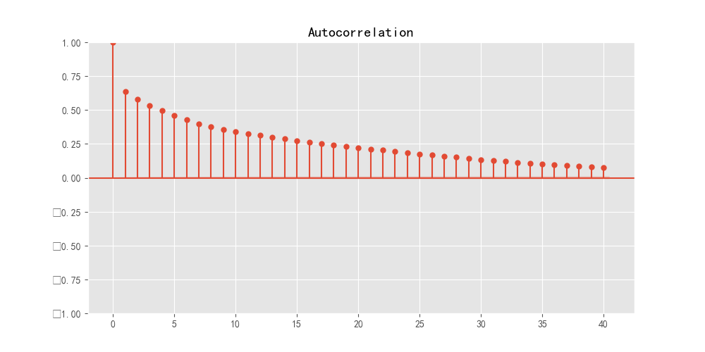  
  
# 使用PACF函数 偏自相关图  
fig, ax = plt.subplots(figsize=(10, 5))  
sm.graphics.tsa.plot_pacf(series, lags=40, ax=ax)  
plt.show()

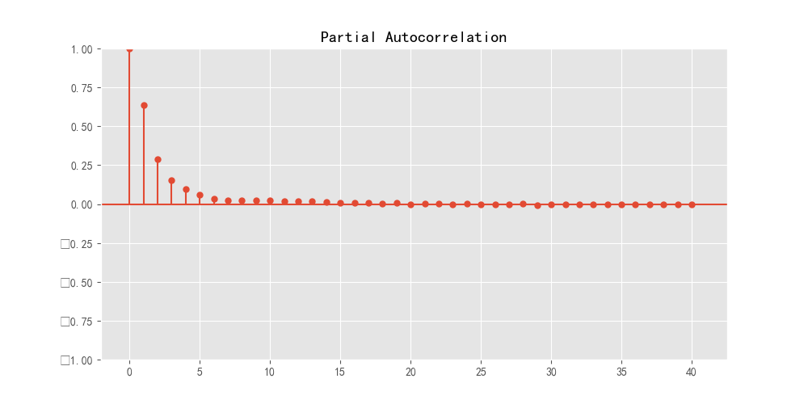

#信息准则定阶：AIC、BIC  
def get_pq(series):  
 #AIC  
 AIC = sm.tsa.arma_order_select_ic(series, max_ar=6, max_ma=4, ic='aic')['aic_min_order']  
 #BIC  
 BIC = sm.tsa.arma_order_select_ic(series, max_ar=6, max_ma=4, ic='bic')['bic_min_order']  
 print('the AIC is{},\nthe BIC is{}\n'.format(AIC,BIC))  
get_pq(series)

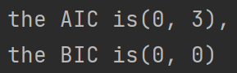

from statsmodels.tsa.arima.model import ARIMA  
model = ARIMA(data["食用菌"], order=(0,1,0))#order=(p,d,q)  
result = model.fit()  
print(result.summary())

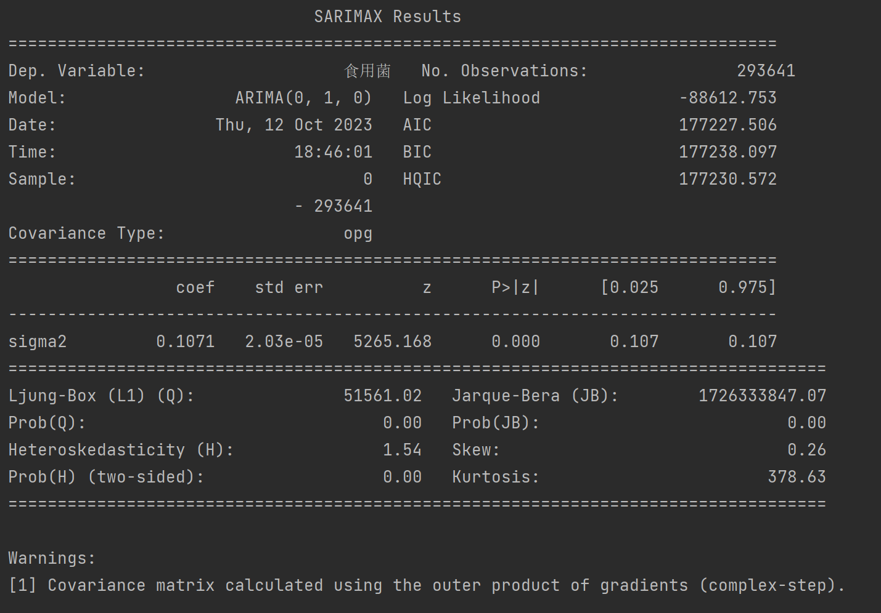

resid = result.resid#残差  
fig = plt.figure(figsize=(12,8))  
ax = fig.add_subplot(111)  
fig = qqplot(resid, line='q', ax=ax, fit=True)  
fig.show()

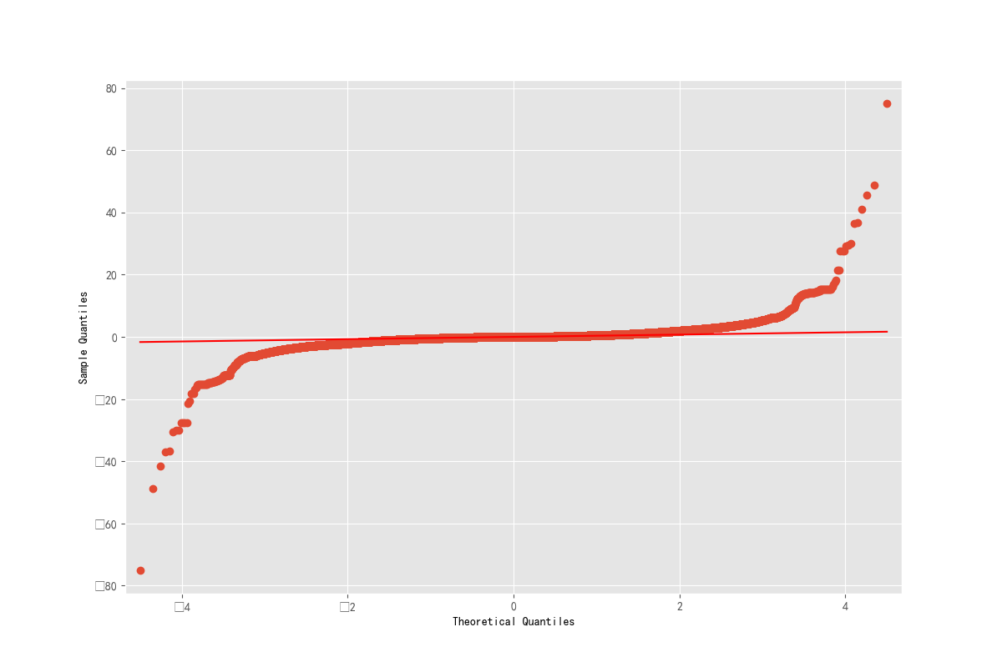

#预测

pred = result.predict('2023-07-01',dynamic=True, typ='levels')  
print (pred)  
  
plt.figure(figsize=(12, 8))  
plt.xticks(rotation=45)  
plt.plot(pred)  
plt.plot(data["食用菌"])  
plt.show()