非线性规划

例题：

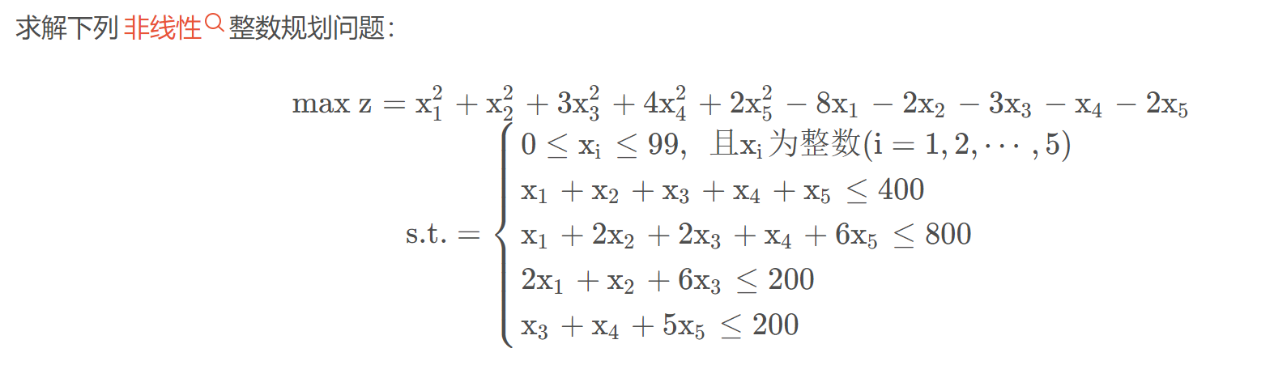

import cvxpy as cp  
import numpy as np  
  
n = 5  
x = cp.Variable(n,integer = True)  
# 约束1  
A1 = np.array([[1,1,1,1,1],  
 [1,2,2,1,6],  
 [2,1,6,0,0],  
 [0,0,1,1,5]])  
b1 = np.array([400,800,200,200])  
prob = cp.Problem(cp.Minimize(x[0]**2+x[1]**2+3*x[2]**2+4*x[3]**2+2*x[4]**2-8*x[0]-2*x[1]-3*x[2]-x[3]-2*x[4]),  
 [A1 @ x <= b1,  
 x >= 0,  
 x <= 99])  
# 求解  
ans = prob.solve(solver='CPLEX')  
# 输出结果  
print("目标函数最小值:", ans)  
print(x.value)

