Relative Pronouns

<http://www.englisch-hilfen.de/grammar/who_which.htm>

**who** → *der/die/das* und wird bei **Personen** eingesetzt

**which** → *der/die/das* und wird bei **Sachen** und **Tieren** eingesetzt

**whose** → *dessen* und wird bei **Personen**, **Sachen** und **Tieren** eingesetzt

Man benutzt für *who/which* auch manchmal *that*. Nach einem Komma aber immer which

**where** → Platz/Ort

**when** → Zeit

http://www.englisch-hilfen.de/exercises/relativ1.gif

http://www.englisch-hilfen.de/exercises/relativ2.gif

http://www.englisch-hilfen.de/exercises/relativ3.gif

Defining and non-defining relative clauses

<http://www.englisch-hilfen.de/grammar/relativsaetze.htm>

## Die Arten der Relativsätze

Um den Unterschied zwischen that und which zu verstehen, ist es wichtig, **bestimmende** (defining/restrictive) und **nicht bestimmende** (non-defining/non-restrictive) Relativsätze zu verstehen.

1. Nicht bestimmende Relativsätze

Ein **nicht bestimmender** (non-defining oder non-restrictive) **Relativsatz** ist ein Satz, der **eingeschoben** ist:   
  
My house**, which has a blue door,** needs painting.  
  
Die schräggedruckten Wörter sind eine Zusatzinformation, die weggelassen werden kann. Im eigentlichen Satz (My house needs painting.) geht es darum, dass das Haus gestrichen werden muss, die blaue Tür beschreibt dieses Haus nur näher.

**Benutze Kommas** im **nicht bestimmenden Relativsatz**. So werden die nicht bestimmenden Elemente vom restlichen Satz abgetrennt. Solche Satzelemente können Wortgruppen sein, die Subjekt und Verb enthalten oder Verbindungen, die weder Subjekt noch Verb enthalten.

Merke: In non-relative Sentence immer which verwenden. Steht ein which ohne im Satz, dann wird ein Komma benötigt.

## 2. Bestimmende Relativsätze

Ein **bestimmender Relativsatz** (defining oder restrictive clause) ist **unentbehrlich** für den Sinn des Satzes.

My house ***that has a blue door*** needs painting.   
  
Hier ist die "blaue Tür" ganz wichtig, denn in diesem Satz habe ich mehrere Häuser und nur das "Haus mit der blauen Tür" soll gestrichen werden.

**Bestimmende Relativsätze** werden **nicht durch Kommas abgetrennt.** Ein bestimmender Relativsatz ist für die Bedeutung des Satzes unentbehrlich und darf deswegen auch nicht weggelassen werden, da sich der Sinn des Satzes sonst dramatisch ändern würde.

### Hinweise

Beachte, dass sowohl nicht bestimmende als auch bestimmende Relativsätze durch das passende Relativpronomen eingeleitet werden müssen.

**Bestimmende Relativsätze** dürfen **NIE** durch **Kommas** abgetrennt werden, **nichtbestimmende Relativsätze** werden **IMMER** durch **Kommas** getrennt.

Prepositions in Relative Clauses

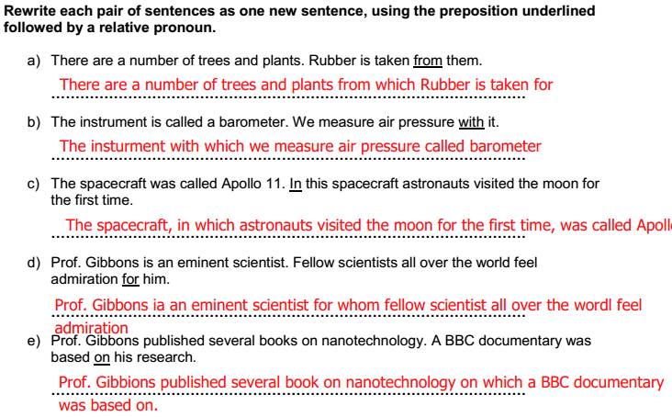

Reported Speech

##### <http://www.englisch-hilfen.de/grammar_list/satz.htm>

**2. Der Einleitungssatz**

Wird ein Satz in die indirekte Rede gesetzt, gibt es zwei grundlegende Unterscheidungen.

Der **Einleitungssatz** in der indirekten Rede **steht entweder in der Gegenwart oder in der Vergangenheit**.

**direkte Rede:**

* Susan: “**Mary** **works** in an office.”

**indirekte Rede:**

* Einleitungssatz in der Gegenwart → Susan **says** (that)* **Mary** **works** in an office.
* Einleitungssatz in der Vergangenheit → Susan **said** (that)* **Mary** **worked** in an office.

**3. Anpassung der Personen/Pronomen**

Steht in der direkten Rede ein Pronomen, dann ändert sich dieses möglicherweise in der indirekten Rede. Das hängt von der jeweiligen Situation ab.

* direkte Rede → Susan: “**I** work in an office.”
* indirekte Rede → **Susan said** (that)* **she** worked in an office.

In diesem Beispiel wird aus dem **I** → **she**.

**4. Verschiebung der Zeitformen (backshift)**

Wird die Zeitform der direkten Rede in der indirekten geändert, dann wird die Zeitform wie folgt zurückverschoben *(backshift)*:

* direkte Rede → Peter: “**I** **work** in the garden.”
* indirekte Rede → Peter said (that)* **he** **worked** in the garden.

| **direkte Rede** | **indirekte Rede** |
| --- | --- |
| **Simple Formen** | |
| Simple Present | Simple Past |
| Simple Past | Past Perfect |
| Present Perfect |
| Past Perfect |
| will | would |
| **Progressive Formen** | |
| am/are/is | was/were |
| was/were | had been |
| has been |
| had been |

**5. Anpassung von Orts- und Zeitangaben im Satz**

Wenn im Satz eine **Zeitangabe** steht, dann wird auch die, je nach Situation, geändert.

* direkte Rede → Peter: “I worked in the garden **yesterday**.”
* indirekte Rede → Peter said (that)* he had worked in the garden **the day before**.

| **direkte Rede** | **indirekte Rede** |
| --- | --- |
| **this** evening | **that** evening |
| **to**day/**this** day | **that** day |
| **these** days | **those** days |
| **now** | **then** |
| a week **ago** | a week **before** |
| **last** weekend | the weekend **before** / the **previous** weekend |
| **next** week | the **following** week |
| **tomorrow** | **the next/following day** |
| **here** | **there** |

**5 Reported Speech**

**5.1 Theory**

Reported speech is quite a common feature of language, particularly in newspapers where journalists often report what people have said.

When direct speech is changed into reported speech, with a reporting verb in the past, the verb tense may have to be changed to indicate a time shift to the past.

***That*** is often used to connect the clauses.

**A. Tense shift**

The company’s spokeswoman said: “We **are** breaking into new markets.”

The company’s spokeswoman said *that* they **were** breaking into new markets.

The company’s spokeswoman said: “2014 **will** be a very successful year.”

The company’s spokeswoman said *that* 2014 **would** be a very successful year.

It is usually better style to use more precise **reporting verbs** than *say* or *tell*. Examples of reporting verbs are: **admit, advise, apologise, anounce, promise, threaten, refuse etc.**

**B. Expressions referring to the “here and now”,** e.g. time phrases and pronouns, may have to be changed.

**Changing time expressions**

yesterday **➔** the day before

last week **➔** the week before

tomorrow **➔** the next day / the following day

**Pronouns**

The president announced: “It’s time for **my** resignation”

The president announced that it was time for **his** resignation.

**C. Reported instructions and requests**

If you report what someone tells someone else to do, use ***ask/tell* + someone + to + infinitive.**

“Marc, could you call the IT manager?”

Marc’s boss asked / told **him** **to** **call** the IT manager.

**D. Reporting questions**

**Whether / if** or **questions words** are used to link the clauses.

He asked: “Melanie, do you often travel for business?”

He asked her ***whether*** she often travelled for business.

He wanted to know: “***What*** safety measures are planned?”

He wanted to know ***what*** safety measures were planned.

**6 Question Formation**

**6.1 Theory**

**A. Yes / no question**

Questions with the answer yes or no are formed with an **auxiliary verb + subject + main verb**.

The ***auxiliary*** can be ***do, be, have*** or a modal verb like ***can, will, would***.

Short answers repeat the auxiliary.

**Do** you **study** at HSR?

**Are** you **working** on a group project at the moment?

**Have** you **finished** your self-study reading yet?

**Will** you **spend** some time abroad after your studies?

**Can** you **write** an iPhone app?

**B. Question word questions**

Question words are: **what, when, where, which, who, whose, why and how**

The structure is: **question word + auxiliary + subject + main verb**

**Whose** computer **did** you **borrow** for the presentation?

**When** **do** we **write** the module exam?

**Which** projects **are** you **working** on at the moment?

**C. Questions words as subject**

Sometimes the question word is the subject of the sentence and then the structure changes slightly: **question word + main verb**

Compare the following two sentence pairs:

**What** did you do? (What = object)

**What** happened? (What = subject – directly followed by main verb)

**Who** did you meet at the Conference? (Who = object)

**Who** met you at the airport? (Who = subject - main verb)

**D. Question phrases**

**What** **time** are you arriving?

**What** **areas** do we need to cover in the meeting?

**Which** **operating** **system** do they use?

**Which** **way** is it?

**How** **often** do you back up your files?

**E. Questions with prepositions**

Prepositions normally come at the end of questions but before time and place expressions

What company does she work **for**?

Who did you want to speak **to**?

Which department do you work **in?**

**F. Embedded questions– Indirect questions**

Statements or questions with verbs like know and wonder or polite requests like “*Can you tell* *me…?”* can introduce a second questions. The second question is in statement form. This is often seen as a more polite and less aggressive way to raise issues.

Where does the blue wire go? Can you tell me where the blue wire goes?

Can you help me with this problem? I was wondering if you could help me with this problem.

**G. Different functions of questions**

We use negative questions to disagree politely

But don’t you think that different cultures might take a different approach to this issue?

Isn’t there a limit in what one can introduce from the US to Europe in terms of the new

**7 BUSINESS LANGUAGE**

**7.1 Company Language**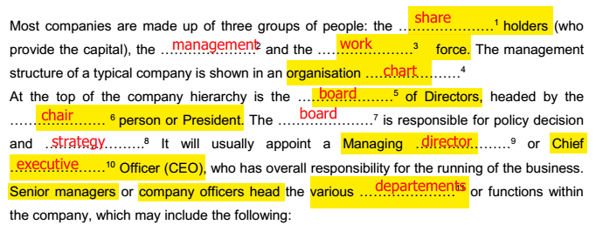

**7.2 Meetings Language**

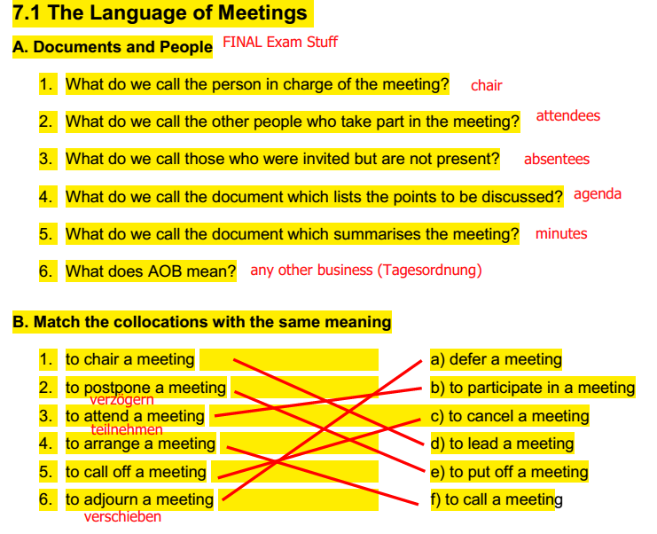

**7.2 Telephone Language**

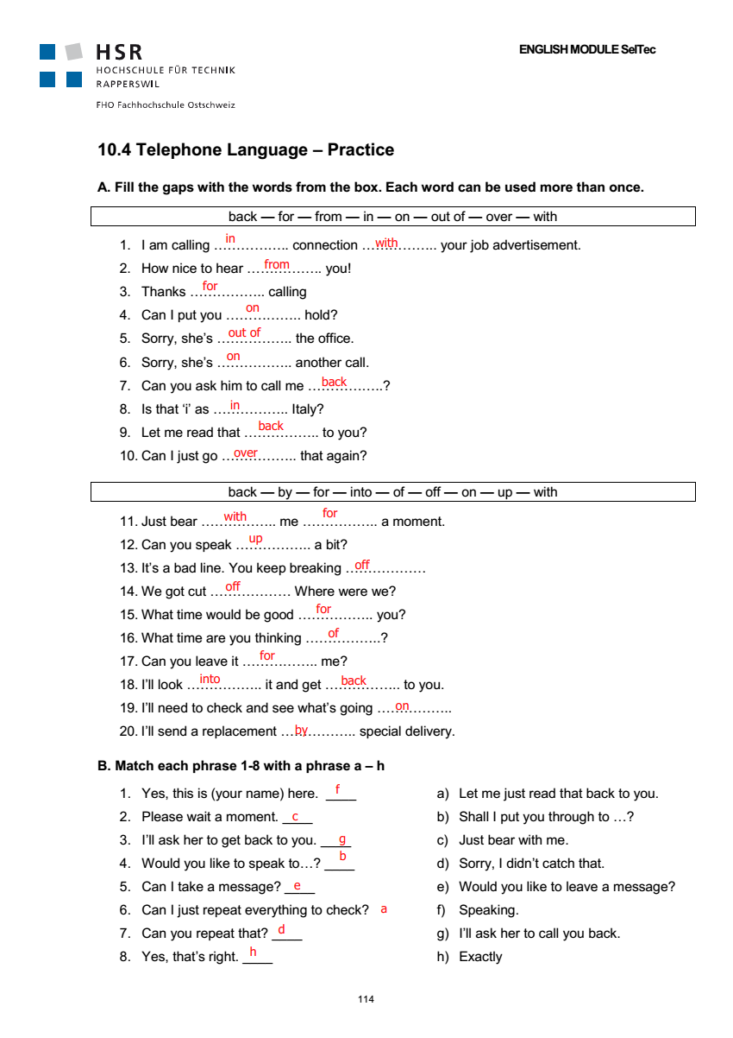

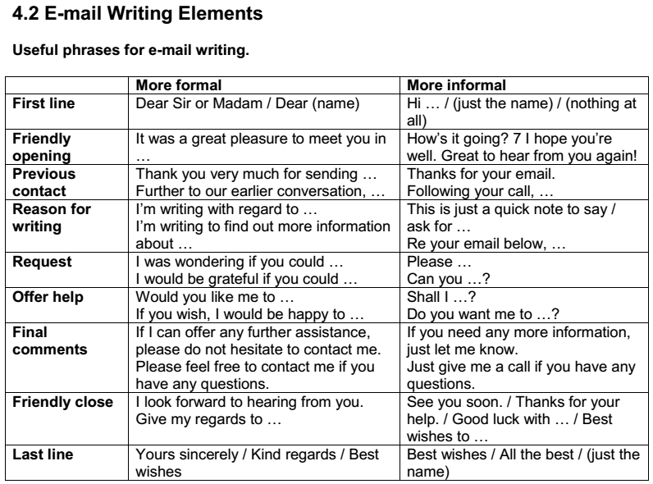

|  |  |
| --- | --- |
| **Informal phrase** | **Formal phrase** |
| Re your last email | I’m writing with regard to your last email |
| Following up your earlier call | Futher to our earlier conversation |
| Sorry about | I would like to apologise for |
| Please send me | I would be grateful if you could send me |
| Let me know if you can make it next Friday | Is next Firday convenient for you? |
| Please contact me | Please don’t hestate to contact me |
| Thanks for asking me | Thank you for our kind invitation |
| Can you .. ? | I was wondering if you could |
| I’d love to come | I would be very pleased to come |
| Just a quick note to remind you that | I would like to remind everyone that |
| I’ll get back to you very soon | I will contact you again in the near future |
| Good luck with everything | We wish you every success in the future |
| I’ve attached | Please find attached |
| Thanks again for all your help. Much appreciated | I would like to thank you very much for… I really appreciate it. |

