CS 623

PROJECT

Guidelines

- This is a group project that you will have to do in a group of 2 students (maximum).
- Post your team in the spreadsheet.
- You will use Java or Python or SQL (for MS in DS students).
- You will use PostgreSQL (rather than MySQL).
- Your code should also be on your individual GitHub. This is where I will check it. The code is developed as a team but available on the GitHub of both students.

Deliverables

- Code in GitHub
- Video of < 3 minutes to show and explain your work
- Fill out the spreadsheet with the information about the project
- No PowerPoint / GoogleDocs presentation

Description

We consider the Product, Depot and Stock relations / tables that we already used in homeworks.

The key of product is #prod (prodid).
The key of depot is #dep (depid).
The key of stock is #prod, #dep. #prod and #dep are foreign keys.

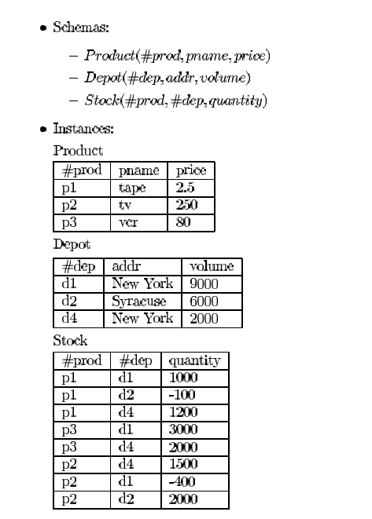

- Code the following transactions. (70 points including 20 points for the video)

A transaction implements the ACID properties. If the code you will provide does not implement the ACID properties, you will get 0 for the question.

Show and explain how you implemented a transaction in the video.

This is the list of transactions to be implemented:

- Group 1/7 – The product p1 is deleted from Product and Stock.

- Group 2/8 – The depot d1 is deleted from Depot and Stock.

- Group 3/9 – The product p1 changes its name to pp1 in Product and Stock.

- Group 4/10 – The depot d1 changes its name to dd1 in Depot and Stock.

- Group 5/11 – We add a product (p100, cd, 5) in Product and (p100, d2, 50) in Stock.

- Group 6/12 – We add a depot (d100, Chicago, 100) in Depot and (p1, d100, 100) in Stock.

- Individual GitHub

Each member of the team posts the code of the project in GitHub. (INDIVIDUAL) (30 points – Individual)

Evaluation of the presentation / video

THE OPENING 1 2 3 4 5

Made the necessary introductions of self and others
Immediately captured interest and convinced to pay attention
Indicate what would be covered and how it would be covered

ORGANIZATION 1 2 3 4 5

Communicated an organizing scheme making comprehension and retention easy
Was organized and easy to follow
Main ideas clearly distinguished
Each section was introduced and concluded well

CONTENT 1 2 3 4 5

Appropriate amount of content (not too much or too little covered)
Supporting facts and data were accurate
Facts and evidence were clearly referenced
Research was current and based on the literature
Information was geared toward the needs and concerns of the audience
Provided interesting, correct and relevant information to the audience

DELIVERY STYLE 1 2 3 4 5

Presenter(s) were well prepared
Used a variety of styles: logical (arguments, intellectual (facts), emotional (stories), humor, etc.
Did NOT read material from a script

AUDIOVISUALS 1 2 3 4 5

Audiovisuals were titled, clear, easy to understand and not overly simple or overly complex
Audiovisuals were used appropriately
Presenters were comfortable and familiar with the audiovisuals used

THE CLOSING 1 2 3 4 5

The conclusion summarized the presentation
Major points/results and their importance were emphasized

Total: /30

General comments:

