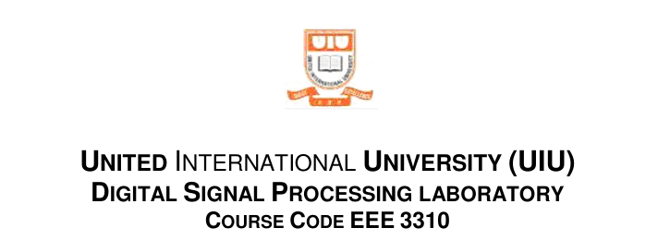

Lab Report : 04
Frequency Domain Analysis using MATLAB

Group No: 02

Group Members:

0212330092 Md. Hussain Shahriar Rokon
0212320035 Nowshin Tabassum Rihun
021213012 Rifa Akter

Home Work Answers:

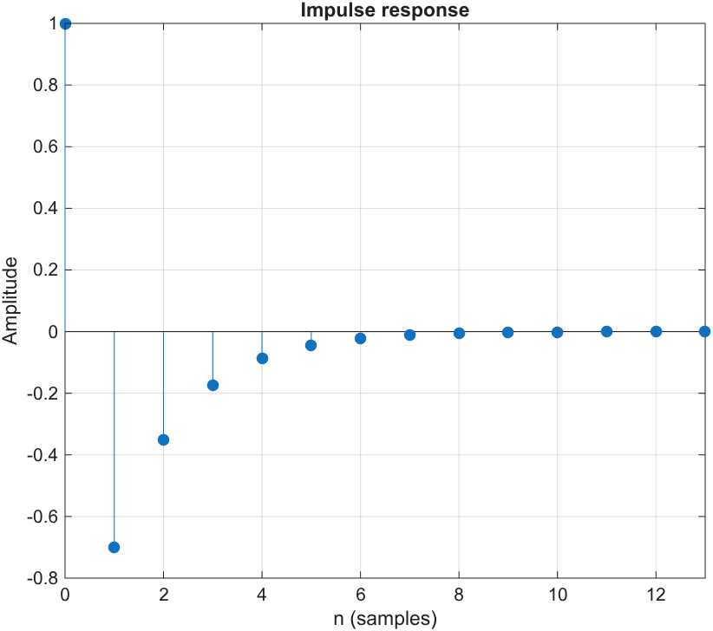

Q1: (i)

Matlab Code:

%% Q1
clc; close all; clear;
b=[1 -1.2];
a=[1 -0.5];
%(i)
figure
impz(b,a)
title('Impulse response')
grid on;

The impulse response decays exponentially, so the system is stable.

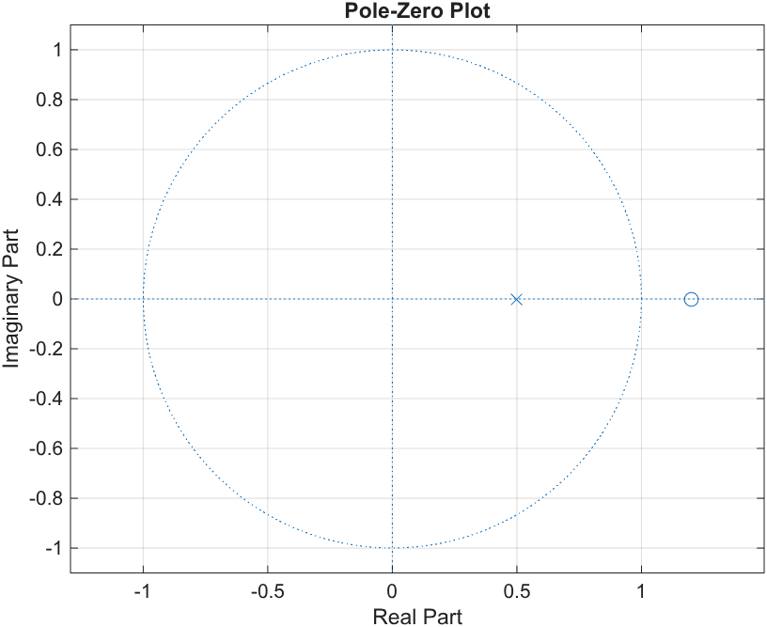

Q1: (ii)

clc; close all; clear;
b=[1 -1.2];
a=[1 -0.5];

%(ii)
figure
zplane(b,a)
title('Pole-Zero Plot')
grid on;

Pole is inside unit circle, so its a stable system.
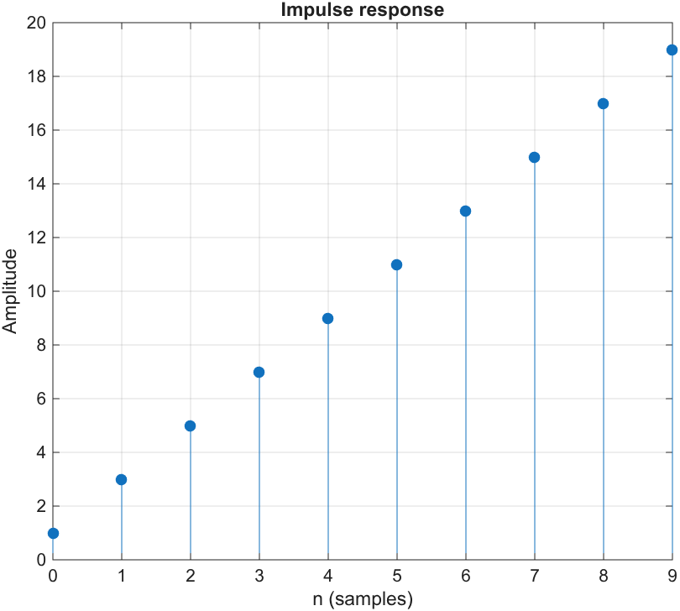
Q2: (i)

Matlab Code:
%% Q2
clc; close all; clear;
b=[1 1];
a=[1 -2 1];
%(i)
figure
impz(b,a)
title('Impulse response')
grid on;

The impulse response grows linearly, so the system is unstable.

Q2: (ii)

Multiple(2) poles on the unit circle, so the system is unstable.

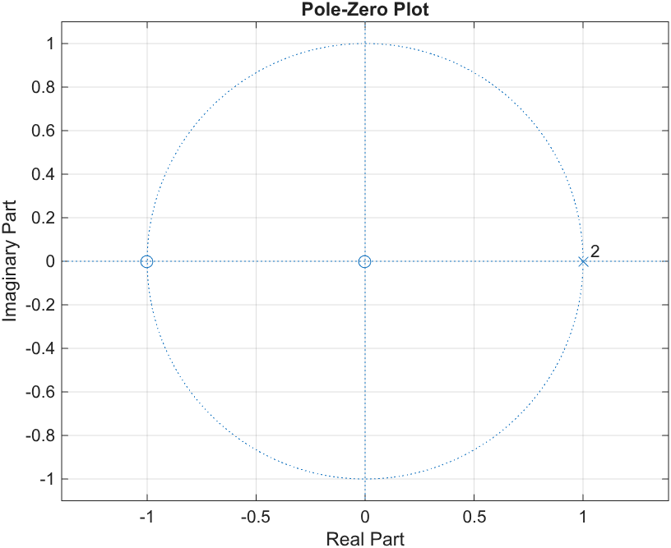

Matlab Code:
%% Q2
clc; close all; clear;
b=[1 1];
a=[1 -2 1];

%(ii)
figure
zplane(b,a)
title('Pole-Zero Plot')
grid on;

Q3: (a)
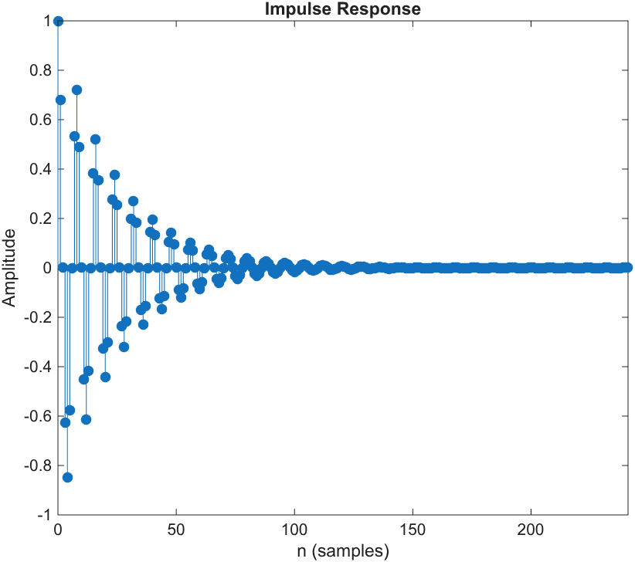

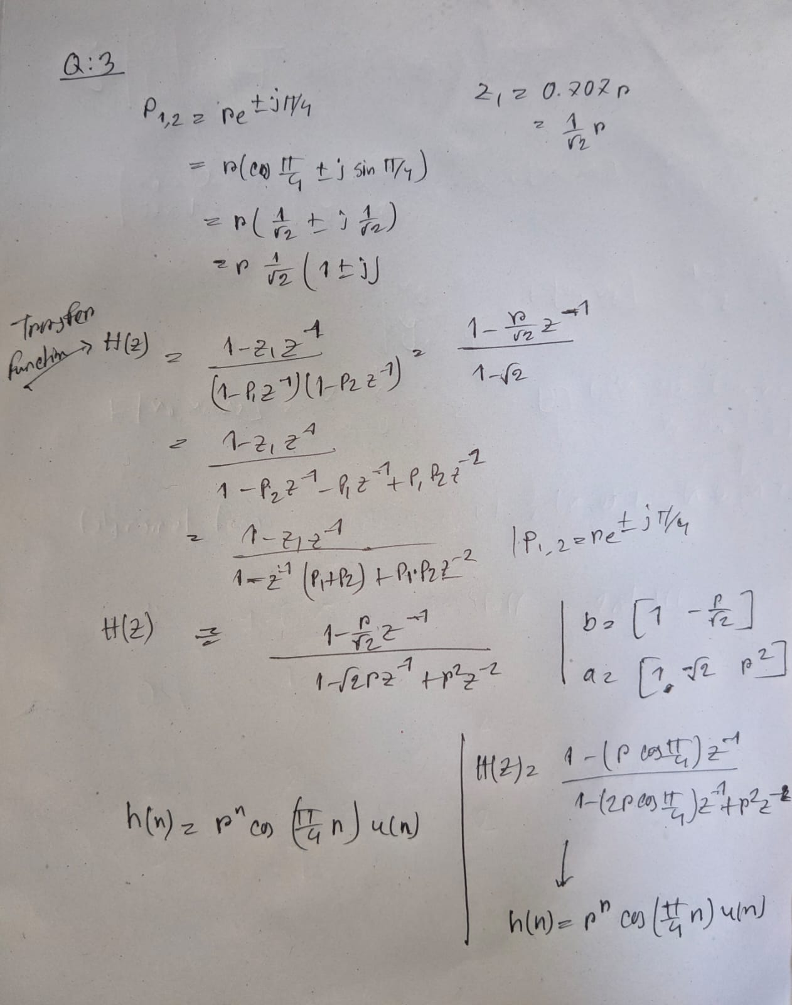
Matlab Code:
%% Q3
clc; clear all; close all;
% (a)
r1 = 0.96;
b1 = [1, -0.707*r1];
a1 = [1, -sqrt(2)*r1, r1^2];
impz(b1, a1);

Dependence on r:
- r^n an exponential decay factor
- If r = 0.96, decay is very slow
- r = 0.71, decay is medium
- r = 0.14, decay is extremely fast

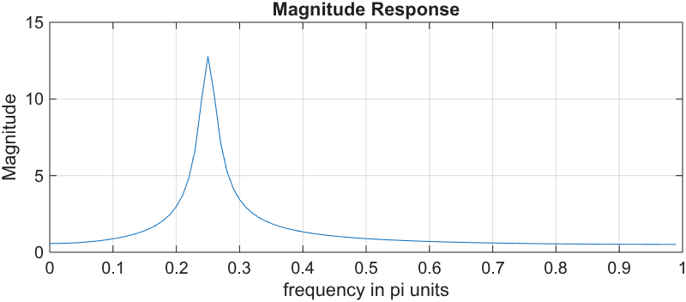
Q3: (b)

clc; clear all; close all;
% (b)
r1 = 0.96;
b1 = [1 -0.707*r1];
a1 = [1 -sqrt(2)*r1 r1^2];

[H1,w]=freqz(b1,a1,100);
magH1=abs(H1);
phaH1=angle(H1);
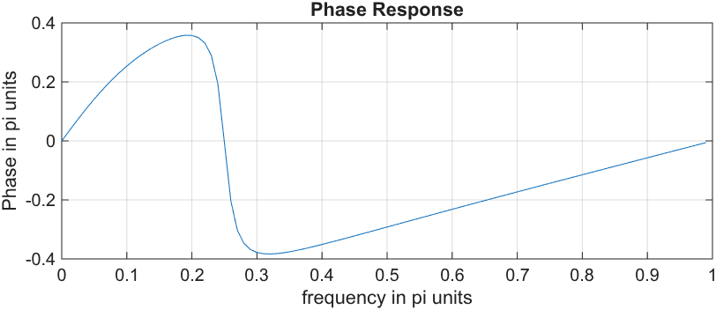
figure;
subplot(2,1,1); plot(w/pi,magH1);
grid;
title('Magnitude Response');
xlabel('frequency in pi units');
ylabel('Magnitude');

subplot(2,1,2); plot(w/pi, phaH1/pi);
grid;
title('Phase Response');
xlabel('frequency in pi units');
ylabel('Phase in pi units');

Q3: (c)
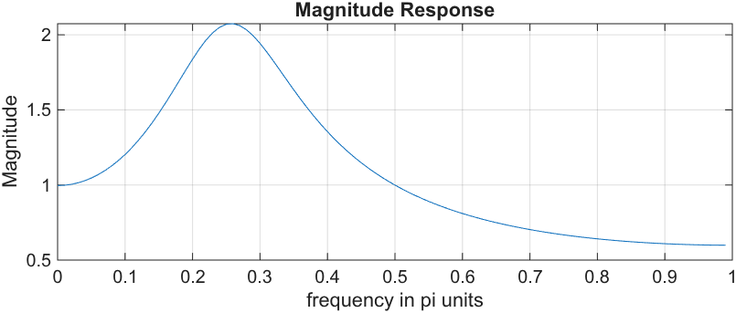
%% (c)
r2=0.71;
b2=[1 -0.707*r2];
a2=[1 -sqrt(2)*r2 r2^2];

[H2,w] =freqz(b2,a2,100);
magH2=abs(H2);
phaH2=angle(H2);

figure;
subplot(2,1,1); plot(w/pi,magH2);
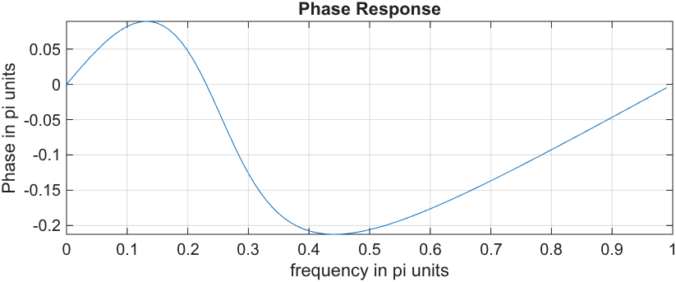
grid;
title('Magnitude Response');
xlabel('frequency in pi units');
ylabel('Magnitude');

subplot(2,1,2); plot(w/pi, phaH2/pi);
grid;
title('Phase Response');
xlabel('frequency in pi units');
ylabel('Phase in pi units');

Q3: (d)
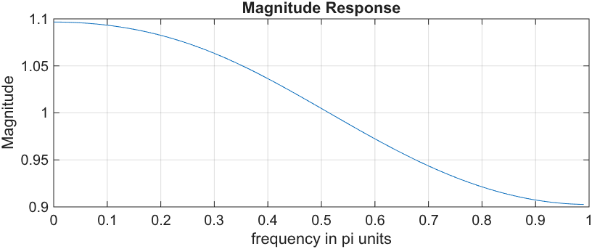
%% (d)
r3=0.14;
b3=[1 -0.707*r3];
a3 = [1 -sqrt(2)*r3 r3^2];

[H3,w]=freqz(b3,a3,100);
magH3=abs(H3);
phaH3=angle(H3);

figure;
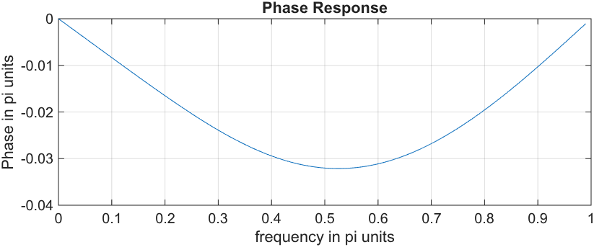
subplot(2,1,1); plot(w/pi, magH3);
grid;
title('Magnitude Response');
xlabel('frequency in pi units');
ylabel('Magnitude');

subplot(2,1,2); plot(w/pi, phaH3/pi);
grid;
title('Phase Response');
xlabel('frequency in pi units');
ylabel('Phase in pi units');

Q3: (e)

When r gets smaller (from 0.96 down to 0.14), the sharp peak at 0.25 pi flattens out, and the signal strength drops. The phase line becomes smoother and flatter.
When r is close to 1 (closer to the unit circle), the filter becomes much better at picking out its main frequency.

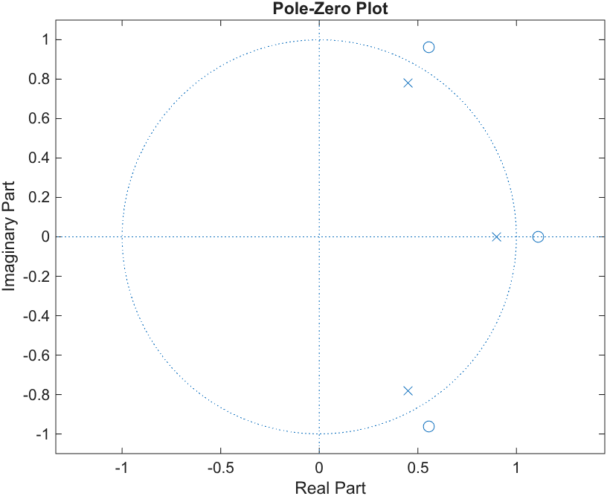
Q4: (a)

%% Q4
clc; clear all; close all;

b=[-0.729 1.62 -1.8 1];
a=[1 -1.8 1.62 -0.729];

zplane(b,a)

Q4: (b)

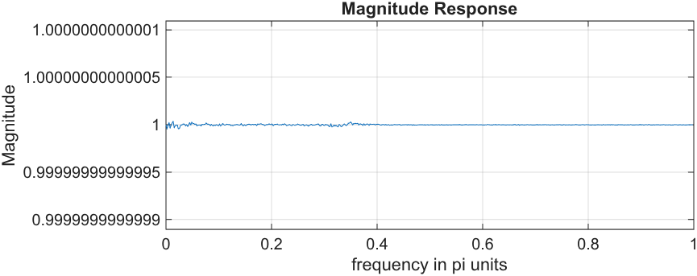
clc; clear all; close all;
b=[-0.729 1.62 -1.8 1];
a=[1 -1.8 1.62 -0.729];

[H,w]=freqz(b,a,512);
magH=abs(H);
phaH=angle(H);

figure;
subplot(2,1,1); plot(w/pi,magH);
grid;
title('Magnitude Response');
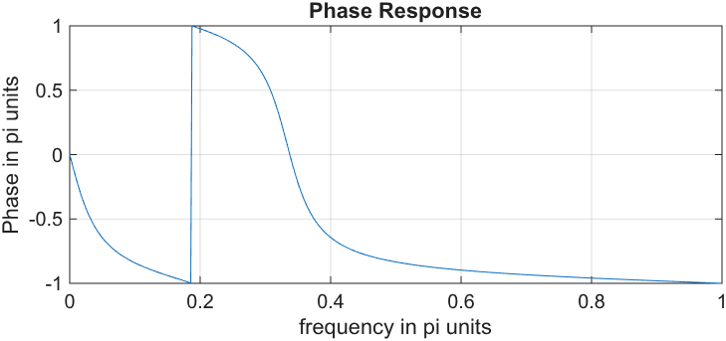
xlabel('frequency in pi units');
ylabel('Magnitude');

subplot(2,1,2); plot(w/pi,phaH/pi); grid;
title('Phase Response');
xlabel('frequency in pi units');
ylabel('Phase in pi units');

Q4: (C)

The magnitude looks constant and equal to 1 across all frequencies from 0 to pi. It does not amplify any frequency component.

The phase decreases non-linearly from 0 to negative values as frequency increases, which means it delays different frequencies by different amounts.

Q4: (d)

This system is an All-Pass Filter.

It lets all frequencies pass through without changing their strength (gain stays at 1), and only changes their timing/phase.

Its zeros are placed inverse to its poles across the unit circle.

