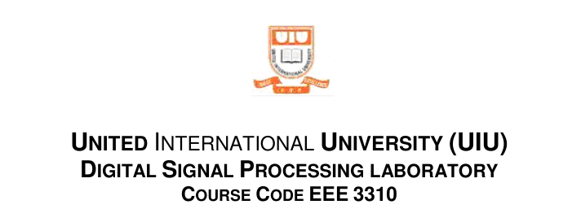

Lab Report : 06
DFT Computation Using FFT Algorithm in MATLAB

Group No: 02

Group Members:

0212330092 Md. Hussain Shahriar Rokon
021213012 Rifa Akter
0212320035 Nowshin Tabassum Rihun

Answer: 6.2 Exercise (HW6.01)

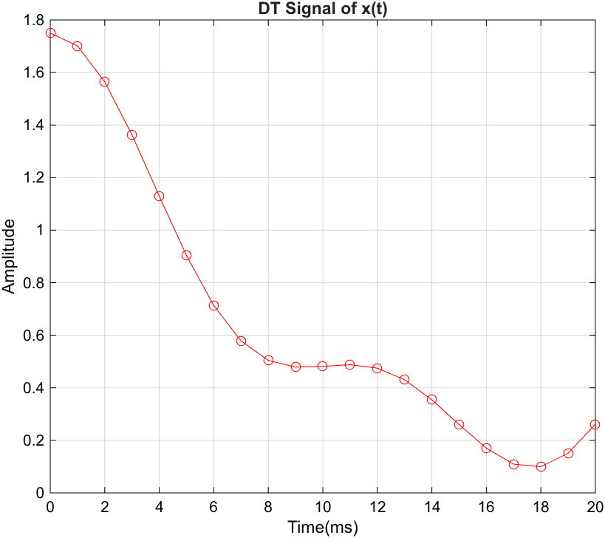
(i) Output Figure

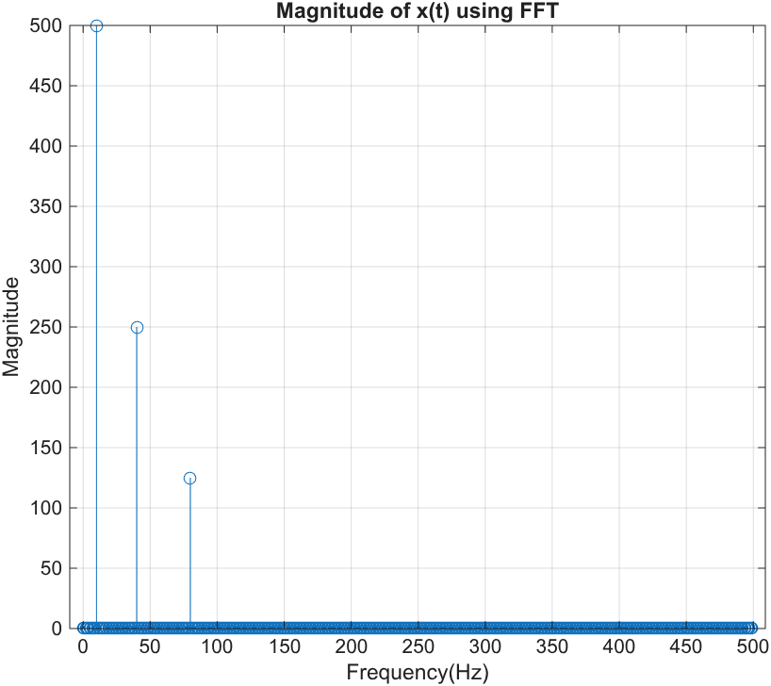
(ii) Output Figure

Matlab Code:

clc; clear all; close all;
Fs =1000;
Ts =1/Fs;

% Part (i)
t =0:Ts:0.02;%time array for 20 ms
x =cos(20*pi*t)+0.5*cos(80*pi*t)+0.25*cos(160*pi*t);

figure
plot(t*1000,x,'r-o');
title('DT Signal of x(t)');
xlabel('Time(ms)');
ylabel('Amplitude');
grid on;

% Part(ii)
t_1 =0:Ts:1-Ts; % t =1 second for better resolution
x =cos(20*pi*t_1) + 0.5*cos(80*pi*t_1) + 0.25*cos(160*pi*t_1);
N =length(x);% FFT points
X =fft(x, N);
k =0:N-1;% frequency index
F =(Fs/N)*k;% frequency axis in Hz

figure
stem(F(1:N/2), abs(X(1:N/2)));
% 1:N/2 for first half points, and this first half will repeat
% abs for the magnitude only
title('Magnitude of x(t) using FFT');
xlabel('Frequency(Hz)'); ylabel('Magnitude');
grid on;

