

Session 06: Hive Introduction

Assignment 1

*Downloaded Data from given link:-*

https://drive.google.com/file/d/0Bxr27gVaXO5sa0JBamZXdkpYUFk/view?usp=sharing

*Create a database named 'custom'.*

hive> create database custom;

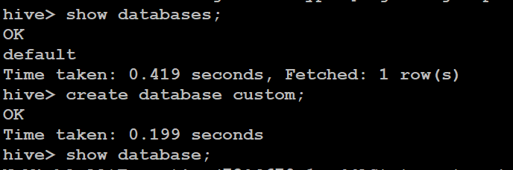

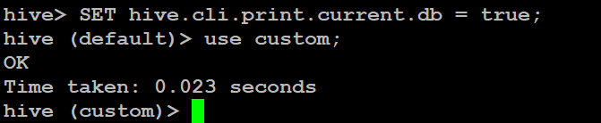

hive> SET hive.cli.print.current.db = true;

hive (default)> use custom;

*Create a table named temperature_data inside custom having below fields:*

1. *date (mm-dd-yyyy) format*
2. *zip code*
3. *temperature*

hive (custom)> create table temperature_data

> (date1 String,

> zip_code int,

> temp int

> )

> row format delimited fields terminated by ',';

OK

Time taken: 0.385 seconds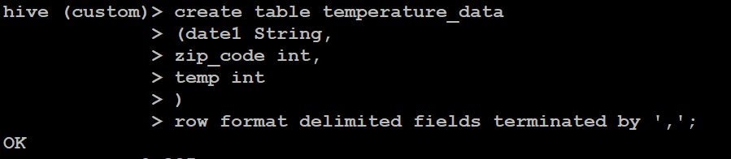

The table will be loaded from comma-delimited file.

hive (custom)> load data inpath '/user/hive/dataset.txt' into table temperature_data;

Loading data to table custom.temperature_data

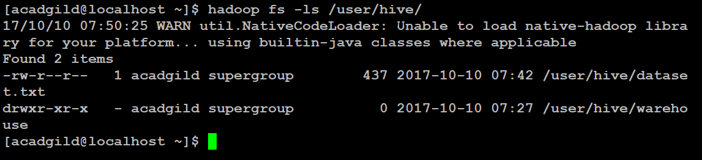

Load the dataset.txt (which is ',' delimited) in the table.

