

Session 06: Hive Introduction

Assignment 2

*As from previous assignment we have already data in temperature_data table*

* *Fetch date and temperature from temperature_data where zip code is greater than 300000 and less than 399999.*

hive (custom)> select date1,temp from temperature_data where zip_code > 30000 and zip_code < 399999;

OK

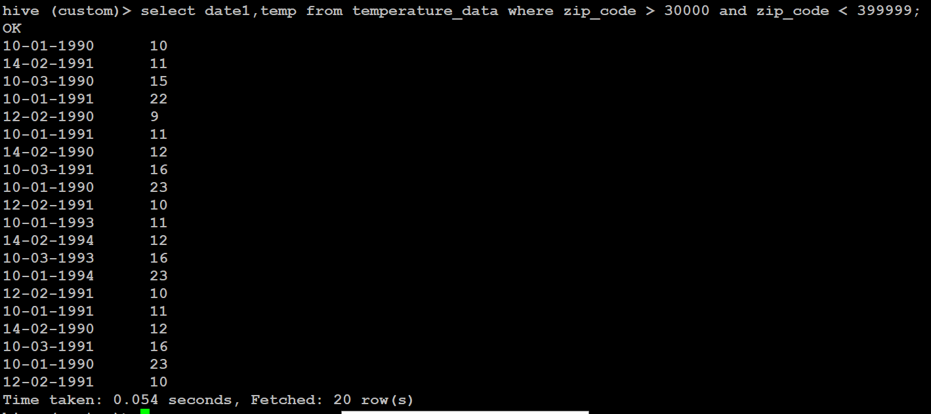

* *Calculate maximum temperature corresponding to every year from temperature_data table*.

hive (custom)> select substr(date1,6),max(temp) from temperature_data group by substr(date1,6);

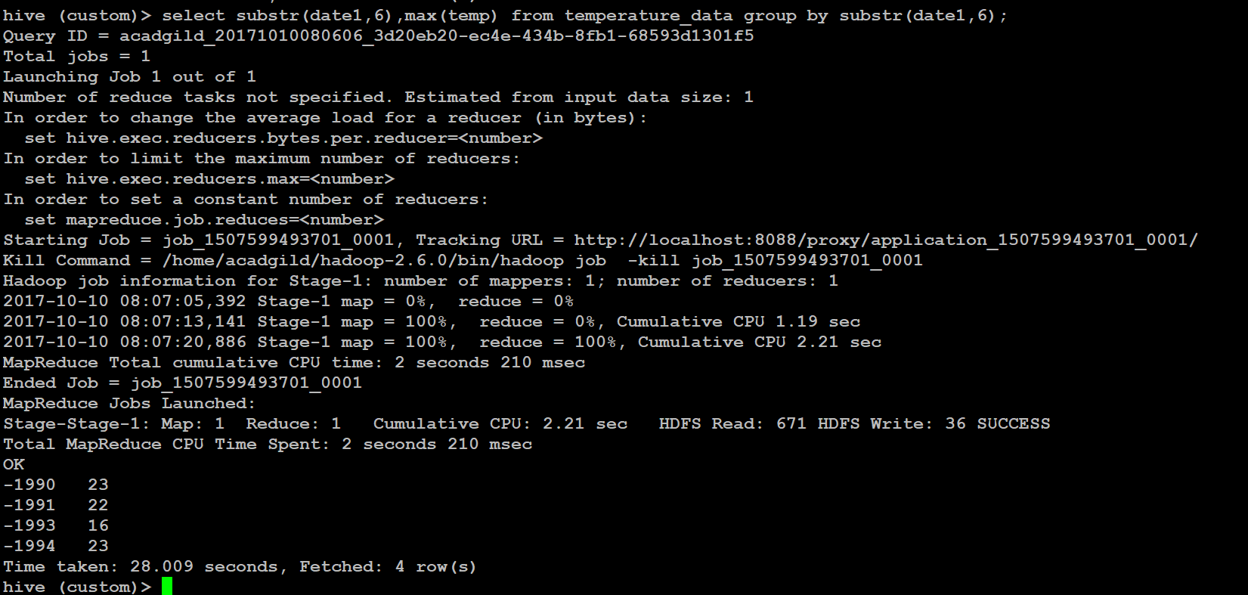

* *Calculate maximum temperature from temperature_data table corresponding to those years which have at least 2 entries in the table.*

hive (custom)> select substr(date1,6),max(temp) from temperature_data group by substr(date1,6) having count(temp)>1;

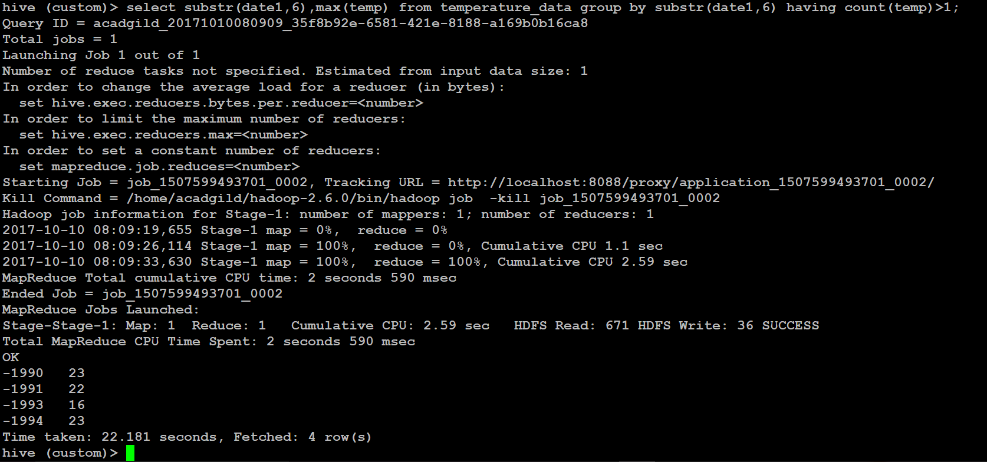

* *Create a view on the top of last query, name it temperature_data_vw.*

hive (custom)> create view temperature_data_vw select substr(date1,6),max(temp) from temperature_data group by substr(date1,6) having count(temp)>1;

hive (custom)> select * from temperature_data_vw;

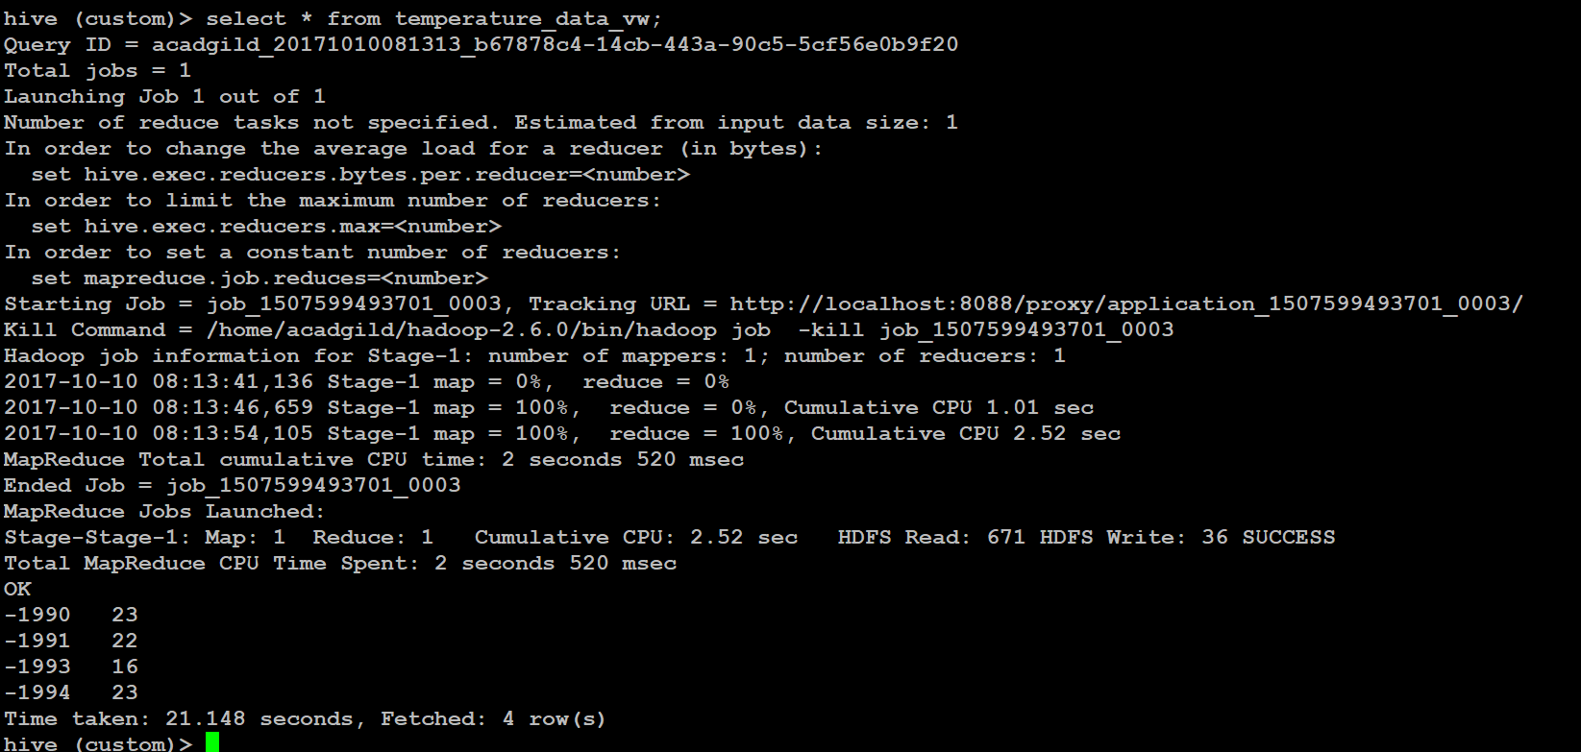

* *Export contents from temperature_data_vw to a file in local file system, such that each file is '|' delimited.*

hive (custom)> insert overwrite local directory '/home/acadgild/Desktop/hive_out' row format delimited fields terminated by '|' select * from temperature_data_vw;

