



**Session 06: Hive Introduction**

**Explain Hive Architecture in Brief.**

## What is Hive?

Hive is an ETL and Data warehousing tool developed on top of Hadoop Distributed File System (HDFS). Hive makes job easy for performing operations like

* Data encapsulation
* Ad-hoc queries
* Analysis of huge datasets

## Important characteristics of Hive

* In Hive, tables and databases are created first and then data is loaded into these tables.
* Hive as data warehouse designed for managing and querying only structured data that is stored in tables.
* While dealing with structured data, Map Reduce doesn't have optimization and usability features like UDFs but Hive framework does. Query optimization refers to an effective way of query execution in terms of performance.
* Hive's SQL-inspired language separates the user from the complexity of Map Reduce programming. It reuses familiar concepts from the relational database world, such as tables, rows, columns and schema, etc. for ease of learning.
* Hadoop's programming works on flat files. So, Hive can use directory structures to "partition" data to improve performance on certain queries.
* A new and important component of Hive i.e. Metastore used for storing schema information. This Metastore typically resides in a relational database. We can interact with Hive using methods like
  + **Web GUI**
  + **Java Database Connectivity (JDBC) interface**
* Most interactions tend to take place over a command line interface (CLI). Hive provides a CLI to write Hive queries using Hive Query Language(HQL)
* Generally, HQL syntax is similar to the[SQL](https://www.guru99.com/sql.html)syntax that most data analysts are familiar with. The Sample query below display all the records present in mentioned table name.
  + **Sample query**: Select * from <Table Name>
* Hive supports four file formats those are **TEXTFILE, SEQUENCEFILE, ORC and RCFILE** (Record Columnar File).
* For single user metadata storage, Hive uses derby database and for multiple user Metadata or shared Metadata Case Hive uses MYSQL.

*Some of the key points about Hive:*

* The major difference between HQL and[SQL](https://www.guru99.com/sql.html)is that Hive query executes on Hadoop's infrastructure rather than the traditional database.
* The Hive query execution is going to be like series of automatically generated map reduce Jobs.
* Hive supports partition and buckets concepts for easy retrieval of data when the client executes the query.
* Hive supports custom specific UDF (User Defined Functions) for data cleansing, filtering, etc. According to the requirements of the programmers one can define Hive UDFs.

## *Hive Vs Relational Databases: -*

By using Hive, we can perform some peculiar functionality that is not achieved in Relational Databases. For a huge amount of data that is in peta-bytes, querying it and getting results in seconds is important. And Hive does this quite efficiently, it processes the queries fast and produce results in second's time.

**Some key differences between Hive and relational databases are the following;**

Relational databases are of "**Schema on READ and Schema on Write**". First creating a table then inserting data into the particular table. On relational database tables, functions like Insertions, Updates, and Modifications can be performed.

Hive is "**Schema on READ only**". So, functions like the update, modifications, etc. don't work with this. Because the Hive query in a typical cluster runs on multiple Data Nodes. So, it is not possible to update and modify data across multiple nodes Also, Hive supports "**READ Many WRITE Once**" pattern. Which means that after inserting table we can update the table in the latest Hive versions.

**NOTE**: However, the new version of Hive comes with updated features. Hive versions (Hive 0.14) comes up with Update and Delete options as new features

## *Hive Architecture*

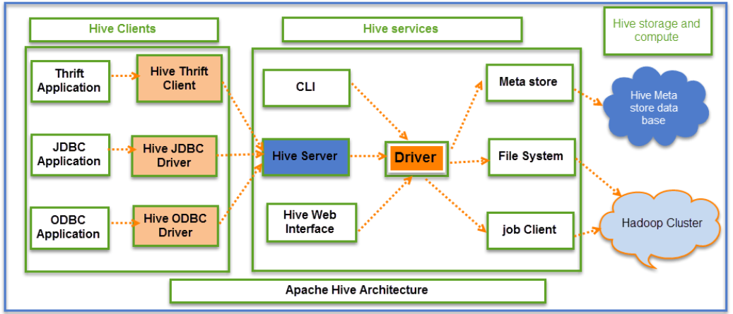

The above screenshot explains the[Apache](https://www.guru99.com/apache.html)Hive architecture in detail

*Hive Consists of Mainly 3 core parts*

1. **Hive Clients**
2. **Hive Services**
3. **Hive Storage and Computing**

**Hive Clients:**

Hive provides different drivers for communication with a different type of applications. For Thrift based applications, it will provide Thrift client for communication.

For java related applications, it provides JDBC Drivers. Other than any type of applications provided ODBC drivers. These Clients and drivers in turn again communicate with Hive server in the Hive services.

**Hive Services:**

Client interactions with Hive can be performed through Hive Services. If the client wants to perform any query related operations in Hive, it has to communicate through Hive Services.

CLI is the command line interface acts as Hive service for DDL (Data definition Language) operations. All drivers communicate with Hive server and to the main driver in Hive services as shown in above architecture diagram.

Driver present in the Hive services represents the main driver, and it communicates all type of JDBC, ODBC, and other client specific applications. Driver will process those requests from different applications to meta store and field systems for further processing.

**Hive Storage and Computing:**

Hive services such as Meta store, File system, and Job Client in turn communicates with Hive storage and performs the following actions

* Metadata information of tables created in Hive is stored in Hive "Meta storage database".
* Query results and data loaded in the tables are going to be stored in Hadoop cluster on HDFS.
* **Job execution flow:**

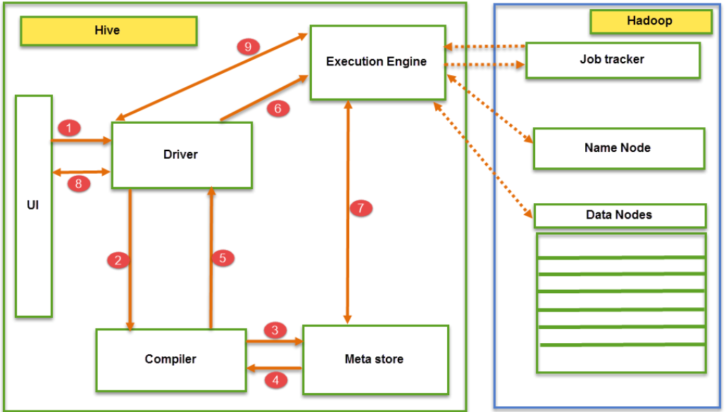

From the above screenshot we can understand the Job execution flow in Hive with Hadoop

The data flow in Hive behaves in the following pattern;

1. Executing Query from the UI (User Interface)
2. The driver is interacting with Compiler for getting the plan. (Here plan refers to query execution) process and its related metadata information gathering
3. The compiler creates the plan for a job to be executed. Compiler communicating with Meta store for getting metadata request
4. Meta store sends metadata information back to compiler
5. Compiler communicating with Driver with the proposed plan to execute the query
6. Driver Sending execution plans to Execution engine
7. Execution Engine (EE) acts as a bridge between Hive and Hadoop to process the query. For DFS operations.

* EE should first contacts Name Node and then to Data nodes to get the values stored in tables.
* EE is going to fetch desired records from Data Nodes. The actual data of tables resides in data node only. While from Name Node it only fetches the metadata information for the query.
* It collects actual data from data nodes related to mentioned query
* Execution Engine (EE) communicates bi-directionally with Meta store present in Hive to perform DDL (Data Definition Language) operations. Here DDL operations like CREATE, DROP and ALTERING tables and databases are done. Meta store will store information about database name, table names and column names only. It will fetch data related to query mentioned.
* Execution Engine (EE) in turn communicates with Hadoop daemons such as Name node, Data nodes, and job tracker to execute the query on top of Hadoop file system

1. Fetching results from driver
2. Sending results to Execution engine. Once the results fetched from data nodes to the EE, it will send results back to driver and to UI (front end)

Hive Continuously in contact with Hadoop file system and its daemons via Execution engine. The dotted arrow in the Job flow diagram shows the Execution engine communication with Hadoop daemons.

## Different modes of Hive

Hive can operate in two modes depending on the size of data nodes in Hadoop.

These modes are,

* **Local mode**
* **Map reduce mode**

**When to use Local mode:**

* If the Hadoop installed under pseudo mode with having one data node we use Hive in this mode
* If the data size is smaller in term of limited to single local machine, we can use this mode
* Processing will be very fast on smaller data sets present in the local machine

**When to use Map reduce mode:**

* If Hadoop is having multiple data nodes and data is distributed across different node we use Hive in this mode
* It will perform on large amount of data sets and query going to execute in parallel way
* Processing of large data sets with better performance can be achieved through this mode

**Explain Hive Components in Brief.**

**UI: -**UI means User Interface, The user interface for users to submit queries and other operations to the system.

**Driver: -**The Driver is used for receives the quires from UI .This component implements the notion of session handles and provides execute and fetch APIs modeled on JDBC/ODBC interfaces.

**Compiler: -**The component that parses the query, does semantic analysis on the different query blocks and query expressions and eventually generates an execution plan with the help of the table and partition metadata looked up from the metastore.

**MetaStore:-**The component that stores all the structure information of the various tables and partitions in the warehouse including column and column type information, the serializes and reserializes necessary to read and write data and the corresponding HDFS files where the data is stored.

**Execution Engine: -**The component which executes the execution plan created by the compiler. The plan is a DAG of stages. The execution engine manages the dependencies between these different stages of the plan and executes these stages on the appropriate system components.

