



Session 4: Schedulers in YARN & Introduction to Pig

Assignment 1 Question

*Session 4: Assignment 1*

## Problem Statement

1. *Write a java code with the class named ‘acad’ and a method ‘main’. Hard Code the program with two integers and print the sum of those two.*

Code: -

import java.util.*;

class acad1

{

public static void main(String[] args)

{

int a=5; int b=4; int c;

c=a+b; System.out.println(c);

}

}

Output:-

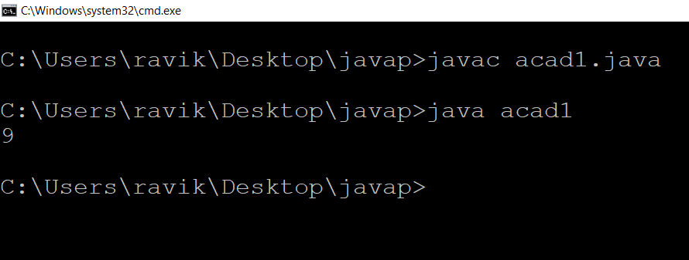

1. *Rewrite the above code, where, inputs are provided by the user at runtime and the output is printed.*

Code:-

import java.util.*;

public class acad2

{

public static void main(String[] args)

{

Scanner ss = new Scanner(System.in); int a=ss.nextInt();

int b=ss.nextInt(); int c;

c=a+b;

System.out.println(c);

ss.close();

}

}

Output :-

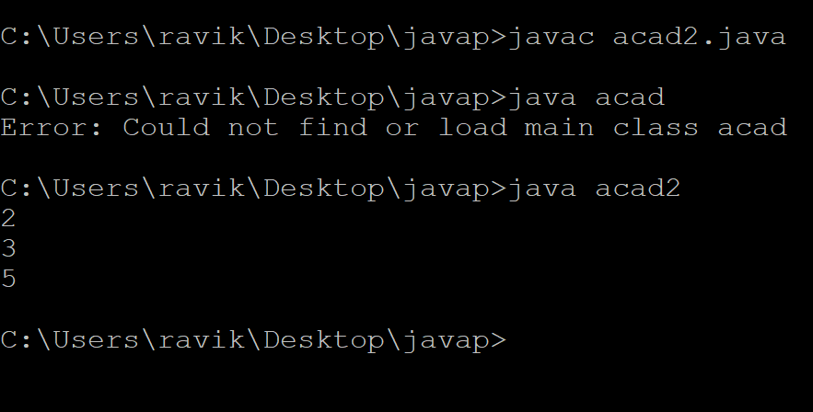

1. *Write a program with method name sum() that accepts two parameters from user and print the sum of two numbers. Output format should be as:*

Code:-

import java.util.*;

public class acad3 {

public static void main(String[] args)

{

sum();

}

static void sum() {

Scanner ss = new Scanner(System.in);

System.out.println("Enter first number");

int a=ss.nextInt();

System.out.println("Enter second number");

int b=ss.nextInt();

int c;

c=a+b;

System.out.println("Result of addition = " +c);

ss.close(); } }

Output: -

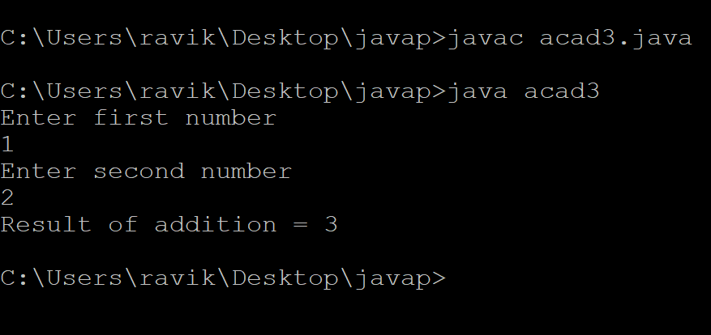

1. *Write a program to accepts two numbers from stdin and find all the odd as well as even numbers present in between them.*

Code:-

import java.util.Scanner;

class OddEven_Ex4 {

Scanner scan;

int start, end;

void getVal() {

scan = new Scanner(System.in);

System.out.println("Calculate total number of " +

"Odd & Even numbers between two numbers");

System.out.println("\nEnter the Starting value : ");

start = Integer.parseInt(scan.nextLine());

System.out.println("Enter the End value : ");

end = Integer.parseInt(scan.nextLine());

}

void check() {

int odd = 0;

int even = 0;

for(int i=start; i<=end; i++) {

if((i % 2) == 0)

even ++;

else

odd ++;

}

System.out.println("\nTotal number of Odd number is " + odd);

System.out.println("Total number of Even number is " + even);

}

}

class Acad4 {

public static void main(String args[])

{

OddEven_Ex4 obj = new OddEven_Ex4();

obj.getVal();

obj.check();

}

}

Output:-

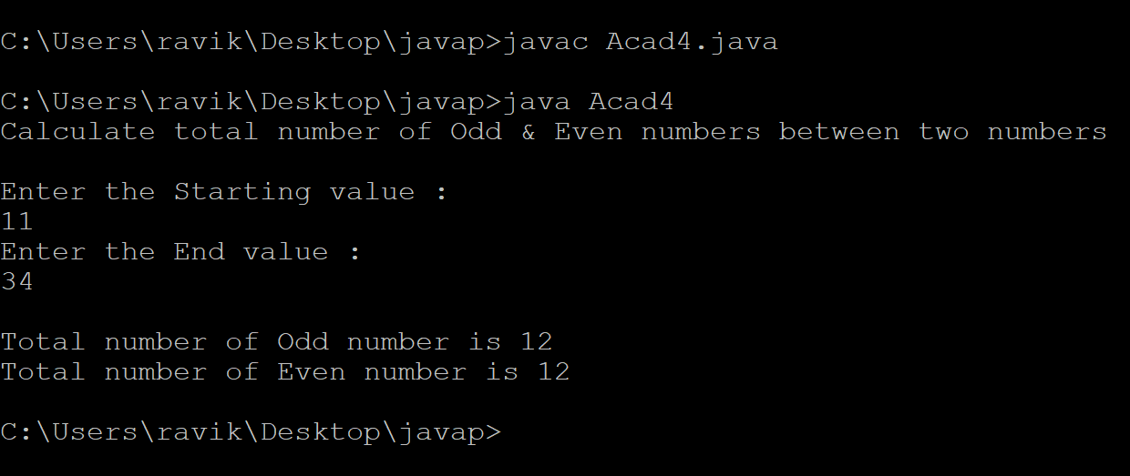

1. *Joe is scared to go to school. When her dad asked the reason, joe said she is unable to complete the task given by her teacher. The task was to find the “first 10 multiples” of the number entered from stdin . Eg:*

*Input: 3 O/p:*

*3 x 1 = 3*

*3 x 2 = 6*

*3 x 10 = 30*

*Help Joe in completing the task!*

Code:-

import java.util.Scanner;

class Acad5

{

public static void main (String args[])

{

int a, i;

Scanner s=new Scanner(System.in);

System.out.println("Enter number");

a=s.nextInt();

for(i=1;i<=10;i++)

System.out.println("multiplies of \t" +a+"\t with \t" +i+ "is =\t" +i*a);

}

}

Output:-

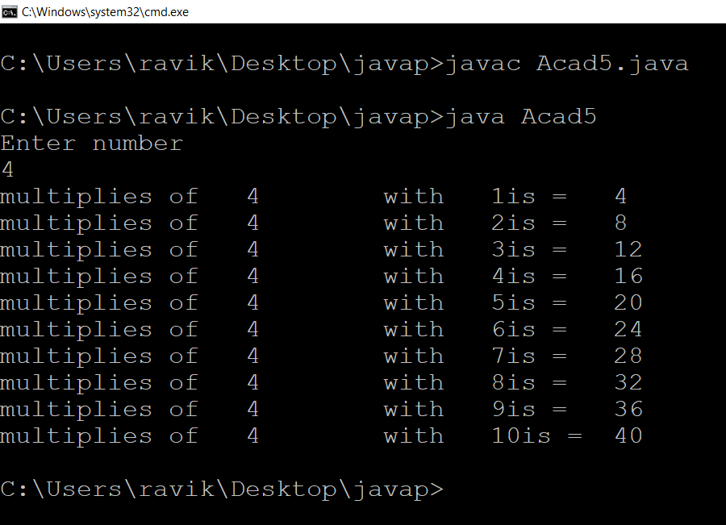

1. *Write a program consisting method sum() and demonstrate the concept of method overloading using this method*.

Code:-

class Acad{

static int add(int a, int b){return a+b;}

static double add(double a, double b){return a+b;}

}

class Acad6{

public static void main(String[] args)

{

System.out.println(Acad.add(11,11));

System.out.println(Acad.add(12.3,12.6));

}

}

Output:-

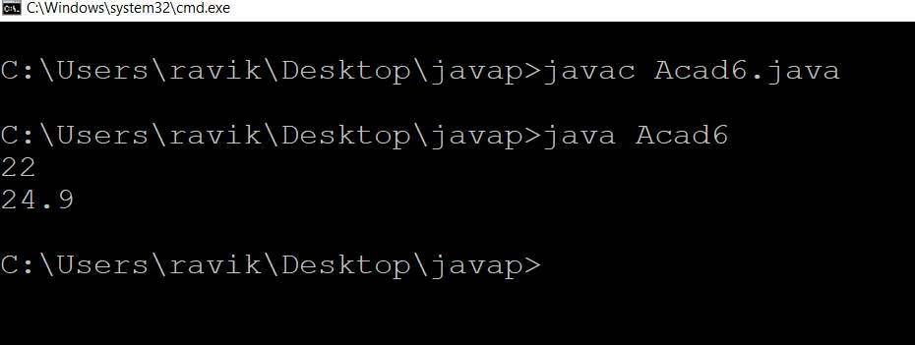

1. *Can you overload a method with same return type.? Explain your answer with proper logic.*

In java, method overloading is not possible by changing the return type of the method only because of ambiguity. Let's see how ambiguity may occur:

**class** Adder{

**static** **int** add(**int** a,**int** b){**return** a+b;}

**static** **double** add(**int** a,**int** b){**return** a+b;}

}

**class** TestOverloading3{

**public** **static** **void** main(String[] args){

System.out.println(Adder.add(11,11));//ambiguity

}}

Output: - Compile Time Error: method add(int,int) is already defined in class Adder

1. *Write a program in java using Arrays, that sorts the element in descending order.*

Code: -

import java.util.Scanner;

public class Acad8

{

public static void main(String[] args)

{

int n, temp;

Scanner s = new Scanner(System.in);

System.out.print("Enter no. of elements you want in array:");

n = s.nextInt();

int a[] = new int[n];

System.out.println("Enter all the elements:");

for (int i = 0; i < n; i++)

{

a[i] = s.nextInt();

}

for (int i = 0; i < n; i++)

{

for (int j = i + 1; j < n; j++)

{

if (a[i] < a[j])

{

temp = a[i];

a[i] = a[j];

a[j] = temp;

}

}

}

System.out.print("Descending Order:");

for (int i = 0; i < n - 1; i++)

{

System.out.print(a[i] + ",");

}

System.out.print(a[n - 1]);

}

}

Output :-

