*Big Data and Hadoop Development*



Session 1: How to Solve Big Data

Assignment 1

*Assignment 1 –Import Acadgild VM into Oracle virtual box*

Step1: Downloaded oracle virtual box an installed into System (Version virtualBox-5.1.28-117968-Win)

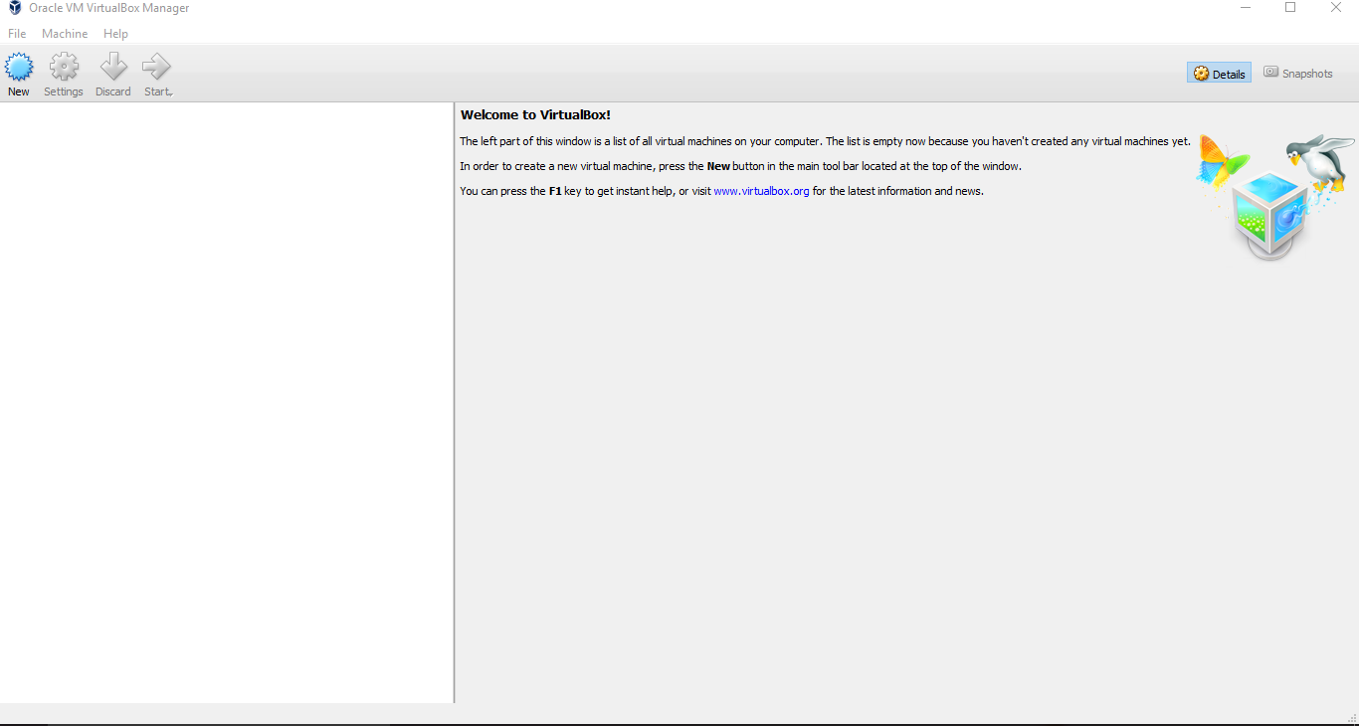

Step2: Downloaded image from Dash board and saved into D drive

Import Appliances and given directory where VM image has been saved

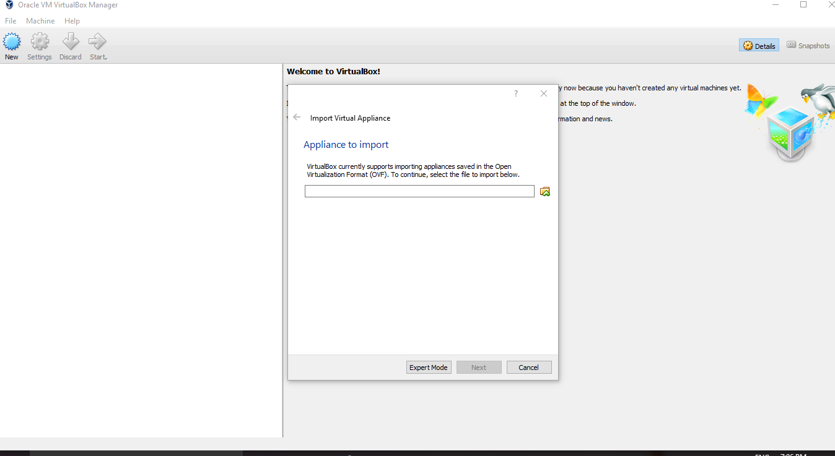

Step3: RAM size and configuration setting provided to new machine and clicked on import button

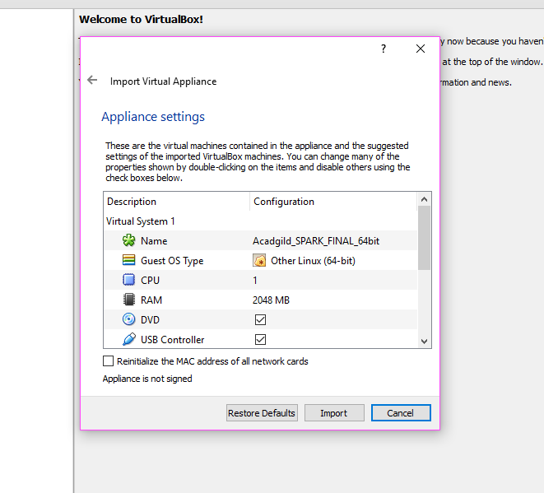

Step4: It took approx. 10 minutes to import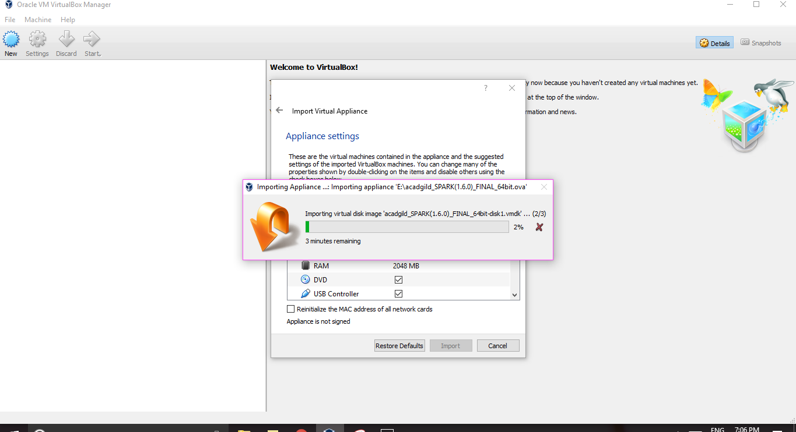

Step5: Login with acadgild username and password

Username: acadgild

Password: acadgild

