



Session 1: How to Solve Big Data Problem

Assignment 2 Question

*Session 1: Assignment 2*

Linux Command: -

1. pwd :-It show present working directory

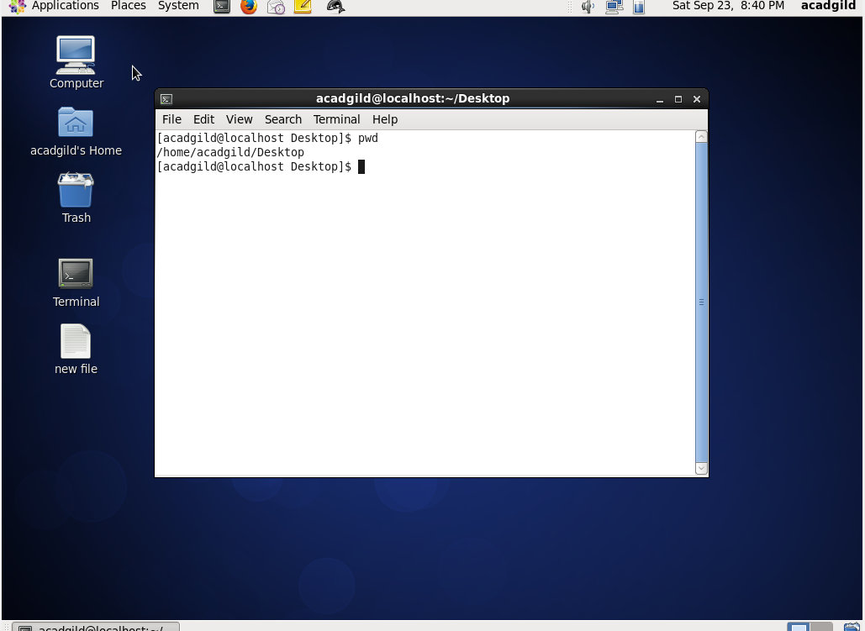

1. vi:- vi is a screen-oriented text editor

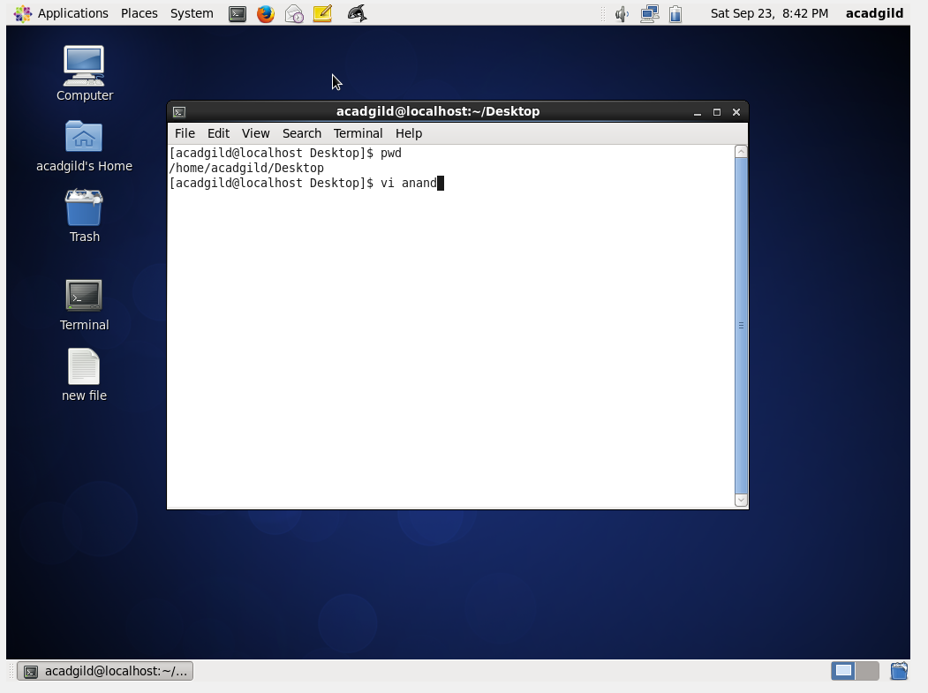

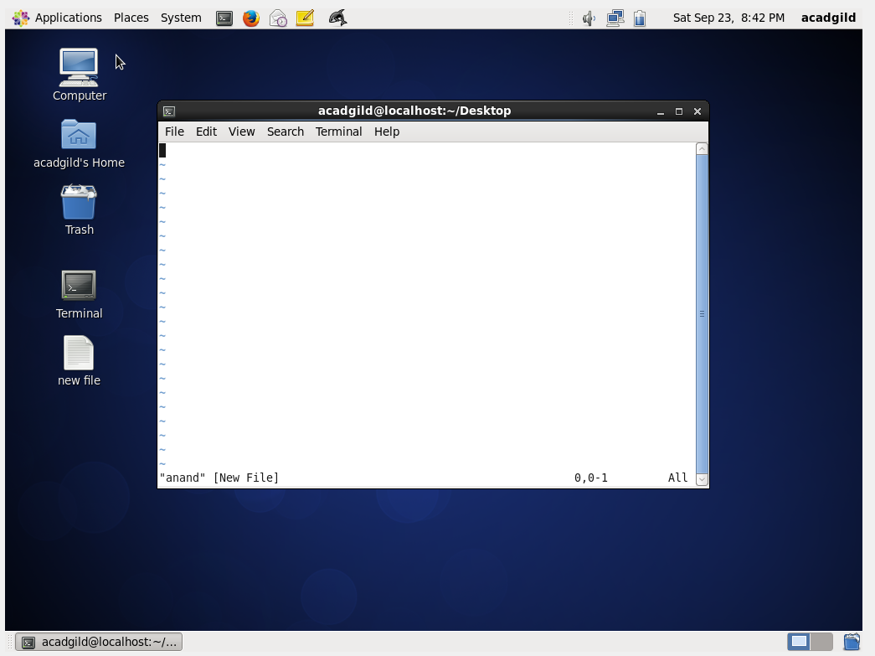

1. touch: -it create new empty file

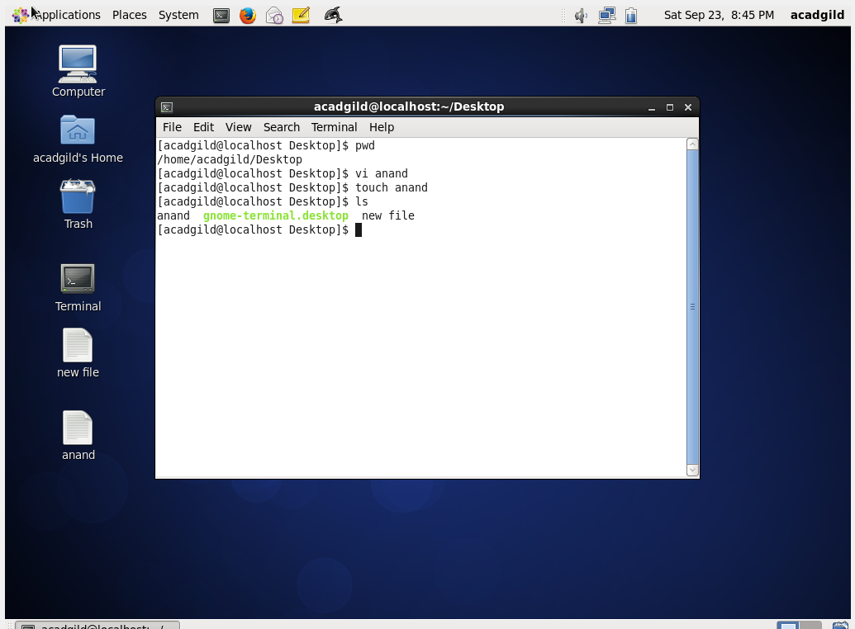

1. mkdir :- It create new directory

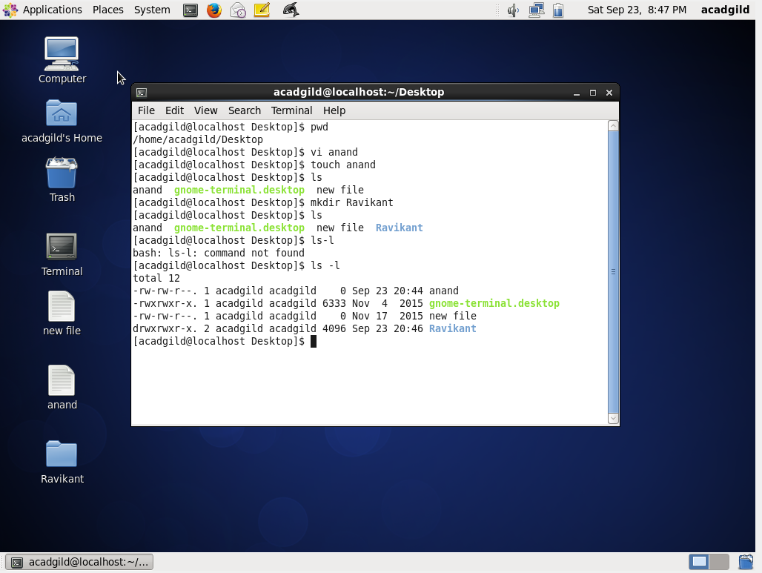

1. rm :- The rm command removes ([deletes](https://www.computerhope.com/jargon/d/delete.htm)) [files](https://www.computerhope.com/jargon/f/file.htm) or [directories](https://www.computerhope.com/jargon/d/director.htm).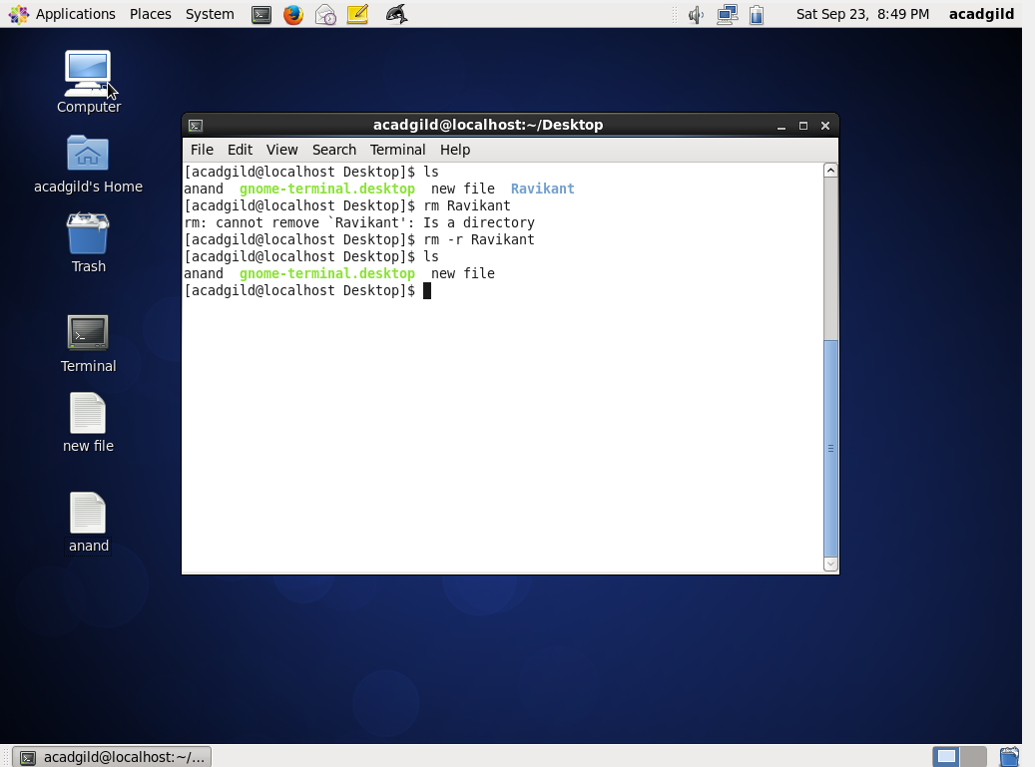
2. ls:-list all files

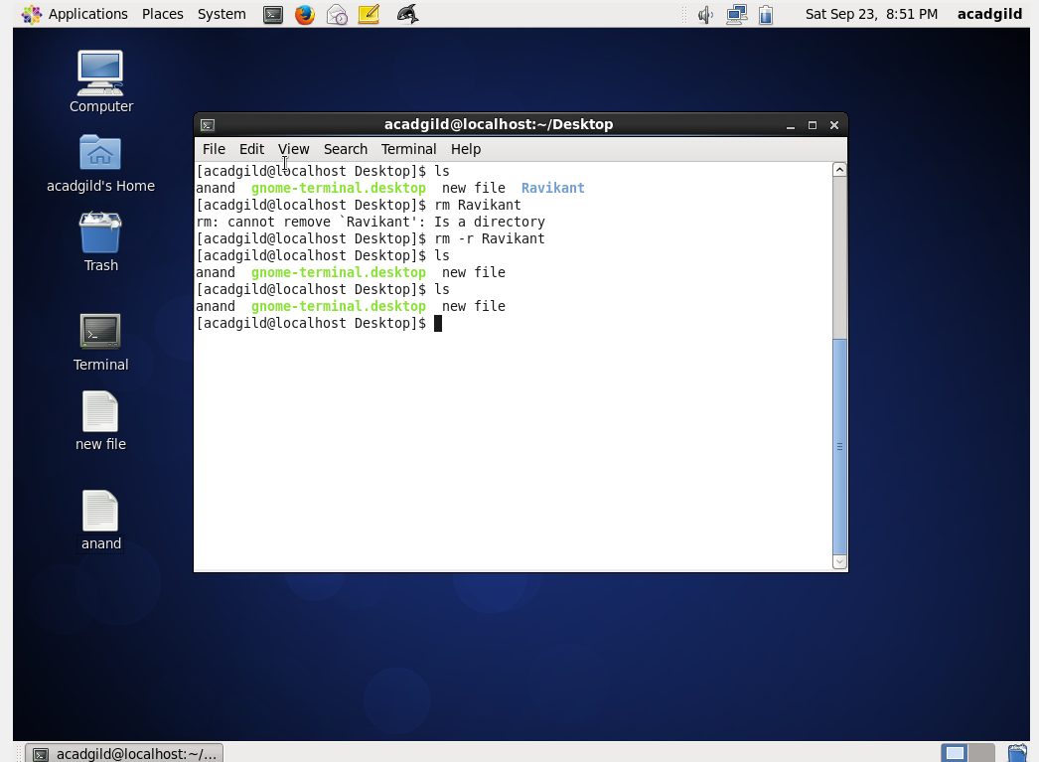

1. echo :-It display content on standard output device

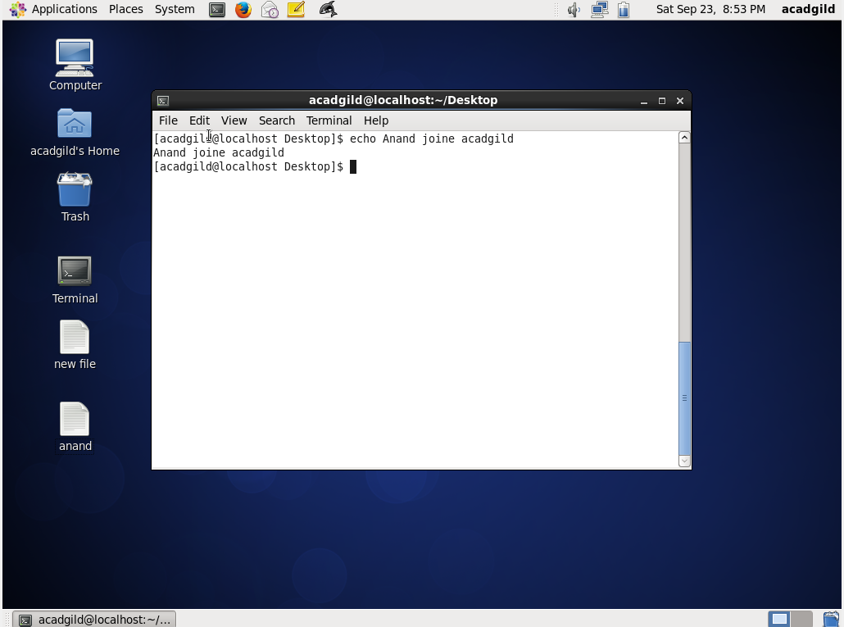

1. cat: - Display text file on screen, Create a new text file, Read text file

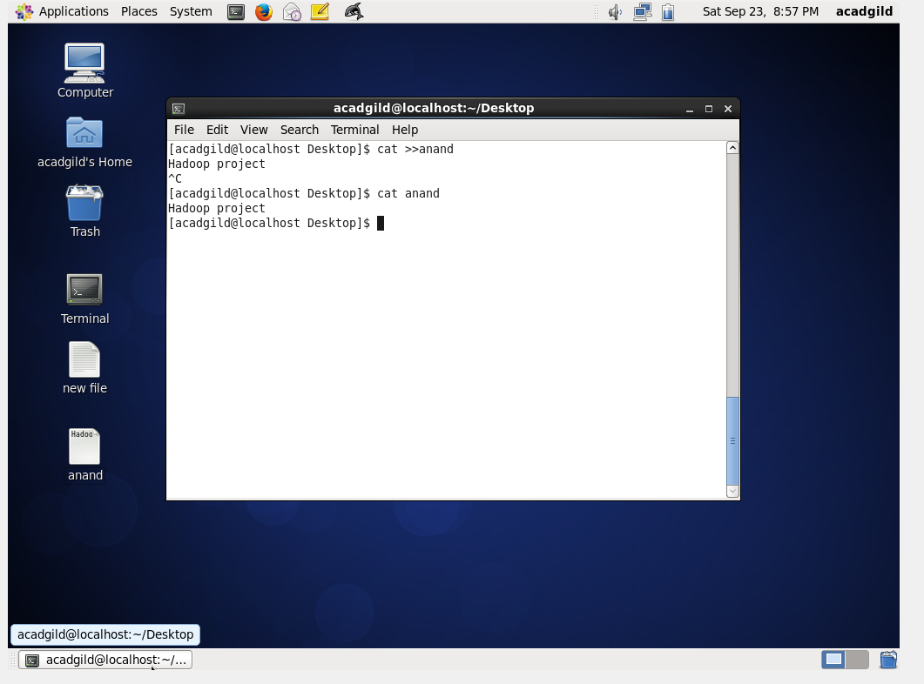

1. who: - Time of last system boot, List of users logged-in

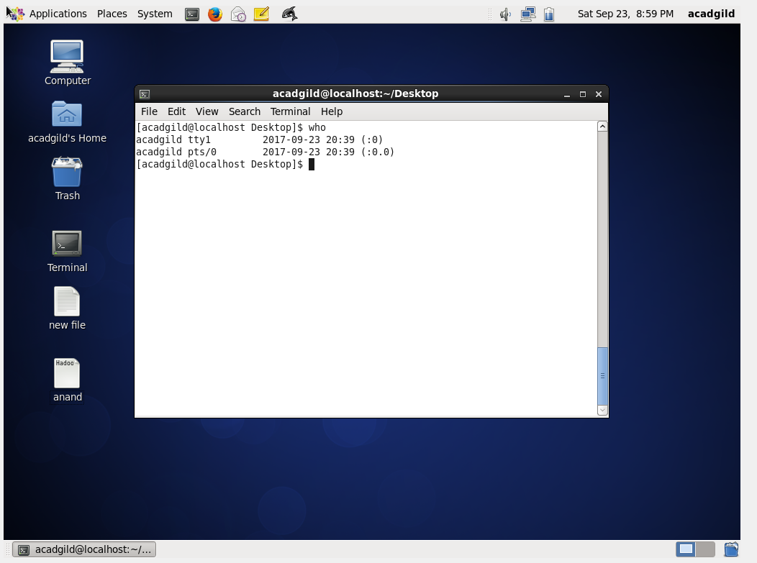

1. cd: - It is used to change directory

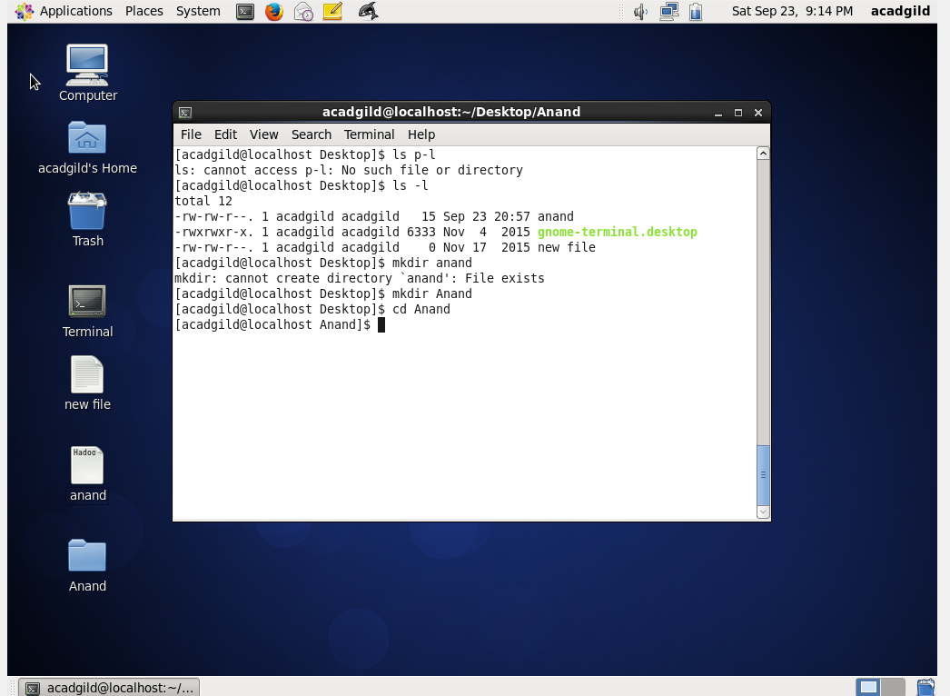

1. date: -Current system date information

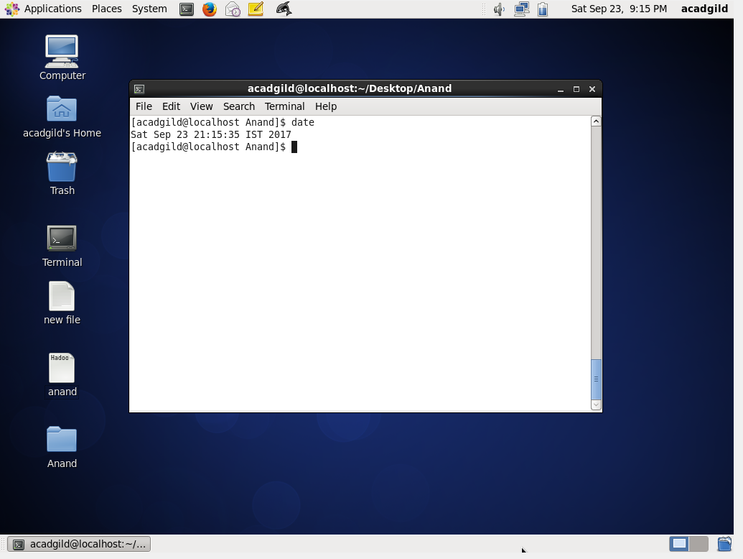

1. cal :- It show calendar details

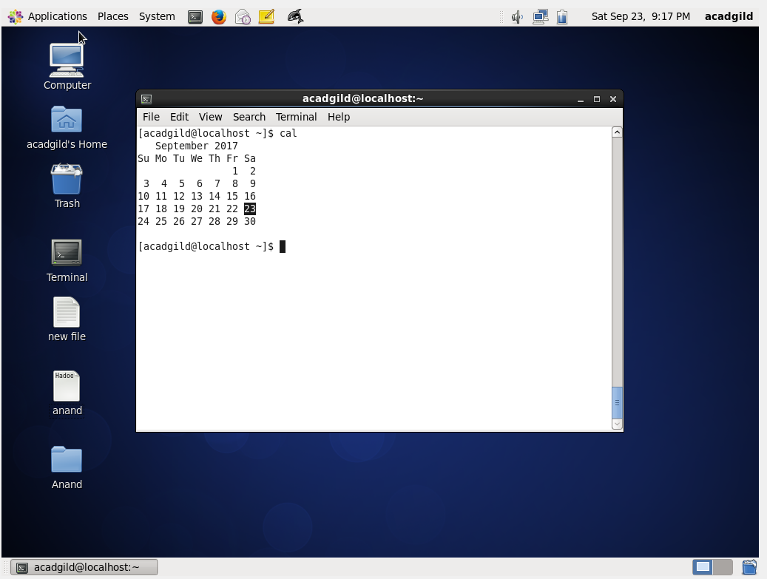

1. mv:- It is used to rename file name in folder

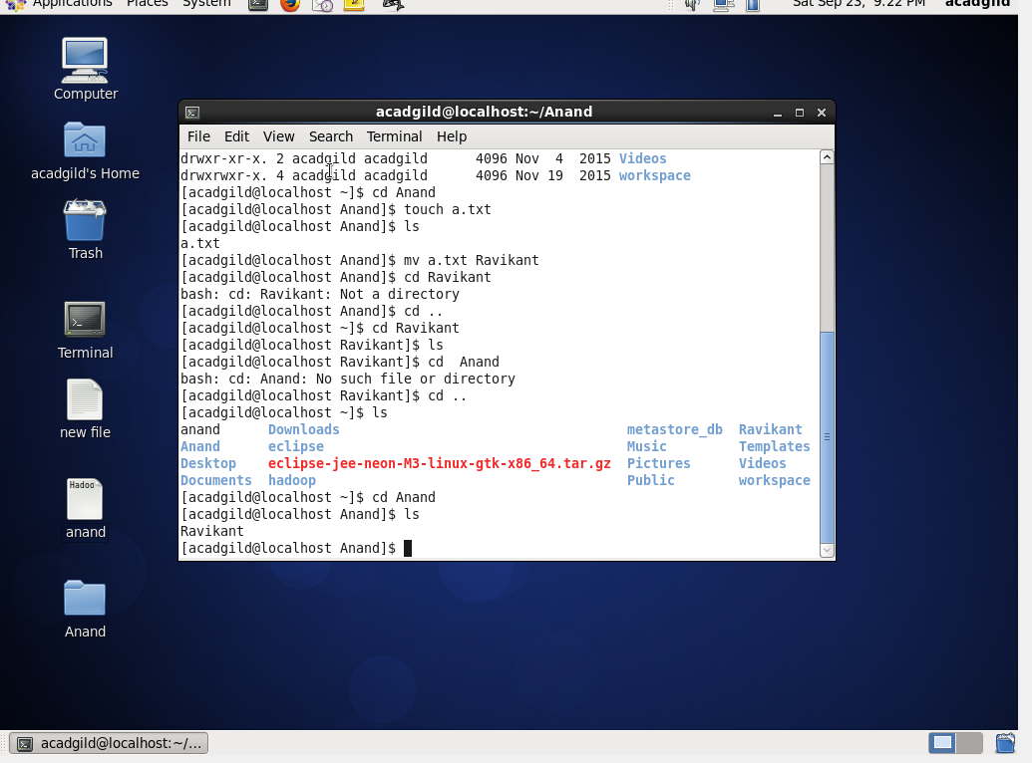

1. cp:- It used to copy file in same directory or in another directory

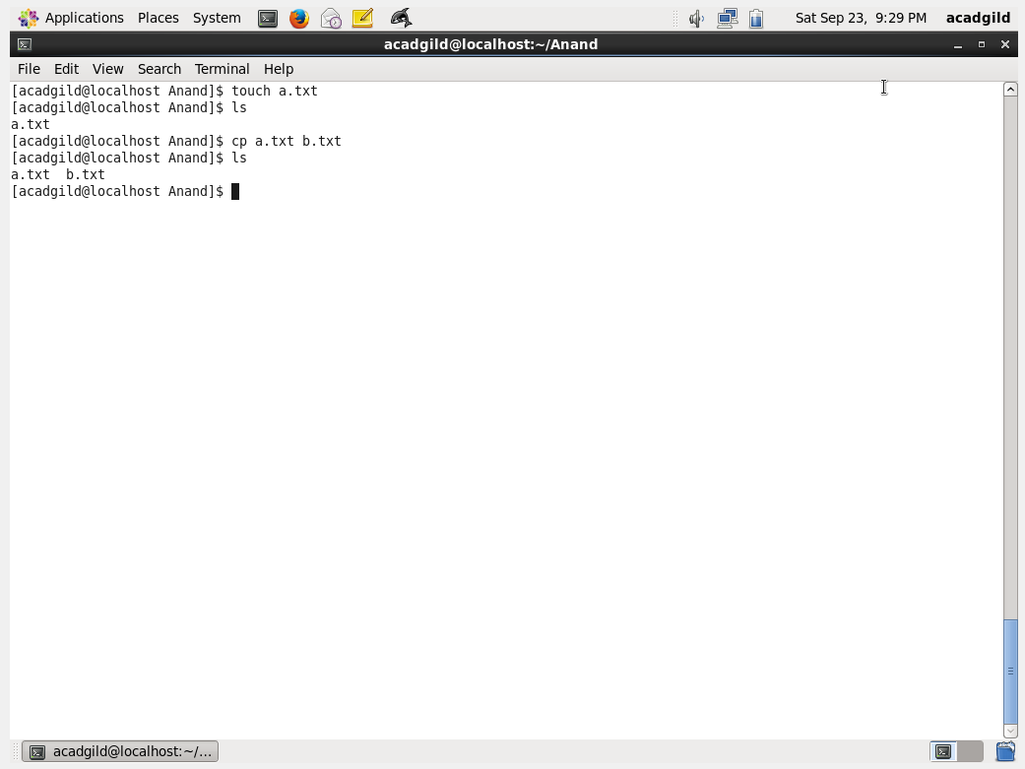

1. which:- “which” **commands** searches the path of executable in system paths set in $PATH environment variable. It locates **command** names – “ls”, “gdb”, “open” and “grep” specified as arguments to “which” **command** and displays paths of each executable where it exists in the system.

