

Session 2: HDFS

Assignment 1

**Task 1:**

*Check whether /user/acadgild directory exists or not in the HDFS.*

Command: - Hdfs dfs -ls (no acadgild directory exist)

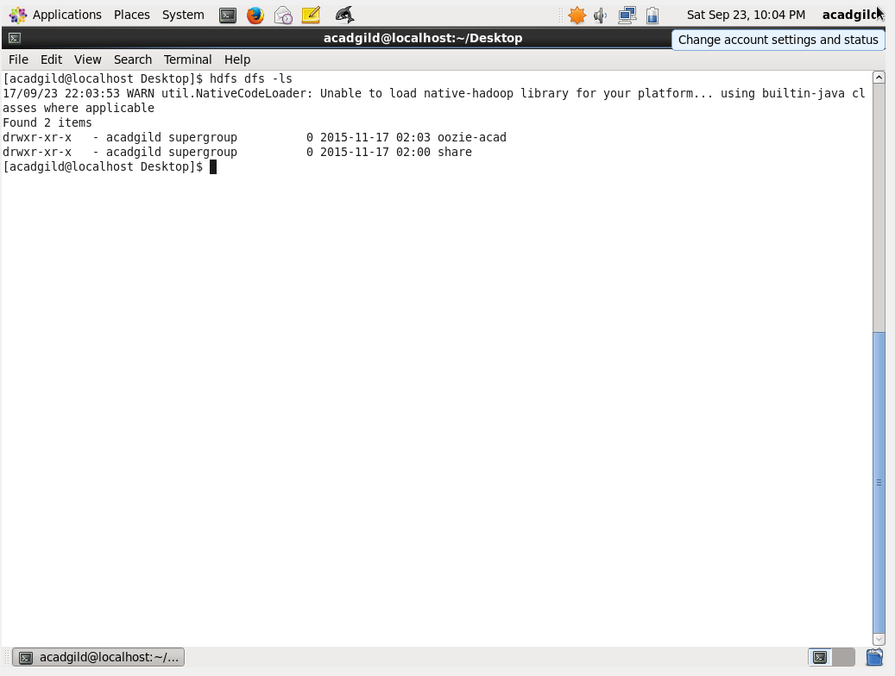

If it doesn't exist, then create this.

*Create a directory /user/acadgild/hadoop.*

Command: Hadoop fs -mkdir /user/acadgild/hadoop

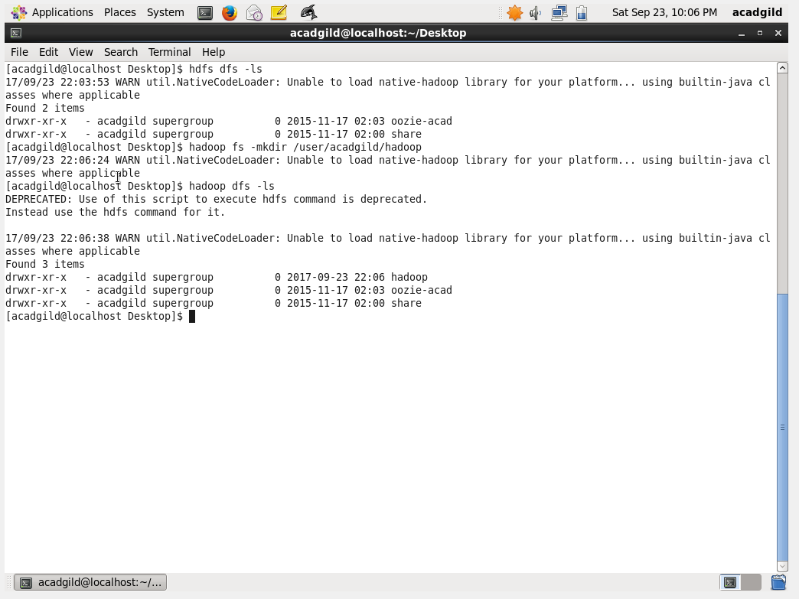

**Task 2:**

*Create a file in HDFS under directory /user/acadgild/hadoop, with name word-count.txt*.

Command: hdfs dfs touchz /user/acadgild/Hadoop/wordcount.txt

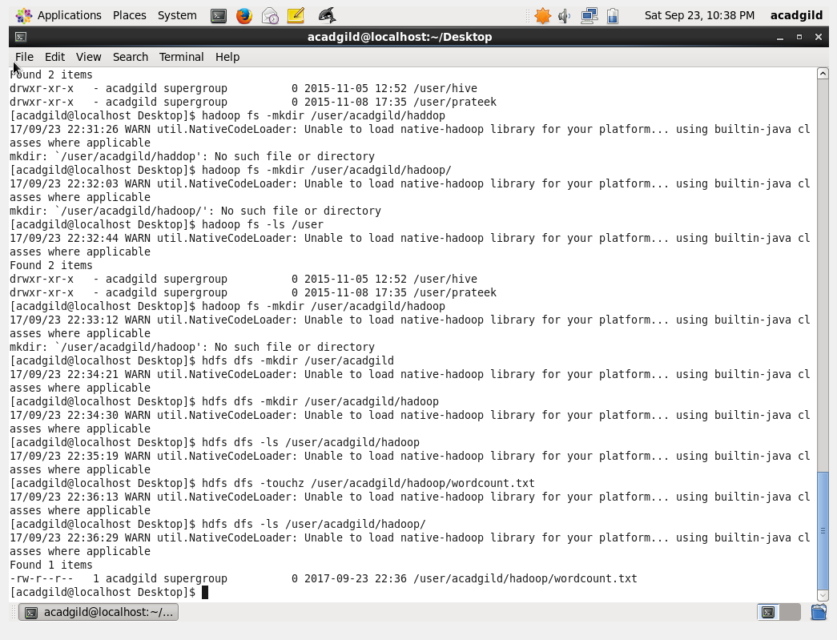

*Whatever we type on screen should get appended to the file*.

Command:-echo “Hello Wolrd” | Hadoop fs -appendToFile /user/acadgild/Hadoop/wordcount.txt

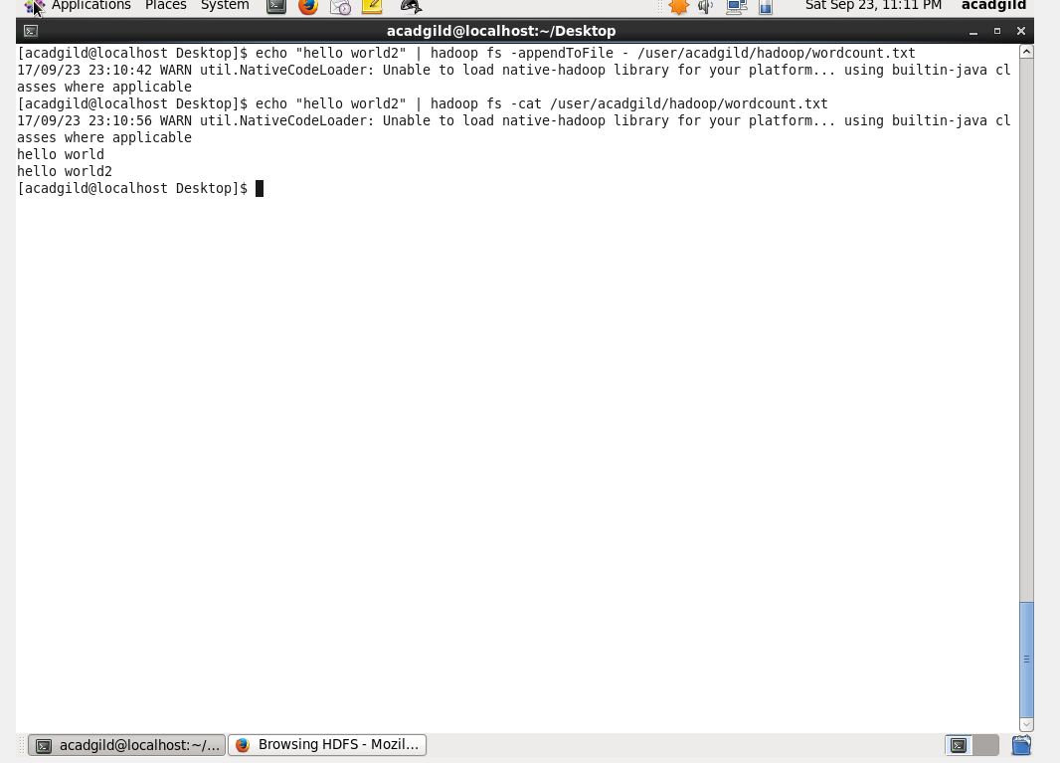

Command:- cat | Hadoop fs -appendToFile -/user/acadgild/Hadoop/wordcount.txt

