

Session 2: HDFS

Assignment 2

## Task:3

Create a file max-temp.txt in local FS.

Put some 10-15 records of date and temperature example: dd-mm-yyyy,temperature

Command:- cat >>temp.txt

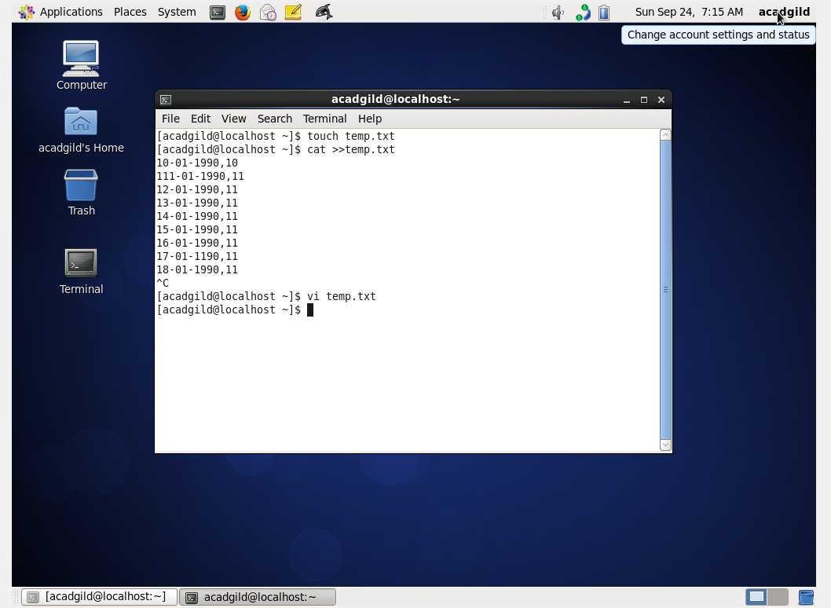

Example:

10-01-1990,10

10-02-1991,20

Move this file to HDFS at /user/acadgild/hadoop.

Command: - Hadoop fs -put temp.txt/user/acadgild/hadoop/

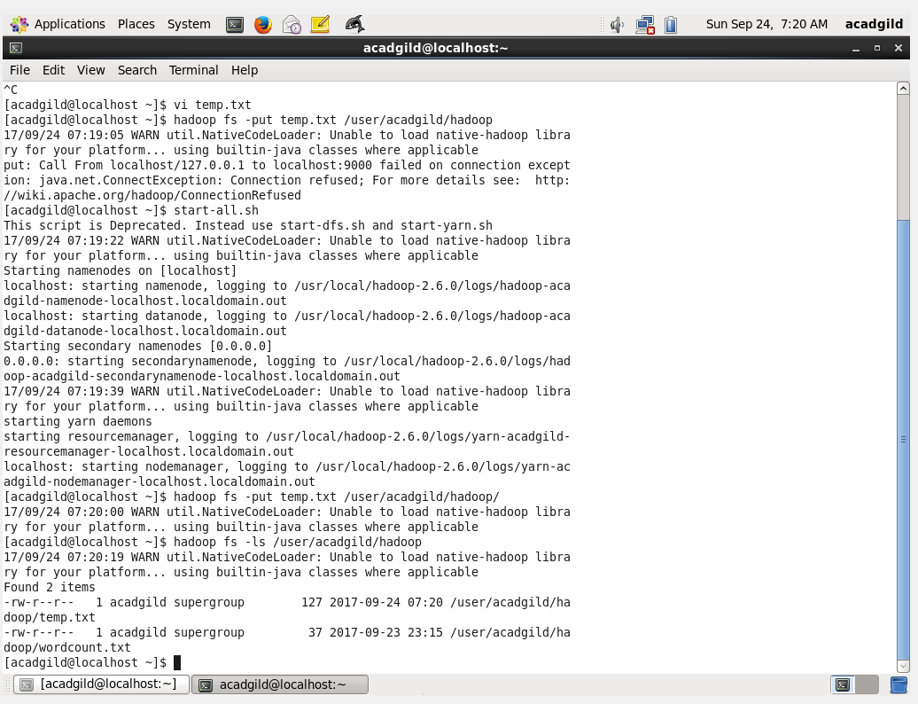

## Tasks:4

Change the permission of the file /user/acadgild/hadoop/max-temp.txt, such that only the owner and the group members have full control over the file.

Command for owner file: hdfs dfs -chown acadgild:acadgild /user/acadgild/hadoop/temp.txt

Command for group:- hdfs dfs -chgrp acadgild /user/acadgild/hadoop/temp.txt

