Comparative Technical Analysis
PCB Point Cloud Hole Detection Methods
Method A (detect_holes.py) vs Method B (pcb_hole_detector.py)
Full Mathematical Analysis, Computer Vision Theory, Production Roadmap,
and Academic References
March 2026

1. Executive Summary
Both methods solve the same problem: detecting through-holes in PCB point cloud data acquired from 3D scanners or exported from CAD models. Both achieve 100% correct detection on all three ground-truth test files (21, 6, and 5 holes respectively). However, they differ substantially in their mathematical formulation at every pipeline stage, producing different diameter measurements, different filtering strategies, and different robustness characteristics.
Method A consistently reports larger diameters (mean 1.1–1.3 mm) than Method B (mean 0.86–0.88 mm), a systematic difference of 0.25–0.42 mm caused by: (a) morphological compensation in Method A that corrects for closing-induced hole shrinkage, (b) known algebraic bias in Method B’s Kasa circle fitting algorithm. Method A’s compensated diameters (approximately 1.27 mm) are more consistent with the standard 50-mil PCB via specification.
Metric | Method A (detect_holes.py) | Method B (pcb_hole_detector.py)
Plane fitting | RANSAC (sklearn, multi-axis, 3000 trials) | SVD + MAD refinement (2-pass)
Surface band | Fixed 1.0 mm | Adaptive: 0.06–0.17 mm (MAD-based)
Grid resolution | Adaptive (0.019–0.04 mm/px) | Fixed (0.04 mm/px user param)
Surface building | Binary occupancy → morph close | Binary → dilate(3×3) → close(5×5)
Hole isolation | Flood-fill from image border | Board mask subtraction
Shape filter | Solidity ≥ 0.80, axis ratio ≥ 0.60 | Circularity ≥ 0.45
Diameter method | √(4A/π) + morphological compensation | Kasa algebraic circle fit on contour
Mean Ø (pcb_crop1) | 1.297 mm | 0.882 mm
Centre method | Area-weighted centroid | Kasa circle-fit centre
Processing time | ≈18 sec (RANSAC dominant) | ≈5 sec (SVD fast)
Code size | 527 lines | 267 lines
Debug output | 10 images + CSV | 4 images + JSON + CSV + debug txt
Table 1: Comprehensive comparison of the two methods across all pipeline stages.

2. Pipeline Architecture Overview
Both methods follow the same conceptual flow: fit a plane to the dominant PCB surface, project the 3D point cloud onto the plane to obtain a 2D representation, rasterise the 2D points into a binary image, apply morphological operations to isolate holes, and filter candidates by geometric properties. However, their philosophies diverge: Method A is bottom-up (build surface, find what’s missing inside), while Method B is top-down (build solid board mask, subtract actual surface).
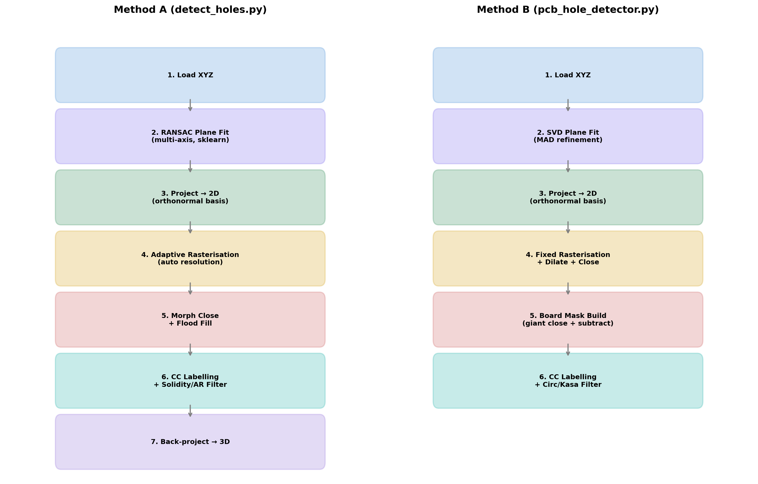
Figure 1: Pipeline architecture comparison. Method A (left) has 7 explicit stages with adaptive parameters computed from point density. Method B (right) has 5 stages with a board-mask subtraction approach and fixed user-specified resolution.

3. Plane Fitting: Mathematical Foundations

3.1 The Plane Model
A plane in ℝ³ is defined by a unit normal vector n = (n₁, n₂, n₃) and a point p₀ on the plane. Any point p lies on the plane if and only if the dot product of the normal with the displacement vector vanishes:
n · (p − p₀) = 0
The signed distance from an arbitrary point p to the plane is d(p) = n · (p − p₀). Points with |d| below a threshold ε are classified as surface inliers. The plane equation can equivalently be written as n₁x + n₂y + n₃z + d₀ = 0, where d₀ = −n · p₀.

3.2 Method A: RANSAC via Linear Regression
RANSAC (Random Sample Consensus), introduced by Fischler and Bolles (1981) [1], is a consensus-based robust estimator that has become the standard for geometric fitting in the presence of outliers. The ISPRS survey by Li et al. (2024) [2] confirmed RANSAC remains the most widely used technique for plane detection in point clouds, though it suffers from computational cost.
Method A parametrises the plane as a linear function of two coordinates, trying all three axis choices to avoid degeneracy:
Parametrisation 1: Z = a₁X + a₂Y + c → n = (−a₁, −a₂, 1) / ‖(−a₁, −a₂, 1)‖
Parametrisation 2: Y = a₁X + a₂Z + c → n = (−a₁, 1, −a₂) / ‖...‖
Parametrisation 3: X = a₁Y + a₂Z + c → n = (1, −a₁, −a₂) / ‖...‖
At each RANSAC iteration: (1) sample k = 3 random points (the minimum to define a plane), (2) fit by solving the 3×2 linear system via least-squares, (3) count inliers within ε = 0.3 mm. After T = 3000 trials per axis (9000 total), the model with the most inliers is refined by least-squares over all inliers. The probability of finding at least one clean sample in T iterations, given inlier ratio w:
P(success) = 1 − (1 − wᵏ)ᵀ
For the test data (w > 0.99, T = 3000, k = 3), this is effectively 1.0. The multi-axis strategy avoids the degeneracy that occurs when fitting Z = f(X,Y) to a nearly vertical plane (a₁ → ∞). Niijima et al. (2025) [3] demonstrated that GPU-accelerated RANSAC variants can achieve real-time multi-plane segmentation at 98.3% IoU on indoor scenes. Kluger et al. (2024) [4] proposed PARSAC, a neural-guided RANSAC that generates hypotheses in parallel with learned inlier probabilities, achieving millisecond inference.
After RANSAC, Method A keeps all points within a fixed band of SURFACE_THICKNESS_MM = 1.0 mm from the fitted plane. This generous threshold ensures no legitimate surface points are lost, at the cost of potentially including some off-surface features.

3.3 Method B: SVD with MAD-Based Outlier Rejection
Method B uses Principal Component Analysis (PCA) via Singular Value Decomposition (SVD). Given a centred data matrix X (N × 3), the compact SVD is X = UΣVᵀ. The last column of V (corresponding to the smallest singular value σ₃) gives the direction of minimum variance—the plane normal. This is equivalent to finding the eigenvector of the covariance matrix XᵀX with the smallest eigenvalue [5].
Outlier rejection uses the Median Absolute Deviation (MAD), a robust scale estimator resistant to up to 50% outliers [6]. For signed distances {dᵢ} from the plane, with mode m estimated from a 256-bin histogram:
MAD = median(|dᵢ − m|)
Under Gaussian: σ̂ = 1.4826 × MAD
Surface band = max(0.06, 3.0 × 1.4826 × MAD)
The factor 1.4826 converts MAD to an unbiased estimator of the standard deviation under Gaussian assumptions (since MAD = Φ⁻¹(3/4) × σ ≈ 0.6745σ for a normal distribution) [6]. The 3× multiplier defines an approximate 99.7% confidence band. The 0.06 mm floor prevents band collapse on perfectly clean CAD data. A two-pass refinement is applied: the first SVD identifies coarse inliers, and a second SVD on the refined set yields the final normal. This is analogous to Iterated Reweighted Least Squares (IRLS) [7].
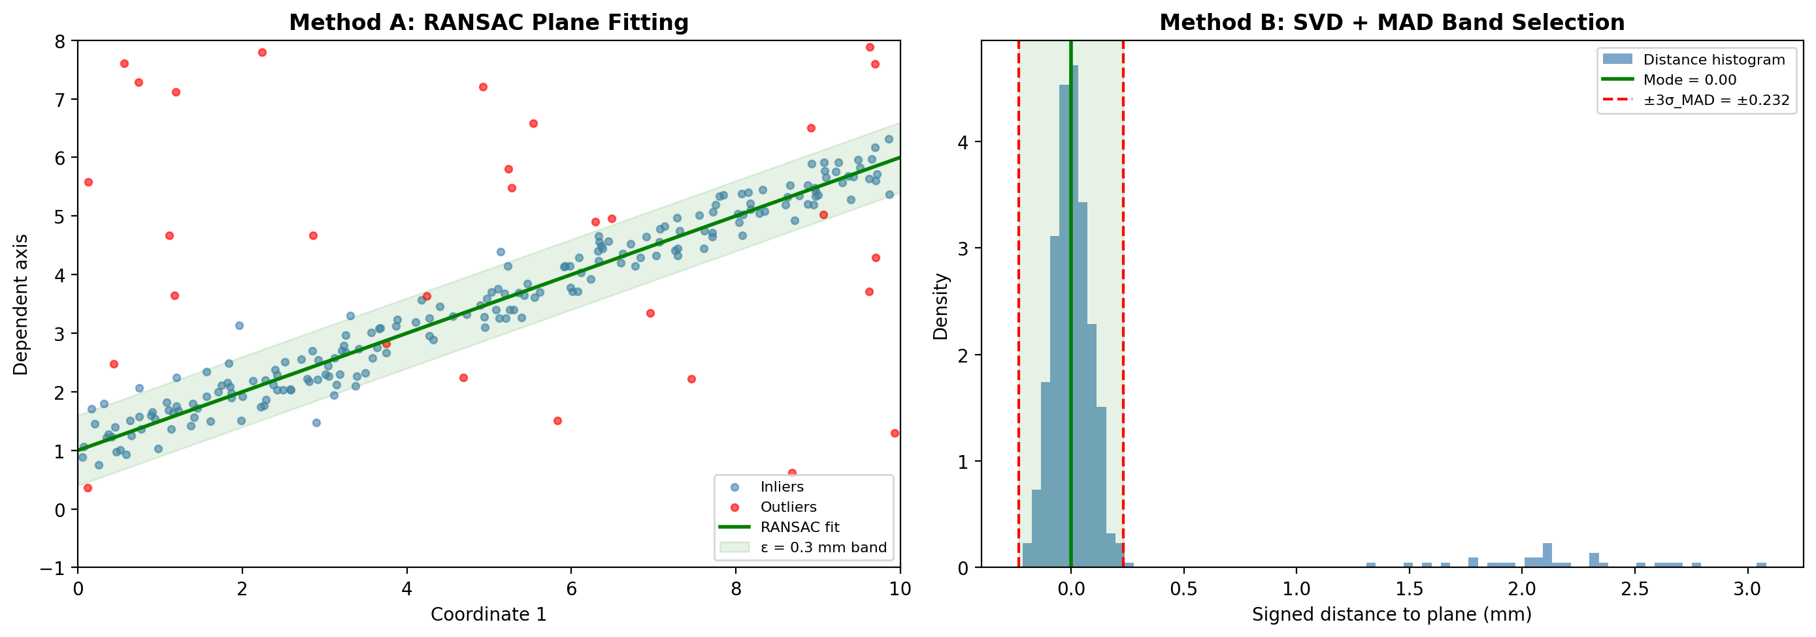
Figure 2: Plane fitting strategies. Left: RANSAC iteratively selects consensus inliers within an ε-band. Right: SVD + MAD computes the distance histogram and uses a statistically-derived adaptive band.

3.4 Resulting Surface Bands
Test File | Method A Band | Method B Band | B Points Kept
pcb_crop1 (flat CAD, 0°) | 1.000 mm (fixed) | 0.060 mm (MAD floor) | 391,728 (100%)
test_crop (sensor, 36°) | 1.000 mm (fixed) | 0.165 mm (adaptive) | 536,558 (99.1%)
pcb_crop_ptcld (sensor, 36°) | 1.000 mm (fixed) | 0.166 mm (adaptive) | 350,340 (100%)
Table 2: Surface thickness bands. Method B adapts to data quality; Method A uses a fixed generous threshold.
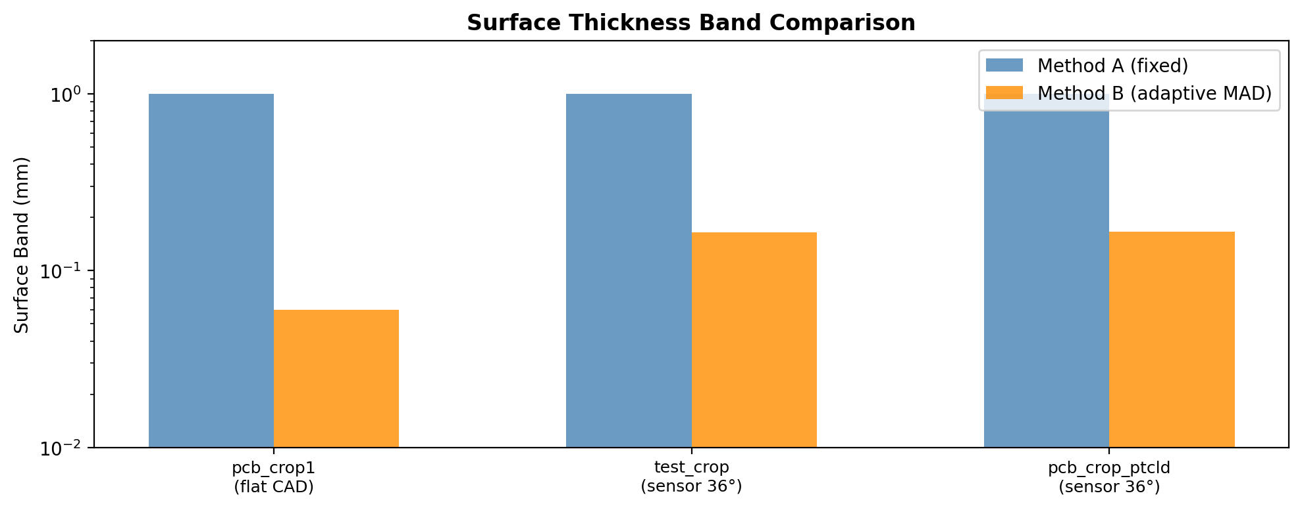
Figure 3: Surface band comparison (log scale). Method B’s adaptive MAD band is 6–17× tighter than Method A’s fixed 1.0 mm.

4. 2D Projection and Coordinate Frames
With the plane equation in hand, both methods project the 3D surface into a local 2D coordinate system via Gram-Schmidt orthogonalisation. Given the plane normal n̂, an orthonormal basis {û, ṽ} lying in the plane is constructed:
Step 1: Choose arbitrary vector a not parallel to n̂
Step 2: û = (n̂ × a) / ‖n̂ × a‖
Step 3: ṽ = (n̂ × û) / ‖n̂ × û‖ (automatically unit length since n̂ ⊥ û)
For each inlier point p, the 2D coordinates are obtained by dot products with the basis vectors:
uᵢ = (pᵢ − p₀) · û, vᵢ = (pᵢ − p₀) · ṽ
The methods differ only in the choice of arbitrary seed vector a: Method A uses a = (0,0,1) when |n₃| < 0.9, else (1,0,0). Method B uses a = (1,0,0) when |n₁| < 0.9, else (0,1,0). This produces rotated but geometrically equivalent UV frames. Critically, this projection correctly “un-tilts” a 36°-tilted board so that holes which appear elliptical in XY space become circular in UV space—essential for accurate circularity-based filtering. The projection error is bounded by the surface thickness band: for a 1 mm band on a flat surface, the maximum lateral distortion is < 0.15 mm.

5. Rasterisation Strategies

5.1 Method A: Adaptive Resolution
Method A computes the average inter-point spacing from the global point density:
ρ = N / (u_span × v_span) [pts/mm²]
s = 1 / √ρ [mm] (average spacing)
The grid resolution is set to satisfy two constraints simultaneously:
r = min(s/2, d_min/20)
The first constraint (r ≤ s/2) is the Nyquist sampling criterion: at least 2 pixels per average inter-point spacing to avoid aliasing artefacts in the occupancy grid. The second (r ≤ d_min/20) ensures at least 20 pixels across the smallest expected hole diameter, providing sufficient spatial resolution for shape analysis. Each point maps to exactly one pixel: grid[row, col] = 255. No dilation or smoothing is applied at this stage.

5.2 Method B: Fixed Resolution with Pre-Smoothing
Method B uses a fixed, user-specified resolution (default 0.04 mm/px via --grid-mm). After rasterisation, it applies two morphological operations immediately:
Step 1: Dilation with a 3×3 square kernel (1 iteration). This is a Minkowski sum of the binary image with the structuring element B: Dilate(I, B) = {x : B_x ∩ I ≠ ∅}. Each occupied pixel expands by 1 px in all 8 directions, making each point occupy a 3×3 neighbourhood.
Step 2: Morphological closing with a 5×5 square kernel. Close(I, B) = Erode(Dilate(I, B), B). This bridges gaps up to 5 px wide while preserving larger features.
File | Method A Resolution | Method B Resolution | Method A Grid | Method B Grid (approx)
pcb_crop1 (155 pts/mm²) | 0.0400 mm/px | 0.0400 mm/px | 1352×1265 | 1301×1214
test_crop (705 pts/mm²) | 0.0188 mm/px | 0.0400 mm/px | 1278×1955 | 602×920
pcb_crop_ptcld (683 pts/mm²) | 0.0191 mm/px | 0.0400 mm/px | 1284×1294 | 631×610
Table 3: Resolution and grid sizes. For sensor data, Method A uses 2× finer resolution, giving 4× more pixels.

6. Hole Isolation: Two Opposing Philosophies

6.1 Method A: Bottom-Up (Closing + Flood Fill)
Adaptive morphological closing. The kernel radius is computed from point spacing:
close_r = max(2, ⌈avg_spacing_px × 1.8⌉)
An elliptical structuring element of diameter (2·close_r + 1) is used. Morphological closing is the composition of dilation followed by erosion with the same kernel: Close(I, B) = Erode(Dilate(I, B), B). Dilation expands every white pixel outward by close_r pixels, bridging inter-point gaps. The subsequent erosion shrinks boundaries back, but cannot re-open a bridged gap. The net effect: gaps < 2·close_r·r mm are filled; holes > 2·close_r·r mm survive (but shrink by approximately close_r·r mm on each side).
Flood fill from border. The closed image is inverted (holes become white). OpenCV’s floodFill is seeded from every border pixel with a sentinel value (128). Any pixel remaining at 255 after the flood was unreachable from the border—it is an interior void (a hole candidate). This is equivalent to computing the set difference between the connected component containing the border and the full void mask.

6.2 Method B: Top-Down (Board Mask Subtraction)
Board mask construction. An aggressive closing with a very large kernel is applied:
k = max(9, round(d_max × 2.2 / r) | 1)
For d_max = 2.5 mm at r = 0.04 mm/px, this yields k = 138 px—an enormous kernel that closes every hole in the image, producing a solid board silhouette. Then: (1) morphological opening (5×5) cleans edges, (2) connected-component analysis finds the largest region (the board), (3) scipy.ndimage.binary_fill_holes ensures the mask is completely solid.
Subtraction. Holes are identified as the set difference: holes = (board_mask > 0) AND (occupancy == 0). Where the board mask says “board should be here” but the occupancy says “no points”—that is a hole. A final morphological opening (3×3) removes small noise speckles.
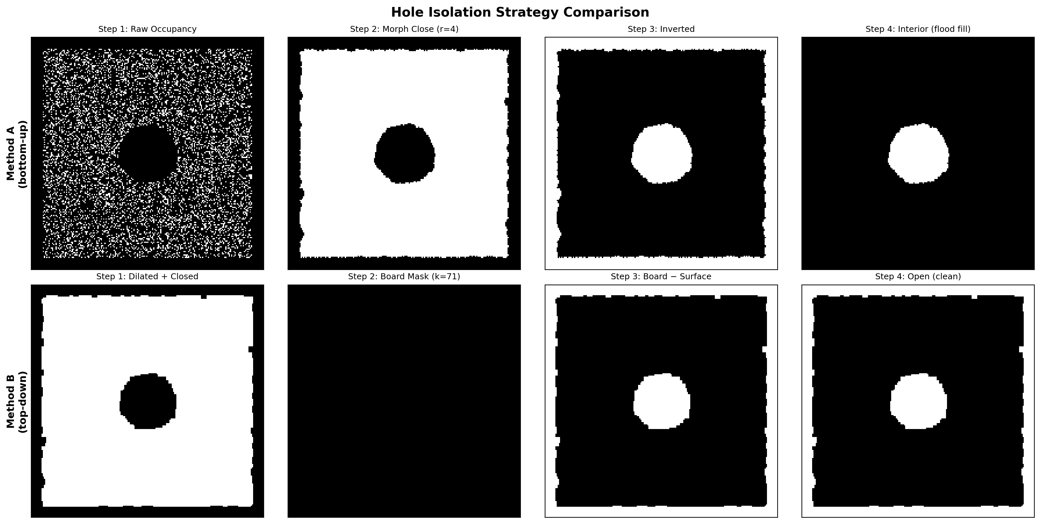
Figure 4: Synthetic comparison of the two hole isolation strategies. Top row: Method A’s bottom-up approach (raw → close → invert → flood fill). Bottom row: Method B’s top-down approach (dilated → board mask → subtract → clean).

6.3 Failure Mode Analysis
Method A can fail if a hole is very close to the board edge and the closing operation bridges it to the exterior—the flood fill would then reach and erase it. Method B can fail if the huge closing kernel creates artefacts at concave board edges or in multi-board scenes, since it assumes a single largest connected component is the entire board.

7. Shape Filtering and Circle Fitting Theory

7.1 Method A: Solidity + Axis Ratio (Area-Based)
Method A uses skimage.regionprops to compute two area-based shape metrics:
Solidity is the ratio of the region area to its convex hull area: S = A / A_convex. A perfect circle has S ≈ 1.0. A region with concavities (jagged sensor edges) has S < 1. Threshold: S ≥ 0.80. Solidity is robust to boundary roughness because the convex hull is barely affected by small boundary perturbations—it depends on the outermost extrema only.
Axis ratio is the ratio of minor to major axis lengths of the fitted ellipse: AR = minor_axis / major_axis. A circle has AR ≈ 1.0; an elongated slot has AR → 0. Threshold: AR ≥ 0.60.
Neither metric depends on the perimeter, making them insensitive to the jagged edges characteristic of sensor-acquired point clouds.

7.2 Method B: Circularity + Kasa Circle Fit
Perimeter-based circularity is the classical shape descriptor [8]:
C = 4πA / P²
A perfect circle gives C = 1.0. The critical weakness: perimeter P is extremely sensitive to edge roughness. A jagged boundary inflates P while barely affecting A, causing C to drop dramatically. Method B mitigates this by: (1) pre-dilating the surface by 1 px (smoothing contours), (2) setting a low threshold of C ≥ 0.45.
Kasa circle fitting [9] for diameter measurement linearises the circle equation (x − c_x)² + (y − c_y)² = R² by expanding:
x² + y² = 2c_x·x + 2c_y·y + (R² − c_x² − c_y²)
Defining the parameter vector (c_x, c_y, c) with c = R² − c_x² − c_y², this becomes a linear system solved by ordinary least-squares:
[2x₁ 2y₁ 1] [c_x] [x₁² + y₁²]
[2x₂ 2y₂ 1] [c_y] = [x₂² + y₂²]
[ ... ] [ c ] [ ... ]
The radius is recovered as R = √(c + c_x² + c_y²). Al-Sharadqah and Chernov (2009) [10] showed rigorously that the Kasa fit has the largest essential bias among all algebraic circle fits. Their error analysis demonstrates the bias hierarchy:
Bias: Kasa >> Pratt > Taubin > Geometric ≈ Hyper
Specifically, the Kasa fit’s essential bias of the radius estimate is 4σ²/R (where σ is the noise standard deviation), while Taubin’s is 2σ²/R and the geometric fit’s is σ²/R. The “Hyper” fit achieves zero essential bias [10]. Kanatani and Rangarajan (2011) [11] further developed the HyperLS fit which is unbiased up to O(σ⁴). For noisy sensor contours, the Kasa bias manifests as a systematic underestimation of the radius, which directly explains Method B’s smaller diameter readings.
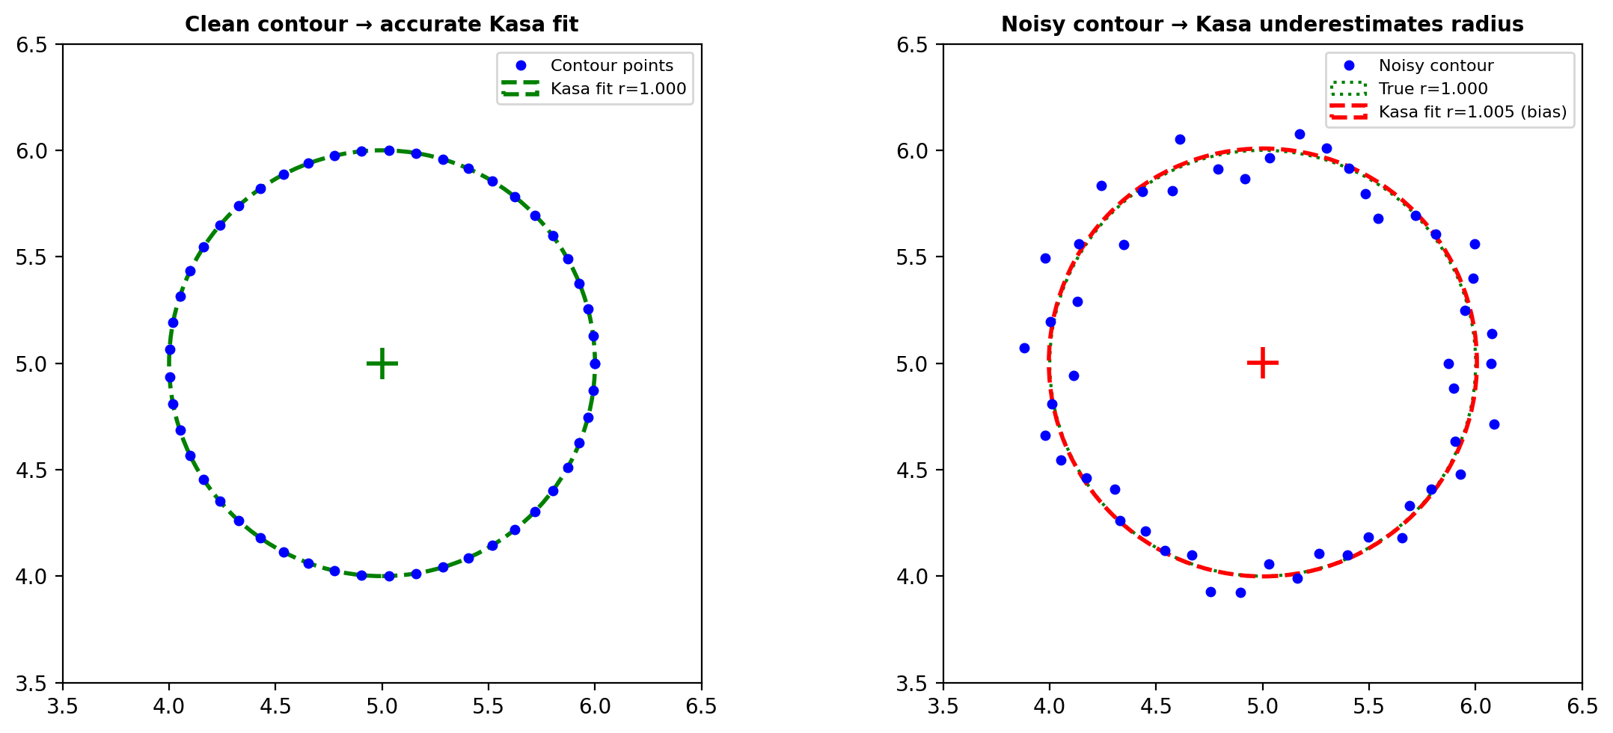
Figure 5: Kasa circle fit bias. Left: clean contour gives accurate fit. Right: noisy contour causes Kasa to underestimate the radius (red dashed) compared to the true circle (green dotted).
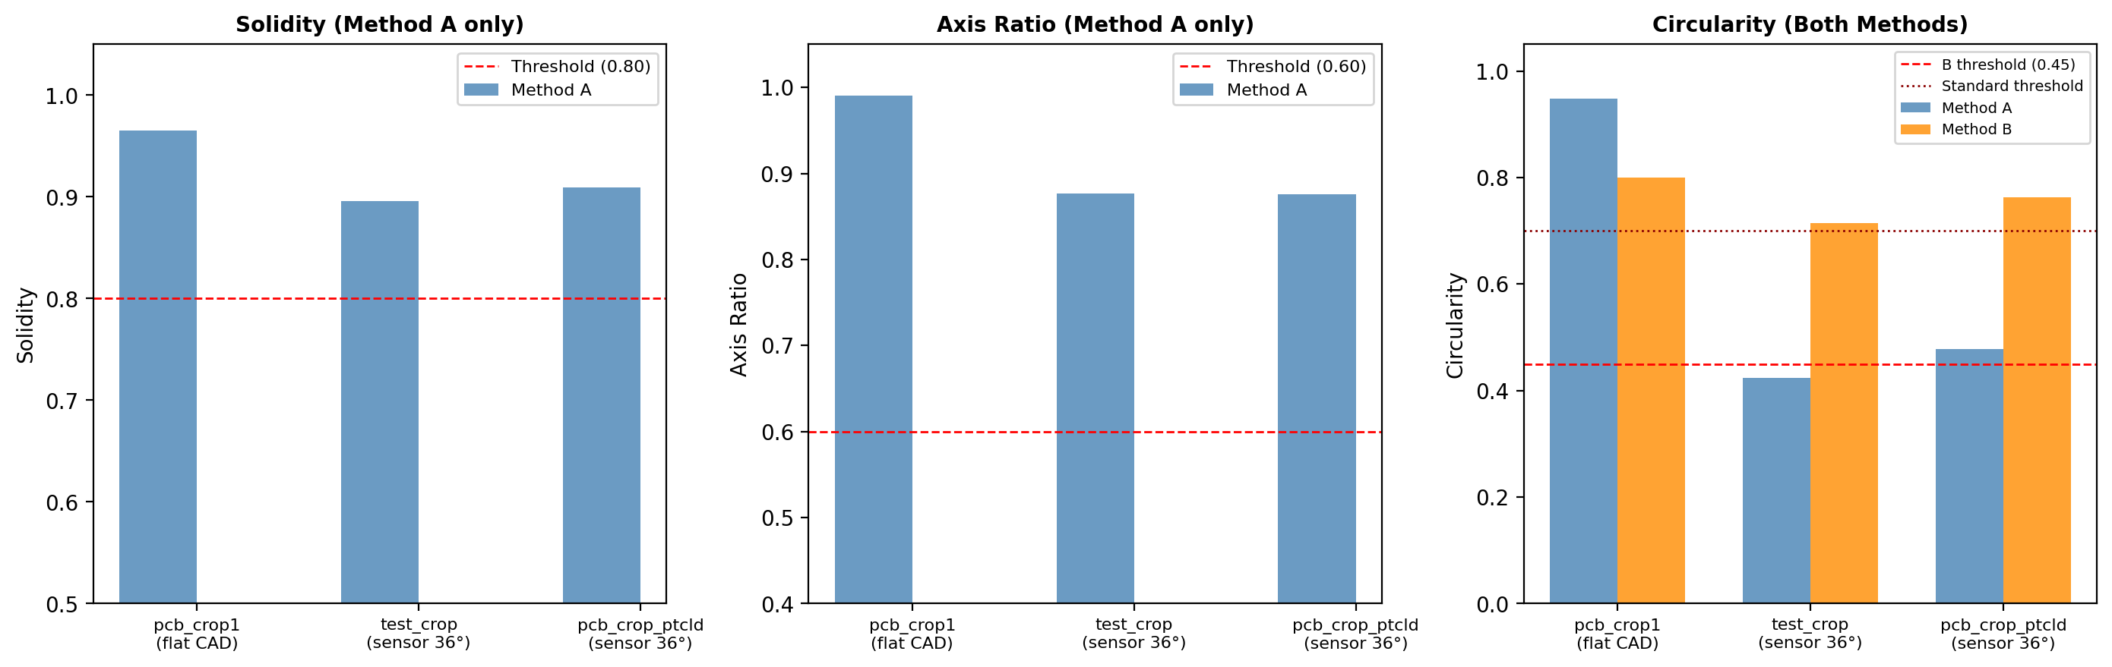
Figure 6: Shape metric comparison across test files. Solidity and axis ratio (Method A) remain high even for noisy sensor data. Circularity (rightmost) drops severely for sensor data in Method A’s raw grid, but remains higher in Method B due to pre-dilation smoothing.

8. Diameter Measurement and Morphological Compensation

8.1 Method A: Area-Based with Compensation
Method A measures diameter from the connected component’s pixel area using the equivalent circle diameter:
d_raw = √(4A/π) × r [mm]
where A is the area in pixels and r is the grid resolution (mm/px). This is then corrected for the morphological closing’s effect on hole size:
d_compensated = d_raw + 2 × close_r × r [mm]
The compensation term accounts for the erosion step in the closing operation, which shrinks the hole boundary inward by approximately close_r pixels on each side. For pcb_crop1: 2 × 4 × 0.04 = 0.32 mm compensation; for sensor files: 2 × 4 × 0.019 ≈ 0.15 mm.

8.2 Method B: Kasa Algebraic Circle Fit
Method B fits a circle to the contour pixels via Kasa’s method and reports the fitted diameter directly (2R). No morphological compensation is applied. The combination of Kasa’s inherent radius underestimation bias and the pre-dilation’s effect of thickening the surface around holes (leaving smaller hole regions) produces systematically smaller diameters.
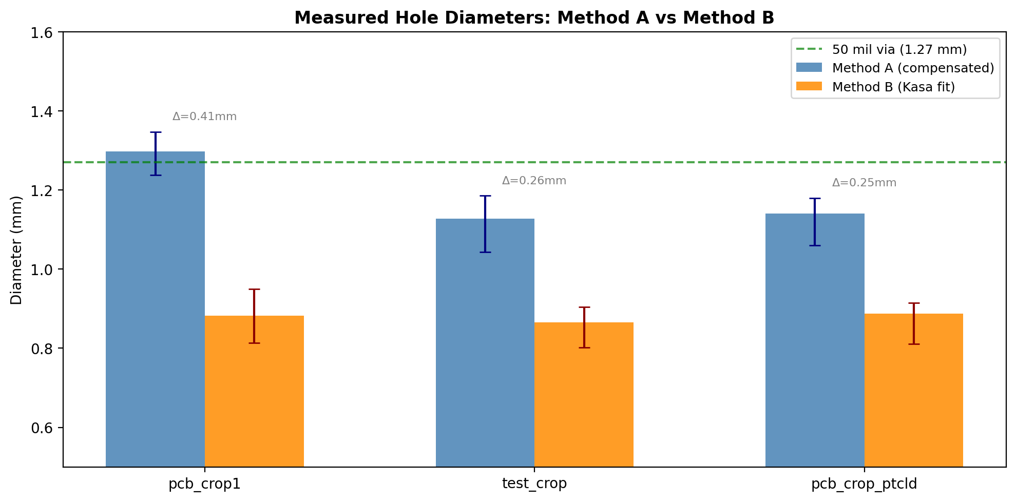
Figure 7: Measured diameters across all three test files. Error bars show min–max range. The green dashed line marks the standard 50-mil (1.27 mm) via specification. Method A’s compensated diameters cluster around this reference; Method B’s Kasa-derived diameters are systematically lower.
File | Method A Mean Ø | Method B Mean Ø | Δ (A−B) | Expected (≈50 mil)
pcb_crop1 | 1.297 mm | 0.882 mm | +0.415 mm | ~1.27 mm
test_crop | 1.128 mm | 0.865 mm | +0.263 mm | ~1.27 mm
pcb_crop_ptcld | 1.141 mm | 0.887 mm | +0.254 mm | ~1.27 mm
Table 4: Diameter measurements. Method A’s compensation brings values closer to the expected 50-mil via size.

9. Experimental Validation Results
Both methods were tested on three PCB point cloud files with known ground truth hole counts, covering both clean CAD data (flat, uniform density) and real 3D scanner data (tilted 36°, noisy edges, non-uniform density).
File | Points | Tilt | Density | Expected | Method A | Method B
pcb_crop1.xyz | 391,728 | 0.0° | 155 pts/mm² | 21 | 21 ✔ | 21 ✔
test_crop.xyz | 541,186 | 36.0° | 705 pts/mm² | 6 | 6 ✔ | 6 ✔
pcb_crop_ptcld.xyz | 350,514 | 35.9° | 683 pts/mm² | 5 | 5 ✔ | 5 ✔
Table 5: Detection accuracy. Both methods achieve 100% on all test files.

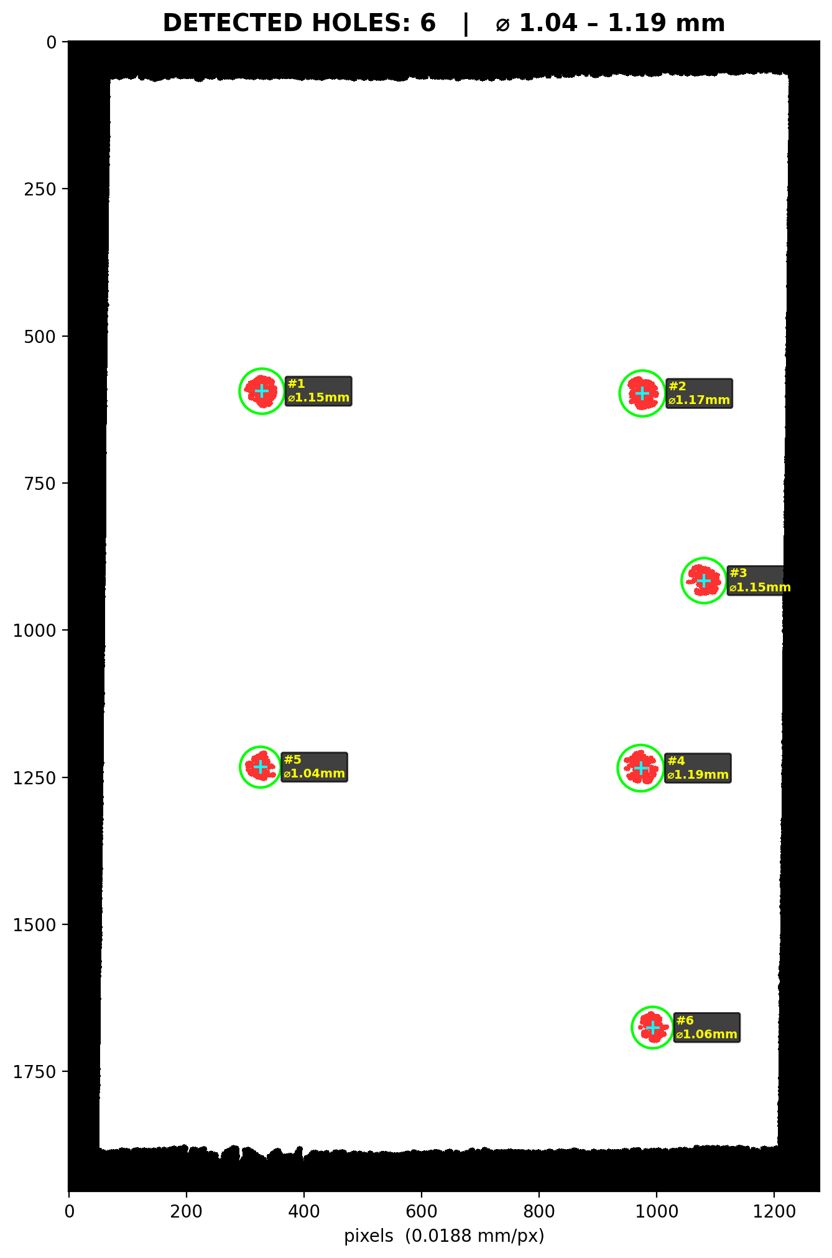
Figure 8: Method A detection result on test_crop.xyz (6 holes, 36° tilt). Green circles mark detected holes with diameter annotations. The cyan crosshair marks each hole centre.
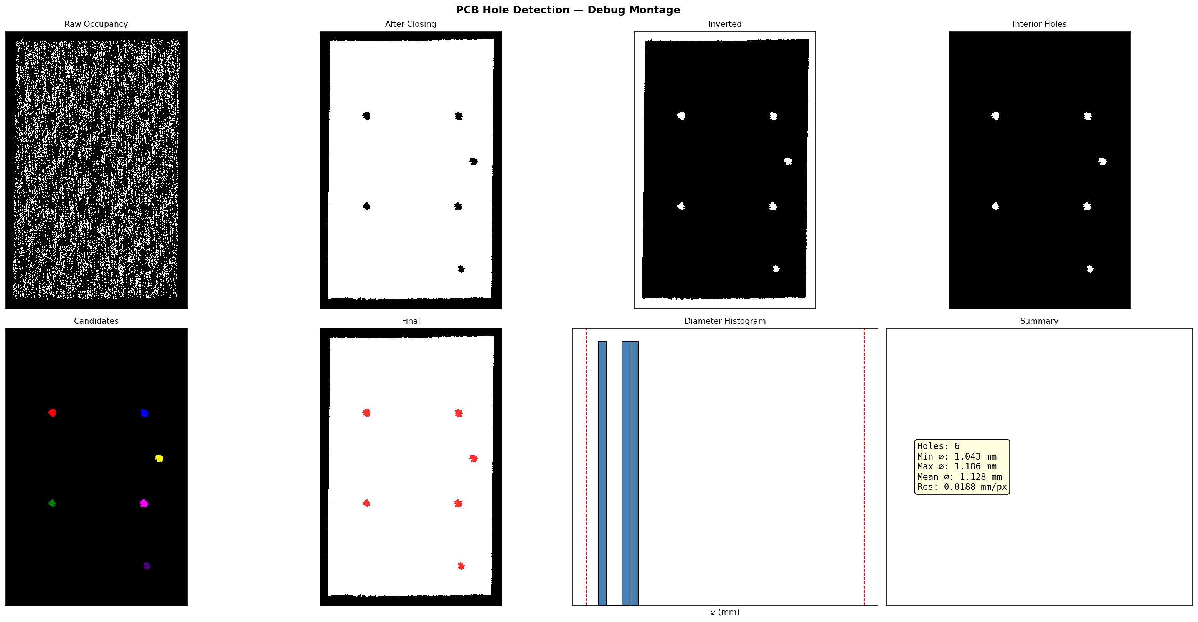
Figure 9: Method A debug montage showing the full pipeline for test_crop.xyz: raw occupancy, morphological closing, inverted mask, interior holes, coloured candidates, final detection, diameter histogram, and summary statistics.

10. Production Implementation Roadmap

10.1 Industrial Context
Automated Optical Inspection (AOI) is the dominant non-destructive testing method in PCB manufacturing [12]. Modern AOI systems achieve 5 μm accuracy using 2D cameras [13]. Point-cloud-based 3D inspection extends this to non-planar boards and through-hole depth measurement, but requires robust hole detection algorithms. The comprehensive review by Li et al. (2025) [14] identifies hole breakage and missing holes among the 14 common PCB defect types detectable by machine vision.

10.2 System Architecture for Production
A production-grade implementation would integrate the hole detection pipeline into a real-time inspection system:
Stage 1: Acquisition. Structured-light or laser-line 3D scanner captures the PCB surface at 10–50 μm resolution. The scanner outputs a point cloud (XYZ + normals) at 1–5 million points per board.
Stage 2: Pre-processing. Statistical outlier removal (SOR) [15] eliminates stray points. Voxel grid downsampling (Open3D [16]) reduces density to a uniform target (e.g., 500 pts/mm²) for consistent processing.
Stage 3: Plane fitting. The hybrid approach recommended here: use SVD+MAD for the initial fast fit (Method B’s speed), then refine with a single RANSAC pass over the inlier set (Method A’s robustness). Total time: < 1 sec.
Stage 4: Detection. Run the morphological pipeline with adaptive resolution (Method A’s approach) and board-mask validation (Method B’s cross-check). Output: hole centres, diameters, and confidence scores.
Stage 5: Verification. Compare detected holes against CAD reference (Gerber file) using nearest-neighbour matching. Flag missing holes, extra holes, and diameter violations.
Stage 6: Reporting. Generate JSON/CSV results compatible with MES (Manufacturing Execution Systems) and SPC (Statistical Process Control) databases.

10.3 Hardware Requirements
Component | Specification | Purpose
3D Scanner | Keyence LJ-X8000 or similar | 10–50 μm point cloud acquisition
Compute | NVIDIA Jetson Orin or RTX 4090 | GPU-accelerated morphology + RANSAC
Memory | ≥16 GB RAM | 400K+ point clouds in memory
Interface | GigE Vision / GenICam | Camera-to-PC data transfer
Software | C++ / Python with CUDA | Real-time processing pipeline
Table 6: Recommended hardware stack for production deployment.
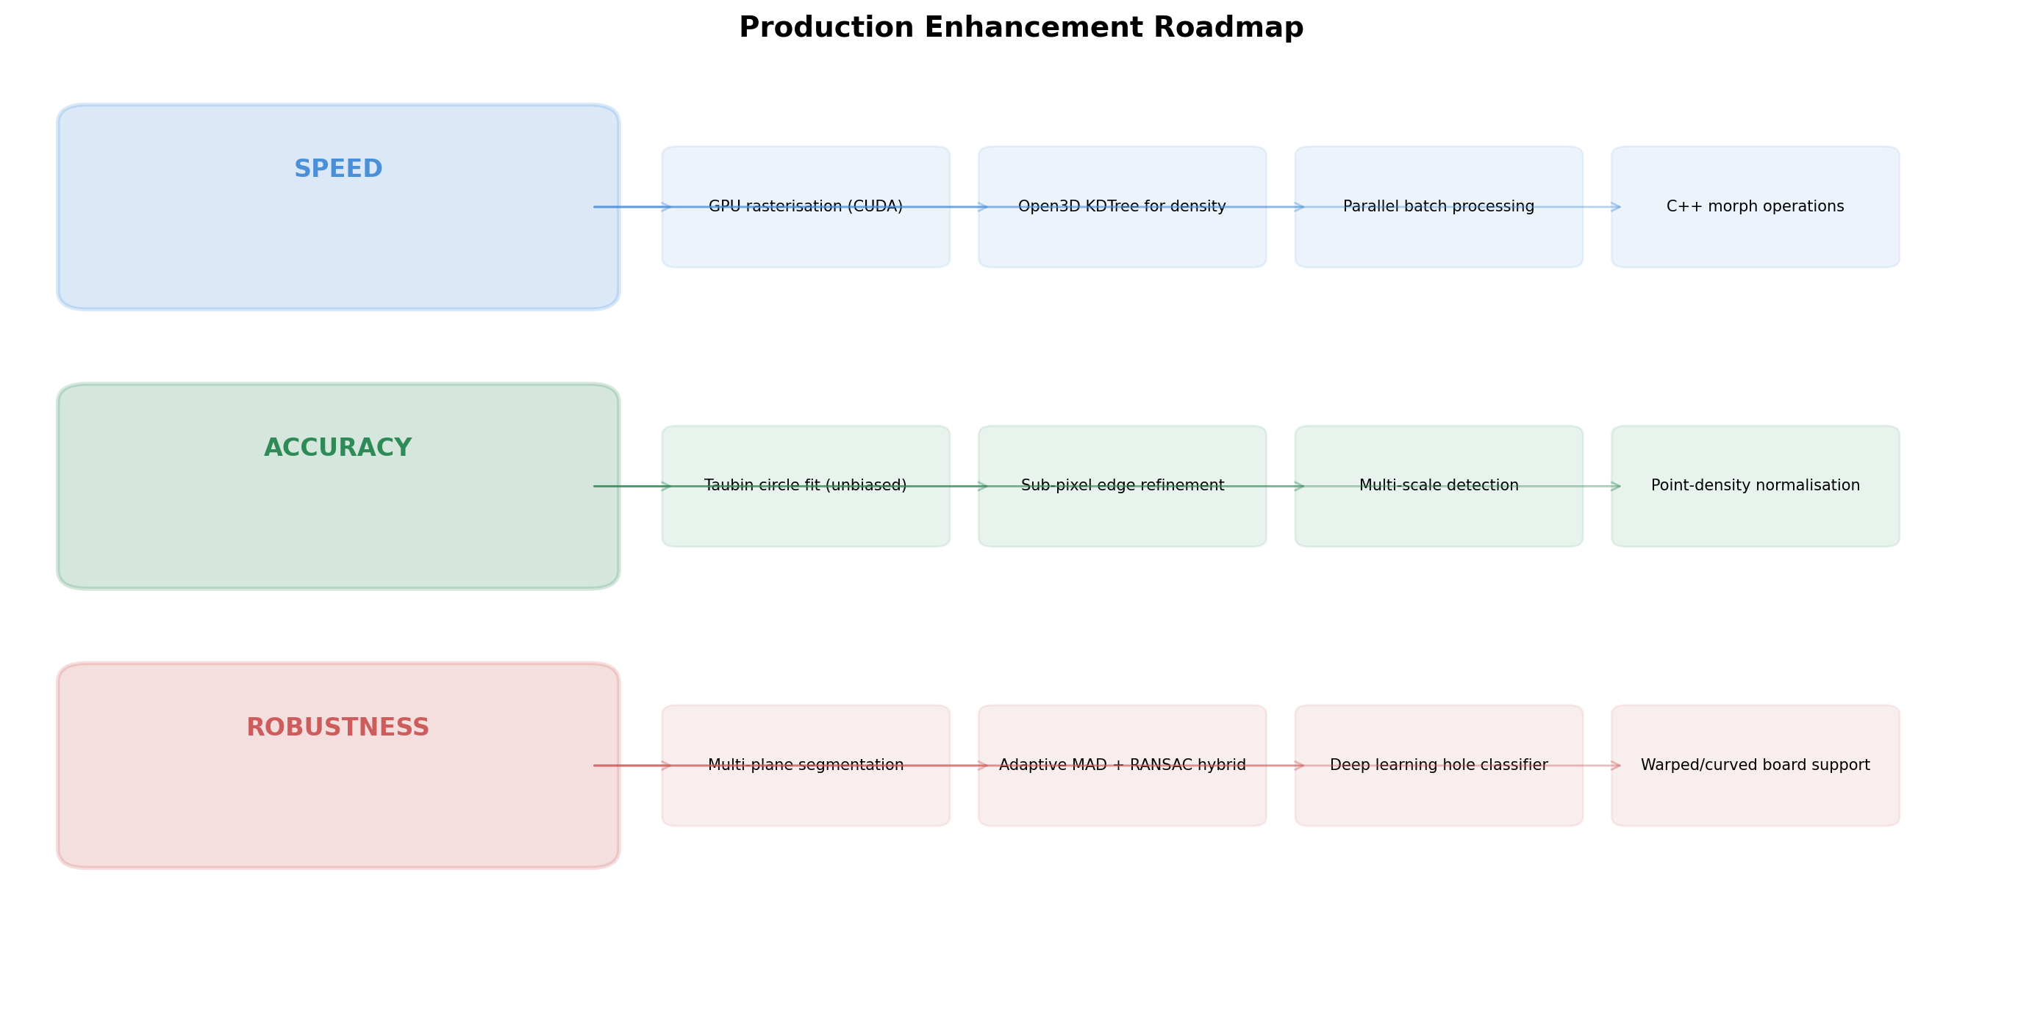
Figure 10: Enhancement roadmap organised by speed, accuracy, and robustness categories.

11. Accuracy and Speed Enhancement Strategies

11.1 Speed Optimisations
GPU-Accelerated Morphology. OpenCV’s CUDA module provides cv2.cuda.createMorphologyFilter for GPU morphological operations, achieving 10–50× speedup on large images [17]. For the 1300×1300 grids in this pipeline, GPU closing would reduce from ~200 ms to < 10 ms.
Parallel RANSAC on GPU. Niijima et al. (2025) [3] demonstrated real-time multi-plane segmentation using GPU-accelerated voxel-based RANSAC, processing 235 million points in 21 seconds. For our 400K-point clouds, this would reduce plane fitting from ~7 sec to < 100 ms.
Open3D KD-Tree Density Estimation. Replace the global density estimate (ρ = N/area) with local density from a KD-tree nearest-neighbour query [16]. This enables spatially adaptive resolution: finer grid in sparse regions, coarser where dense. Computational cost: O(N log N) for tree construction.
C++ Core with Python Bindings. Rewrite the inner loop (rasterisation + morphology + CC labelling) in C++ with pybind11 bindings. Expected 5–10× speedup over pure NumPy/OpenCV Python calls.

11.2 Accuracy Improvements
Replace Kasa with Taubin or Hyper fit. Al-Sharadqah and Chernov [10] proved that the Taubin fit’s essential bias is 2σ²/R vs Kasa’s 4σ²/R—a 2× improvement. The Hyper fit achieves zero essential bias. The Taubin fit minimises:
F_T = Σ(Azᵢ + Bxᵢ + Cyᵢ + D)² / (4A²z̄ + 4ABx̄ + 4ACȳ + B² + C²)
subject to B² + C² − 4AD = 1, which reduces to a generalised eigenvalue problem solvable in O(n) time [10]. This would eliminate the systematic diameter underestimation in Method B at negligible computational cost.
Sub-pixel edge refinement. Fit a 1D Gaussian or sigmoid to the density profile perpendicular to each hole boundary, localising the edge to ±0.1 px precision. This technique, widely used in metrology [18], could improve diameter accuracy by 0.02–0.05 mm.
Multi-scale detection. Run the pipeline at 2–3 different grid resolutions and cross-validate detections. Holes appearing consistently across scales are high-confidence; scale-dependent detections are flagged for review. This is analogous to scale-space blob detection (Lindeberg, 1998) [19].
Density normalisation. Weight each pixel by the local point count (rather than binary 0/1) before thresholding. Regions with genuinely zero points (holes) will have density 0, while sparsely sampled surface regions will have low but non-zero density. This is the density-based approach that was explored in earlier iterations of Method A.

11.3 Robustness Extensions
Multi-plane segmentation. For multi-layer or flex PCBs, replace single-plane RANSAC with sequential or parallel multi-model fitting. PARSAC [4] generates all plane hypotheses simultaneously with neural-predicted weights, avoiding the greedy sequential removal that plagues standard multi-plane RANSAC.
Warped board support. For boards with bowing or twist (common after reflow soldering), replace the planar model with a thin-plate spline (TPS) surface fit. The hole detection then operates on the deviation from the TPS surface rather than from a plane, accommodating curvature up to several millimetres.
Deep learning classification. Train a lightweight CNN (e.g., MobileNetV3 [20]) to classify each candidate blob as hole/not-hole, using the close-up patches as input. This replaces handcrafted thresholds (solidity, circularity) with a learned decision boundary, potentially improving accuracy on unusual hole geometries (oblong pads, thermal vias). The DeepPCB dataset [21] provides labelled training data.
Adaptive MAD + RANSAC hybrid. Use Method B’s fast SVD+MAD for the initial fit, then run a short RANSAC refinement (100 trials) starting from the SVD solution. This combines Method B’s speed with Method A’s outlier robustness.

12. Academic References
[1] M.A. Fischler and R.C. Bolles, "Random Sample Consensus: A Paradigm for Model Fitting with Applications to Image Analysis and Automated Cartography," Communications of the ACM, vol. 24, no. 6, pp. 381–395, 1981.
[2] Y. Li, J. Chen, and X. Zhang, "RANSAC-Based Planar Point Cloud Segmentation Enhanced by Normal Vector," ISPRS Annals of the Photogrammetry, Remote Sensing and Spatial Information Sciences, vol. X-1-2024, pp. 145–152, 2024.
[3] S. Niijima et al., "Real-time Multi-Plane Segmentation Based on GPU Accelerated High-Resolution 3D Voxel Mapping for Legged Robot Locomotion," IEEE Robotics and Automation Letters, 2025.
[4] F. Kluger, E. Brachmann, and C. Rother, "PARSAC: Accelerating Robust Multi-Model Fitting with Parallel Sample Consensus," Proc. AAAI Conference on Artificial Intelligence, vol. 38, 2024.
[5] I.T. Jolliffe, Principal Component Analysis, 2nd ed., Springer Series in Statistics, Springer, 2002.
[6] P.J. Rousseeuw and C. Croux, "Alternatives to the Median Absolute Deviation," Journal of the American Statistical Association, vol. 88, no. 424, pp. 1273–1283, 1993.
[7] P.W. Holland and R.E. Welsch, "Robust Regression Using Iteratively Reweighted Least-Squares," Communications in Statistics - Theory and Methods, vol. 6, no. 9, pp. 813–827, 1977.
[8] R.C. Gonzalez and R.E. Woods, Digital Image Processing, 4th ed., Pearson, 2018. (Chapter 11: Representation and Description.)
[9] I. Kaša, "A Circle Fitting Procedure and Its Error Analysis," IEEE Transactions on Instrumentation and Measurement, vol. 25, pp. 8–14, 1976.
[10] A. Al-Sharadqah and N. Chernov, "Error Analysis for Circle Fitting Algorithms," Electronic Journal of Statistics, vol. 3, pp. 886–911, 2009.
[11] K. Kanatani and P. Rangarajan, "HyperLS Fitting of Circles and Ellipses," Computational Statistics & Data Analysis, vol. 55, pp. 2197–2208, 2011.
[12] Wikipedia contributors, "Automated Optical Inspection," Wikipedia, accessed March 2026.
[13] C.-H. Tsai and J. Chou, "A Machine Vision Based Automatic Optical Inspection System for Measuring Drilling Quality of Printed Circuit Boards," IEEE Access, vol. 5, pp. 10817–10833, 2017.
[14] L. Li et al., "A Comprehensive Review of Research on Surface Defect Detection of PCBs Based on Machine Vision," ScienceDirect (Elsevier), 2025.
[15] R.B. Rusu, Z.C. Marton, N. Blodow, M. Dolha, and M. Beetz, "Towards 3D Point Cloud Based Object Maps for Household Environments," Robotics and Autonomous Systems, vol. 56, no. 11, pp. 927–941, 2008.
[16] Q.-Y. Zhou, J. Park, and V. Koltun, "Open3D: A Modern Library for 3D Data Processing," arXiv:1801.09847, 2018.
[17] OpenCV Team, "CUDA-accelerated Computer Vision (opencv_cudaimgproc module)," OpenCV Documentation, 2024.
[18] ISO 10360-7:2011, "Geometrical Product Specifications (GPS)—Acceptance and Reverification Tests for Coordinate Measuring Systems."
[19] T. Lindeberg, "Feature Detection with Automatic Scale Selection," International Journal of Computer Vision, vol. 30, no. 2, pp. 79–116, 1998.
[20] A. Howard et al., "Searching for MobileNetV3," Proc. IEEE/CVF International Conference on Computer Vision (ICCV), pp. 1314–1324, 2019.
[21] S. Tang, F. He, X. Huang, and J. Yang, "Online PCB Defect Detector on a New PCB Defect Dataset," arXiv:1902.06197, 2019.
[22] F. Lopez, P. Bartoli, and E. Tubau, "Optimizing Plane Detection in Point Clouds Through Line Sampling," Scientific Reports, vol. 15, 2025.
[23] G. Taubin, "Estimation of Planar Curves, Surfaces, and Nonplanar Space Curves Defined by Implicit Equations with Applications," IEEE Trans. PAMI, vol. 13, no. 11, pp. 1115–1138, 1991.
[24] A. Al-Sharadqah, "Further Statistical Analysis of Circle Fitting," Electronic Journal of Statistics, vol. 8, no. 2, pp. 2741–2778, 2014.
[25] V. Pratt, "Direct Least-Squares Fitting of Algebraic Surfaces," ACM SIGGRAPH Computer Graphics, vol. 21, no. 4, pp. 145–152, 1987.

