Figures
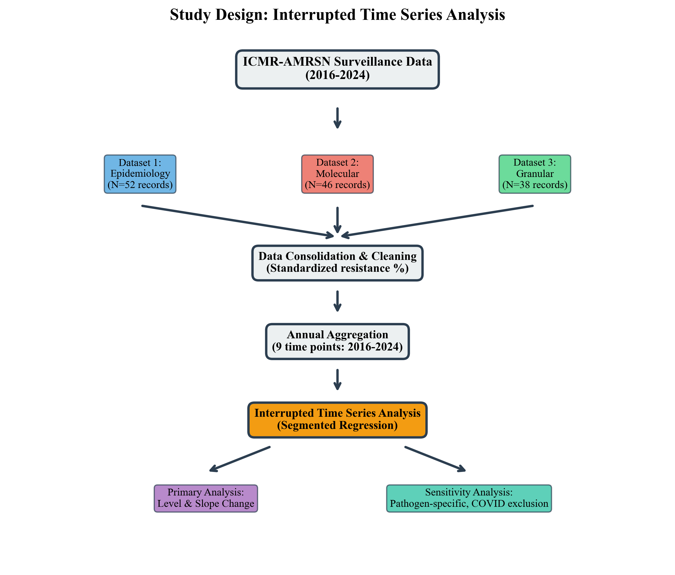
Figure 1: Study Design and Data Flow

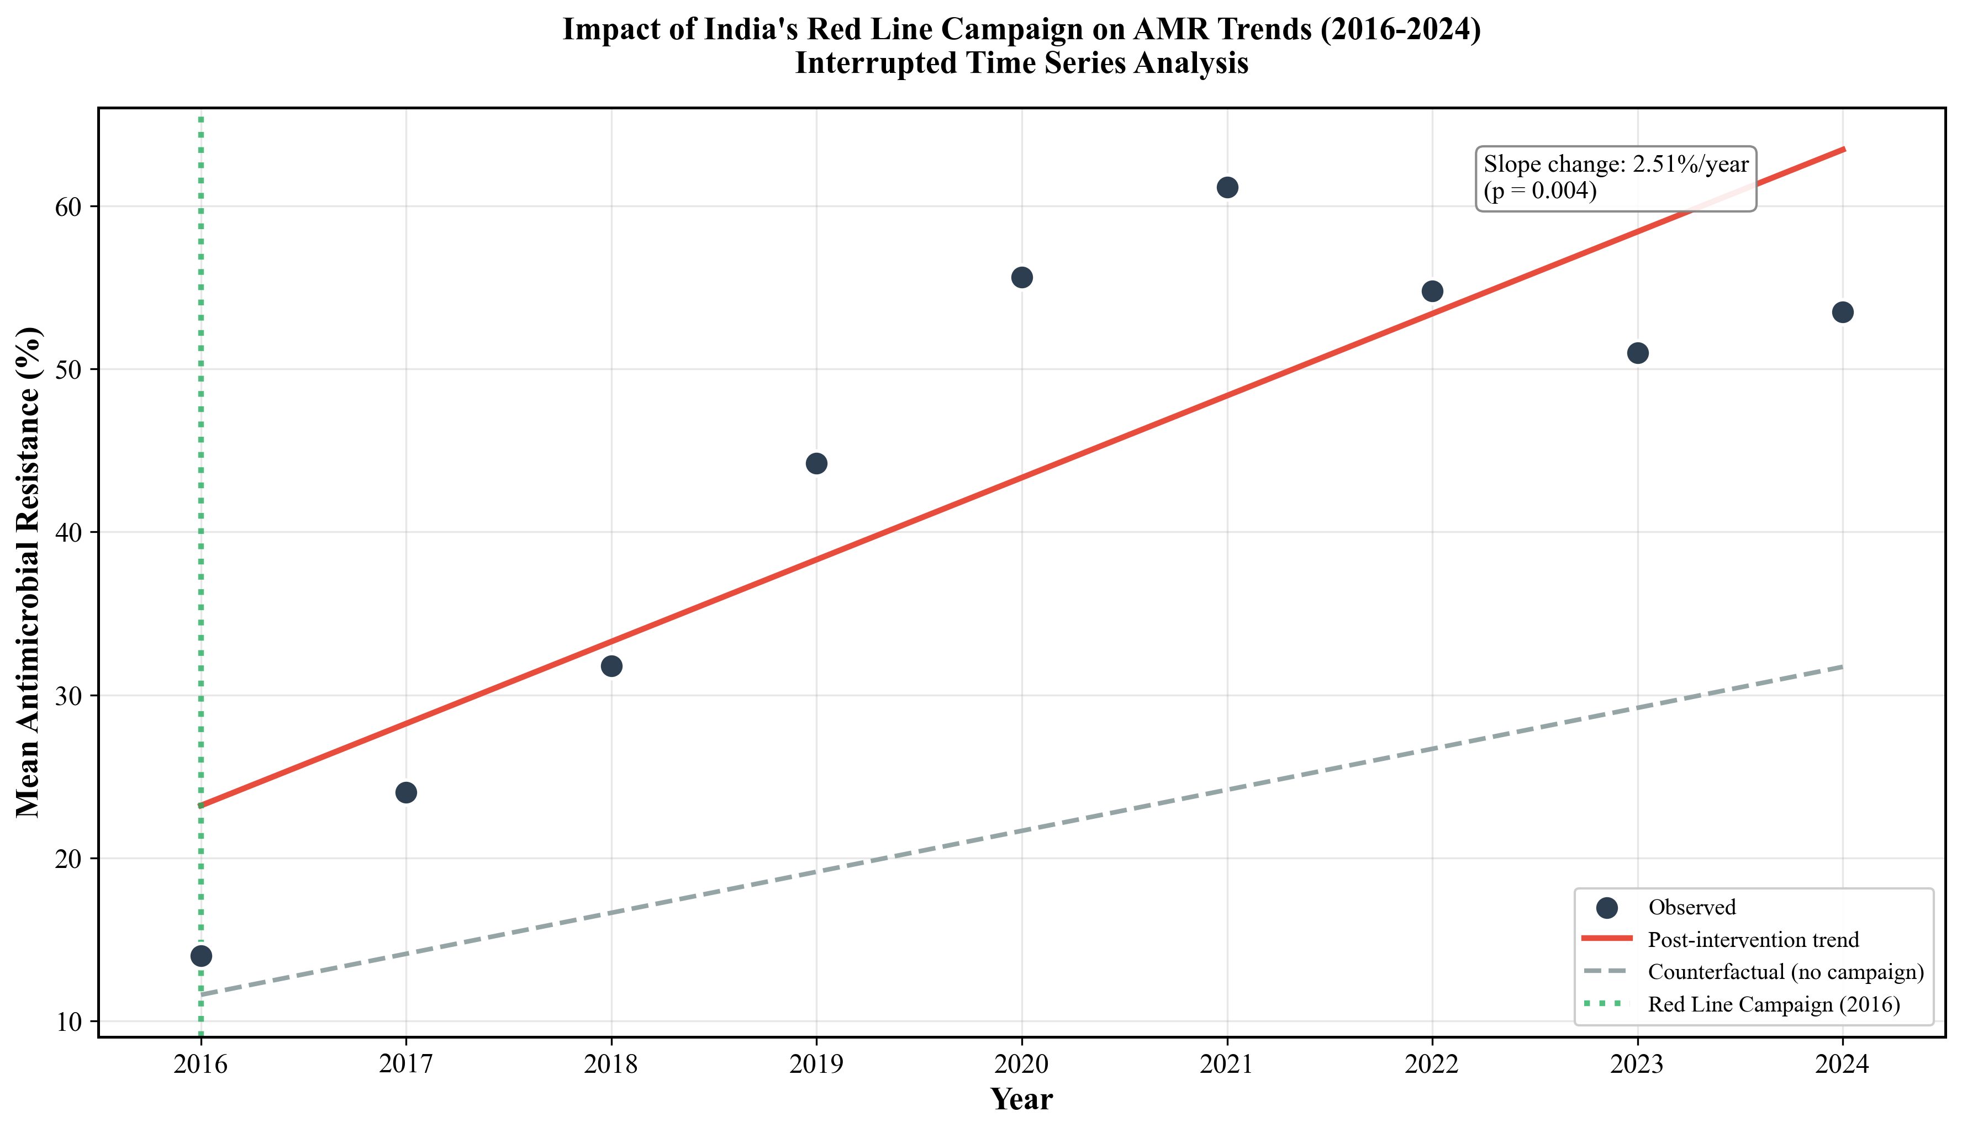
Figure 2: Interrupted Time Series Analysis of AMR Trends

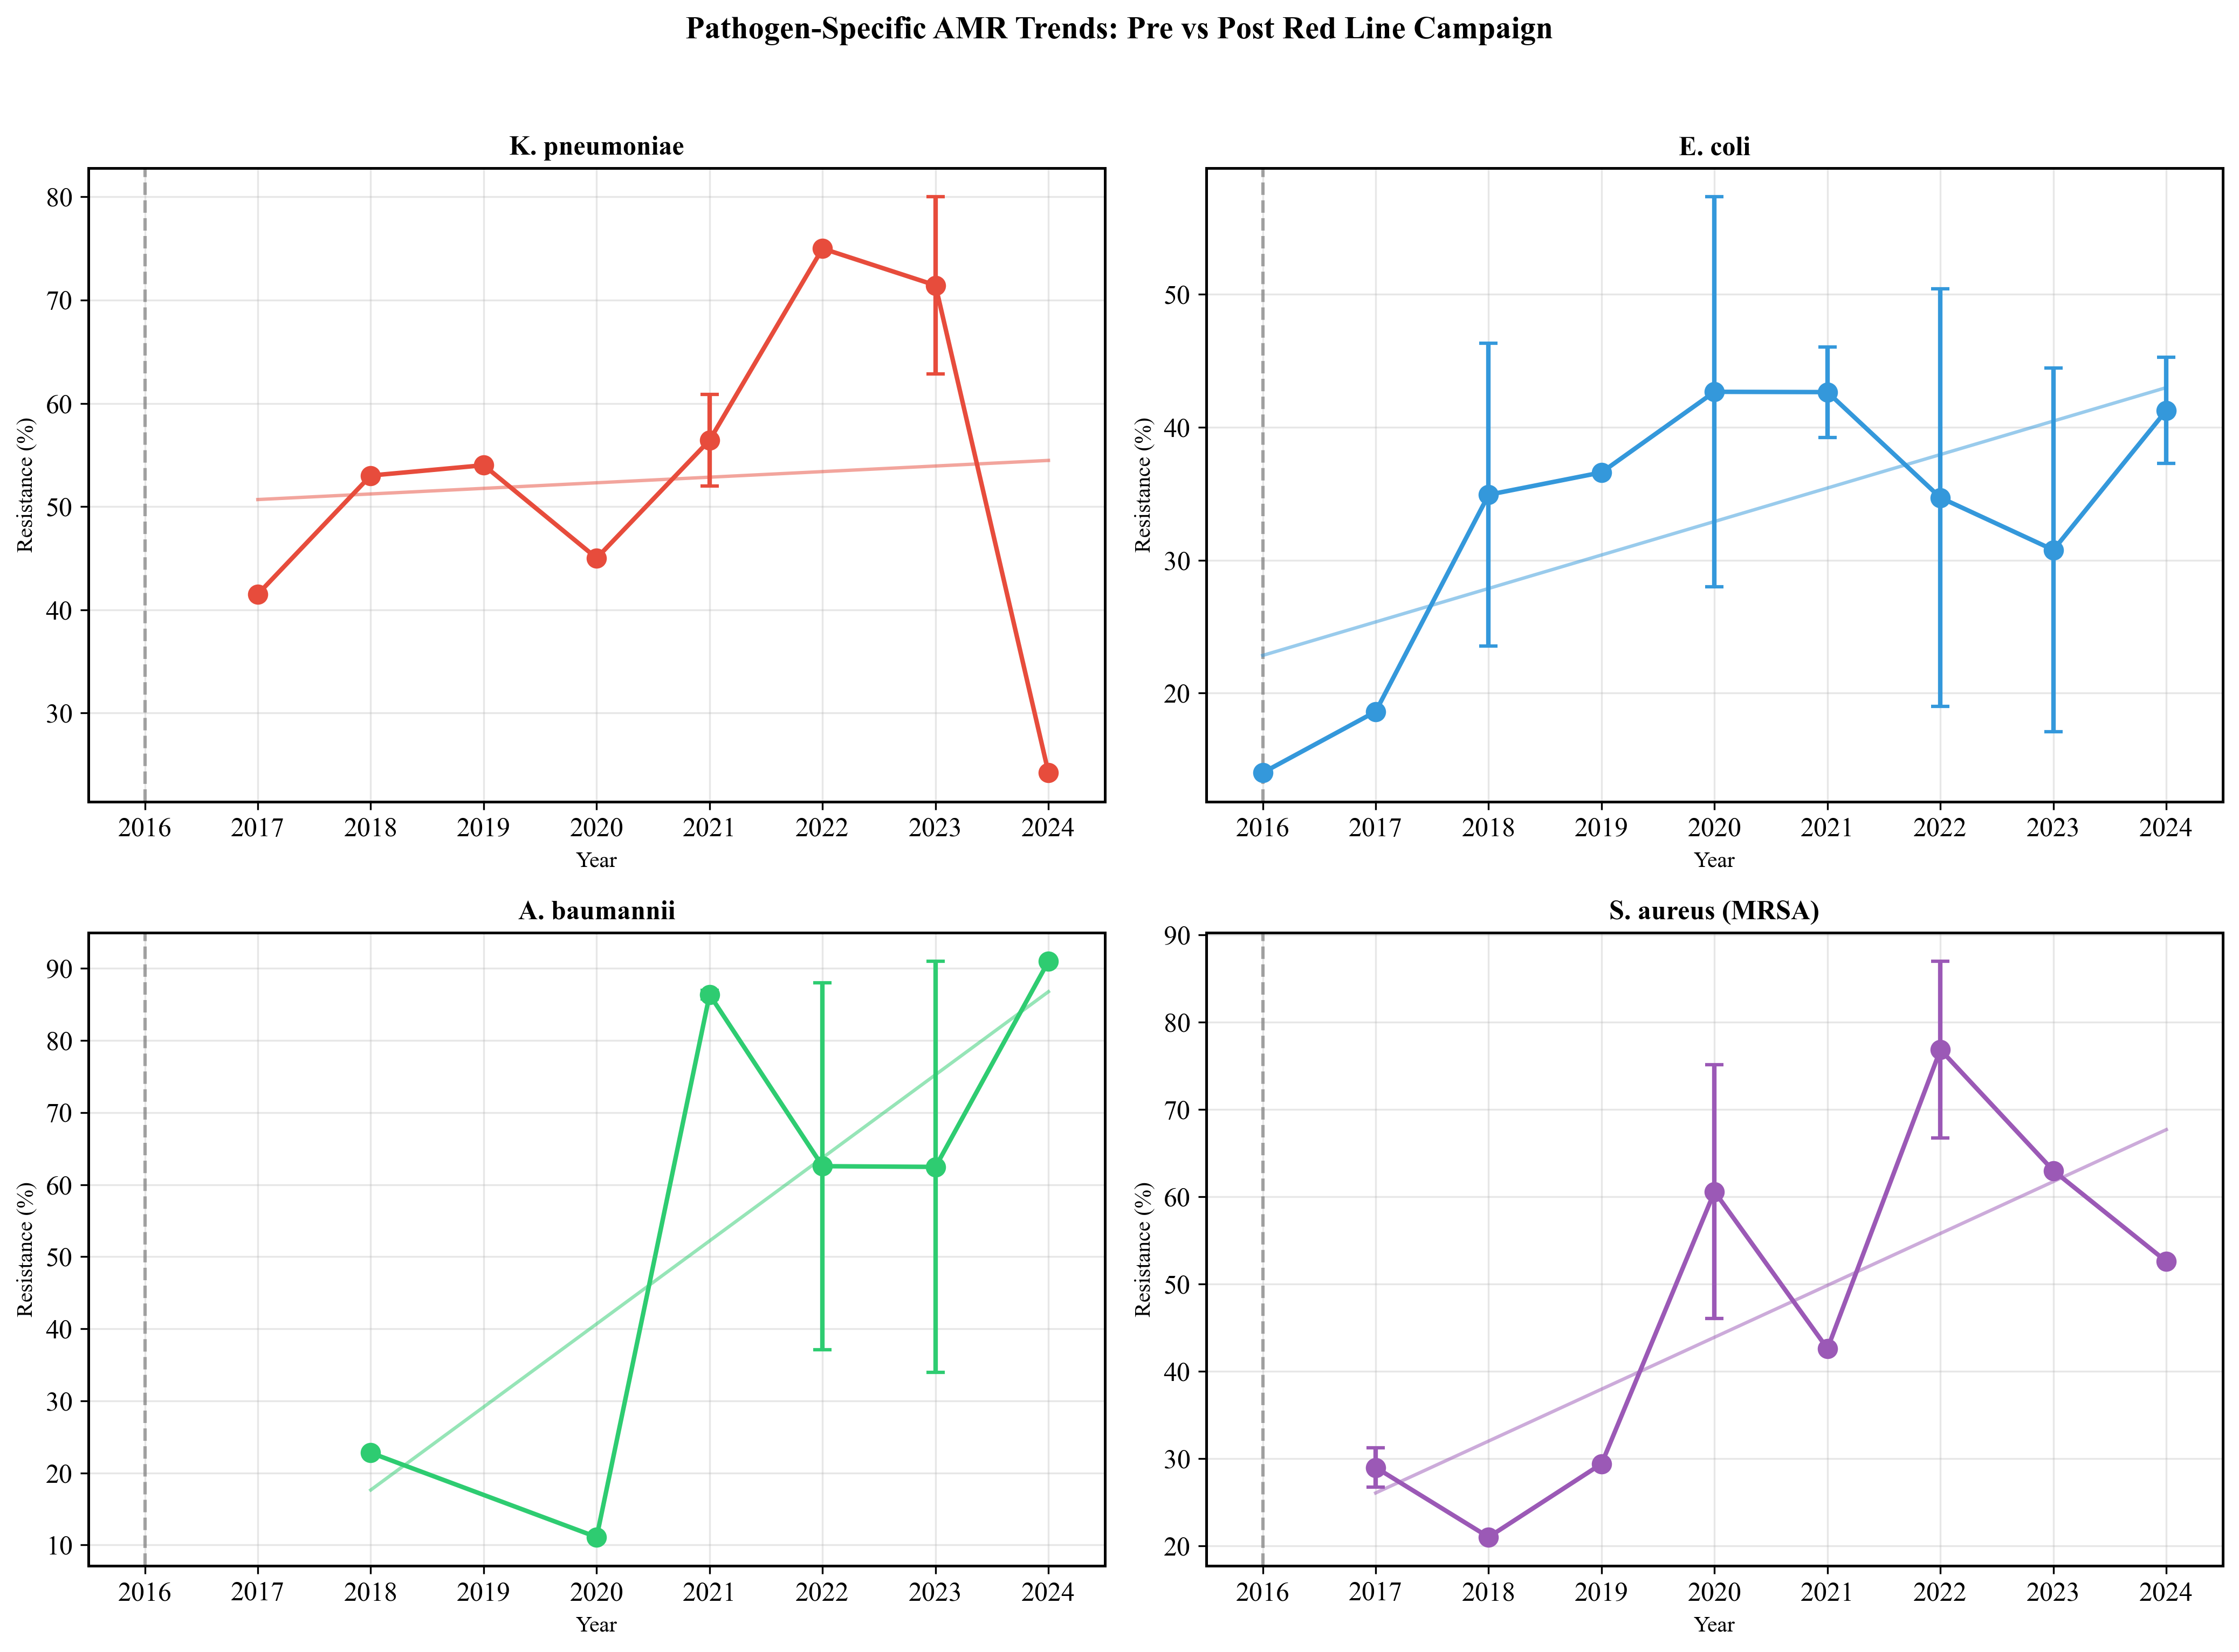
Figure 3: Pathogen-Specific Resistance Trends

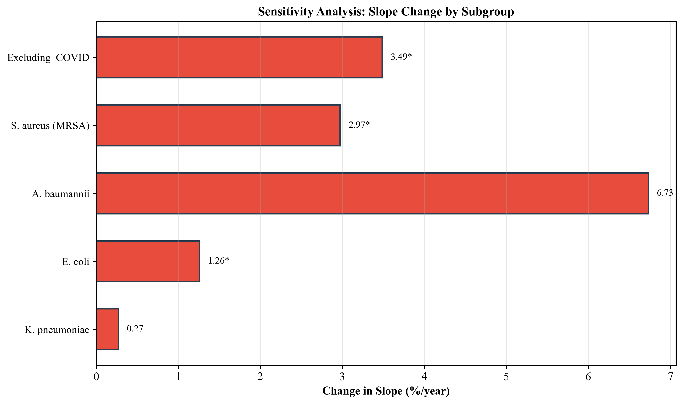
Figure 4: Sensitivity Analysis Forest Plot

