Figures

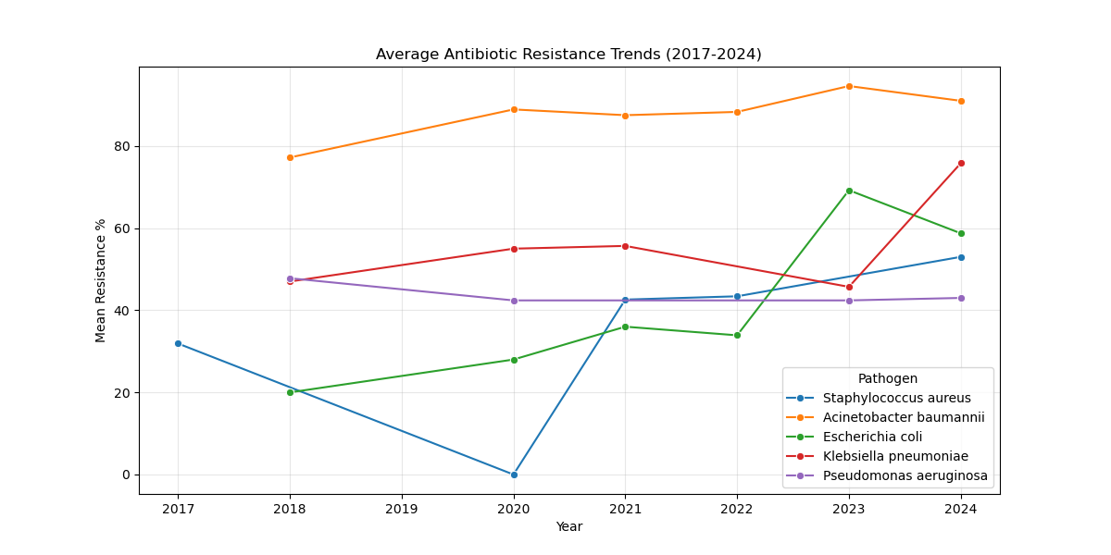

Figure 1: Longitudinal trends of antimicrobial resistance in priority pathogens across 21 ICMR-AMRSN Regional Centers (2017-2024). CRKP = Carbapenem-Resistant *Klebsiella pneumoniae*; CREC = Carbapenem-Resistant *Escherichia coli*; MRSA = Methicillin-Resistant *Staphylococcus aureus*.

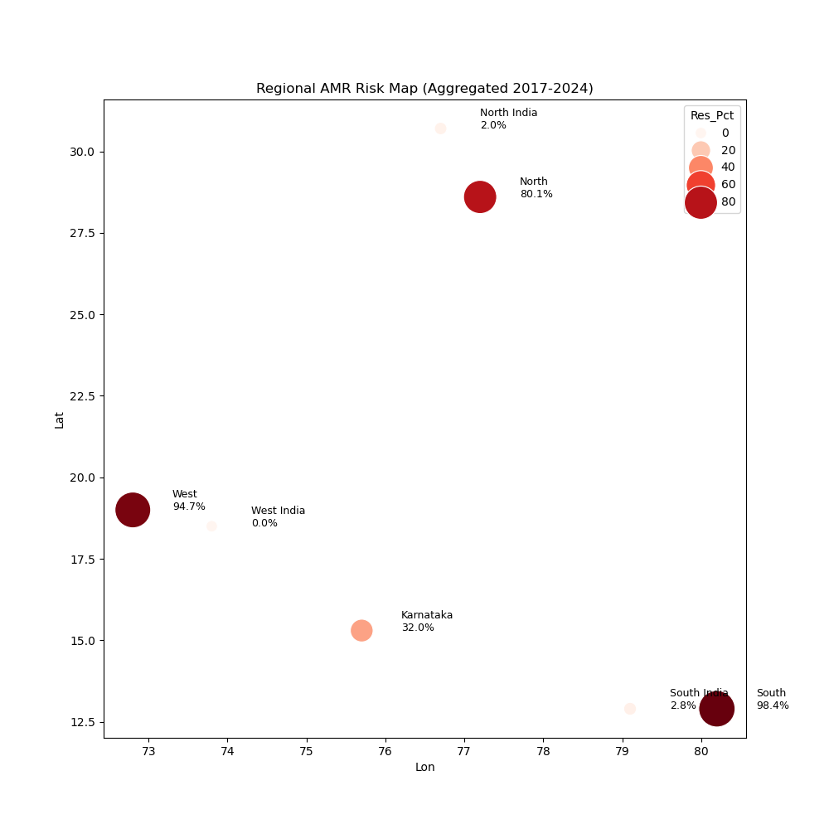

Figure 2: Heatmap of resistance hotspots across Indian Regional Centers. Darker shades indicate higher carbapenem resistance prevalence. The Northern cluster (Delhi, Chandigarh) and Southern cluster (Vellore) are prominently visible.

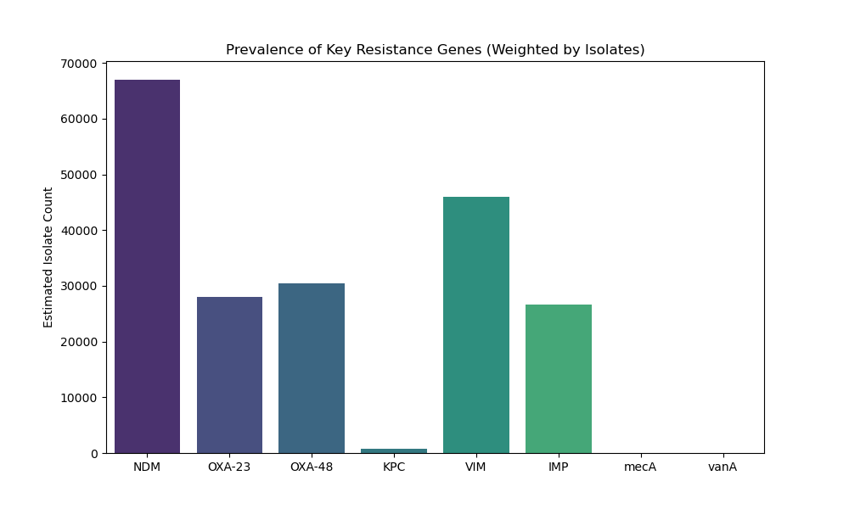

Figure 3: Prevalence of key resistance genes and mechanisms among carbapenem-resistant isolates in India. NDM = New Delhi Metallo-beta-lactamase; OXA = Oxacillinase-type beta-lactamase; KPC = *Klebsiella pneumoniae* Carbapenemase.

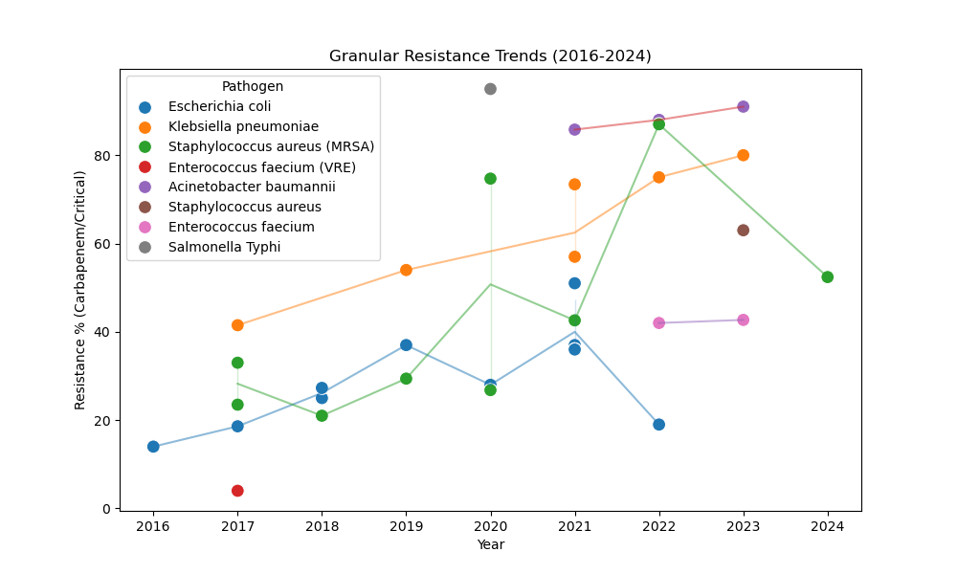

Figure 4: Machine Learning forecast (dashed line) versus actual observation (solid line) for key sentinel centers. The Random Forest model achieved an R-squared of 0.87 on the held-out test set (2022-2024).

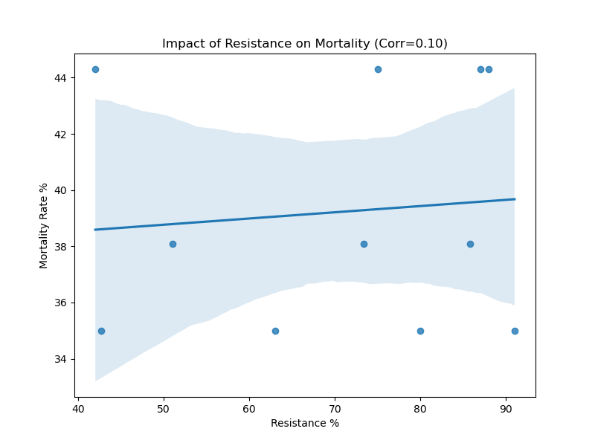

Figure 5: Correlation between Carbapenem Resistance (%) and aggregate ICU Mortality Rate at the center level. The weak but positive correlation (r=0.10, p=0.08) suggests a potential link between AMR burden and clinical outcomes.

