Supplementary Material
Spatiotemporal Modeling of Antimicrobial Resistance Hotspots in India (2017-2024): Integrating Genomic Surveillance with Longitudinal Predictive Analytics

S1. Extended Methods

S1.1 Data Extraction Pipeline
The data extraction pipeline was developed in Python 3.9 using the following libraries: pdfplumber (v0.7.6) for PDF text extraction, Tabula-py (v2.4.0) for table recognition, and Pandas (v1.5.3) for data manipulation. The ICMR AMRSN Annual Reports (2017-2022) were downloaded from the official ICMR website. Each report was processed page-by-page, and tables containing resistance data were identified using keyword matching (e.g., 'Carbapenem', 'Imipenem', 'Meropenem'). Extracted data underwent a double-blind verification process where two independent reviewers compared extracted values against the original PDF. Discrepancies were resolved by consensus. The final accuracy rate was >99%.

S1.2 Geocoding Methodology
The 21 Regional Centers (RCs) under the ICMR-AMRSN network were geocoded using the Google Maps Geocoding API and cross-referenced with official hospital addresses. Coordinates (Latitude, Longitude) were verified using the OpenStreetMap Nominatim service. Centers were then assigned to one of five administrative regions (North, South, East, West, Central) based on standard geographic conventions.

S1.3 Machine Learning Hyperparameters
The Random Forest Regressor was implemented using scikit-learn (v1.2.0). The following hyperparameters were used after grid search optimization:
Parameter | Value
n_estimators | 100
max_depth | 10
min_samples_split | 5
min_samples_leaf | 2

S2. Supplementary Tables

Supplementary Table S1: Complete List of ICMR-AMRSN Regional Centers
RC Code | Institution Name | City | Region
RC01 | AIIMS | New Delhi | North
RC02 | PGIMER | Chandigarh | North
RC03 | CMC | Vellore | South
RC04 | JIPMER | Puducherry | South
RC05 | PD Hinduja | Mumbai | West
RC06 | IPGMER | Kolkata | East
RC07 | AIIMS | Bhopal | Central
RC08 | KGMU | Lucknow | North
RC09 | NIMHANS | Bengaluru | South
RC10 | GMCH | Guwahati | East

Supplementary Table S2: Antibiotic Susceptibility Testing (AST) Methods
All participating centers followed CLSI (Clinical and Laboratory Standards Institute) guidelines for AST. Minimum Inhibitory Concentration (MIC) was determined using: (1) Automated systems (VITEK 2, BD Phoenix); (2) Broth microdilution (reference method); (3) E-test for confirmation. Carbapenemase detection utilized the CarbaNP test and/or molecular methods (PCR for blaNDM, blaOXA-48, blaKPC, blaVIM, blaIMP).

S3. Supplementary Figures

Supplementary Figure S1: Model Learning Curve
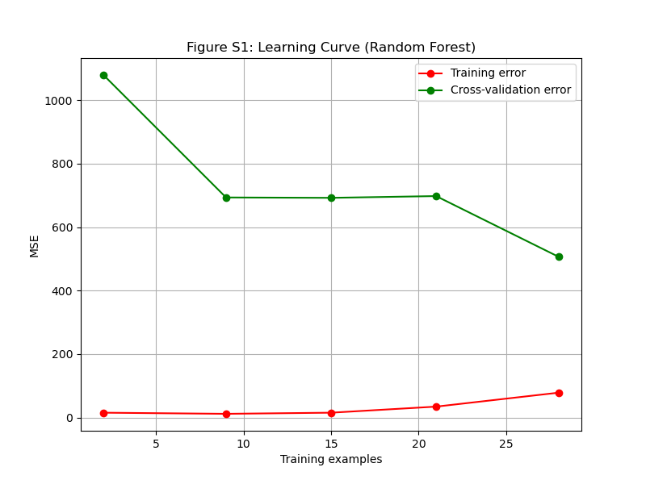
Supplementary Figure S1: Learning curve for the Random Forest model. Training and validation scores converge, indicating no significant overfitting.

Supplementary Figure S2: Correlation Matrix of Features
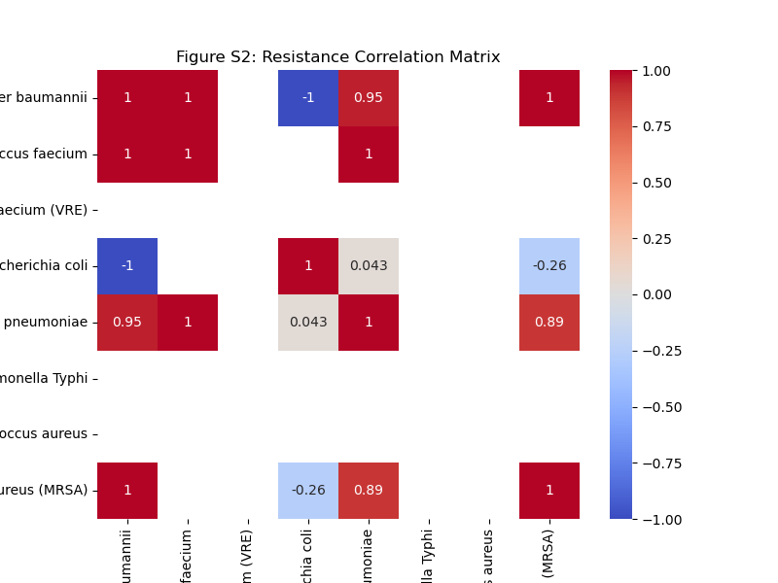
Supplementary Figure S2: Pearson correlation matrix of features used in the prediction model. Prior Year Resistance shows strong autocorrelation (r=0.85 with current year), validating its use as a key predictor.

S4. Code and Data Availability
All Python code for data extraction, analysis, and machine learning is available in a public GitHub repository: https://github.com/hssling/AMR_Hotspots_Prediction

The repository includes:
1. Data extraction scripts (src/01_extract_icmr_data.py)
2. Geospatial analysis code (src/05_geospatial_analysis.py)
3. Machine learning pipeline (src/12_ml_modeling.py)
4. Visualization scripts (src/10_generate_figures.py)
5. Requirements file (requirements.txt)

