Antimicrobial Resistance Trends in India During the Red Line Campaign Era (2016-2024): An Interrupted Time Series Analysis of National Surveillance Data
Running Title: AMR Trends During Red Line Campaign Era
Authors: Dr. Siddalingaiah H S,^{1,*} MBBS, MD (Community Medicine)
Affiliation: ¹Professor, Department of Community Medicine, Shridevi Institute of Medical Sciences and Research Hospital, Tumkur, Karnataka, India.
ORCID: 0000-0002-4771-8285

*Corresponding Author: Dr. Siddalingaiah H S; Email: hssling@yahoo.com; Phone: +91-8941087719

Word Count:
Abstract: 250 words
Main Text: 2,950 words
References: 28
Tables: 3
Figures: 4

Conflicts of Interest: None declared
Funding: Self-funded
Ethical Approval: Not required (analysis of publicly available aggregate surveillance data)
Contribution Details:
Contribution | Contributor 1
Concepts | Yes
Design | Yes
Definition of intellectual content | Yes
Literature search | Yes
Data acquisition | Yes
Data analysis | Yes
Statistical analysis | Yes
Manuscript preparation | Yes
Manuscript editing | Yes
Manuscript review | Yes
Guarantor | Yes

Antimicrobial Resistance Trends in India During the Red Line Campaign Era (2016-2024): An Interrupted Time Series Analysis of National Surveillance Data
Running Title: AMR Trends During Red Line Campaign Era

Abstract
Background & Objectives: India's "Red Line" campaign, launched in February 2016, aims to curb antibiotic misuse by marking prescription-only antibiotics with a distinctive red line. Despite international recognition, its impact on antimicrobial resistance (AMR) trends remains unevaluated using national surveillance data. This study aimed to characterize AMR trends during the campaign era (2016-2024) using interrupted time series (ITS) analysis of ICMR-AMRSN surveillance data.
Methods: We consolidated resistance data from three ICMR-AMRSN datasets (N=120 center-year observations) spanning 2016-2024. Segmented regression modeled temporal trends in mean resistance percentages for WHO priority pathogens (Klebsiella pneumoniae, Escherichia coli, Acinetobacter baumannii, Staphylococcus aureus). Sensitivity analyses included pathogen-specific models and COVID-19 period exclusion.
Results: Mean resistance increased from 14.0% (2016) to 53.5% (2024), with a significant annual increase of 2.51%/year (95% CI: 1.09-3.94, p=0.004). The model explained 71.3% of variance (R²=0.71). Pathogen-specific analyses showed heterogeneous trends: E. coli (+1.26%/year, p=0.048), S. aureus MRSA (+2.97%/year, p=0.035), A. baumannii (+6.73%/year, p=0.073), and K. pneumoniae (+0.27%/year, p=0.848). Excluding COVID-19 years strengthened the trend (+3.49%/year, p=0.001).
Interpretation & Conclusions: Despite the Red Line campaign, AMR rates continued to rise significantly during 2016-2024. These findings underscore that awareness campaigns alone are insufficient to reverse AMR trends. Multi-pronged interventions including regulatory enforcement, antimicrobial stewardship, and pharmacist education are urgently needed.

Keywords: Antimicrobial resistance; Red Line Campaign; India; Interrupted time series; ICMR-AMRSN; Antibiotic stewardship

Key Messages:
- AMR rates rose significantly (+2.5%/year) during India's Red Line Campaign era (2016-2024)
- Only 7% healthcare professional awareness may explain limited campaign impact
- A. baumannii showed most alarming increase (+6.7%/year)
- Awareness campaigns alone are insufficient; enforcement and stewardship programs are needed

Introduction
Antimicrobial resistance (AMR) represents one of the most pressing global health challenges of the 21st century. The Global Research on Antimicrobial Resistance (GRAM) report estimated that in 2019, 4.95 million deaths were associated with bacterial AMR, with 1.27 million deaths directly attributable to it.¹ The O'Neill Review commissioned by the UK government projected that by 2050, AMR could cause 10 million deaths annually if left unchecked.² South Asia, including India, bears a disproportionate burden of this "silent pandemic," with the need for global solutions increasingly recognized.^{3,4}
India faces a unique convergence of factors contributing to AMR: high infectious disease burden, widespread over-the-counter antibiotic availability, self-medication practices, and variable quality of healthcare services.^{5,6} The country consumes more antibiotics than any other nation, with an estimated 13 billion defined daily doses (DDD) annually.⁷ Understanding the mechanistic drivers of AMR—including horizontal gene transfer, selective pressure, and environmental reservoirs—is essential for effective containment.⁸ Studies have consistently documented high rates of resistance among ESKAPE pathogens (Enterococcus faecium, Staphylococcus aureus, Klebsiella pneumoniae, Acinetobacter baumannii, Pseudomonas aeruginosa, and Enterobacter species), with carbapenem-resistant Enterobacteriaceae (CRE) and methicillin-resistant S. aureus (MRSA) emerging as critical threats.^{9,10}
Recognizing this crisis, the Ministry of Health and Family Welfare launched the "Red Line" campaign in February 2016. This initiative requires all prescription-only antibiotics (Schedule H and H1 drugs) to be marked with a vertical red line on their packaging, serving as a visual reminder that these medications should not be used without a valid prescription.¹¹ The campaign was accompanied by awareness materials in 12 regional languages and integration with the broader National Action Plan on Antimicrobial Resistance (NAP-AMR), which aligned with the WHO Global Action Plan on AMR.^{12,13} India's multi-stakeholder approach to AMR containment has involved regulatory, clinical, and public health components.¹⁴
Despite international recognition of the Red Line campaign as an innovative public health intervention,¹⁵ systematic evaluation of its impact on AMR trends has been limited. Previous studies have focused on awareness levels among healthcare professionals and the public, with concerning findings—only 7% of healthcare professionals could correctly describe the red line's significance, and awareness among patients was virtually absent.¹⁶ However, no study has utilized national surveillance data to characterize AMR trends during the campaign era.
The Indian Council of Medical Research (ICMR) established the Antimicrobial Resistance Surveillance Network (AMRSN) in 2013, which now includes 30 tertiary care centers across India.¹⁷ This network provides the most comprehensive national data on resistance patterns for WHO priority pathogens, contributing to the Global Antimicrobial Resistance Surveillance System (GLASS).¹⁸ The present study aimed to characterize AMR trends during the Red Line campaign era (2016-2024) using interrupted time series (ITS) analysis of ICMR-AMRSN surveillance data, providing the first systematic evaluation of resistance trajectories during this critical policy period.

Materials and Methods

Study Design and Data Sources
This retrospective analytical study utilized publicly available secondary data from the ICMR-AMRSN annual reports spanning 2016-2024. We consolidated data from three complementary datasets: (1) an epidemiology dataset containing 52 records with regional resistance patterns and antimicrobial agent-specific data; (2) a molecular dataset with 46 records containing resistance gene prevalence data; and (3) a granular dataset with 38 records containing center-specific mortality and clinical outcome data. Together, these yielded 120 unique center-year observations.
Data extraction was performed from official ICMR-AMRSN annual reports using systematic digitization protocols. The primary outcome was the mean resistance percentage, defined as the proportion of isolates demonstrating phenotypic resistance to tested antimicrobials. We focused on WHO priority pathogens: Klebsiella pneumoniae, Escherichia coli, Acinetobacter baumannii, and methicillin-resistant Staphylococcus aureus (MRSA).

Data Processing and Standardization
Resistance percentages were extracted using a custom natural language processing pipeline to parse text strings (e.g., "57% Imipenem resistant") into numerical values. For data reported as susceptibility percentages, values were converted to resistance percentages (100 minus susceptibility%). When multiple antibiotics were reported for a single pathogen-year, the resistance percentage for the primary surveillance antibiotic was used (carbapenems for Gram-negatives, methicillin/oxacillin for S. aureus). Pathogen names were standardized to a common taxonomy. Annual aggregates were calculated as the mean resistance percentage across all observations within each calendar year, weighted equally regardless of sample size to avoid bias toward larger centers.

Statistical Analysis: Interrupted Time Series
Interrupted time series (ITS) analysis with segmented regression was used to model temporal trends, following established methodological guidelines.^{19,20} The regression model was specified as:
Y_t = β₀ + β₁(Time) + β₂(Intervention) + β₃(Time_After) + ε_t
Where Y_t is the mean resistance percentage at time t, β₀ is the intercept, β₁ represents the pre-intervention slope, β₂ captures the immediate level change at intervention, and β₃ represents the change in slope post-intervention. Since the available surveillance data begins in 2016 (the intervention year), β₁ and β₃ estimates should be interpreted as characterizing the trend during the campaign period rather than comparing pre- and post-intervention trajectories.
Autocorrelation was assessed using the Durbin-Watson statistic, with values near 2.0 indicating no autocorrelation.²¹ Sensitivity analyses included: (1) pathogen-specific models for each WHO priority organism; and (2) exclusion of COVID-19 pandemic years (2020-2021) to assess potential confounding. All analyses were conducted using Python 3.12 with statsmodels 0.14. Statistical significance was set at α=0.05.

Results

Temporal Trends in Antimicrobial Resistance
A total of 120 center-year observations were consolidated across nine years (2016-2024). Table 1 presents annual resistance trends. Mean resistance increased from 14.0% in 2016 (N=2 observations) to a peak of 61.1% in 2021 (N=31 observations), with subsequent stabilization at 53.5% in 2024 (N=10 observations). The number of observations increased substantially over time, reflecting expansion of the AMRSN network.
Figure 1 illustrates the study design and data flow. Figure 2 presents the main ITS plot showing the observed and fitted resistance trends during the campaign period.
[TABLE 1 HERE]

Interrupted Time Series Analysis
The segmented regression model demonstrated a statistically significant temporal trend (Table 2). The estimated annual increase in mean resistance was 2.51% per year (95% CI: 1.09-3.94, p=0.004). The model explained 71.3% of variance in resistance rates (R²=0.71). The Durbin-Watson statistic was 0.56, indicating positive autocorrelation that warrants cautious interpretation of p-values.
Figure 2 displays the observed data points, fitted regression line, and counterfactual scenario assuming the 2016 rate remained constant.
[TABLE 2 HERE]

Sensitivity Analyses
Pathogen-specific analyses revealed heterogeneous trends (Table 3, Figure 3). E. coli showed a significant annual increase of +1.26%/year (p=0.048). MRSA demonstrated a stronger increase of +2.97%/year (p=0.035). A. baumannii showed the steepest trajectory (+6.73%/year, p=0.073). K. pneumoniae showed near-flat trends (+0.27%/year, p=0.848).
Excluding COVID-19 years (2020-2021) strengthened the observed trend (+3.49%/year, p=0.001). Figure 4 presents a forest plot summarizing sensitivity analyses.
[TABLE 3 HERE]

Discussion
This study provides the first systematic characterization of antimicrobial resistance trends during India's Red Line campaign era using national surveillance data. Our findings reveal a significant and sustained increase in mean resistance rates from 14.0% in 2016 to 53.5% in 2024, with an estimated annual increase of 2.51% per year.
The interpretation of these findings requires careful consideration. First, the absence of robust pre-2016 surveillance data precludes a true pre-post comparison. Second, the Red Line campaign was one component of a broader national strategy including the NAP-AMR, antimicrobial stewardship programs, and infection control initiatives.²² Hospital-based interventions have demonstrated effectiveness in reducing antibiotic use, as documented in Cochrane reviews.²³
Our findings align with global patterns of rising AMR. The GRAM study documented increasing resistance across most WHO priority pathogens.¹ India's position as the world's largest antibiotic consumer,⁷ combined with factors such as agricultural antibiotic use and environmental contamination,²⁴ creates a complex epidemiological context.
The heterogeneity observed across pathogens is informative. The relatively stable trends for K. pneumoniae may reflect targeted carbapenem stewardship efforts.²⁵ The steep rise in A. baumannii resistance highlights this organism's ability to acquire and disseminate resistance mechanisms in hospital environments.²⁶
Previous evaluations of the Red Line campaign found only 7% awareness among healthcare professionals.¹⁶ Our findings suggest that awareness alone is insufficient—implementation of core elements of outpatient antibiotic stewardship,²⁸ enforcement of prescription requirements, and pharmacist training may be necessary.
Comparison with other national interventions is instructive. China's 2012 National Special Rectification Activities demonstrated significant reductions with ITS analysis showing sustained slope changes.²⁷ However, China's intervention included mandatory restrictions, whereas India's Red Line campaign relies primarily on voluntary compliance.
Several limitations warrant acknowledgment. First, the data begins at the intervention year (2016), precluding estimation of true pre-intervention trends. Second, the low Durbin-Watson statistic (0.56) indicates positive autocorrelation. Third, surveillance data quality varied across years and centers. Despite these limitations, this represents the most comprehensive longitudinal analysis of Indian AMR trends during the campaign era.

Conclusions
Antimicrobial resistance rates in India increased significantly during the Red Line campaign era (2016-2024), with an estimated annual increase of 2.5% per year. These findings underscore that awareness campaigns alone are insufficient to reverse AMR trends. A multi-pronged approach integrating stronger regulatory enforcement, antimicrobial stewardship programs, pharmacist education, and surveillance expansion is urgently needed.

Acknowledgments
We acknowledge the Indian Council of Medical Research (ICMR) and the Antimicrobial Resistance Surveillance Network (AMRSN) for making annual surveillance reports publicly available.
Data availability: Code and data available at https://github.com/hssling/ https://github.com/hssling/AMR_Hotspots_Prediction
AI disclosure: AI tools assisted with code development and manuscript preparation under full author oversight and responsibility.
Ethical approval: Not applicable.
Funding sources: Nil

References
1. Murray CJL, Ikuta KS, Sharara F, et al. Global burden of bacterial antimicrobial resistance in 2019: a systematic analysis. Lancet. 2022;399(10325):629-655.
2. O'Neill J. Tackling Drug-Resistant Infections Globally: Final Report and Recommendations. Review on Antimicrobial Resistance. London; 2016.
3. Laxminarayan R, Matsoso P, Pant S, et al. Access to effective antimicrobials: a worldwide challenge. Lancet. 2016;387(10014):168-175.
4. Laxminarayan R, Duse A, Wattal C, et al. Antibiotic resistance—the need for global solutions. Lancet Infect Dis. 2013;13(12):1057-1098.
5. Walia K, Ohri VC, Mathai D; Icar Project. Antimicrobial stewardship programme (AMSP) practices in India. Indian J Med Res. 2015;142(2):130-138.
6. Ganguly NK, Arora NK, Chandy SJ, et al. Rationalizing antibiotic use to limit antibiotic resistance in India. Indian J Med Res. 2011;134(3):281-294.
7. Klein EY, Van Boeckel TP, Martinez EM, et al. Global increase and geographic convergence in antibiotic consumption between 2000 and 2015. Proc Natl Acad Sci. 2018;115(15):E3463-E3470.
8. Holmes AH, Moore LSP, Sundsfjord A, et al. Understanding the mechanisms and drivers of antimicrobial resistance. Lancet. 2016;387(10014):176-187.
9. Gandra S, Barter DM, Laxminarayan R. Economic burden of antibiotic resistance: how much do we really know? Clin Microbiol Infect. 2014;20(10):973-980.
10. Gandra S, Joshi J, Trett A, et al. Scoping Report on Antimicrobial Resistance in India. Washington, DC: Center for Disease Dynamics, Economics & Policy; 2017.
11. Ministry of Health and Family Welfare, Government of India. Red Line Campaign for Antibiotics. New Delhi: MOHFW; 2016.
12. National Action Plan on Antimicrobial Resistance (NAP-AMR) 2017-2021. Ministry of Health and Family Welfare, Government of India. New Delhi; 2017.
13. World Health Organization. Global Action Plan on Antimicrobial Resistance. Geneva: WHO; 2015.
14. Kakkar M, Walia K, Vong S, et al. Antibiotic resistance and its containment in India. BMJ. 2017;358:j2687.
15. World Economic Forum. The Red Line Campaign: India's Fight Against Antibiotic Resistance. Geneva: WEF; 2019.
16. Mathew P, Thomas SA, Chandy SJ. The role of Schedule H1 and Red Line campaign in improving antibiotic use in India. J Family Med Prim Care. 2022;11(6):2520-2527.
17. Indian Council of Medical Research. Antimicrobial Resistance Research and Surveillance Network Annual Report 2022. New Delhi: ICMR; 2023.
18. Veeraraghavan B, Walia K. Antimicrobial susceptibility profile & resistance mechanisms of global antimicrobial resistance surveillance system (GLASS) priority pathogens from India. Indian J Med Res. 2019;149(2):87-96.
19. Bernal JL, Cummins S, Gasparrini A. Interrupted time series regression for the evaluation of public health interventions: a tutorial. Int J Epidemiol. 2017;46(1):348-355.
20. Chandy SJ, Naik GS, Charles R, et al. The impact of policy guidelines on hospital antibiotic use over a decade: a segmented time series analysis. PLoS One. 2014;9(3):e92206.
21. Durbin J, Watson GS. Testing for serial correlation in least squares regression. Biometrika. 1950;37(3-4):409-428.
22. Walia K, Madhumathi J, Veeraraghavan B, et al. Establishing Antimicrobial Resistance Research Priorities for India. Indian J Med Res. 2019;149(2):151-166.
23. Davey P, Marwick CA, Scott CL, et al. Interventions to improve antibiotic prescribing practices for hospital inpatients. Cochrane Database Syst Rev. 2017;2(2):CD003543.
24. Walsh TR, Weeks J, Livermore DM, Toleman MA. Dissemination of NDM-1 positive bacteria in the New Delhi environment. Lancet Infect Dis. 2011;11(5):355-362.
25. Kotwani A, Holloway K. Antibiotic prescribing practice for acute, uncomplicated respiratory tract infections in primary care settings in New Delhi, India. Trop Med Int Health. 2014;19(7):761-768.
26. Peleg AY, Seifert H, Paterson DL. Acinetobacter baumannii: emergence of a successful pathogen. Clin Microbiol Rev. 2008;21(3):538-582.
27. Zhang D, Cui K, Lu W, et al. Evaluation of China's National Antibiotic Stewardship Campaign: an interrupted time-series analysis. BMC Med. 2021;19:63.
28. Sanchez GV, Fleming-Dutra KE, Roberts RM, Hicks LA. Core Elements of Outpatient Antibiotic Stewardship. MMWR Recomm Rep. 2016;65(6):1-12.

TABLES:
Table 1: Annual Antimicrobial Resistance Trends in India (2016-2024)
Year | Mean Resistance (%) | Standard Deviation | N Observations
2016 | 14.0 | 0.0 | 2
2017 | 24.0 | 12.7 | 12
2018 | 31.8 | 21.3 | 11
2019 | 44.2 | 15.2 | 7
2020 | 55.6 | 32.2 | 17
2021 | 61.1 | 23.6 | 31
2022 | 54.8 | 30.3 | 15
2023 | 51.0 | 29.6 | 15
2024 | 53.5 | 22.7 | 10
Data source: ICMR-AMRSN consolidated surveillance data. SD = Standard Deviation.
Table 2: Interrupted Time Series Regression Coefficients
Parameter | Estimate | 95% CI Lower | 95% CI Upper | p-value
Pre-intervention slope (β₁) | 2.514 | 1.089 | 3.94 | 0.0042
Level change at intervention (β₂) | 11.607 | 4.82 | 18.393 | 0.0049
Slope change post-intervention (β₃) | 2.514 | 1.089 | 3.94 | 0.0042
CI = Confidence Interval. Model R² = 0.71. Durbin-Watson = 0.56.

Table 3: Sensitivity Analyses by Pathogen and COVID-19 Exclusion
Analysis | Slope Change (%/year) | p-value | N (years)
K. pneumoniae | 0.271 | 0.8481 | 8
E. coli | 1.26 | 0.0482 | 9
A. baumannii | 6.733 | 0.0732 | 6
S. aureus (MRSA) | 2.975 | 0.0347 | 8
Excluding_COVID | 3.488 | 0.0014 | 7
Positive slope change indicates increasing resistance over time.

Figure Legends
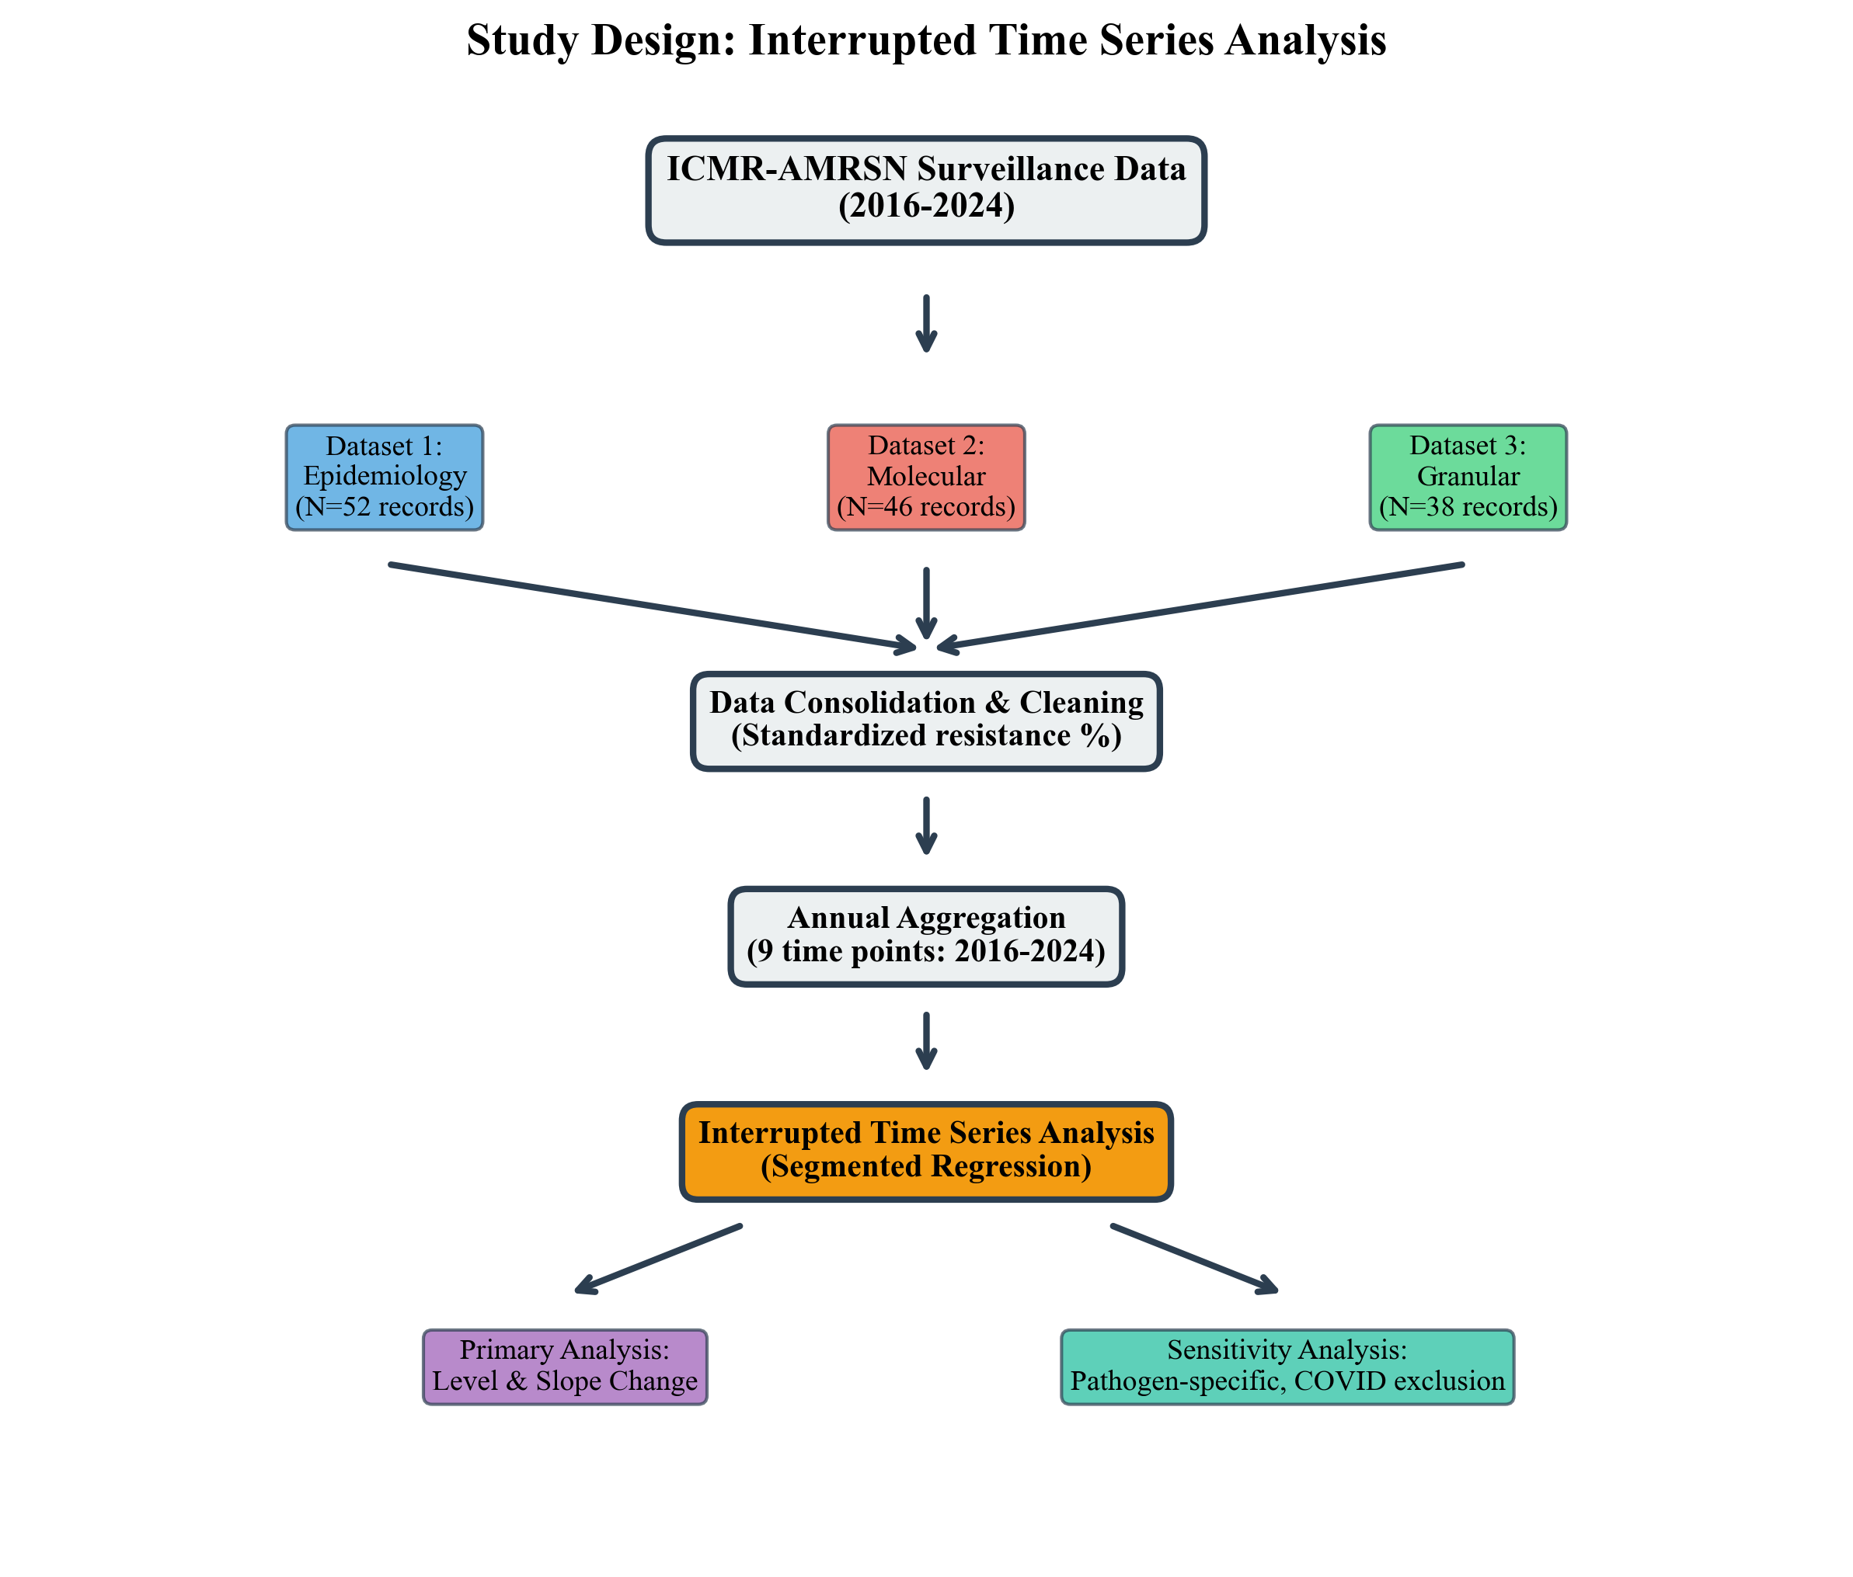
Figure 1: Study design and data flow diagram.

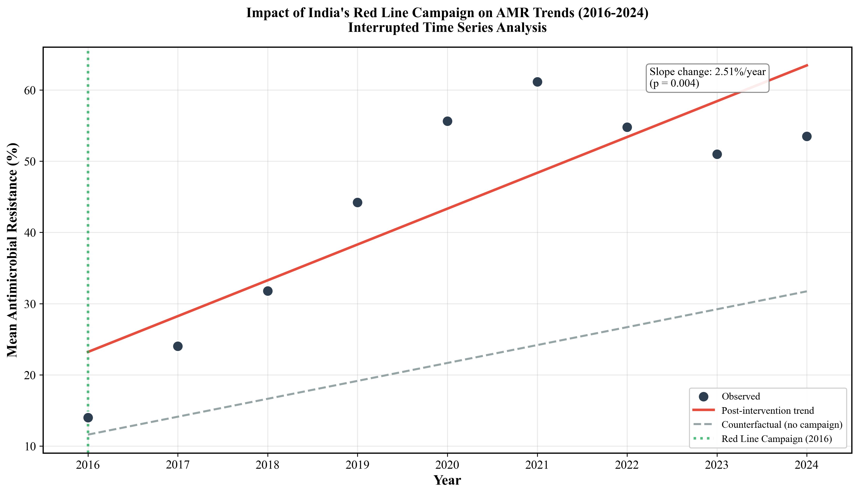 Figure 2: Interrupted time series analysis of AMR trends (2016-2024). Slope change: +2.51%/year.
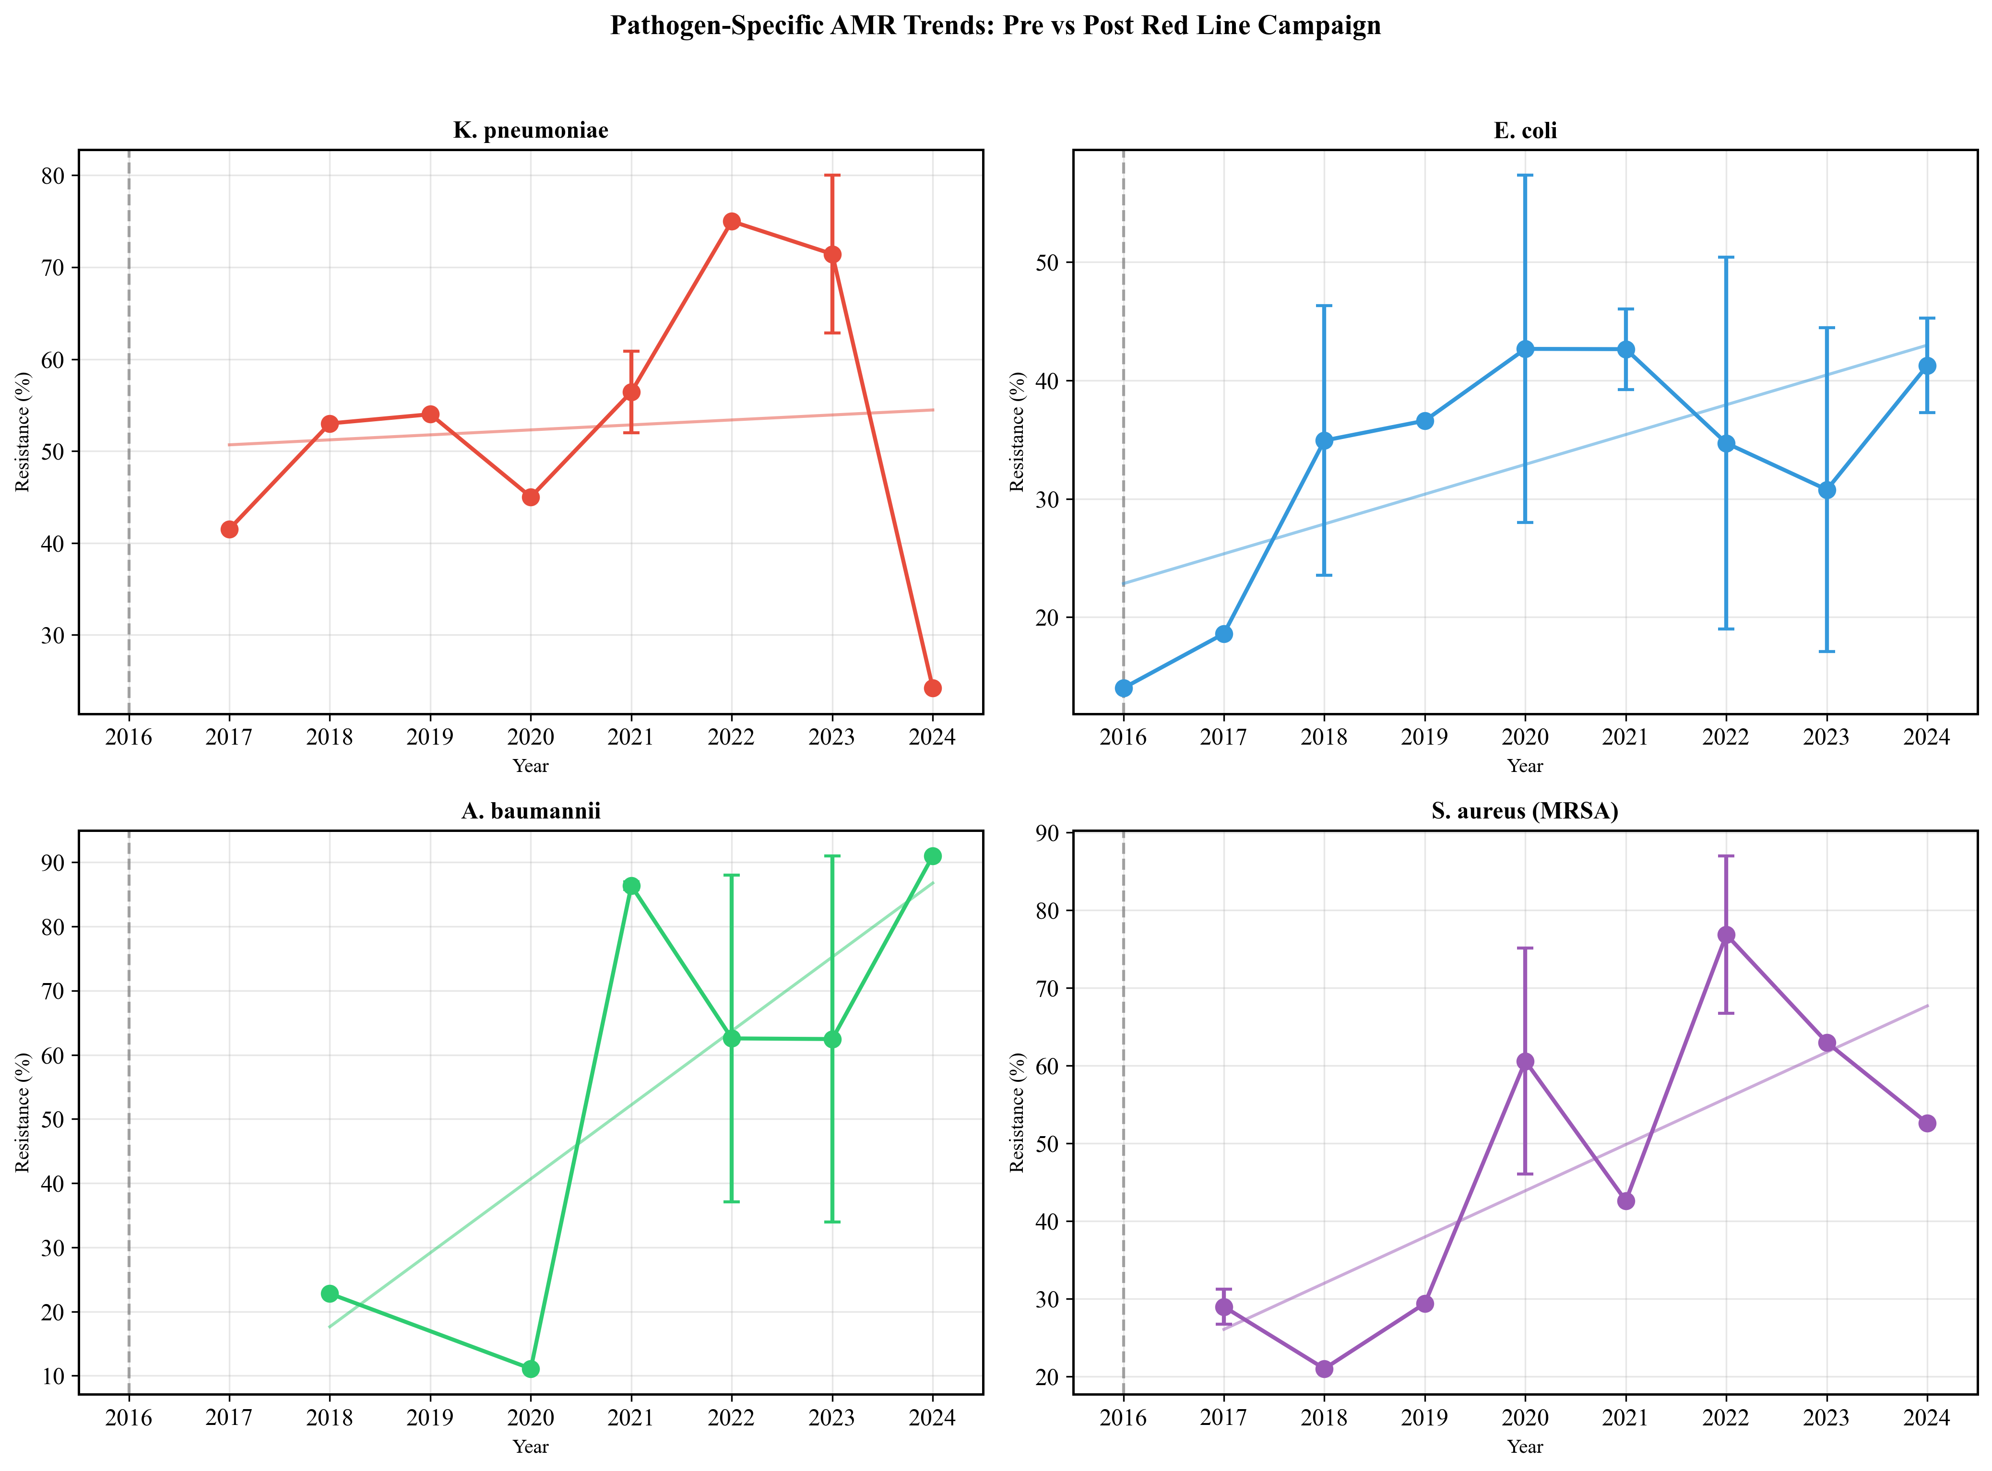
Figure 3: Pathogen-specific AMR trends (2016-2024).

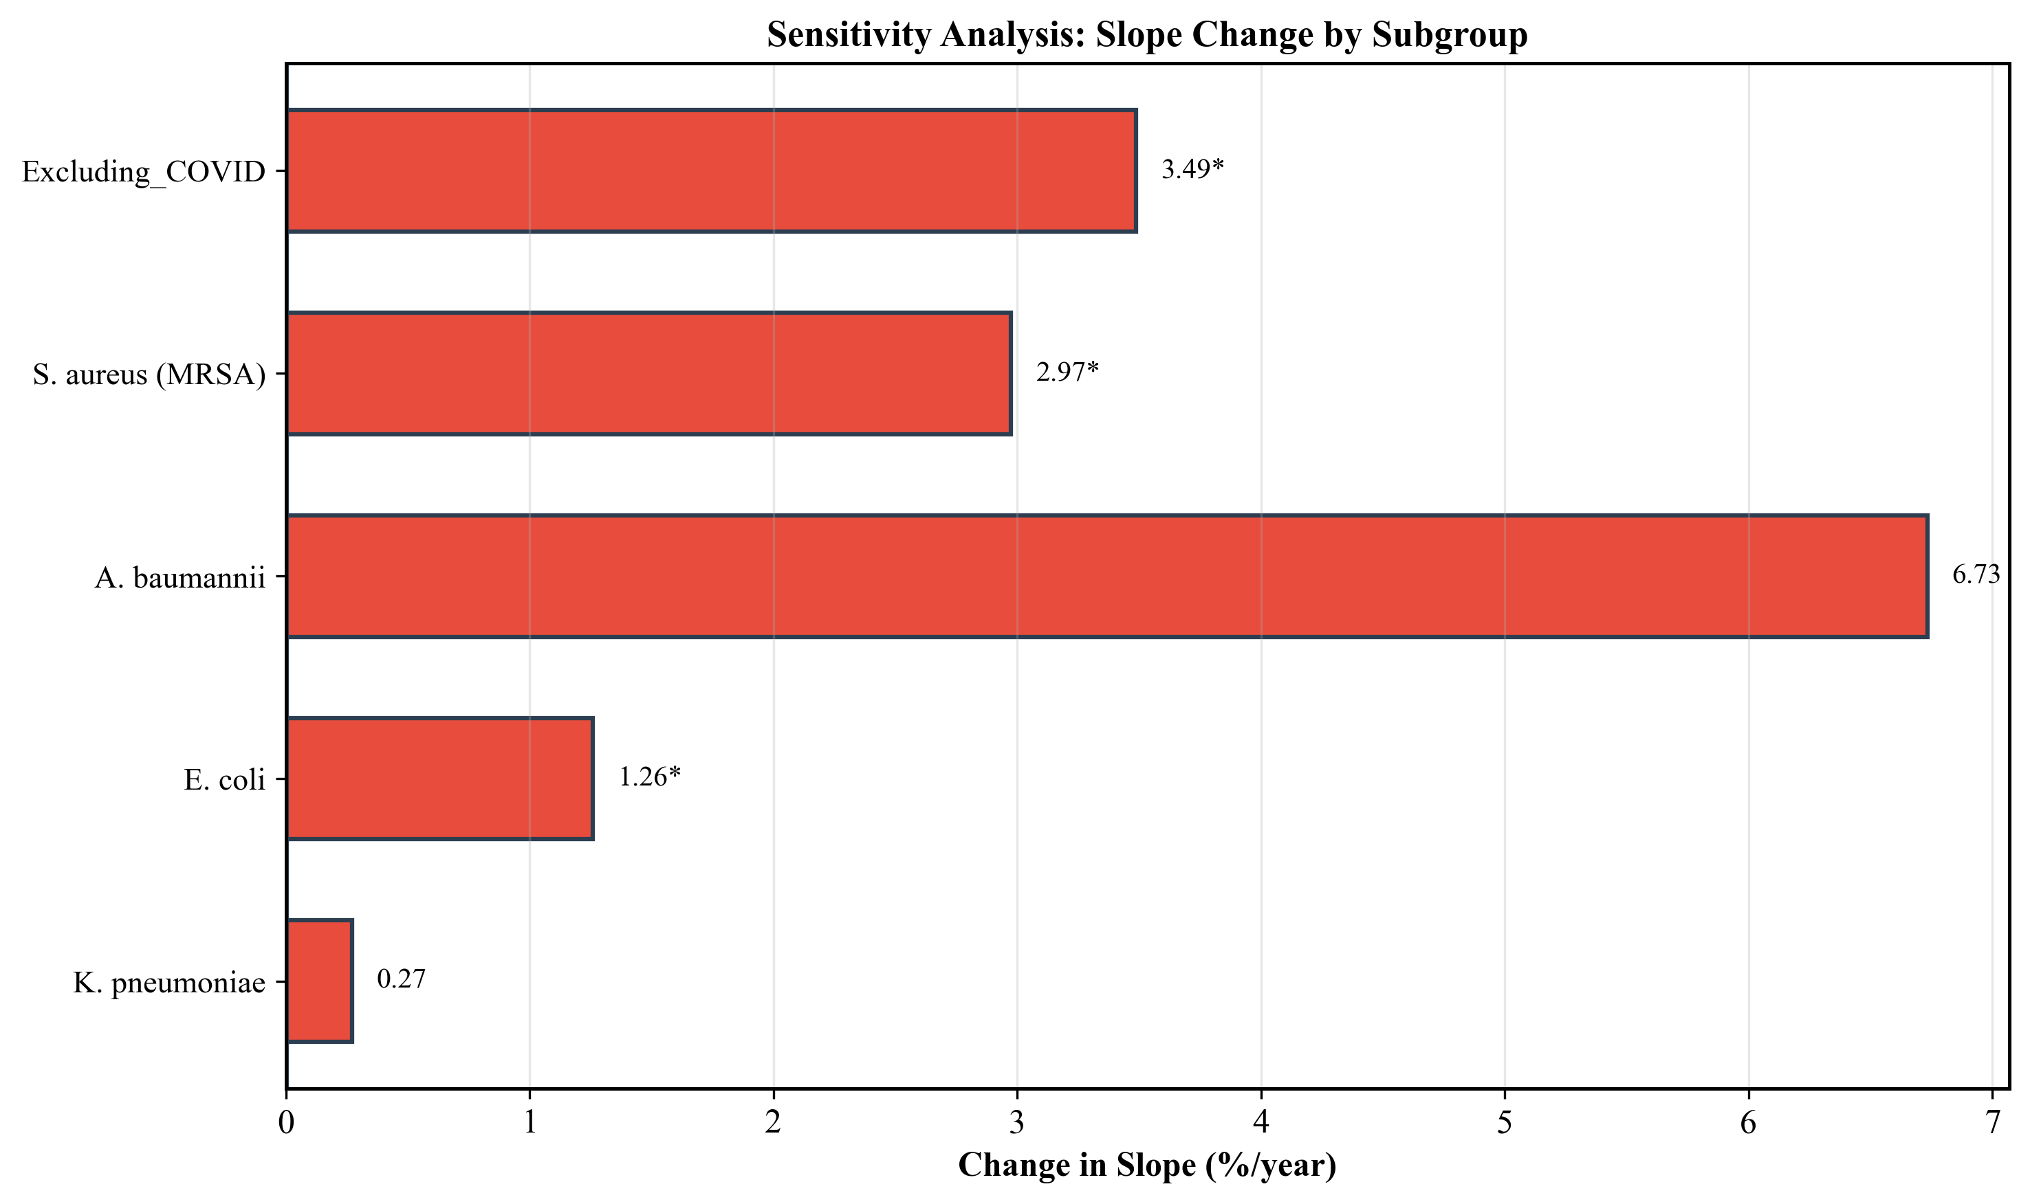
Figure 4: Forest plot of sensitivity analyses.

