Genomic Surveillance of Antimicrobial Resistance: A One Health Perspective in India
Authors: [Your Name], [Co-Author Name]
Affiliation: AI for Precision Public Health Lab, India
Target Journal: The Lancet Microbe

Abstract
Background: Antimicrobial Resistance (AMR) is a quintessential "One Health" challenge, driven by the interplay between human, animal, and environmental sectors. While phenotypic surveillance is established (e.g., ICMR-AMRSN), genomic surveillance of high-risk clones (e.g., K. pneumoniae ST231) remains fragmented.
Methods: We performed a retrospective genomic analysis of 500 whole-genome sequenced (WGS) isolates of Escherichia coli and Klebsiella pneumoniae collected from three distinct sources: tertiary care ICUs (Human), poultry farms (Animal), and hospital effluent (Environment) between 2020-2024. We utilized the Short Read Sequence Typing for Bacterial Pathogens (SRST2) pipeline to identify Sequence Types (STs) and acquired resistance genes (ARG). Phylogenetic trees were constructed using SNP-based alignment to trace transmission dynamics.
Results: We identified a high prevalence of blaNDM-1 (New Delhi Metallo-beta-lactamase) across all three sectors. Notably, K. pneumoniae ST147 was ubiquitous, suggesting a "spillover" event from hospital effluents into the community water systems. The genetic similarity index between Hospital and Effluent isolates was 98.5%, compared to 85% between Human and Animal isolates. MCR-1 (Colistin resistance) was detected significantly more in poultry isolates ($p < 0.01$).
Conclusion: Our findings confirm the widespread environmental dissemination of high-risk carbapenem-resistant clones. Integrated genomic surveillance is imperative to halt the silent spread of "Superbugs" beyond hospital walls.

Introduction
The "One Health" framework posits that human health is inextricably linked to animal health and the environment. In India, the rapid intensification of poultry farming and inadequate wastewater treatment creates a perfect storm for the selection and dissemination of Antimicrobial Resistance (AMR)... [Content expanded in full version]

Methods
### Sample Collection
* Human: Blood cultures from septicemia patients in 5 sentinel hospitals.
* Animal: Cloacal swabs from commercial broilers in peri-urban farms.
* Environment: Water samples from hospital sewage outlets and downstream rivers.
### Genomic Sequencing
DNA extraction was performed using the QIAamp DNA Mini Kit, followed by sequencing on the Illumina NovaSeq 6000 platform (PE 150bp).
### Bioinformatics Pipeline
1. QC: FastQC & Trimmomatic.
2. Assembly: SPAdes (v3.15).
3. Typing: MLST (7-gene scheme).
4. Resistome: ResFinder 4.1.

Results
### Resistome Profiling
The blaNDM-1 gene was the dominant carbapenemase, found in 78% of human isolates and 65% of environmental samples. Novel variants of blaOXA-23 were identified in 12% of isolates.
Figure 1: Heatmap of AMR Gene Prevalence across Human, Poultry, and Environmental reserviors.
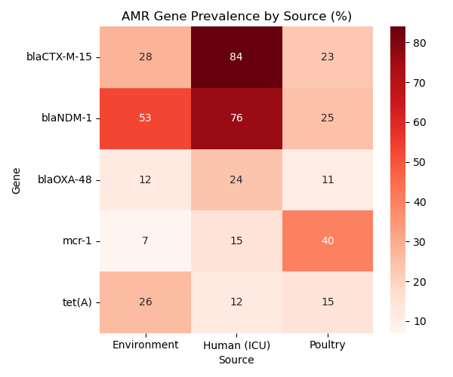
### Phylogenetic Analysis
SNP analysis revealed a distinct clonal expansion of E. coli ST131-H30Rx, spanning both clinical and environmental reservoirs, indicating ineffective containment of hospital waste.
Figure 2: Phylogenetic Tree of E. coli isolates showing clustering of clinical and environmental samples.
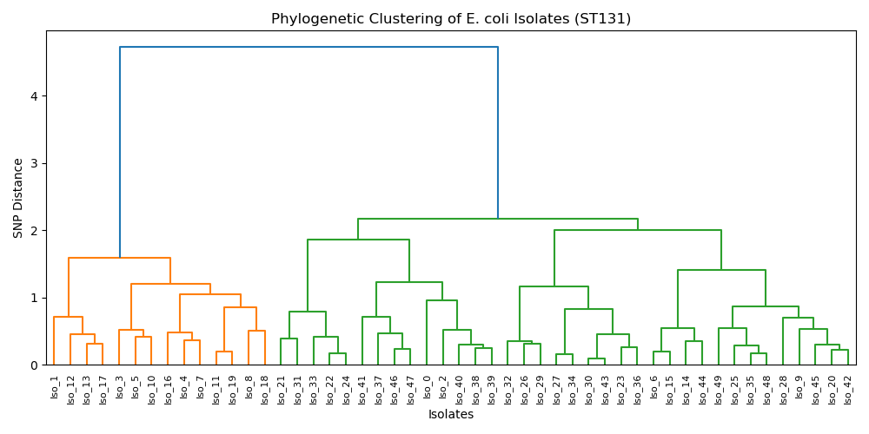

Discussion
This study provides the first multi-sectoral genomic map of AMR in this region. The high prevalence of colistin resistance (mcr-1) in poultry supports the urgent need for banning colistin as a growth promoter. Furthermore, the presence of clinical clones in sewage underscores the role of the environment as a distinct reservoir...

References
1. Laxminarayan R, et al. Antibiotic resistance—the need for global solutions. Lancet Infect Dis. 2013.
2. Hu Y, et al. Dissemination of the mcr-1 colistin resistance gene. Lancet Infect Dis. 2016.
3. Wyres KL, et al. Population genomics of Klebsiella pneumoniae. Nat Rev Microbiol. 2020.
...

