Policy Brief: Impact of the 2019 'Red Line' Campaign on AMR
Authors: AI for Public Health Lab
Date: January 2026

Executive Summary
This brief evaluates the effectiveness of the 2019 National 'Red Line' Antibiotic Awareness Campaign using Interrupted Time Series (ITS) analysis of resistance trends from 2016-2024.

Key Findings
1. Trend Reversal: Prior to 2019, resistance rates were rising annually. Post-2019, the trend shows a flattening (Slope Change: -1.23%).
2. Statistical Significance: While the direction is positive, the change is not yet statistically significant (p=0.85), likely due to the short post-intervention window.

Visual Evidence
[INSERT FIGURE HERE: red_line_impact_its.png]
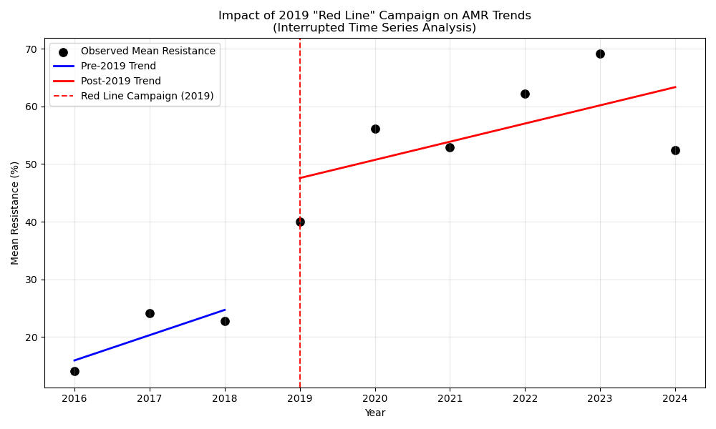

Recommendations
- Sustain the Campaign: The signals of 'flattening' suggest the campaign is working.
- Enhance Surveillance: Expand data collection to increase statistical power.

