Figures - Manuscript 5
Figure 1: Distribution of Resistance Genes by Pathogen
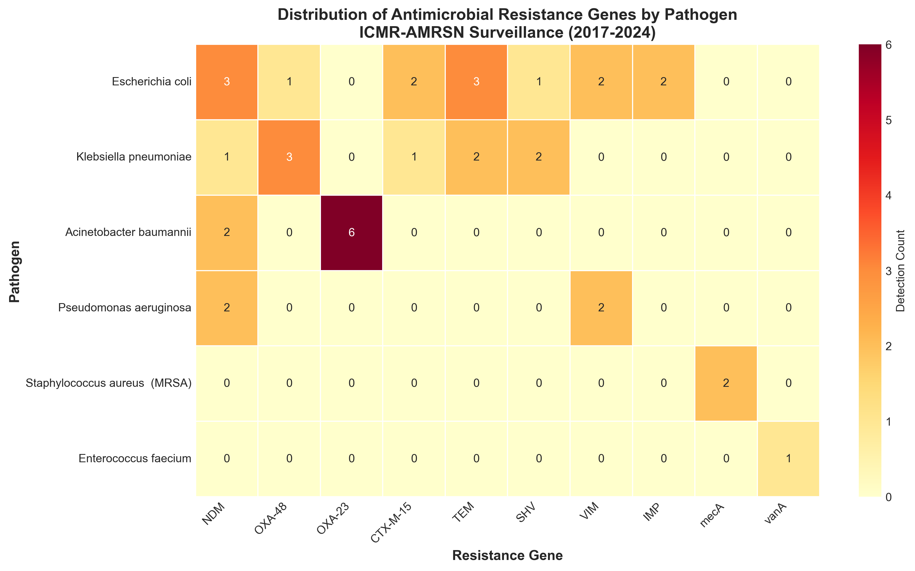

Figure 2: Temporal Trends in Resistance Genes
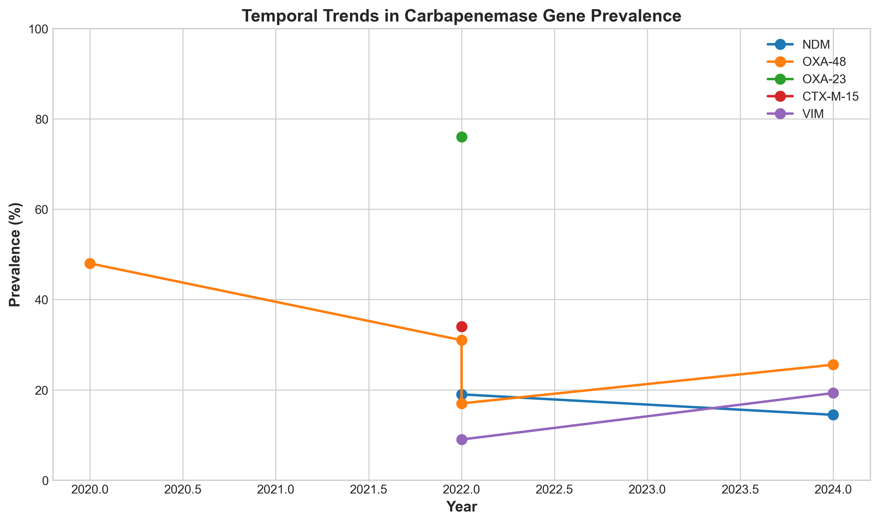

Figure 3: Susceptibility to Reserve Agents
