Figures - Manuscript 4

Figure 1: Mortality by Pathogen
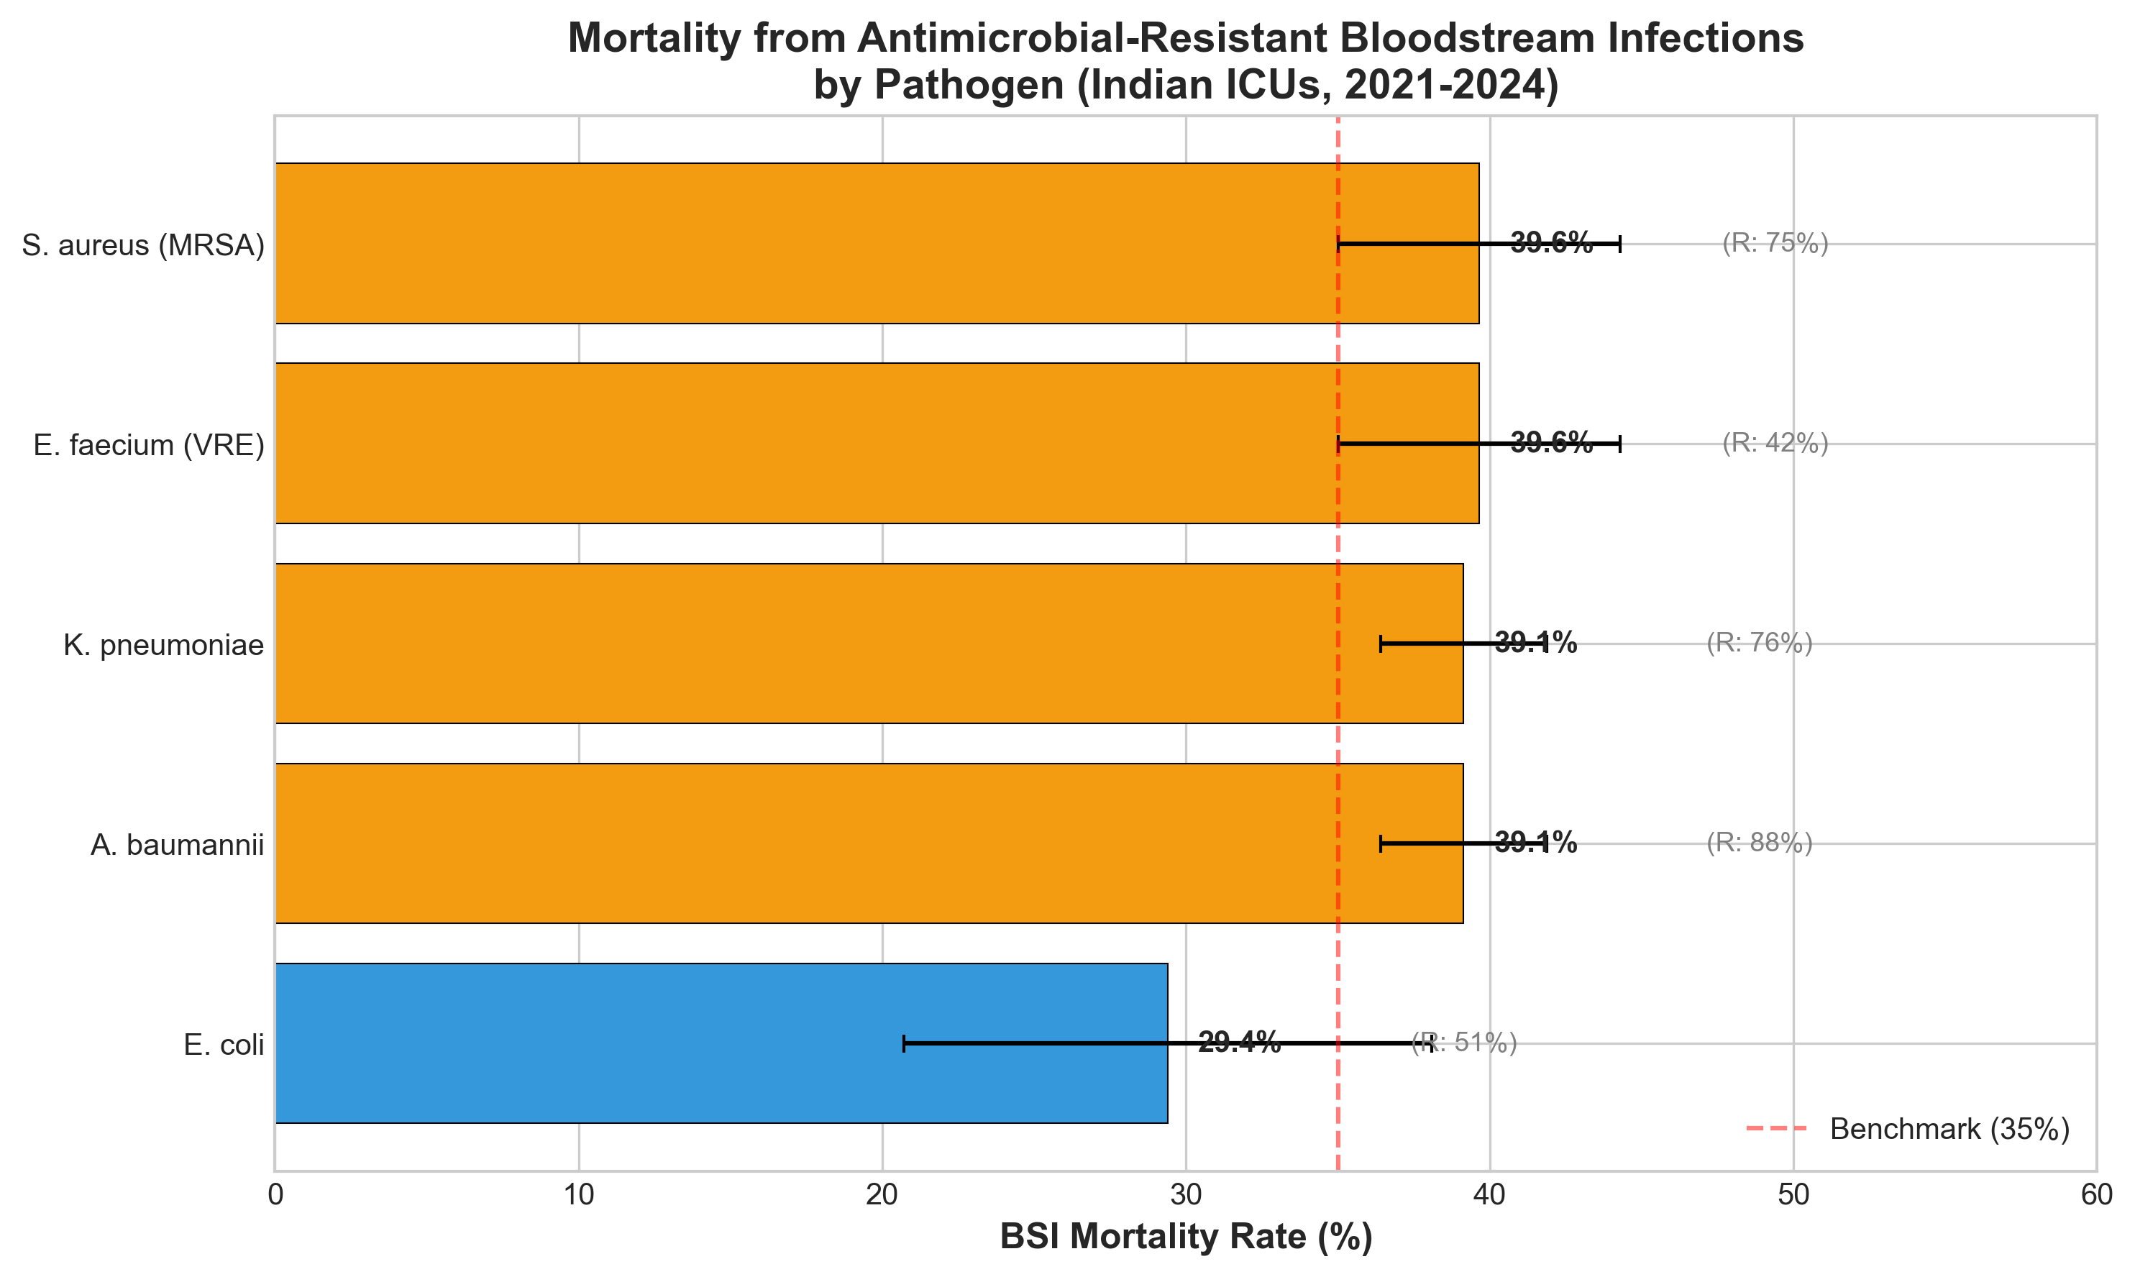

Figure 2: Temporal Trends
