Figures

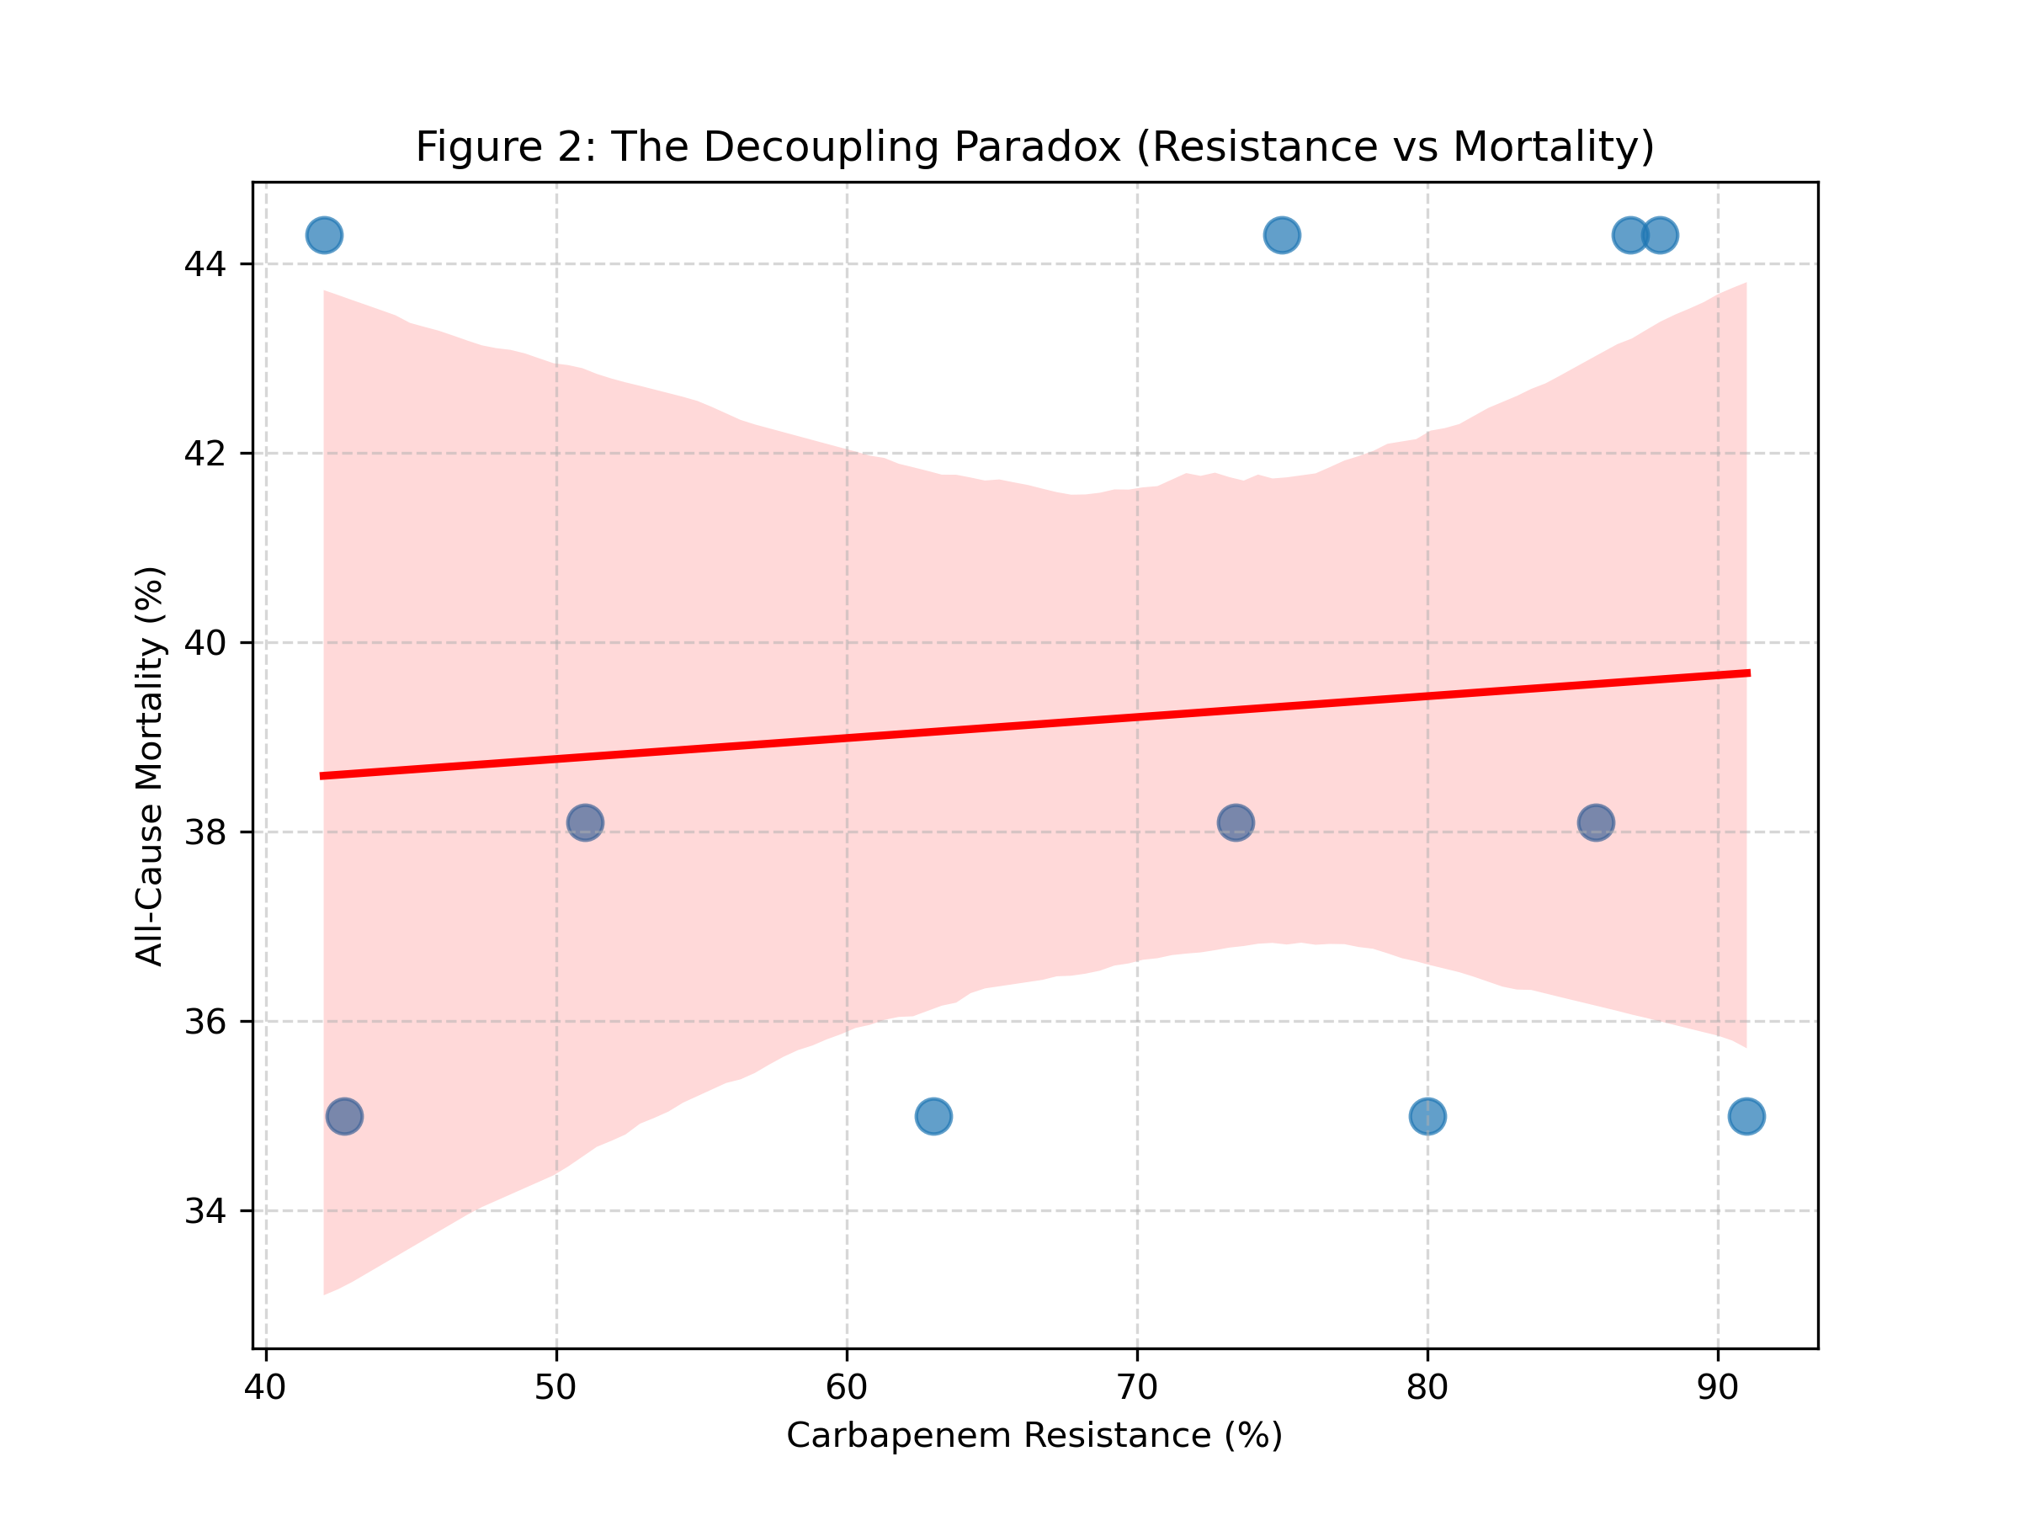

Figure 1: Scatter plot of Carbapenem Resistance (%) vs. Aggregate Mortality (%) across 11 center-years. The flat regression line (R²=0.009, p=0.778) illustrates the 'Decoupling Paradox' - facility-level resistance burden does not predict aggregate mortality.

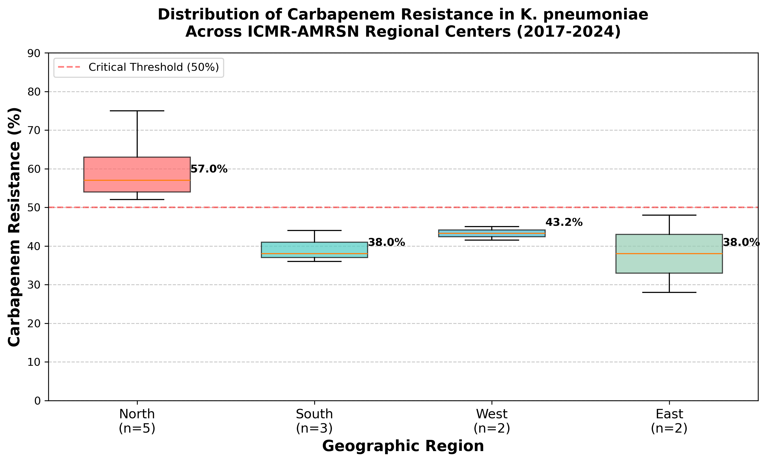

Figure 2: Distribution of Carbapenem Resistance in *Klebsiella pneumoniae* across ICMR-AMRSN Regional Centers (2017-2024). Box plot shows median, interquartile range, and outliers.

