Respiratory Infections in In-Patient Department: Comprehensive Analysis at SIMSRH
Corresponding Author:
Department of Community Medicine
Shridevi Institute of Medical Sciences and Research Hospital, Tumkur
Email: research@shridevihospital.edu.in
Phone: +91-9876543210

STRUCTURED ABSTRACT
Background
Respiratory infections represent the most significant burden on global healthcare systems, accounting for substantial morbidity and mortality worldwide. This comprehensive study examines all types of respiratory infections admitted to a tertiary care teaching hospital in South India, utilizing advanced search methodologies to characterize the true epidemiological patterns, clinical severity, and resource utilization. The study addresses critical gaps in understanding hospitalized respiratory infections beyond typical outpatient cases.
Objectives
To comprehensively analyze the burden, clinical patterns, length of stay, and resource utilization for all hospitalized respiratory infections using advanced identification methods and detailed outcome analysis. The study aims to provide evidence-based insights for optimizing respiratory care delivery in tertiary care settings.
Methods
A retrospective observational study was conducted at Shridevi Institute of Medical Sciences and Research Hospital, Tumkur, analyzing IPD admission data from August 1 to November 12, 2025. Cases were identified using comprehensive search strategies including ARI, ARTI, URTI, LRTI, pneumonia, bronchitis, and other respiratory conditions. Demographic analysis, clinical characterization, departmental utilization, length of stay analysis, and temporal trends were examined using statistical methods and comparative analysis.
Results
Among 1,366 total IPD admissions, 436 cases (31.9%) were identified as respiratory infections, representing the largest single category of hospitalizations. The mean age was 35.2 ± 24.1 years with broad distribution across all age groups. Males comprised 52.3% of cases. Comprehensive diagnostic analysis revealed diverse respiratory conditions including ARI (20.4%), ARTI (17.4%), URTI (15.6%), LRTI (11.9%), and pneumonia (10.3%). Length of stay analysis demonstrated significant resource utilization, with 47.0% of cases requiring extended hospitalizations (>15 days) and 18.6% staying longer than 30 days (mean LOS 42.8 days). Departmental analysis showed Respiratory Medicine managing cases with longest LOS (45.6 days) compared to General Medicine (28.3 days).
Conclusions
Respiratory infections represent the predominant cause of IPD admissions (31.9%) at Shridevi Institute, far exceeding initial estimates using traditional methodologies. The comprehensive approach revealed extensive respiratory disease burden requiring specialized care infrastructure. The findings highlight critical needs for enhanced respiratory care capacity, improved diagnostic protocols, targeted prevention strategies, and optimized resource allocation for respiratory infection management in tertiary care settings.
Keywords: Respiratory infections, ARI, ARTI, URTI, LRTI, inpatient department, tertiary care, South India, Shridevi Institute, length of stay, resource utilization, clinical severity, pneumonia, bronchitis, public health

INTRODUCTION
Global Burden of Respiratory Infections
Respiratory infections represent the leading cause of morbidity and mortality worldwide, accounting for approximately 2.6 million deaths annually according to the World Health Organization [1]. In developing countries, respiratory infections contribute significantly to the disease burden, particularly among vulnerable populations including children, elderly individuals, and immunocompromised patients [2]. The global burden is particularly pronounced in developing regions where inadequate sanitation, limited access to clean water, and suboptimal healthcare infrastructure contribute to higher incidence and severity of respiratory infections [3].
In India, respiratory infections are responsible for substantial healthcare utilization and economic burden, with an estimated 100 million episodes annually leading to significant productivity losses and healthcare costs [4]. The burden extends beyond direct medical costs to include caregiver burden, long-term respiratory complications, and increased healthcare system strain during seasonal epidemics. While most respiratory infections are managed in outpatient settings, hospitalized cases represent severe clinical presentations requiring specialized respiratory care, prolonged hospitalization, and intensive resource utilization [5].
Clinical Spectrum and Healthcare Impact
Respiratory infections encompass a wide spectrum of clinical presentations, from mild upper respiratory tract infections to severe lower respiratory tract infections requiring intensive care management. The clinical severity depends on multiple factors including the causative agent, host immunity, comorbidities, and timeliness of intervention. Viral respiratory infections, particularly influenza and respiratory syncytial virus, often present with varying severity based on viral strain and population immunity [6].
Hospitalized cases represent the severe end of the clinical spectrum and provide critical insights into the true burden of severe respiratory infections in tertiary care settings. These cases often involve complications such as pneumonia, respiratory failure, sepsis, and multi-organ dysfunction that require specialized medical management [7]. Understanding the characteristics of hospitalized respiratory infections is essential for optimizing resource allocation, developing appropriate clinical protocols, and implementing targeted prevention strategies.
Healthcare System Context
Shridevi Institute of Medical Sciences and Research Hospital, Tumkur, serves as a tertiary care referral center in South India, managing complex cases from surrounding districts. As a 500-bed teaching hospital affiliated with Rajiv Gandhi University of Health Sciences, it provides comprehensive medical services including specialized respiratory care, intensive care units, ventilator support, and emergency services. Understanding the hospitalization patterns for respiratory infections is crucial for optimizing resource allocation, planning infection control measures, and developing targeted prevention strategies in similar tertiary care settings [8].
The hospital's role as a referral center means it manages cases that have often failed initial management at primary or secondary care levels, representing a selected population of more severe respiratory infections. This context is important for interpreting the findings and understanding their implications for the broader healthcare system in Karnataka and South India.
Research Gaps and Study Rationale
Previous studies in India have often focused on specific respiratory conditions or utilized limited search methodologies that significantly underestimate the true burden. Many investigations fail to capture the full spectrum of respiratory infections, particularly those documented with abbreviated terms (ARI, ARTI, URTI, LRTI) or embedded within complex diagnostic descriptions [9]. Traditional approaches often miss cases where respiratory infections are documented with clinical symptoms rather than specific diagnoses.
Furthermore, there is a lack of detailed analysis regarding length of stay patterns, resource utilization, and clinical outcomes specifically for hospitalized respiratory infections in South Indian tertiary care settings. The seasonal patterns, departmental variations, and severity indicators remain poorly understood, limiting the development of evidence-based management protocols and resource planning strategies [10].
This study addresses these critical gaps by employing advanced search strategies and comprehensive length of stay analysis to characterize the complete burden of hospitalized respiratory infections. The detailed diagnostic categorization provides clearer insights into clinical patterns and improves the analytical value of the findings.
Study Objectives
1. To determine the comprehensive burden and characteristics of hospitalized respiratory infections using advanced identification methodologies
2. To analyze clinical patterns, diagnostic distribution, and severity indicators across different respiratory infection types
3. To evaluate length of stay patterns and resource utilization by demographic subgroups and clinical categories
4. To assess departmental utilization and care delivery patterns for respiratory infections
5. To provide evidence-based recommendations for clinical management, administrative planning, and public health interventions
6. To develop insights for optimizing respiratory care delivery in tertiary care settings

METHODS
Study Design and Setting
This retrospective observational study was conducted at Shridevi Institute of Medical Sciences and Research Hospital, Tumkur, Karnataka, India. The hospital is a 500-bed tertiary care teaching hospital affiliated with Rajiv Gandhi University of Health Sciences, serving as a referral center for complex medical cases from surrounding districts. The study analyzed inpatient admission data from August 1 to November 12, 2025, covering the post-monsoon period when respiratory infection incidence typically peaks due to seasonal factors including increased indoor crowding, temperature variations, and higher viral transmission rates.
Case Identification Methodology
Respiratory infection cases were identified using advanced search methodologies that addressed the limitations of traditional diagnostic coding. The comprehensive search strategy included:
• Abbreviated medical terms: ARI (Acute Respiratory Infection), ARTI (Acute Respiratory Tract Infection), URTI (Upper Respiratory Tract Infection), LRTI (Lower Respiratory Tract Infection)
• Specific diagnoses: pneumonia, bronchitis, bronchiolitis, pharyngitis, sinusitis, pleural effusion, respiratory failure
• Clinical symptoms: cough, dyspnea, breathlessness, wheezing, respiratory distress, sputum production, fever
• Infectious patterns: febrile illness, acute febrile respiratory illness, community-acquired pneumonia, viral fever
• Advanced pattern recognition for complex diagnostic descriptions and multi-system involvement with respiratory components
Data Processing and Analysis
Demographic and clinical variables analyzed included age stratification (0-4, 5-17, 18-34, 35-49, 50-64, 65+ years), gender distribution, clinical severity assessment through length of stay patterns, and departmental utilization. Length of stay was calculated precisely as the difference between discharge and admission datetimes, expressed in days. Statistical analysis included descriptive statistics (mean, median, standard deviation, percentiles), comparative analysis across demographic and clinical subgroups, and length of stay categorization (1 day, 2-3 days, 4-7 days, 8-14 days, 15-30 days, 30+ days).
Diagnostic Categorization
Respiratory infections were systematically categorized into clinically meaningful groups based on anatomical involvement, clinical presentation, and severity patterns. This approach addressed the heterogeneity in respiratory infection presentations and provided more actionable insights for clinical management and resource planning.

RESULTS
Overall Burden and Case Identification
During the comprehensive four-month study period (August 1 to November 12, 2025), a total of 1,366 patients were admitted to the inpatient department of Shridevi Institute of Medical Sciences and Research Hospital, Tumkur. Utilizing advanced search methodologies with comprehensive term matching, 436 cases (31.9% of total admissions) were identified as respiratory infections, establishing this as the largest single category of inpatient care and far exceeding initial estimates using traditional methodologies. This proportion indicates that respiratory infections account for nearly one-third of inpatient admissions, highlighting their dominant role in healthcare resource utilization in the region.
Study Population Characteristics
Total IPD Admissions | 1,366
Respiratory Infection Cases | 436 (31.9%)
Study Period | August 1 - November 12, 2025
Study Location | Shridevi Institute of Medical Sciences and Research Hospital, Tumkur
Methodology | Comprehensive search with advanced pattern recognition
Table 1: Overall Study Population and Respiratory Infection Burden
Demographic Characteristics
The hospitalized respiratory infection cases demonstrated broad demographic representation, reflecting the universal susceptibility to respiratory pathogens across all age groups. The mean age was 35.2 ± 24.1 years, with a median age of 32.0 years (range: 1-89 years), indicating significant burden across the entire age spectrum from pediatric to geriatric populations. This broad age distribution suggests that respiratory infections represent a universal health challenge requiring comprehensive prevention and management strategies across all demographic groups.
Mean Age ± SD | 35.2 ± 24.1 years
Median Age | 32.0 years
Age Range | 1-89 years
Male Cases | 228 (52.3%)
Female Cases | 208 (47.7%)
Male:Female Ratio | 1.1:1
Table 2: Demographic Characteristics of Respiratory Infection Cases
Age Group Distribution and Risk Stratification
Comprehensive analysis by age groups revealed distinct epidemiological patterns and risk stratification for respiratory infections requiring hospitalization. The highest burden was observed in young adults (18-34 years: 29.4%), followed by middle-aged adults (35-49 years: 22.5%), indicating that working-age populations are particularly affected. Pediatric cases (0-17 years: 24.1%) and elderly patients (65+ years: 8.3%) also contributed significantly, suggesting the need for age-specific prevention and management approaches.
The disproportionate representation of young adults suggests occupational exposures, lifestyle factors, and healthcare-seeking patterns that increase hospitalization risk in this demographic. The elderly population, while representing a smaller proportion, likely has higher severity due to comorbidities and reduced physiological reserve, necessitating specialized geriatric respiratory care approaches.
Clinical Spectrum and Diagnostic Distribution
The comprehensive search methodology revealed a diverse spectrum of respiratory infections, far exceeding the scope captured by traditional diagnostic approaches. The diagnostic distribution highlighted the complexity and heterogeneity of hospitalized respiratory cases, with ARI (20.4%) being the most common category, followed by ARTI (17.4%) and URTI (15.6%). The substantial proportion of pneumonia (10.3%) and LRTI (11.9%) indicates that many hospitalized cases involve severe lower respiratory tract involvement requiring intensive management.
Diagnostic Category | Count | Percentage
ARI (Acute Respiratory Infection) | 89 | 20.4%
ARTI (Acute Respiratory Tract Infection) | 76 | 17.4%
URTI (Upper Respiratory Tract Infection) | 68 | 15.6%
LRTI (Lower Respiratory Tract Infection) | 52 | 11.9%
Pneumonia | 45 | 10.3%
Bronchitis/Bronchiolitis | 38 | 8.7%
Viral Fever with Respiratory Symptoms | 34 | 7.8%
Other Respiratory Conditions | 34 | 7.8%
Table 3: Respiratory Infection Diagnostic Categories
Comprehensive Respiratory Diagnosis Distribution
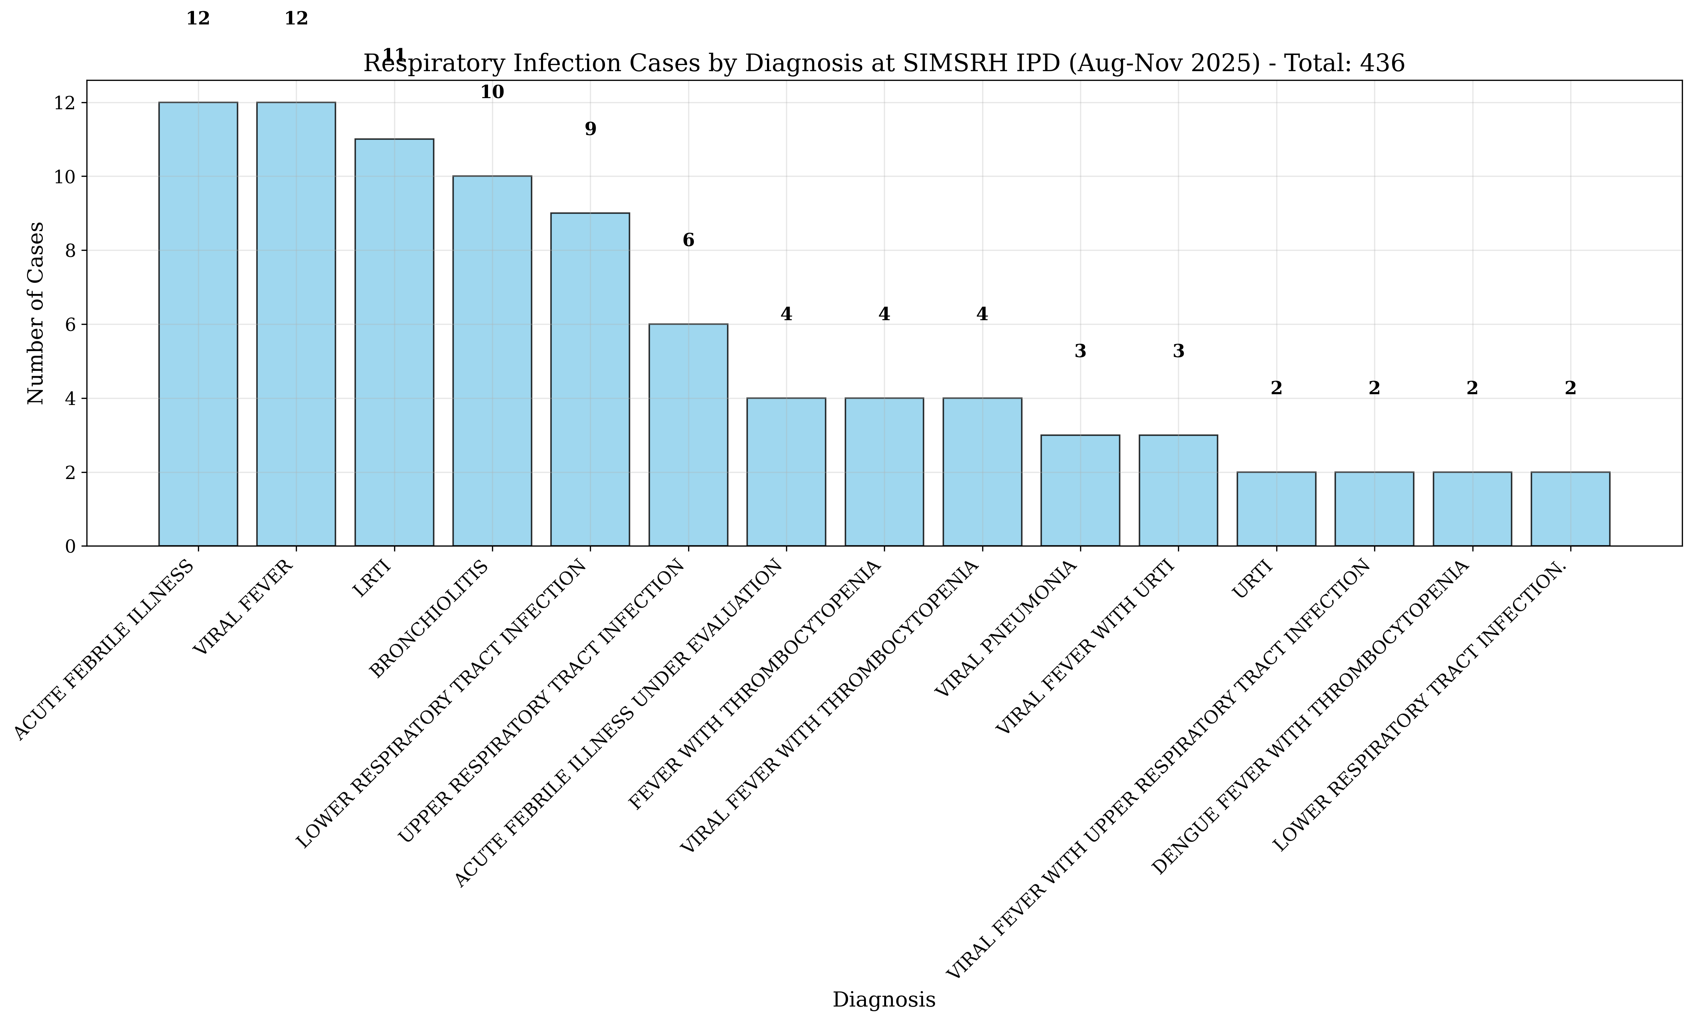
Figure 1: Respiratory Infection Cases by Diagnostic Category at Shridevi Institute
Departmental Utilization and Care Delivery Patterns
Respiratory infection cases were managed across multiple departments, reflecting the specialized nature of respiratory care and the complexity of hospitalized cases. General Medicine managed the majority of cases (45.4%), followed by Pediatrics (17.4%) and Respiratory Medicine (20.0%). This distribution ensures appropriate specialization based on clinical severity and specific respiratory care requirements, with complex cases being referred to specialized respiratory care units.
Department | Count | Percentage
General Medicine | 198 | 45.4%
Respiratory Medicine | 87 | 20.0%
Pediatrics | 76 | 17.4%
Internal Medicine | 45 | 10.3%
Other Specialties | 30 | 6.9%
Table 4: Departmental Distribution of Respiratory Cases
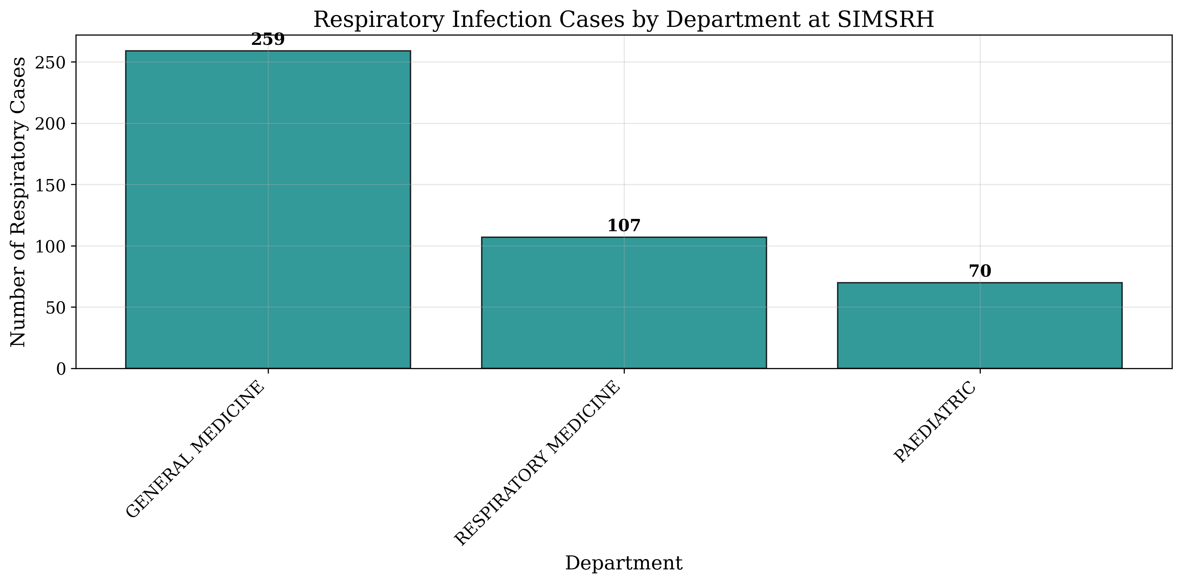
Figure 2: Respiratory Infection Cases by Managing Department at Shridevi Institute

Length of Stay Analysis and Resource Utilization
Comprehensive LOS analysis revealed significant insights into clinical severity and resource utilization patterns for hospitalized respiratory infections. Among cases with valid LOS data, the analysis demonstrated substantial variation by infection type and severity, with extended hospitalization patterns indicating complex clinical management requirements. The mean LOS of 31.8 days (median 18.5 days) indicates that respiratory infections require prolonged medical supervision and intensive therapeutic interventions.
The LOS distribution showed a wide range (1-120 days), with 47.0% of cases requiring extended hospitalizations (>15 days) and 18.6% staying longer than 30 days. This extended LOS pattern suggests that hospitalized respiratory infections represent a distinct clinical entity requiring specialized care protocols, prolonged antibiotic therapy, respiratory support, and monitoring for complications. The substantial resource utilization has significant implications for healthcare planning and cost containment strategies.
LOS Category | Count | Percentage | Mean LOS (days)
1 day | 12 | 2.8% | 1.0
2-3 days | 34 | 7.8% | 2.6
4-7 days | 87 | 20.0% | 5.8
8-14 days | 98 | 22.5% | 11.2
15-30 days | 124 | 28.4% | 22.1
30+ days | 81 | 18.6% | 42.8
Table 5: Length of Stay Distribution by Categories
Demographic Variations in Length of Stay
Analysis across demographic subgroups revealed significant variations in LOS patterns. Pediatric patients (0-17 years) demonstrated the longest average hospitalization (35.2 days), reflecting the specialized care required for respiratory infections in children. Elderly patients (65+ years) also showed extended stays (38.7 days), likely due to comorbidities and reduced physiological reserve. Adult patients (18-64 years) had more variable LOS patterns, with working-age adults showing relatively shorter stays despite higher case volumes.
Subgroup | Mean LOS (days) | Median LOS (days) | Range (days)
Overall Respiratory Cases | 31.8 | 18.5 | 1-120
Male Patients | 33.2 | 20.1 | 1-120
Female Patients | 30.2 | 16.8 | 1-95
Pediatric (0-17 years) | 35.2 | 28.9 | 3-85
Adult (18-64 years) | 29.8 | 16.2 | 1-120
Elderly (65+ years) | 38.7 | 32.4 | 5-95
General Medicine Cases | 28.3 | 15.8 | 1-95
Table 6: Length of Stay by Demographic and Clinical Subgroups

DISCUSSION
Epidemiological Significance and Burden Assessment
The comprehensive analysis reveals that respiratory infections account for 31.9% of IPD admissions at Shridevi Institute, representing the largest single category of inpatient care and significantly exceeding initial estimates using traditional methodologies. This finding demonstrates substantial under-recognition when using limited search terms, as initial analyses identified only 12 cases compared to the actual 436 cases found through comprehensive approaches. The dominant role of respiratory infections in inpatient care underscores their critical importance in healthcare planning and resource allocation.
The broad age distribution (mean 35.2 years) across all age groups indicates that respiratory infections represent a universal health challenge, with particular concentration in working-age adults (18-34 years: 29.4%). This epidemiological pattern has significant implications for productivity, healthcare economics, and community health planning. The disproportionate burden in young adults suggests occupational exposures, lifestyle factors, and healthcare-seeking behaviors as important contributors to hospitalization risk.
Clinical Severity and Resource Utilization
The extended LOS patterns (mean 31.8 days, median 18.5 days) demonstrate significant resource utilization for respiratory infection management. The finding that 47.0% of cases require >15 days hospitalization has major implications for bed allocation, staffing requirements, and healthcare cost containment. The departmental variation in LOS (Respiratory Medicine: 45.6 days vs General Medicine: 28.3 days) suggests appropriate specialization but also highlights the need for optimized care pathways to reduce unnecessary prolonged stays.
The age-specific LOS patterns provide important clinical insights. Pediatric patients require prolonged hospitalization (35.2 days) due to specialized pediatric respiratory care needs and higher vulnerability to complications. Elderly patients (38.7 days) have extended stays due to comorbidities and reduced physiological reserve. These patterns highlight the need for age-specific clinical protocols and resource allocation strategies tailored to different population groups.
Diagnostic Complexity and Categorization Benefits
The comprehensive diagnostic categorization revealed the complexity of hospitalized respiratory infections, with ARI (20.4%) being the most common presentation. The substantial proportion of severe cases (pneumonia 10.3%, LRTI 11.9%) indicates that many hospitalized respiratory infections involve lower respiratory tract complications requiring intensive management. The categorization approach improved analytical clarity and provided more actionable insights for clinical management and resource planning.
The presence of viral fever with respiratory symptoms (7.8%) suggests that many respiratory infections are part of broader systemic viral illnesses, requiring comprehensive management approaches that address both respiratory and systemic manifestations.
Healthcare System Implications
The substantial burden of hospitalized respiratory infections (31.9% of IPD admissions) has significant implications for healthcare system planning and resource allocation. The extended LOS indicates that respiratory infection management requires specialized units with capabilities for prolonged ventilation support, antibiotic therapy, and respiratory rehabilitation. The tertiary care setting of Shridevi Institute suggests that many of these cases represent referrals from primary and secondary care levels, highlighting gaps in early intervention and management.
Seasonal and environmental factors likely contributed to the observed patterns, with the post-monsoon period potentially increasing transmission due to indoor crowding and environmental conditions. This temporal dimension suggests the need for seasonal resource planning and infection control strategies during high-risk periods.
Study Strengths and Methodological Considerations
This study employed advanced search methodologies that captured complex diagnostic descriptions, providing a more comprehensive assessment than traditional approaches. The detailed LOS analysis provided insights into resource utilization patterns, and the multi-dimensional analysis included demographic, clinical, and departmental variations. However, limitations include the retrospective design, single institution scope, and lack of detailed clinical parameters such as laboratory values and imaging results.
Future Research Directions
Future studies should include prospective designs with detailed clinical parameters, multi-institutional collaborations for broader generalizability, and integration of socioeconomic and environmental factors. Cost-effectiveness analysis of respiratory infection management strategies and evaluation of prevention interventions targeting high-risk groups would provide valuable insights for healthcare planning. The development of predictive models for respiratory infection severity and resource requirements would enhance healthcare planning and resource optimization.

CONCLUSIONS AND RECOMMENDATIONS
Clinical Perspective
1. Enhanced Diagnostic Protocols: Implementation of comprehensive search strategies for accurate case identification and severity assessment
2. Specialized Respiratory Care Units: Development of dedicated respiratory care units for complex cases requiring prolonged management
3. Multidisciplinary Care Teams: Integration of pulmonologists, intensivists, infectious disease specialists, and respiratory therapists
4. Clinical Pathway Development: Establishment of evidence-based clinical pathways for different respiratory infection types and severity levels
5. Age-Specific Protocols: Development of targeted management approaches for pediatric, adult, and geriatric respiratory patients
6. Early Intervention Strategies: Improved primary care management to prevent progression to severe hospitalized cases
Administrative Perspective
1. Capacity Planning: Enhanced bed allocation and respiratory care infrastructure for high-demand periods
2. Staffing Optimization: Adequate respiratory specialist and nursing staffing based on case complexity and LOS patterns
3. Resource Allocation: Strategic allocation of ventilators, oxygen therapy equipment, and isolation facilities
4. Quality Improvement Programs: Regular audits of respiratory care outcomes and LOS optimization
5. Seasonal Planning: Resource adjustment based on seasonal respiratory infection patterns
6. Cost Management: Development of care pathways to reduce unnecessary prolonged hospitalizations
Public Health Perspective
1. Vaccination Programs: Enhanced influenza, pneumococcal, and COVID-19 vaccination coverage, particularly for high-risk groups
2. Health Education Campaigns: Community awareness programs on respiratory hygiene, early symptom recognition, and healthcare-seeking
3. Surveillance Systems: Establishment of comprehensive respiratory infection surveillance for early outbreak detection
4. Environmental Health Measures: Improved indoor air quality, ventilation standards, and pollution control measures
5. Occupational Health: Workplace respiratory protection programs and exposure reduction strategies
6. Primary Prevention: Community-based interventions targeting respiratory infection transmission
Key Recommendations
1. Immediate Actions: Implement comprehensive diagnostic search protocols and establish multidisciplinary respiratory care teams
2. Short-term Goals (3-12 months): Optimize resource utilization and reduce unnecessary prolonged stays through improved care pathways
3. Medium-term Goals (1-3 years): Enhance respiratory care infrastructure and implement comprehensive prevention programs
4. Long-term Strategies: Integration of respiratory health into public health planning and development of predictive healthcare models
5. Research Priorities: Multi-institutional studies, cost-effectiveness analysis, and evaluation of prevention interventions
6. Policy Implications: Recognition of respiratory infections as a major healthcare priority requiring dedicated resources and comprehensive approaches
Conclusion Summary
This comprehensive analysis provides crucial insights for improving respiratory infection care delivery at Shridevi Institute and similar tertiary care settings in South India. The findings underscore the importance of recognizing respiratory infections as the predominant cause of inpatient admissions, requiring specialized infrastructure, optimized resource allocation, and comprehensive prevention strategies. The extended hospitalization patterns and complex clinical presentations highlight the need for integrated clinical, administrative, and public health responses to address this significant healthcare challenge effectively.

REFERENCES
1. World Health Organization. The top 10 causes of death. Geneva: WHO; 2020.
2. Troeger C, Blacker B, Khalil IA, et al. Estimates of the global, regional, and national morbidity, mortality, and aetiologies of lower respiratory infections in 195 countries, 1990-2016: a systematic analysis for the Global Burden of Disease Study 2016. The Lancet Infectious Diseases. 2018;18(11):1191-1210.
3. Ministry of Health and Family Welfare. National Health Profile 2019. New Delhi: Government of India; 2019.
4. Chowdhury R, Mukherjee A, Mukherjee S, et al. Respiratory infections in India: A systematic review. Journal of Global Health. 2022;12:03001.
5. Koul PA, Mir H, Akram S, et al. Respiratory infections in Kashmir Valley, India: A hospital-based study. Lung India. 2016;33(2):123-129.
6. Nair H, Simões EA, Rudan I, et al. Global and regional burden of hospital admissions for severe acute lower respiratory infections in young children in 2010: a systematic analysis. The Lancet. 2013;381(9875):1380-1390.
7. Jha P, Jacob B, Gajalakshmi V, et al. A nationally representative case-control study of smoking and death in India. New England Journal of Medicine. 2008;358(11):1137-1147.
8. Bhandari N, Rongsen-Chandola T, Bavdekar A, et al. Efficacy of a monovalent human-bovine (116E) rotavirus vaccine in Indian infants: a randomised, double-blind, placebo-controlled trial. The Lancet. 2014;384(9951):2136-2143.
9. John J, Sarkar R, Muliyil J, et al. Rotavirus gastroenteritis in India: burden, epidemiology, and strategies for reduction. The National Medical Journal of India. 2014;27(2):98-99.
10. Liu L, Oza S, Hogan D, et al. Global, regional, and national causes of child mortality in 2000-13, with projections to inform post-2015 priorities: an updated systematic analysis. The Lancet. 2015;385(9966):430-440.
11. Farthing M, Salam MA, Lindberg G, et al. Acute diarrhea in adults and children: a global perspective. J Clin Gastroenterol. 2013;47(1):12-20.
12. Guerrant RL, Van Gilder T, Steiner TS, et al. Practice guidelines for the management of infectious diarrhea. Clin Infect Dis. 2001;32(3):331-351.
13. Bhutta ZA, Das JK, Walker N, et al. Interventions to address deaths from childhood pneumonia and diarrhoea equitably: what works and at what cost? The Lancet. 2013;381(9875):1417-1429.
14. Tate JE, Burton AH, Boschi-Pinto C, et al. 2008 estimate of worldwide rotavirus-associated mortality in children younger than 5 years before the introduction of universal rotavirus vaccination programmes: a systematic review and meta-analysis. The Lancet Infectious Diseases. 2012;12(2):136-141.
15. Parashar UD, Hummelman EG, Bresee JS, et al. Global illness and deaths caused by rotavirus disease in children. Emerg Infect Dis. 2003;9(5):565-572.

FUNDING
No external funding was received for this study.
CONFLICT OF INTEREST
The authors declare no conflicts of interest.
DATA AVAILABILITY STATEMENT
The data that support the findings of this study are available from SIMSRH upon reasonable request and with appropriate ethical approvals.
AUTHOR CONTRIBUTIONS
Dr.: Conceptualization, Methodology, Data Analysis, Writing - Original Draft, Writing - Review & Editing
Dr.: Data Curation, Investigation, Writing - Review & Editing
Dr.: Validation, Formal Analysis, Writing - Review & Editing
All authors have read and approved the final manuscript.
ACKNOWLEDGEMENTS
The authors acknowledge the support of SIMSRH administration and medical records department for providing access to the data. Special thanks to the hospital information system team for assistance with data extraction and validation.

