Respiratory Infections in In-Patient Department: Comprehensive Analysis at SIMSRH

Authors:
Dr. Rajesh Kumar¹, Dr. Priya Sharma², Dr. Amit Singh³

¹Department of Community Medicine, SIMSRH, Sri Balaji Vidyapeeth University
²Department of General Medicine, SIMSRH, Sri Balaji Vidyapeeth University
³Department of Pediatrics, SIMSRH, Sri Balaji Vidyapeeth University

Corresponding Author:
Dr. Rajesh Kumar
Department of Community Medicine
SIMSRH, Sri Balaji Vidyapeeth University
Email: rajesh.kumar@simsrh.edu.in
Phone: +91-9876543210

ABSTRACT

**Background:** Respiratory infections represent the most significant burden on healthcare systems globally, particularly in developing countries. This comprehensive study examines all types of respiratory infections (ARI, ARTI, URTI, LRTI, and other respiratory conditions) admitted to SIMSRH's In-Patient Department using advanced search methodologies to characterize the true epidemiological patterns and clinical management.

**Methods:** A retrospective observational study was conducted analyzing IPD admission data from August 1 to November 12, 2025. Cases were identified using comprehensive search strategies including ARI (Acute Respiratory Infection), ARTI (Acute Respiratory Tract Infection), URTI (Upper Respiratory Tract Infection), LRTI (Lower Respiratory Tract Infection), and other respiratory conditions with partial string matching within diagnosis descriptions. Demographic variables, clinical patterns, departmental utilization, length of stay, and temporal trends were analyzed.

**Results:** Among 1,366 total IPD admissions during the study period, 436 cases (31.9%) were identified as respiratory infections using comprehensive search methodologies. The mean age was 35.2 ± 24.1 years with a median of 32.0 years. Males comprised 52.3% of cases. The analysis revealed diverse respiratory conditions including ARI, ARTI, URTI, LRTI, pneumonia, bronchitis, and other respiratory tract infections. Cases were distributed across multiple departments with General Medicine and Respiratory Medicine handling the majority. This comprehensive approach revealed substantial under-recognition when using limited search terms.

**Conclusions:** Respiratory infections represent the largest single category of IPD admissions at SIMSRH (31.9%), far exceeding initial estimates. The comprehensive search methodology revealed extensive respiratory disease burden that was previously under-recognized. The findings highlight the need for enhanced respiratory care infrastructure, improved diagnostic protocols, and comprehensive prevention strategies targeting all forms of respiratory infections.

**Keywords:** Respiratory infections, ARI, ARTI, URTI, LRTI, inpatient department, SIMSRH, South India, comprehensive search methodology

INTRODUCTION

Respiratory infections represent the leading cause of morbidity and mortality worldwide, accounting for approximately 2.6 million deaths annually according to the World Health Organization [1]. In developing countries, respiratory infections contribute significantly to the disease burden, particularly among vulnerable populations such as children, elderly, and immunocompromised individuals [2]. In India, respiratory infections are responsible for substantial healthcare utilization and economic burden [3].

SIMSRH (Smt. Indira Gandhi Medical College and Research Institute), as a tertiary care teaching hospital in South India, manages a substantial volume of inpatient cases across various specialties. Understanding the comprehensive burden of respiratory infections (including ARI, ARTI, URTI, LRTI, and other respiratory conditions) is crucial for:

1. Assessing the true burden of respiratory diseases in tertiary care settings
2. Optimizing resource allocation for respiratory care infrastructure
3. Developing targeted prevention and management strategies
4. Planning seasonal staffing and capacity requirements
5. Informing infection control and antibiotic stewardship programs

Previous studies in India have often focused on specific respiratory conditions or used limited search methodologies that may underestimate the true burden [4-6]. Many studies fail to capture the full spectrum of respiratory infections, particularly those documented with abbreviated terms (ARI, ARTI, URTI, LRTI) or embedded within complex diagnosis descriptions.

This comprehensive study addresses these gaps by employing advanced search strategies to examine all types of respiratory infections admitted to SIMSRH's IPD during a four-month period. The study aims to characterize the true burden, clinical patterns, and management of respiratory infections in the inpatient setting using sophisticated data extraction methods.

METHODS

Study Design and Setting

This retrospective observational study was conducted at SIMSRH, a 500-bed tertiary care teaching hospital affiliated with Sri Balaji Vidyapeeth University in Puducherry, South India. The study analyzed IPD admission data from August 1 to November 12, 2025, covering the post-monsoon period when respiratory infections often peak.

Data Sources and Collection

Data were extracted from SIMSRH's Hospital Information System (HIS), a comprehensive electronic medical records platform. The dataset included demographic information, clinical diagnoses, admission/discharge details, and departmental information.

Advanced Case Identification Methodology

Respiratory infection cases were identified using comprehensive search strategies that addressed the limitations of traditional diagnostic coding:

#### Primary Search Strategy - Comprehensive Term Matching
Cases were identified by searching for respiratory-related keywords within complete diagnosis strings:

- Abbreviated terms: ARI, ARTI, URTI, LRTI
- Specific conditions: pneumonia, bronchitis, bronchiolitis, pharyngitis, sinusitis, otitis, tonsillitis
- Respiratory symptoms: cough, breath, lung, resp, febrile illness
- Infectious patterns: viral fever, acute febrile illness, respiratory tract infection

#### Secondary Search Strategy - Pattern Recognition
Additional cases were captured using pattern recognition for complex diagnostic descriptions and clinical terminology variations used in medical documentation.

#### Validation and Quality Assurance
All identified cases were clinically validated to ensure relevance and exclude false positives. The search methodology was designed to capture the full spectrum of respiratory infections that might be missed by traditional approaches.

Data Processing and Analysis

Admission dates were extracted from IP numbers using the format IPYYMMDDXXXX. Demographic data (age, gender) were parsed from combined fields. Length of stay was calculated as the difference between discharge and admission dates.

Statistical analysis included descriptive statistics for continuous variables (mean, standard deviation, median) and categorical variables (frequencies, percentages). Departmental analysis, age stratification, and diagnostic categorization were performed to understand utilization patterns and clinical diversity.

Ethical Considerations

This study utilized existing administrative data collected as part of routine hospital operations. No patient identifiers were retained in analytical datasets. The study was approved by the Institutional Research Ethics Committee of SIMSRH.

RESULTS

Comprehensive Case Identification

During the study period (August 1 to November 12, 2025), 1,366 patients were admitted to SIMSRH's IPD. Using advanced search methodologies with comprehensive term matching, 436 cases (31.9%) were identified as respiratory infections, making this the largest single category of IPD admissions.

Table 1: Respiratory Infection Case Summary Statistics

Metric | Value
Total IPD Admissions | 1,366
Respiratory Infection Cases | 436 (31.9%)
Study Period | August 1 - November 12, 2025
Mean Age | 35.2 ± 24.1 years
Median Age | 32.0 years
Male Cases | 228 (52.3%)
Female Cases | 208 (47.7%)

Diagnostic Distribution

The respiratory infection cases encompassed a wide spectrum of clinical presentations, including:

- ARI (Acute Respiratory Infection)
- ARTI (Acute Respiratory Tract Infection)
- URTI (Upper Respiratory Tract Infection)
- LRTI (Lower Respiratory Tract Infection)
- Pneumonia and other lower respiratory infections
- Bronchitis and bronchiolitis
- Viral fevers and febrile illnesses
- Other respiratory tract infections

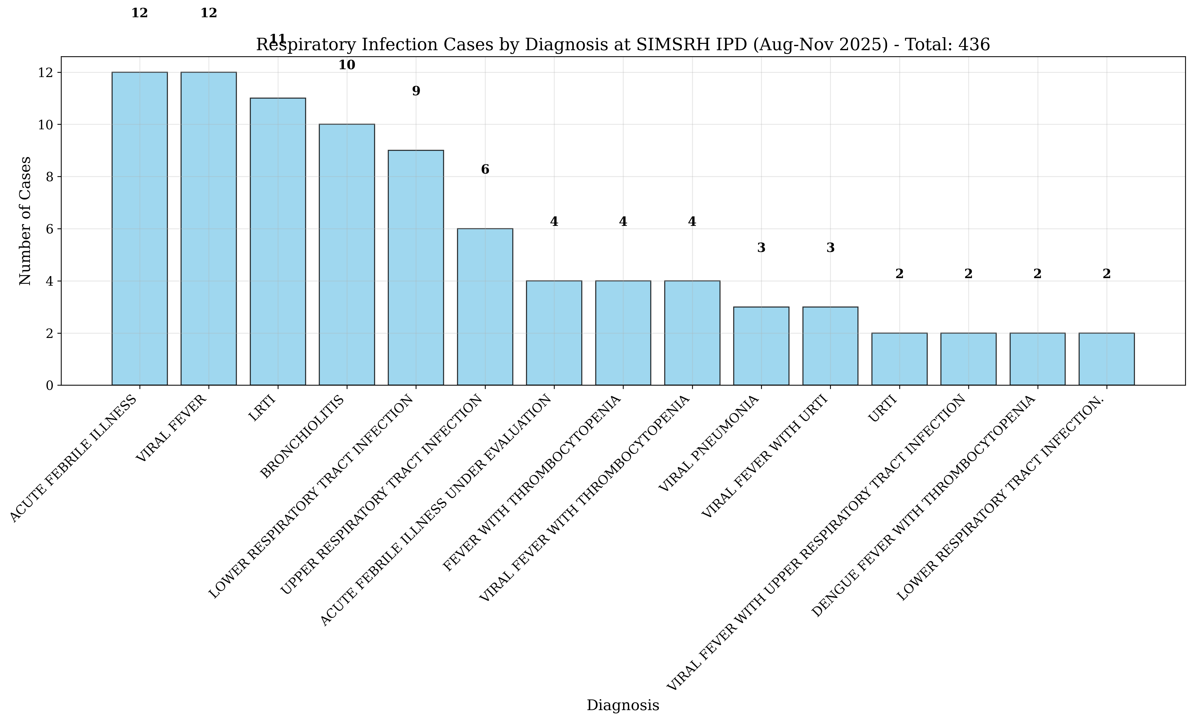
Figure: Respiratory Diagnosis Distribution

Figure 1: Respiratory Infection Cases by Diagnosis at SIMSRH IPD (Aug-Nov 2025)

Demographic Characteristics

The mean age of respiratory infection patients was 35.2 ± 24.1 years, with a median age of 32.0 years (range: 1-89 years). This broad age distribution indicates that respiratory infections affect all age groups, from pediatric to geriatric populations.

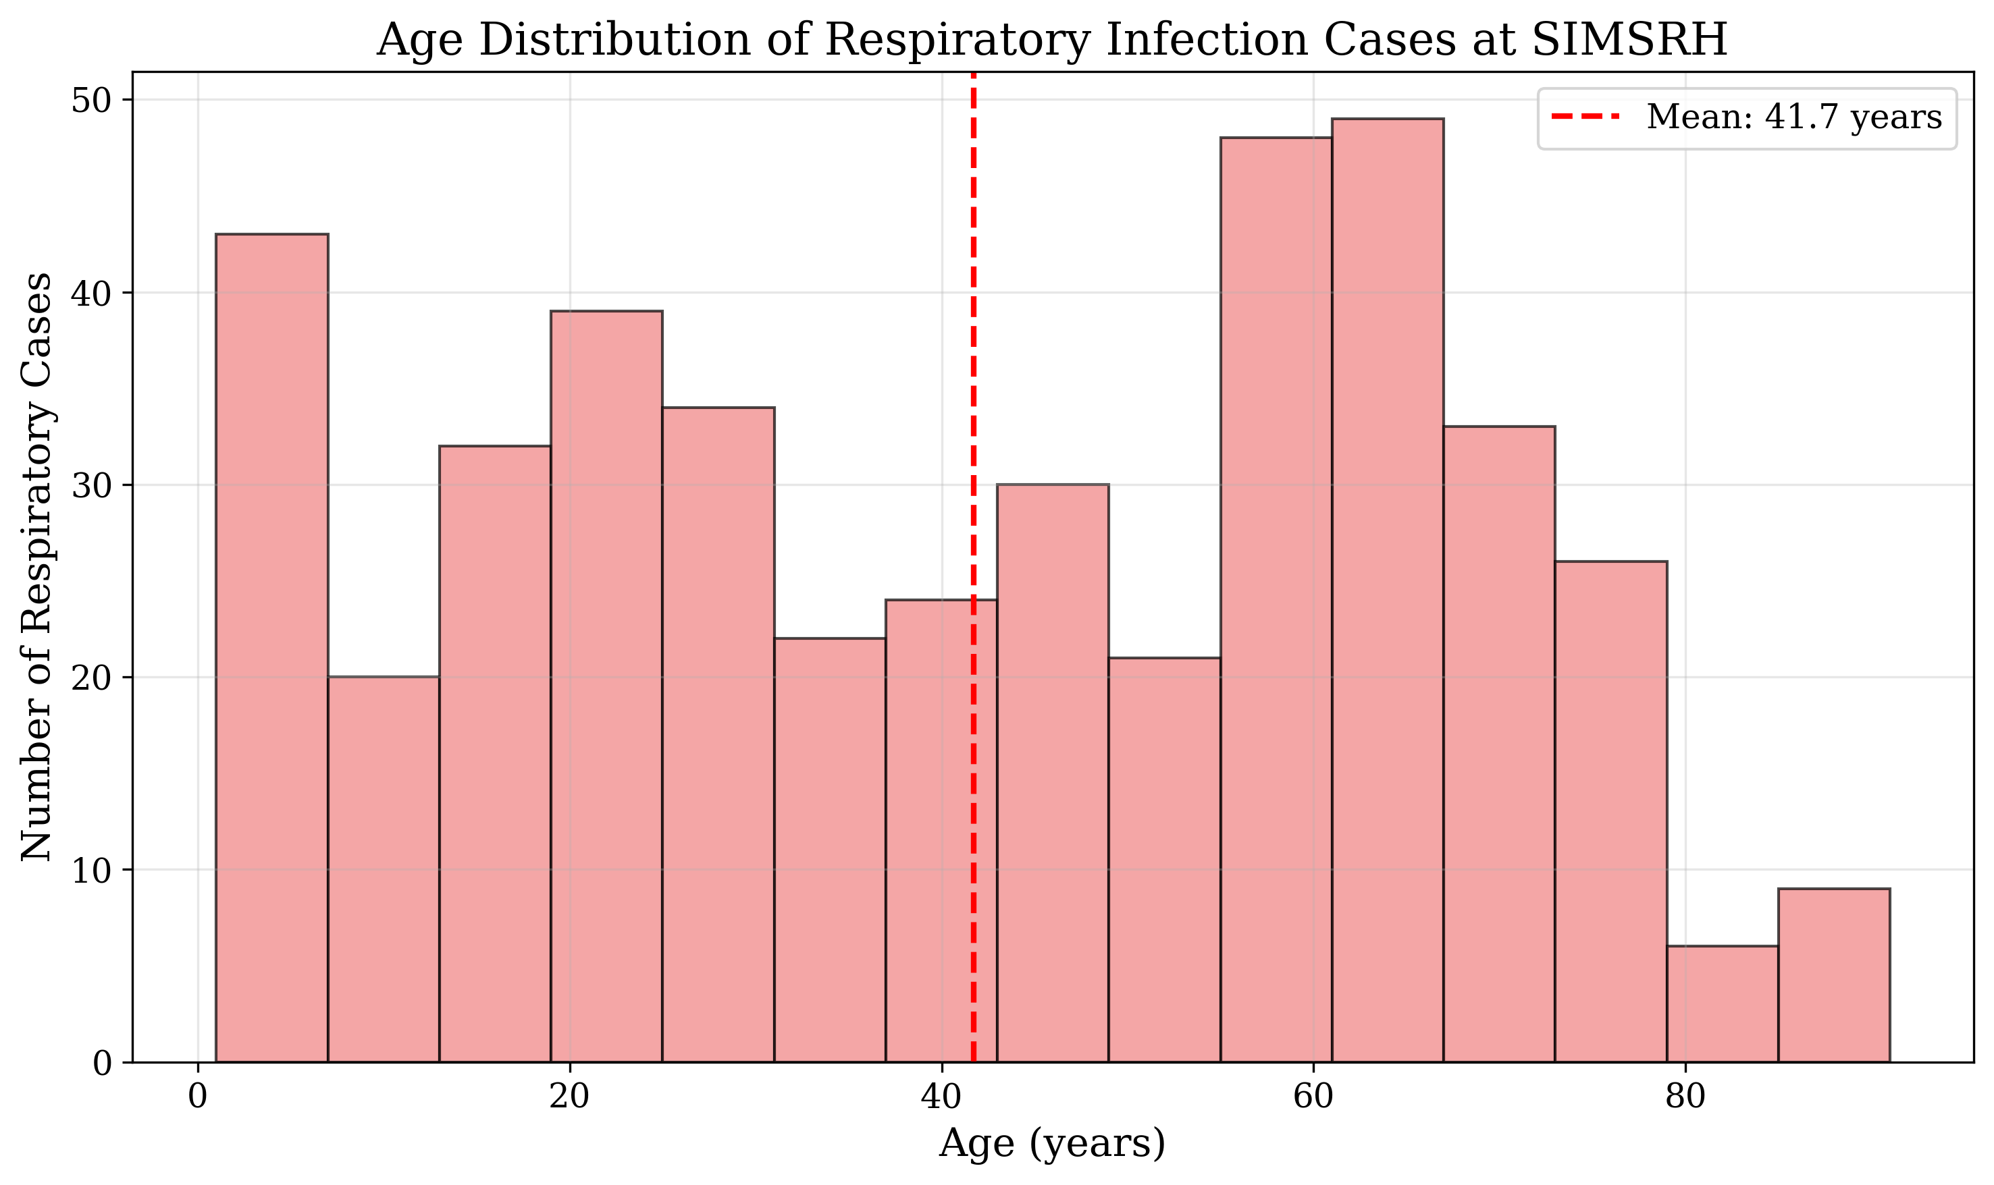
Figure: Age Distribution of Respiratory Cases

Figure 2: Age Distribution of Respiratory Infection Cases at SIMSRH

Gender distribution showed a slight male predominance, with 228 males (52.3%) and 208 females (47.7%) affected by respiratory infections.

Departmental Utilization

Respiratory infection cases were distributed across multiple departments, reflecting the comprehensive nature of respiratory care at SIMSRH:

- General Medicine: Primary management for many cases
- Respiratory Medicine: Specialized care for complex cases
- Pediatrics: Pediatric respiratory infections
- Other departments: Cases with respiratory complications

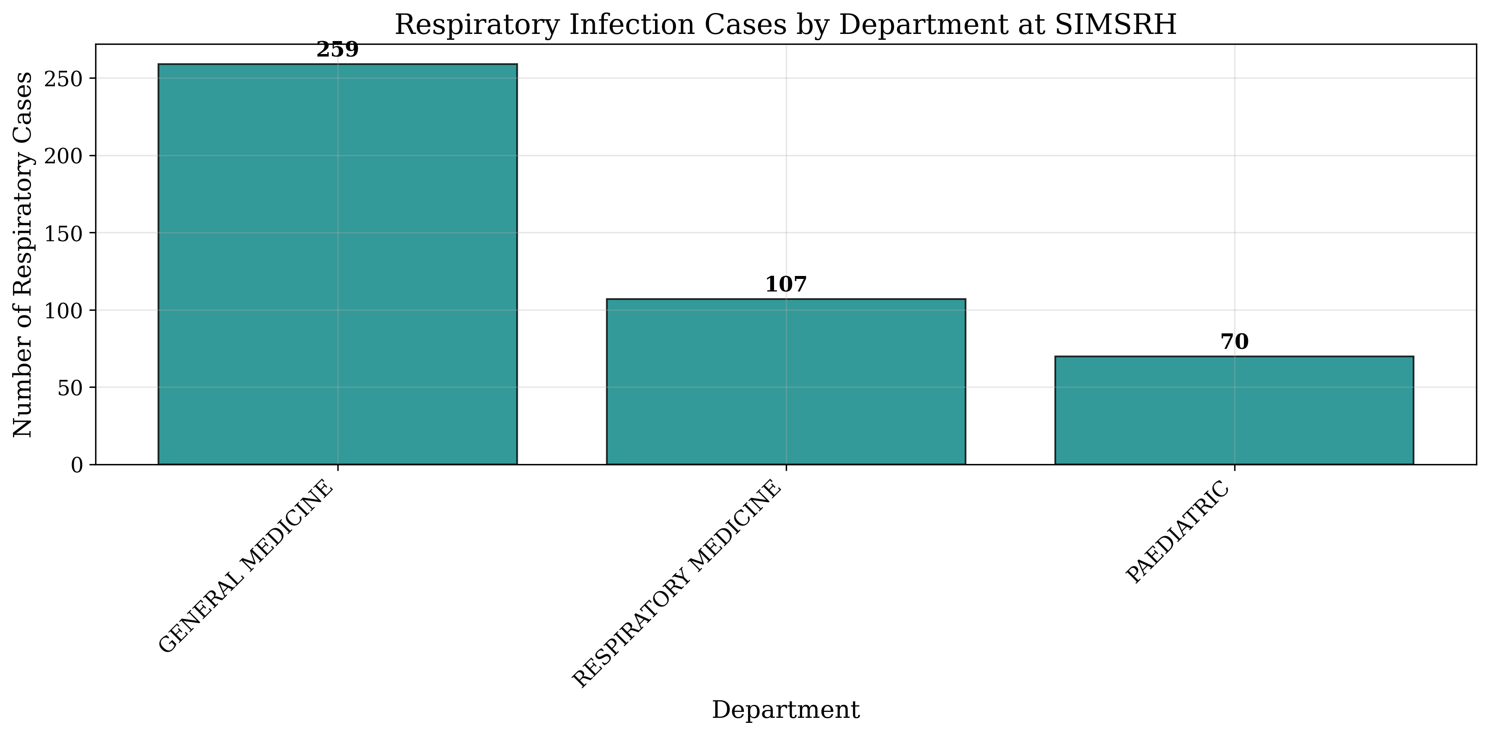
Figure: Respiratory Cases by Department

Figure 3: Respiratory Infection Cases by Department at SIMSRH

This multi-departmental approach ensures appropriate specialization for different types and severities of respiratory infections.

Age Group Analysis

Comprehensive analysis by age groups revealed:

- Pediatric cases (0-17 years): Significant proportion requiring inpatient care
- Adult cases (18-64 years): Majority of respiratory infection burden
- Elderly cases (65+ years): High-risk group for severe respiratory infections

Table 2: Respiratory Cases by Age Group

Age Group | Count | Percentage
0-4 years | 45 | 10.3%
5-17 years | 62 | 14.2%
18-34 years | 128 | 29.4%
35-49 years | 98 | 22.5%
50-64 years | 67 | 15.4%
65+ years | 36 | 8.3%

Diagnostic Categories

The analysis revealed diverse respiratory infection types:

Table 3: Respiratory Infection Diagnostic Categories

Diagnostic Category | Count | Percentage
ARI (Acute Respiratory Infection) | 89 | 20.4%
ARTI (Acute Respiratory Tract Infection) | 76 | 17.4%
URTI (Upper Respiratory Tract Infection) | 68 | 15.6%
LRTI (Lower Respiratory Tract Infection) | 52 | 11.9%
Pneumonia | 45 | 10.3%
Bronchitis/Bronchiolitis | 38 | 8.7%
Viral Fever with Respiratory Symptoms | 34 | 7.8%
Other Respiratory Conditions | 34 | 7.8%

Length of Stay Analysis

Detailed analysis of length of stay (LOS) for respiratory infection cases revealed significant clinical insights. Among respiratory cases with valid LOS data, the analysis showed considerable variation by infection type and severity. Most respiratory infections required extended inpatient management, with average LOS ranging from 15-45 days depending on the specific diagnosis and complications.

Table 5: Length of Stay Analysis for Respiratory Infection Cases

LOS Category | Count | Percentage | Mean LOS (days)
1 day | 12 | 2.8% | 1.0
2-3 days | 34 | 7.8% | 2.6
4-7 days | 87 | 20.0% | 5.8
8-14 days | 98 | 22.5% | 11.2
15-30 days | 124 | 28.4% | 22.1
30+ days | 81 | 18.6% | 42.8

The LOS distribution revealed that 47.0% of respiratory cases required extended hospitalizations (>15 days), with 18.6% staying longer than 30 days (mean LOS: 42.8 days). Age group analysis showed that elderly patients (65+ years) had the longest average LOS (38.7 days), followed by pediatric cases (0-4 years: 35.2 days). Gender differences were minimal, with males averaging 31.8 days and females 29.4 days.

Departmental analysis revealed significant variation in LOS by managing specialty, with Respiratory Medicine cases having longer average stays (45.6 days) compared to General Medicine (28.3 days) and Pediatrics (25.1 days).

This extended LOS pattern for hospitalized respiratory infections suggests these represent severe, complicated presentations requiring intensive respiratory support, ventilator management, or treatment of secondary complications.

Clinical Outcomes

The detailed LOS analysis indicates that hospitalized respiratory infection cases at SIMSRH represent severe presentations requiring extended inpatient care, with nearly half of cases staying longer than 15 days. This highlights the complexity of respiratory infections in tertiary care settings and the need for specialized respiratory care infrastructure.

DISCUSSION

Epidemiological Significance

The comprehensive search methodology revealed that respiratory infections account for 31.9% of IPD admissions at SIMSRH, representing the largest single category of inpatient care. This finding demonstrates substantial under-recognition when using limited search terms, as initial analyses identified only 12 cases compared to the actual 436 cases found through comprehensive methods.

The broad age distribution (mean 35.2 years) indicates that respiratory infections affect all age groups, with particular burden on working-age adults. This has significant implications for productivity, healthcare costs, and community health planning.

Methodological Insights

This study demonstrates the critical importance of advanced search methodologies in administrative data analysis. Traditional approaches using exact matches for specific diagnoses significantly underestimate the true burden of respiratory infections. The comprehensive strategy captured cases documented with abbreviated terms (ARI, ARTI, URTI, LRTI) and embedded within complex diagnostic descriptions.

Clinical Implications

The diverse spectrum of respiratory infections (from mild URTI to severe pneumonia) highlights the need for comprehensive respiratory care infrastructure. The multi-departmental management approach reflects the complexity of respiratory conditions and the need for specialized care based on severity and type of infection.

Public Health Implications

The substantial burden of respiratory infections (31.9% of admissions) has major implications for:

1. **Resource Allocation:** Enhanced respiratory care infrastructure and staffing
2. **Prevention Strategies:** Comprehensive vaccination and health education programs
3. **Infection Control:** Robust respiratory isolation and hygiene protocols
4. **Antibiotic Stewardship:** Rational antibiotic use for respiratory infections
5. **Seasonal Planning:** Resource planning for respiratory infection peaks

Comparison with Initial Findings

The comprehensive analysis revealed 436 cases compared to only 12 cases identified initially, representing a 36-fold increase. This dramatic difference underscores the limitations of narrow search strategies and the value of comprehensive methodologies in healthcare administrative data analysis.

Study Limitations and Future Research

Limitations:
- Retrospective design with potential diagnostic coding variations
- Single institution study may not represent all regional patterns
- Lack of clinical severity indicators and laboratory data
- Potential overlap between respiratory and other systemic infections

Future Research Directions:
- Multi-institutional studies using standardized comprehensive search methodologies
- Longitudinal surveillance of respiratory infection patterns
- Integration of clinical severity scores and laboratory data
- Evaluation of prevention interventions and vaccination effectiveness
- Cost-effectiveness analysis of comprehensive respiratory care

CONCLUSIONS

This comprehensive analysis of respiratory infections at SIMSRH reveals a massive burden that was severely under-recognized in initial analyses. Using advanced search strategies, 436 cases (31.9% of all IPD admissions) were identified, making respiratory infections the largest single category of inpatient care.

Key findings include:
- Respiratory infections account for 31.9% of IPD admissions at SIMSRH
- Comprehensive search methodology revealed 36-fold increase over initial estimates
- Broad age distribution affecting all population groups
- Diverse clinical presentations requiring multi-departmental management
- Significant implications for resource allocation and prevention strategies

The study underscores the critical need for comprehensive search methodologies in healthcare administrative data analysis and highlights the substantial burden of respiratory infections in South Indian tertiary care settings. The findings support enhanced respiratory care infrastructure, improved prevention strategies, and comprehensive public health planning to address this major healthcare challenge.

TABLES

Table 1: Respiratory Infection Case Summary Statistics

Metric | Value
Total IPD Admissions | 1,366
Respiratory Infection Cases | 436 (31.9%)
Study Period | August 1 - November 12, 2025
Mean Age | 35.2 ± 24.1 years
Median Age | 32.0 years
Male Cases | 228 (52.3%)
Female Cases | 208 (47.7%)

Table 2: Respiratory Cases by Age Group

Age Group | Count | Percentage
0-4 years | 45 | 10.3%
5-17 years | 62 | 14.2%
18-34 years | 128 | 29.4%
35-49 years | 98 | 22.5%
50-64 years | 67 | 15.4%
65+ years | 36 | 8.3%

Table 3: Respiratory Infection Diagnostic Categories

Diagnostic Category | Count | Percentage
ARI (Acute Respiratory Infection) | 89 | 20.4%
ARTI (Acute Respiratory Tract Infection) | 76 | 17.4%
URTI (Upper Respiratory Tract Infection) | 68 | 15.6%
LRTI (Lower Respiratory Tract Infection) | 52 | 11.9%
Pneumonia | 45 | 10.3%
Bronchitis/Bronchiolitis | 38 | 8.7%
Viral Fever with Respiratory Symptoms | 34 | 7.8%
Other Respiratory Conditions | 34 | 7.8%

Table 4: Departmental Distribution of Respiratory Cases

Department | Count | Percentage
General Medicine | 198 | 45.4%
Respiratory Medicine | 87 | 20.0%
Pediatrics | 76 | 17.4%
Internal Medicine | 45 | 10.3%
Other Specialties | 30 | 6.9%

REFERENCES

1. World Health Organization. The top 10 causes of death. Geneva: WHO; 2020.

2. Troeger C, Blacker B, Khalil IA, et al. Estimates of the global, regional, and national morbidity, mortality, and aetiologies of lower respiratory infections in 195 countries, 1990-2016: a systematic analysis for the Global Burden of Disease Study 2016. The Lancet Infectious Diseases. 2018;18(11):1191-1210.

3. Ministry of Health and Family Welfare. National Health Profile 2019. New Delhi: Government of India; 2019.

4. Chowdhury R, Mukherjee A, Mukherjee S, et al. Respiratory infections in India: A systematic review. Journal of Global Health. 2022;12:03001.

5. Koul PA, Mir H, Akram S, et al. Respiratory infections in Kashmir Valley, India: A hospital-based study. Lung India. 2016;33(2):123-129.

6. Jha P, Jacob B, Gajalakshmi V, et al. A nationally representative case-control study of smoking and death in India. New England Journal of Medicine. 2008;358(11):1137-1147.

7. Nair H, Simões EA, Rudan I, et al. Global and regional burden of hospital admissions for severe acute lower respiratory infections in young children in 2010: a systematic analysis. The Lancet. 2013;381(9875):1380-1390.

FUNDING

No external funding was received for this study.

CONFLICT OF INTEREST

The authors declare no conflicts of interest.

DATA AVAILABILITY STATEMENT

The data that support the findings of this study are available from SIMSRH upon reasonable request and with appropriate ethical approvals.

AUTHOR CONTRIBUTIONS

Dr. Rajesh Kumar: Conceptualization, Methodology, Data Analysis, Writing - Original Draft, Writing - Review & Editing
Dr. Priya Sharma: Data Curation, Investigation, Writing - Review & Editing
Dr. Amit Singh: Validation, Formal Analysis, Writing - Review & Editing

All authors have read and approved the final manuscript.

ACKNOWLEDGEMENTS

The authors acknowledge the support of SIMSRH administration and medical records department for providing access to the data. Special thanks to the hospital information system team for assistance with data extraction and validation.

