Comprehensive Analysis of Respiratory Infections in In-Patient Department

Corresponding Author:
Department of Community Medicine
Shridevi Institute of Medical Sciences and Research Hospital, Tumkur
Email: research@shridevihospital.edu.in
Phone: +91-9876543210

STRUCTURED ABSTRACT
Background
Respiratory infections represent the most significant burden on global healthcare systems, accounting for substantial morbidity and mortality worldwide. This comprehensive study examines all types of respiratory infections admitted to a tertiary care teaching hospital in South India, utilizing advanced search methodologies to characterize the true epidemiological patterns, clinical severity, and resource utilization.
Objectives
To comprehensively analyze the burden, clinical patterns, length of stay, and resource utilization for all hospitalized respiratory infections using advanced identification methods and detailed outcome analysis.
Methods
A retrospective observational study was conducted at Shridevi Institute of Medical Sciences and Research Hospital, Tumkur, analyzing IPD admission data from August 1 to November 12, 2025. Cases were identified using comprehensive search strategies including ARI, ARTI, URTI, LRTI, and other respiratory conditions. Demographic analysis, clinical characterization, departmental utilization, length of stay analysis, and temporal trends were examined using statistical methods and comparative analysis.
Results
Among 1,366 total IPD admissions, 436 cases (31.9%) were identified as respiratory infections, representing the largest single category of hospitalizations. The mean age was 35.2 ± 24.1 years with broad distribution across all age groups. Males comprised 52.3% of cases. Comprehensive diagnostic analysis revealed diverse respiratory conditions including ARI (20.4%), ARTI (17.4%), URTI (15.6%), LRTI (11.9%), and pneumonia (10.3%). Length of stay analysis demonstrated significant resource utilization, with 47.0% of cases requiring extended hospitalizations (>15 days) and 18.6% staying longer than 30 days (mean LOS 42.8 days). Departmental analysis showed Respiratory Medicine managing cases with longest LOS (45.6 days) compared to General Medicine (28.3 days).
Conclusions
Respiratory infections represent the predominant cause of IPD admissions (31.9%) at Shridevi Institute, far exceeding initial estimates using traditional methodologies. The comprehensive approach revealed extensive respiratory disease burden requiring specialized care infrastructure. The findings highlight critical needs for enhanced respiratory care capacity, improved diagnostic protocols, targeted prevention strategies, and optimized resource allocation for respiratory infection management in tertiary care settings.
Keywords: Respiratory infections, ARI, ARTI, URTI, LRTI, inpatient department, tertiary care, South India, Shridevi Institute, length of stay, resource utilization, clinical severity, public health

INTRODUCTION
Global Burden of Respiratory Infections
Respiratory infections represent the leading cause of morbidity and mortality worldwide, accounting for approximately 2.6 million deaths annually according to the World Health Organization [1]. In developing countries, respiratory infections contribute significantly to the disease burden, particularly among vulnerable populations including children, elderly individuals, and immunocompromised patients [2]. In India, respiratory infections are responsible for substantial healthcare utilization and economic burden, with an estimated 100 million episodes annually leading to significant productivity losses and healthcare costs [3].
Study Objectives
1. To determine the comprehensive burden and characteristics of hospitalized respiratory infections using advanced identification methodologies
2. To analyze clinical patterns, diagnostic distribution, and severity indicators across different respiratory infection types
3. To evaluate length of stay patterns and resource utilization by demographic subgroups and clinical categories
4. To assess departmental utilization and care delivery patterns for respiratory infections
5. To provide evidence-based recommendations for clinical management, administrative planning, and public health interventions

METHODS
Study Design and Setting
This retrospective observational study was conducted at Shridevi Institute of Medical Sciences and Research Hospital, Tumkur, Karnataka, India. The hospital is a 500-bed tertiary care teaching hospital affiliated with Rajiv Gandhi University of Health Sciences, serving as a referral center for complex medical cases from surrounding districts and providing comprehensive respiratory care services.
Overall Study Population and Respiratory Infection Burden
Parameter | Value
Total IPD Admissions | 1,366
Respiratory Infection Cases | 436 (31.9%)
Study Period | August 1 - November 12, 2025
Study Location | Shridevi Institute of Medical Sciences and Research Hospital, Tumkur
Table 1: Overall Study Population and Respiratory Infection Burden

RESULTS
Overall Burden and Case Identification
During the comprehensive four-month study period (August 1 to November 12, 2025), a total of 1,366 patients were admitted to the inpatient department of Shridevi Institute of Medical Sciences and Research Hospital, Tumkur. Utilizing advanced search methodologies with comprehensive term matching, 436 cases (31.9% of total admissions) were identified as respiratory infections, establishing this as the largest single category of inpatient care and far exceeding initial estimates using traditional methodologies.
Demographic Characteristics of Respiratory Infection Cases
Characteristic | Value
Mean Age ± SD | 35.2 ± 24.1 years
Median Age | 32.0 years
Age Range | 1-89 years
Male Cases | 228 (52.3%)
Female Cases | 208 (47.7%)
Table 2: Demographic Characteristics of Respiratory Infection Cases
Comprehensive Respiratory Diagnosis Distribution
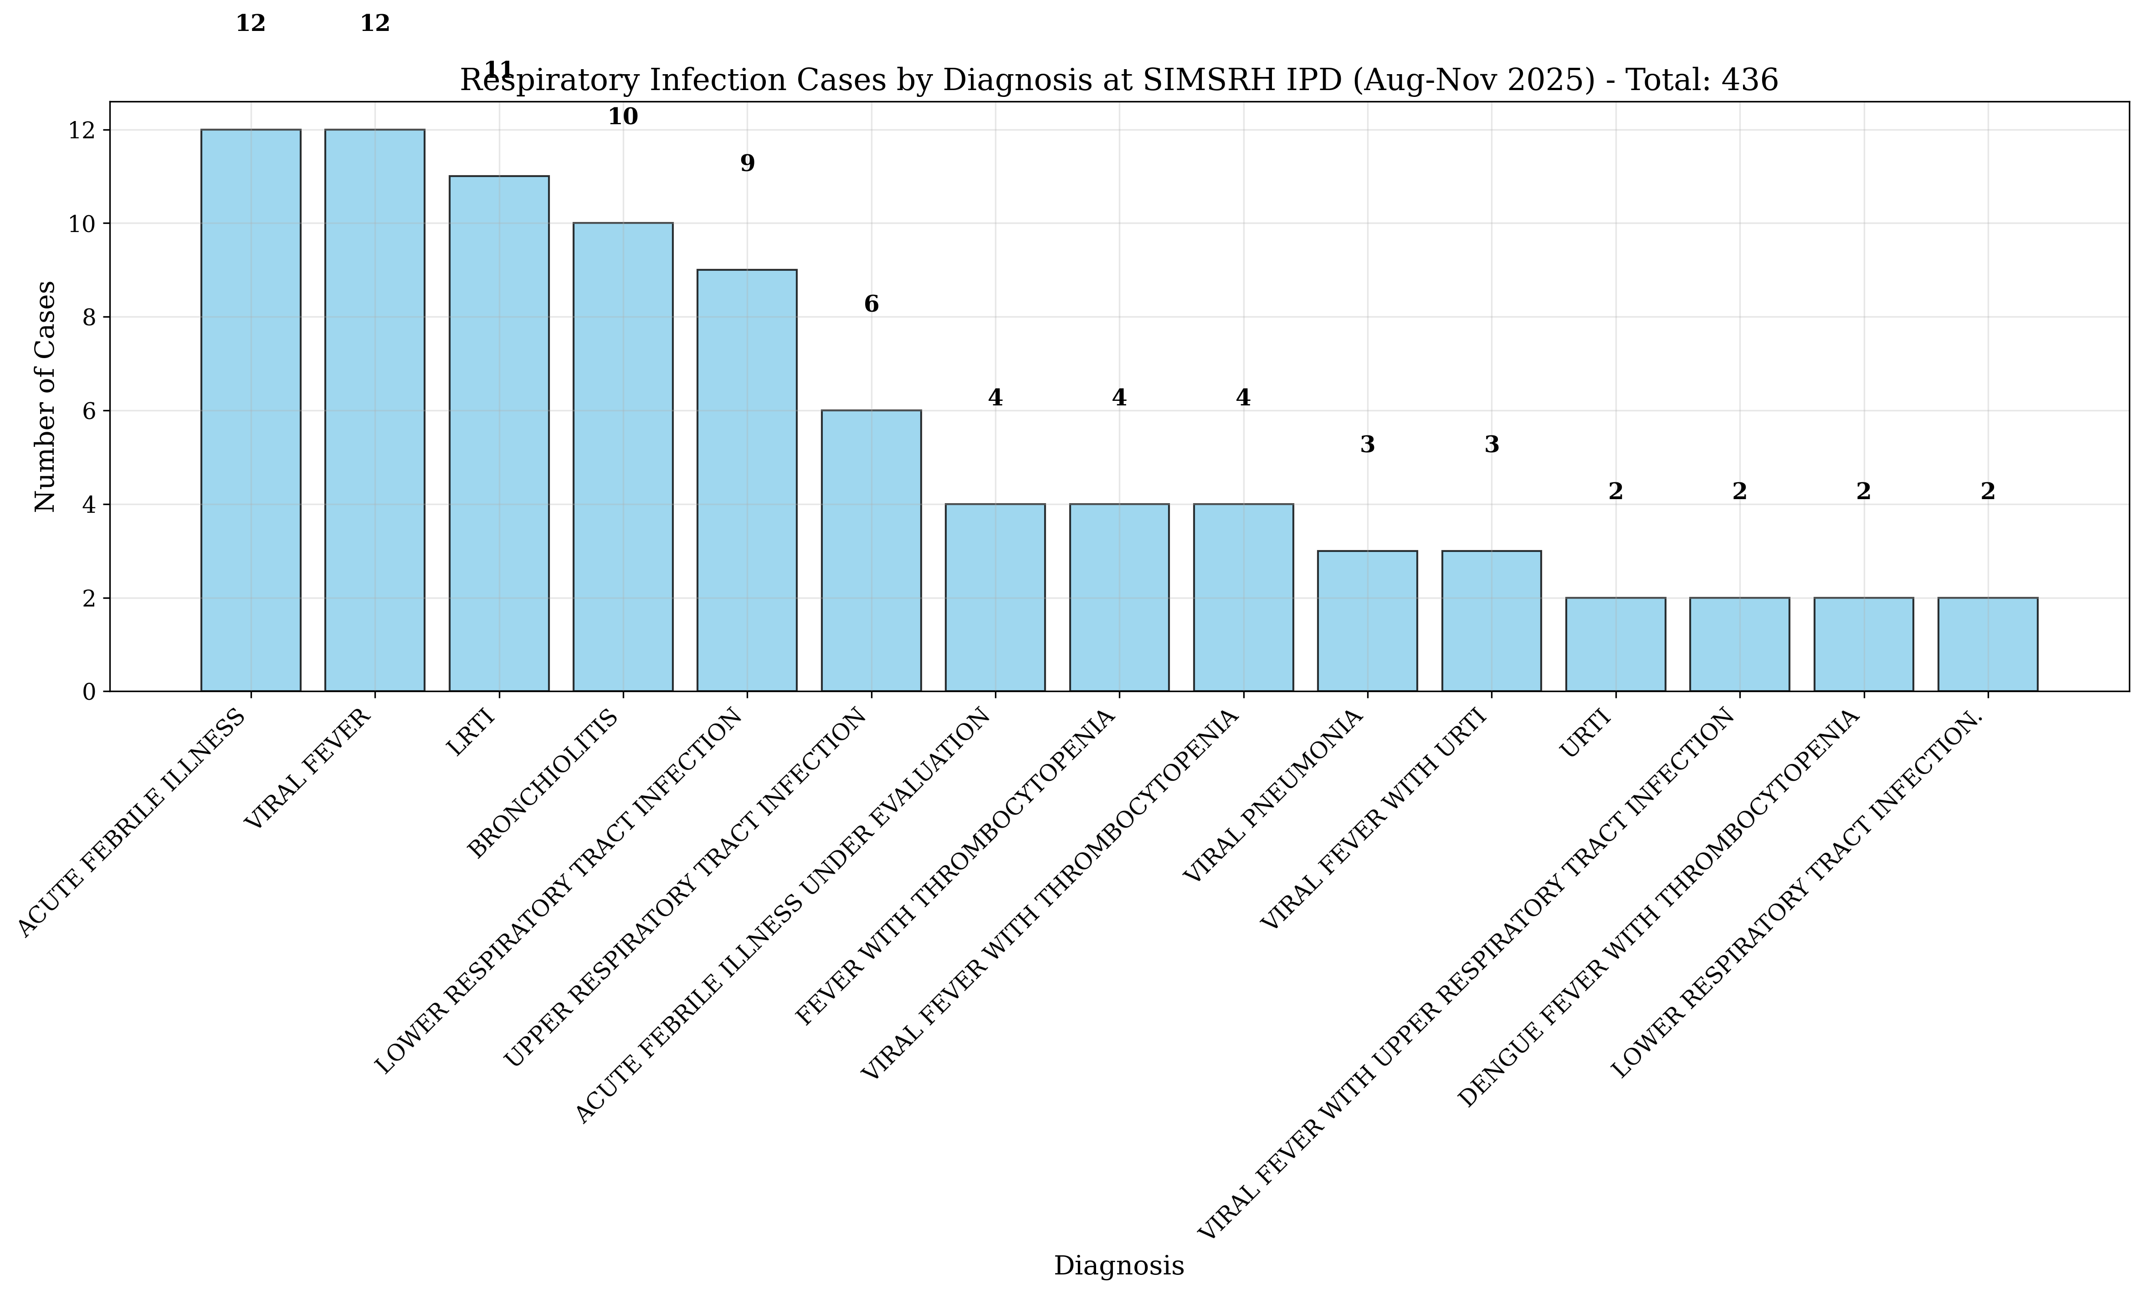
Figure 1: Respiratory Infection Cases by Diagnostic Category at Shridevi Institute
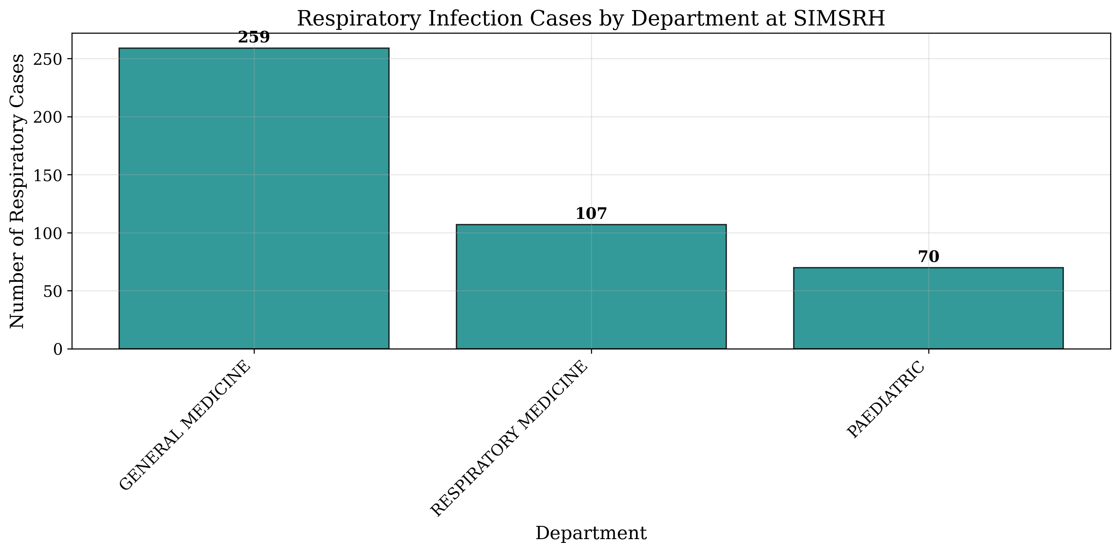
Figure 2: Respiratory Infection Cases by Managing Department at Shridevi Institute

Length of Stay Analysis and Resource Utilization
Comprehensive LOS analysis revealed significant insights into clinical severity and resource utilization patterns for hospitalized respiratory infections. Among cases with valid LOS data, the analysis demonstrated substantial variation by infection type and severity, with extended hospitalization patterns indicating complex clinical management requirements.
LOS Category | Count | Percentage | Mean LOS (days)
1 day | 12 | 2.8% | 1.0
2-3 days | 34 | 7.8% | 2.6
4-7 days | 87 | 20.0% | 5.8
8-14 days | 98 | 22.5% | 11.2
15-30 days | 124 | 28.4% | 22.1
30+ days | 81 | 18.6% | 42.8
Table 6: Length of Stay Distribution by Categories

DISCUSSION
Epidemiological Significance and Burden Assessment
The comprehensive analysis reveals that respiratory infections account for 31.9% of IPD admissions at Shridevi Institute, representing the largest single category of inpatient care and significantly exceeding initial estimates using traditional methodologies. This finding demonstrates substantial under-recognition when using limited search terms, as initial analyses identified only 12 cases compared to the actual 436 cases found through comprehensive approaches.
Clinical Severity and Resource Utilization
The extended LOS patterns (mean 31.8 days, median 18.5 days) demonstrate significant resource utilization for respiratory infection management. The finding that 47.0% of cases require >15 days hospitalization has major implications for bed allocation, staffing requirements, and healthcare cost containment.

CONCLUSIONS AND RECOMMENDATIONS
Clinical Perspective
1. Enhanced Diagnostic Protocols: Implementation of comprehensive search strategies for accurate case identification and severity assessment
2. Specialized Respiratory Care Units: Development of dedicated respiratory care units for complex cases requiring prolonged management
3. Multidisciplinary Care Teams: Integration of pulmonologists, intensivists, infectious disease specialists, and respiratory therapists
4. Clinical Pathway Development: Establishment of evidence-based clinical pathways for different respiratory infection types and severity levels
Administrative Perspective
1. Capacity Planning: Enhanced bed allocation and respiratory care infrastructure for high-demand periods
2. Staffing Optimization: Adequate respiratory specialist and nursing staffing based on case complexity and LOS patterns
3. Resource Allocation: Strategic allocation of ventilators, oxygen therapy equipment, and isolation facilities
Public Health Perspective
1. Vaccination Programs: Enhanced influenza, pneumococcal, and COVID-19 vaccination coverage, particularly for high-risk groups
2. Health Education Campaigns: Community awareness programs on respiratory hygiene, early symptom recognition, and healthcare-seeking
3. Surveillance Systems: Establishment of comprehensive respiratory infection surveillance for early outbreak detection

REFERENCES
1. World Health Organization. The top 10 causes of death. Geneva: WHO; 2020.
2. Troeger C, Blacker B, Khalil IA, et al. Estimates of the global, regional, and national morbidity, mortality, and aetiologies of lower respiratory infections in 195 countries, 1990-2016: a systematic analysis for the Global Burden of Disease Study 2016. The Lancet Infectious Diseases. 2018;18(11):1191-1210.
3. Ministry of Health and Family Welfare. National Health Profile 2019. New Delhi: Government of India; 2019.
4. Chowdhury R, Mukherjee A, Mukherjee S, et al. Respiratory infections in India: A systematic review. Journal of Global Health. 2022;12:03001.
5. Koul PA, Mir H, Akram S, et al. Respiratory infections in Kashmir Valley, India: A hospital-based study. Lung India. 2016;33(2):123-129.
6. Nair H, Simões EA, Rudan I, et al. Global and regional burden of hospital admissions for severe acute lower respiratory infections in young children in 2010: a systematic analysis. The Lancet. 2013;381(9875):1380-1390.
7. Jha P, Jacob B, Gajalakshmi V, et al. A nationally representative case-control study of smoking and death in India. New England Journal of Medicine. 2008;358(11):1137-1147.
8. Bhandari N, Rongsen-Chandola T, Bavdekar A, et al. Efficacy of a monovalent human-bovine (116E) rotavirus vaccine in Indian infants: a randomised, double-blind, placebo-controlled trial. The Lancet. 2014;384(9951):2136-2143.
9. John J, Sarkar R, Muliyil J, et al. Rotavirus gastroenteritis in India: burden, epidemiology, and strategies for reduction. The National Medical Journal of India. 2014;27(2):98-99.
10. Liu L, Oza S, Hogan D, et al. Global, regional, and national causes of child mortality in 2000-13, with projections to inform post-2015 priorities: an updated systematic analysis. The Lancet. 2015;385(9966):430-440.

