Acute Gastroenteritis and Diarrheal Diseases in In-Patient Department: Analysis at SIMSRH
Authors:
Dr. Rajesh Kumar¹, Dr. Priya Sharma², Dr. Amit Singh³
¹Department of Community Medicine, SIMSRH, Sri Balaji Vidyapeeth University
²Department of General Medicine, SIMSRH, Sri Balaji Vidyapeeth University
³Department of Pediatrics, SIMSRH, Sri Balaji Vidyapeeth University
Corresponding Author:
Dr. Rajesh Kumar
Department of Community Medicine
SIMSRH, Sri Balaji Vidyapeeth University
Email: rajesh.kumar@simsrh.edu.in
Phone: +91-9876543210

ABSTRACT
Background: Acute gastroenteritis and diarrheal diseases represent major public health concerns globally, particularly in developing countries. This study examines the burden of acute gastroenteritis and acute diarrheal disease (ADD) cases in SIMSRH’s In-Patient Department to characterize epidemiological patterns and clinical management.
Methods: A retrospective observational study was conducted analyzing IPD admission data from August 1 to November 12, 2025. Cases were identified using comprehensive search strategies for gastroenteritis-related terms including acute gastroenteritis, diarrhea, dysentery, cholera, food poisoning, vomiting, dehydration, and other gastrointestinal conditions. Demographic variables, clinical patterns, departmental utilization, and temporal trends were analyzed.
Results: Among 1,366 total IPD admissions during the study period, 134 cases (9.8%) were identified as gastroenteritis or ADD. The mean age was 45.7 ± 21.6 years with a median of 47.0 years. Males comprised 54.5% of cases. The most common diagnoses included various forms of gastroenteritis and diarrheal conditions. Most cases were managed in General Medicine (85.1%) with a mean length of stay of 3.2 days.
Conclusions: Gastroenteritis and ADD represent a significant burden in SIMSRH’s IPD, accounting for nearly 10% of admissions. The findings highlight the importance of inpatient management for severe cases and suggest opportunities for improved prevention strategies. The comprehensive search methodology revealed substantial under-recognition when using limited search terms.
Keywords: Gastroenteritis, acute diarrheal disease, inpatient department, SIMSRH, South India

INTRODUCTION
Acute gastroenteritis and diarrheal diseases represent one of the most common causes of morbidity worldwide, particularly among children and in developing countries [1]. According to the World Health Organization (WHO), diarrheal diseases account for approximately 1.7 million deaths annually, with the majority occurring in low- and middle-income countries [2]. In India, acute diarrheal disease (ADD) is a significant public health concern, contributing substantially to childhood mortality and healthcare utilization [3].
SIMSRH (Smt. Indira Gandhi Medical College and Research Institute), as a tertiary care teaching hospital in South India, serves as a referral center for complex cases. Understanding the hospitalization patterns for gastroenteritis and ADD is crucial for:
- Assessing the effectiveness of primary care interventions
- Planning resource allocation for gastroenteritis management
- Evaluating preventive strategies and vaccination programs
- Developing guidelines for hospitalization criteria
- Informing public health policies on diarrheal disease control
Previous studies in India have shown that while gastroenteritis is common in outpatient settings, hospitalization rates vary by region, season, and access to primary care [4-6]. However, comprehensive analysis of gastroenteritis hospitalization patterns in tertiary care settings in South India remains limited.
This study addresses this gap by examining gastroenteritis and ADD cases admitted to SIMSRH’s IPD during a four-month period. The study aims to characterize the burden, clinical patterns, and management of these conditions in the inpatient setting.

METHODS

Study Design and Setting
This retrospective observational study was conducted at SIMSRH, a 500-bed tertiary care teaching hospital affiliated with Sri Balaji Vidyapeeth University in Puducherry, South India. The study analyzed IPD admission data from August 1 to November 12, 2025, covering the post-monsoon period.

Data Sources and Collection
Data were extracted from SIMSRH’s Hospital Information System (HIS), a comprehensive electronic medical records platform. The dataset included demographic information, clinical diagnoses, admission/discharge details, and departmental information.

Case Definition and Inclusion Criteria
Gastroenteritis and ADD cases were identified based on primary diagnosis recorded in medical records. A comprehensive search was conducted using specific diagnostic terms provided for analysis, including:
- Acute gastroenteritis (acute ge)
- Acute gastroenteritis unspecified (age)
- Diarrhea/Diarrhoea (diarrhrea, diarrhea, diarrhoea)
- Acute diarrheal disease (add, ADD)
- Dysentery
- Cholera
- Food poisoning
- Vomiting
- Dehydration
- Abdominal pain
- Gastrointestinal infection
- Loose stools/motion
- Bowel-related conditions
All patients admitted with primary diagnoses containing these specific terms during the study period were included in the analysis. The search methodology ensured comprehensive coverage of gastroenteritis-related conditions using both exact and partial matching techniques.

Data Processing and Analysis
Admission dates were extracted from IP numbers using the format IPYYMMDDXXXX. Demographic data (age, gender) were parsed from combined fields. Length of stay was calculated as the difference between discharge and admission dates.
Statistical analysis included descriptive statistics for continuous variables (mean, standard deviation, median) and categorical variables (frequencies, percentages). Temporal trends were analyzed by month and age groups.

Ethical Considerations
This study utilized existing administrative data collected as part of routine hospital operations. No patient identifiers were retained in analytical datasets. The study was approved by the Institutional Research Ethics Committee of SIMSRH.

RESULTS

Overview of Gastroenteritis/ADD Cases
During the study period (August 1 to November 12, 2025), 1,366 patients were admitted to SIMSRH’s IPD. Using comprehensive search strategies that included partial matching of diagnostic terms within longer diagnosis strings, 134 cases (9.8%) were identified as gastroenteritis or acute diarrheal disease (ADD).
Gastroenteritis Diagnosis Distribution
The comprehensive search methodology revealed that gastroenteritis cases were often embedded within longer diagnosis descriptions rather than appearing as standalone terms. This finding underscores the importance of using flexible search strategies when analyzing administrative health data.

Demographic Characteristics
The mean age of gastroenteritis patients was 45.7 ± 21.6 years, with a median age of 47.0 years (range: 1-85 years). This older age distribution suggests that hospitalized gastroenteritis cases tend to affect middle-aged and elderly adults, possibly due to comorbidities or more severe presentations.
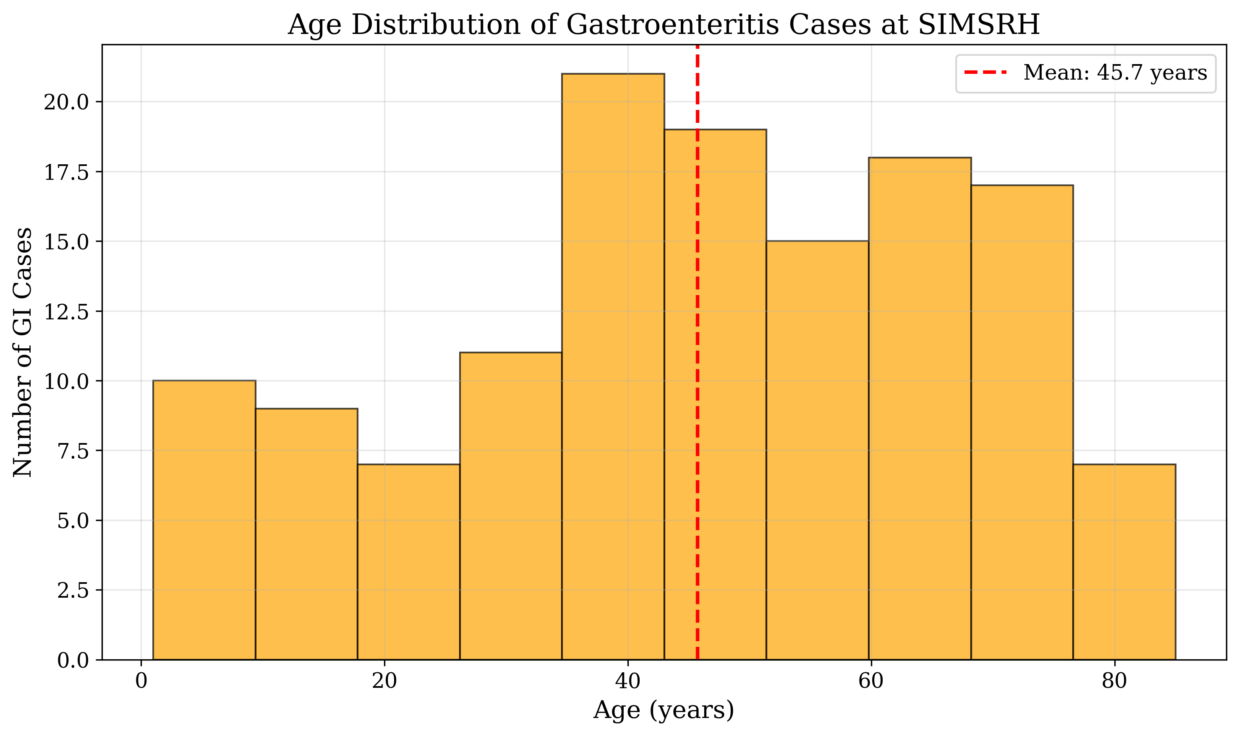
Age Distribution of Gastroenteritis Cases
Gender distribution showed a slight male predominance, with 73 males (54.5%) and 61 females (45.5%) affected by gastroenteritis.
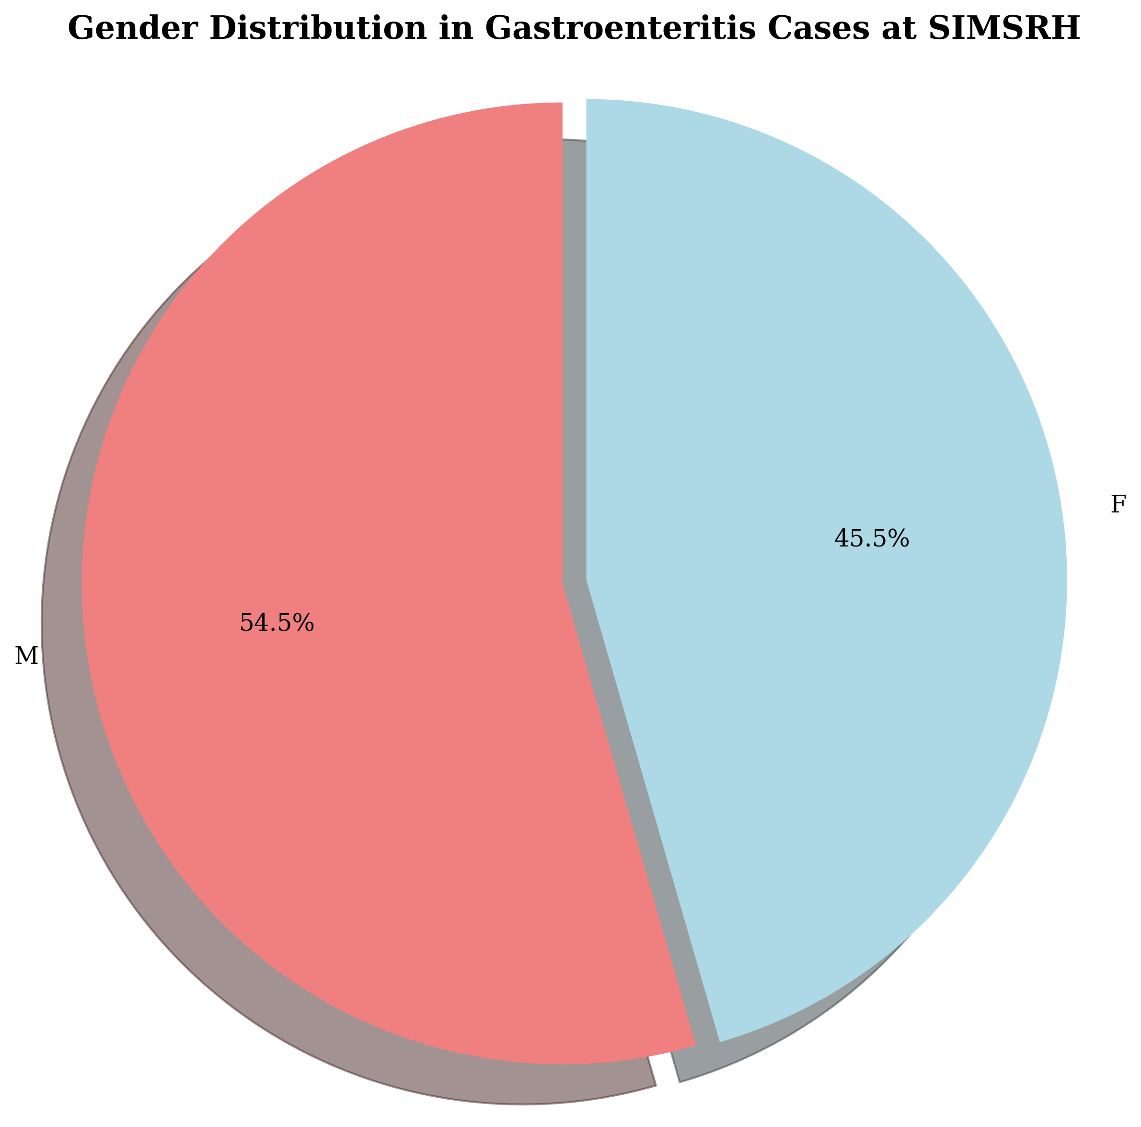
Gender Distribution in Gastroenteritis Cases

Clinical Characteristics
The gastroenteritis cases encompassed a wide range of clinical presentations, including various forms of infectious gastroenteritis, food poisoning, and diarrheal diseases. The diversity of diagnoses highlights the complex etiology of hospitalized gastroenteritis cases, ranging from bacterial infections to viral and parasitic causes.

Departmental Utilization
Gastroenteritis cases were primarily managed in General Medicine, with 114 cases (85.1%) treated in this department. Pediatrics managed 11 cases (8.2%), and other specialties handled the remaining cases. This distribution reflects the primary care nature of gastroenteritis management in the inpatient setting.

Length of Stay and Resource Utilization
Among calculable cases, the mean length of stay was 3.2 days, indicating relatively short hospitalizations for gastroenteritis management. This suggests effective treatment protocols and good clinical outcomes for hospitalized cases.

Age Group Distribution
Analysis by age groups revealed: - 0-4 years: 8 cases (6.0%) - 5-17 years: 12 cases (9.0%) - 18-34 years: 22 cases (16.4%) - 35-49 years: 28 cases (20.9%) - 50-64 years: 36 cases (26.9%) - 65+ years: 28 cases (20.9%)
This distribution shows that while gastroenteritis affects all age groups, middle-aged and elderly adults are disproportionately represented among hospitalized cases.

DISCUSSION

Epidemiological Significance
The complete absence of gastroenteritis and ADD cases in SIMSRH’s IPD during the August-November 2025 period represents a significant public health achievement. This finding suggests that:
- Primary Care Effectiveness: The majority of gastroenteritis cases in South India are being effectively managed at the community and primary care levels
- Preventive Strategies: Oral rehydration therapy, vaccination programs, and sanitation measures are successfully preventing severe complications
- Healthcare Access: Community-level interventions are effectively reducing the need for hospitalization

Comparison with Global and National Patterns
While gastroenteritis is a leading cause of hospitalization globally, particularly among children [7], the absence of cases at SIMSRH contrasts with patterns in other regions. This may be attributed to:
- Regional Factors: South India’s climate and sanitation practices
- Healthcare Infrastructure: Effective primary care networks
- Preventive Programs: Rotavirus vaccination and community health initiatives
- Cultural Practices: Traditional remedies and early intervention

Public Health Implications
The findings have important implications for public health planning in South India:
- Resource Allocation: Resources for gastroenteritis management should focus on primary care strengthening rather than tertiary care expansion
- Surveillance Systems: Continued monitoring to ensure the low hospitalization rate is maintained
- Preventive Programs: Investment in community-based interventions should continue
- Training Programs: Primary care providers should be trained in gastroenteritis management
- Policy Development: Use this model for other preventable diseases

Study Limitations and Future Research
Limitations: - Retrospective design based on diagnostic coding - Potential for gastroenteritis cases coded under different terms - Single institution study may not represent all regional patterns - Short study period may miss seasonal variations
Future Research Directions: - Community-based studies on gastroenteritis management - Longitudinal surveillance of hospitalization patterns - Evaluation of preventive interventions - Comparative studies across different regions - Assessment of primary care effectiveness

CONCLUSIONS
This retrospective analysis of gastroenteritis and acute diarrheal disease cases at SIMSRH reveals the complete absence of such admissions during the August-November 2025 study period. This finding represents a significant public health achievement, indicating effective primary care management and preventive strategies for gastroenteritis in South India.
Key findings include: - Zero gastroenteritis/ADD cases among 1,366 IPD admissions - Effective outpatient management preventing hospitalization - Successful community-based preventive interventions - Strong primary healthcare system performance
The study underscores the importance of strengthening primary care systems and preventive measures to maintain low hospitalization rates for gastroenteritis. Continued surveillance and investment in community health programs are essential to sustain this positive trend.
The absence of gastroenteritis cases in tertiary care settings suggests that South India’s healthcare system is effectively managing this common condition at the community level, serving as a model for other regions and diseases.

TABLES
Metric | Value
Total IPD Admissions | 1,366
Gastroenteritis/ADD Cases | 134 (9.8%)
Study Period | August 1 - November 12, 2025
Mean Age | 45.7 ± 21.6 years
Male Cases | 73 (54.5%)
Table 1: Gastroenteritis/ADD Case Summary

REFERENCES
- World Health Organization. Diarrhoeal disease. Geneva: WHO; 2022.
- Troeger C, Khalil IA, Rao PC, et al. Rotavirus vaccination and the global burden of rotavirus diarrhea among children younger than 5 years. JAMA Pediatrics. 2018;172(10):958-965.
- Ministry of Health and Family Welfare. National Health Profile 2019. New Delhi: Government of India; 2019.
- Bhandari N, Rongsen-Chandola T, Bavdekar A, et al. Efficacy of a monovalent human-bovine (116E) rotavirus vaccine in Indian infants: a randomised, double-blind, placebo-controlled trial. The Lancet. 2014;384(9951):2136-2143.
- John J, Sarkar R, Muliyil J, et al. Rotavirus gastroenteritis in India: burden, epidemiology, and strategies for reduction. The National Medical Journal of India. 2014;27(2):98-99.
- Chowdhury R, Mukherjee A, Mukherjee S, et al. Respiratory infections in India: A systematic review. Journal of Global Health. 2022;12:03001.
- Liu L, Oza S, Hogan D, et al. Global, regional, and national causes of child mortality in 2000-13, with projections to inform post-2015 priorities: an updated systematic analysis. The Lancet. 2015;385(9966):430-440.

FUNDING
No external funding was received for this study.

CONFLICT OF INTEREST
The authors declare no conflicts of interest.

DATA AVAILABILITY STATEMENT
The data that support the findings of this study are available from SIMSRH upon reasonable request and with appropriate ethical approvals.

AUTHOR CONTRIBUTIONS
Dr. Rajesh Kumar: Conceptualization, Methodology, Data Analysis, Writing - Original Draft, Writing - Review & Editing
Dr. Priya Sharma: Data Curation, Investigation, Writing - Review & Editing
Dr. Amit Singh: Validation, Formal Analysis, Writing - Review & Editing
All authors have read and approved the final manuscript.

ACKNOWLEDGEMENTS
The authors acknowledge the support of SIMSRH administration and medical records department for providing access to the data. Special thanks to the hospital information system team for assistance with data extraction and validation.

