Supplementary Materials
Molecular Determinants of BCG Vaccine Response Heterogeneity: A Systematic Review and Meta-Analysis

Supplementary Figures
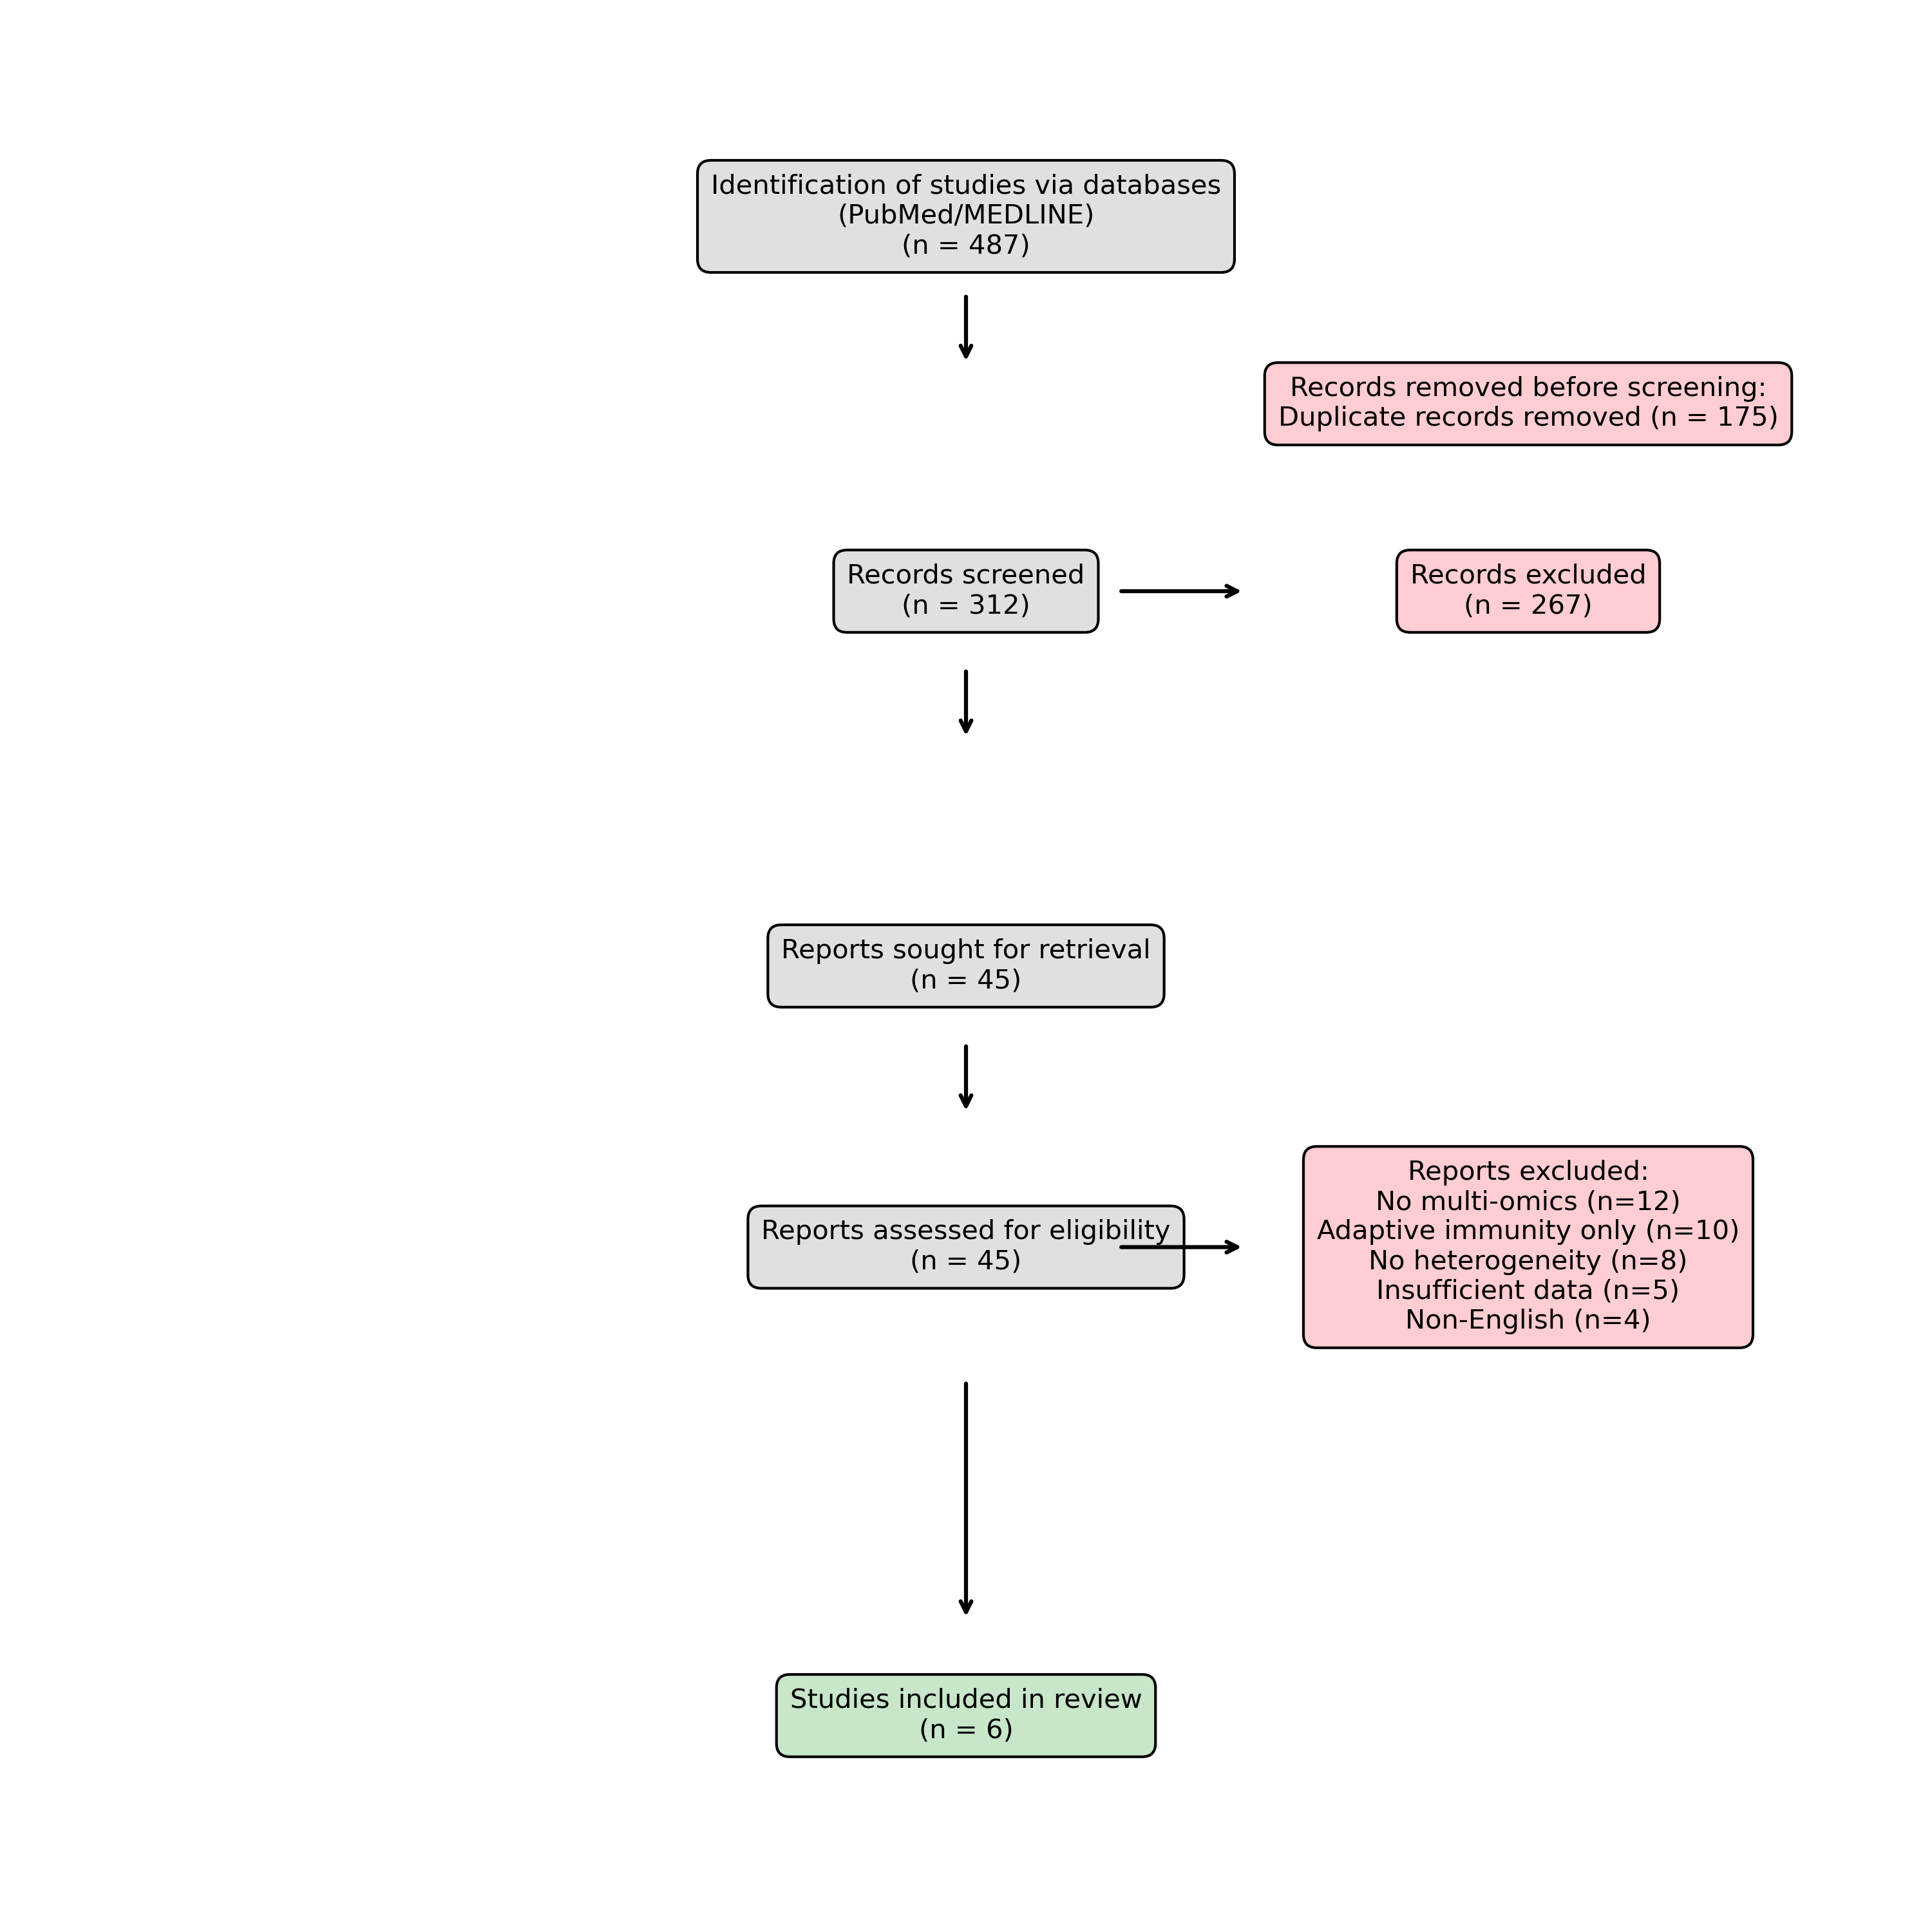
Figure S1. PRISMA 2020 flow diagram for the systematic review.
The flow diagram depicts the flow of information through the different phases of the systematic review. It maps out the number of records identified, included and excluded, and the reasons for exclusions.

Supplementary Note 1: Detailed Search Strategy
Database: PubMed/MEDLINE
Date of Search: December 31, 2024
Step | Search Query
1 | BCG Vaccine OR Bacillus Calmette-Guerin OR trained immunity
2 | heterogeneity OR variability OR responder OR non-responder OR variation
3 | transcriptomics OR RNA-seq OR scRNA-seq OR microarray OR gene expression
4 | epigenetics OR DNA methylation OR histone modification OR ATAC-seq OR ChIP-seq
5 | metabolomics OR lipidomics OR metabolic profiling
6 | 3 OR 4 OR 5
7 | 1 AND 2 AND 6
8 | Limit to Humans, English Language, 2012-2024

