BCG Vaccine Response Heterogeneity: Molecular Mechanisms of Trained Immunity and Predictors of Protection - A Multi-Omics Review

Siddalingaiah H S, MD
Department of Community Medicine, Shridevi Institute of Medical Sciences, Tumkur, Karnataka, India
Email: hssling@yahoo.com | ORCID: 0000-0002-4771-8285
Word count: ~2,900 | Figures: 3 | References: 8

Abstract
Bacillus Calmette-Guerin (BCG) vaccination induces trained immunity, a functional reprogramming of innate immune cells providing enhanced, non-specific protection. However, substantial heterogeneity exists in vaccine responses. Recent multi-omics studies of 323 individuals demonstrated approximately 30% show robust trained immunity, 40% moderate, and 30% minimal responses. Key predictors include baseline H3K4me3 levels at inflammatory gene loci (OR 2.8), STAT1 expression (OR 1.9), and glycolytic capacity (OR 1.7). This review synthesizes molecular mechanisms underlying BCG response heterogeneity and implications for personalized vaccination strategies.
Keywords: BCG; trained immunity; epigenetic reprogramming; vaccine heterogeneity

1. Introduction
BCG is the most widely administered vaccine globally, given to over 100 million newborns annually.1 While efficacy against pulmonary TB in adults varies (0-80%), BCG provides consistent protection against severe TB in children and has non-specific protective effects mediated by trained immunity.7
Trained immunity involves epigenetic modifications, particularly H3K4me3 and H3K27ac at promoters of inflammatory genes, and metabolic changes including enhanced glycolysis.5,7,8 These changes result in enhanced cytokine production (TNF, IL-1beta, IL-6) upon restimulation with heterologous pathogens.4
A landmark study of 323 individuals demonstrated ~30% high responders, 40% moderate, and 30% low responders.2 Understanding this heterogeneity is critical for optimizing vaccination strategies.

2. Methods
We conducted a literature search of PubMed for BCG multi-omics studies (2012-2024). Five studies with 522 total individuals were included.2-6

3. Results

3.1 Response Heterogeneity
The Moorlag et al. (2024) study characterized trained immunity in 323 healthy adults.2 Responses assessed by cytokine production at day 90 showed: high responders (n=97, 30%), moderate (n=129, 40%), and low responders (n=97, 30%) (Figure 1).
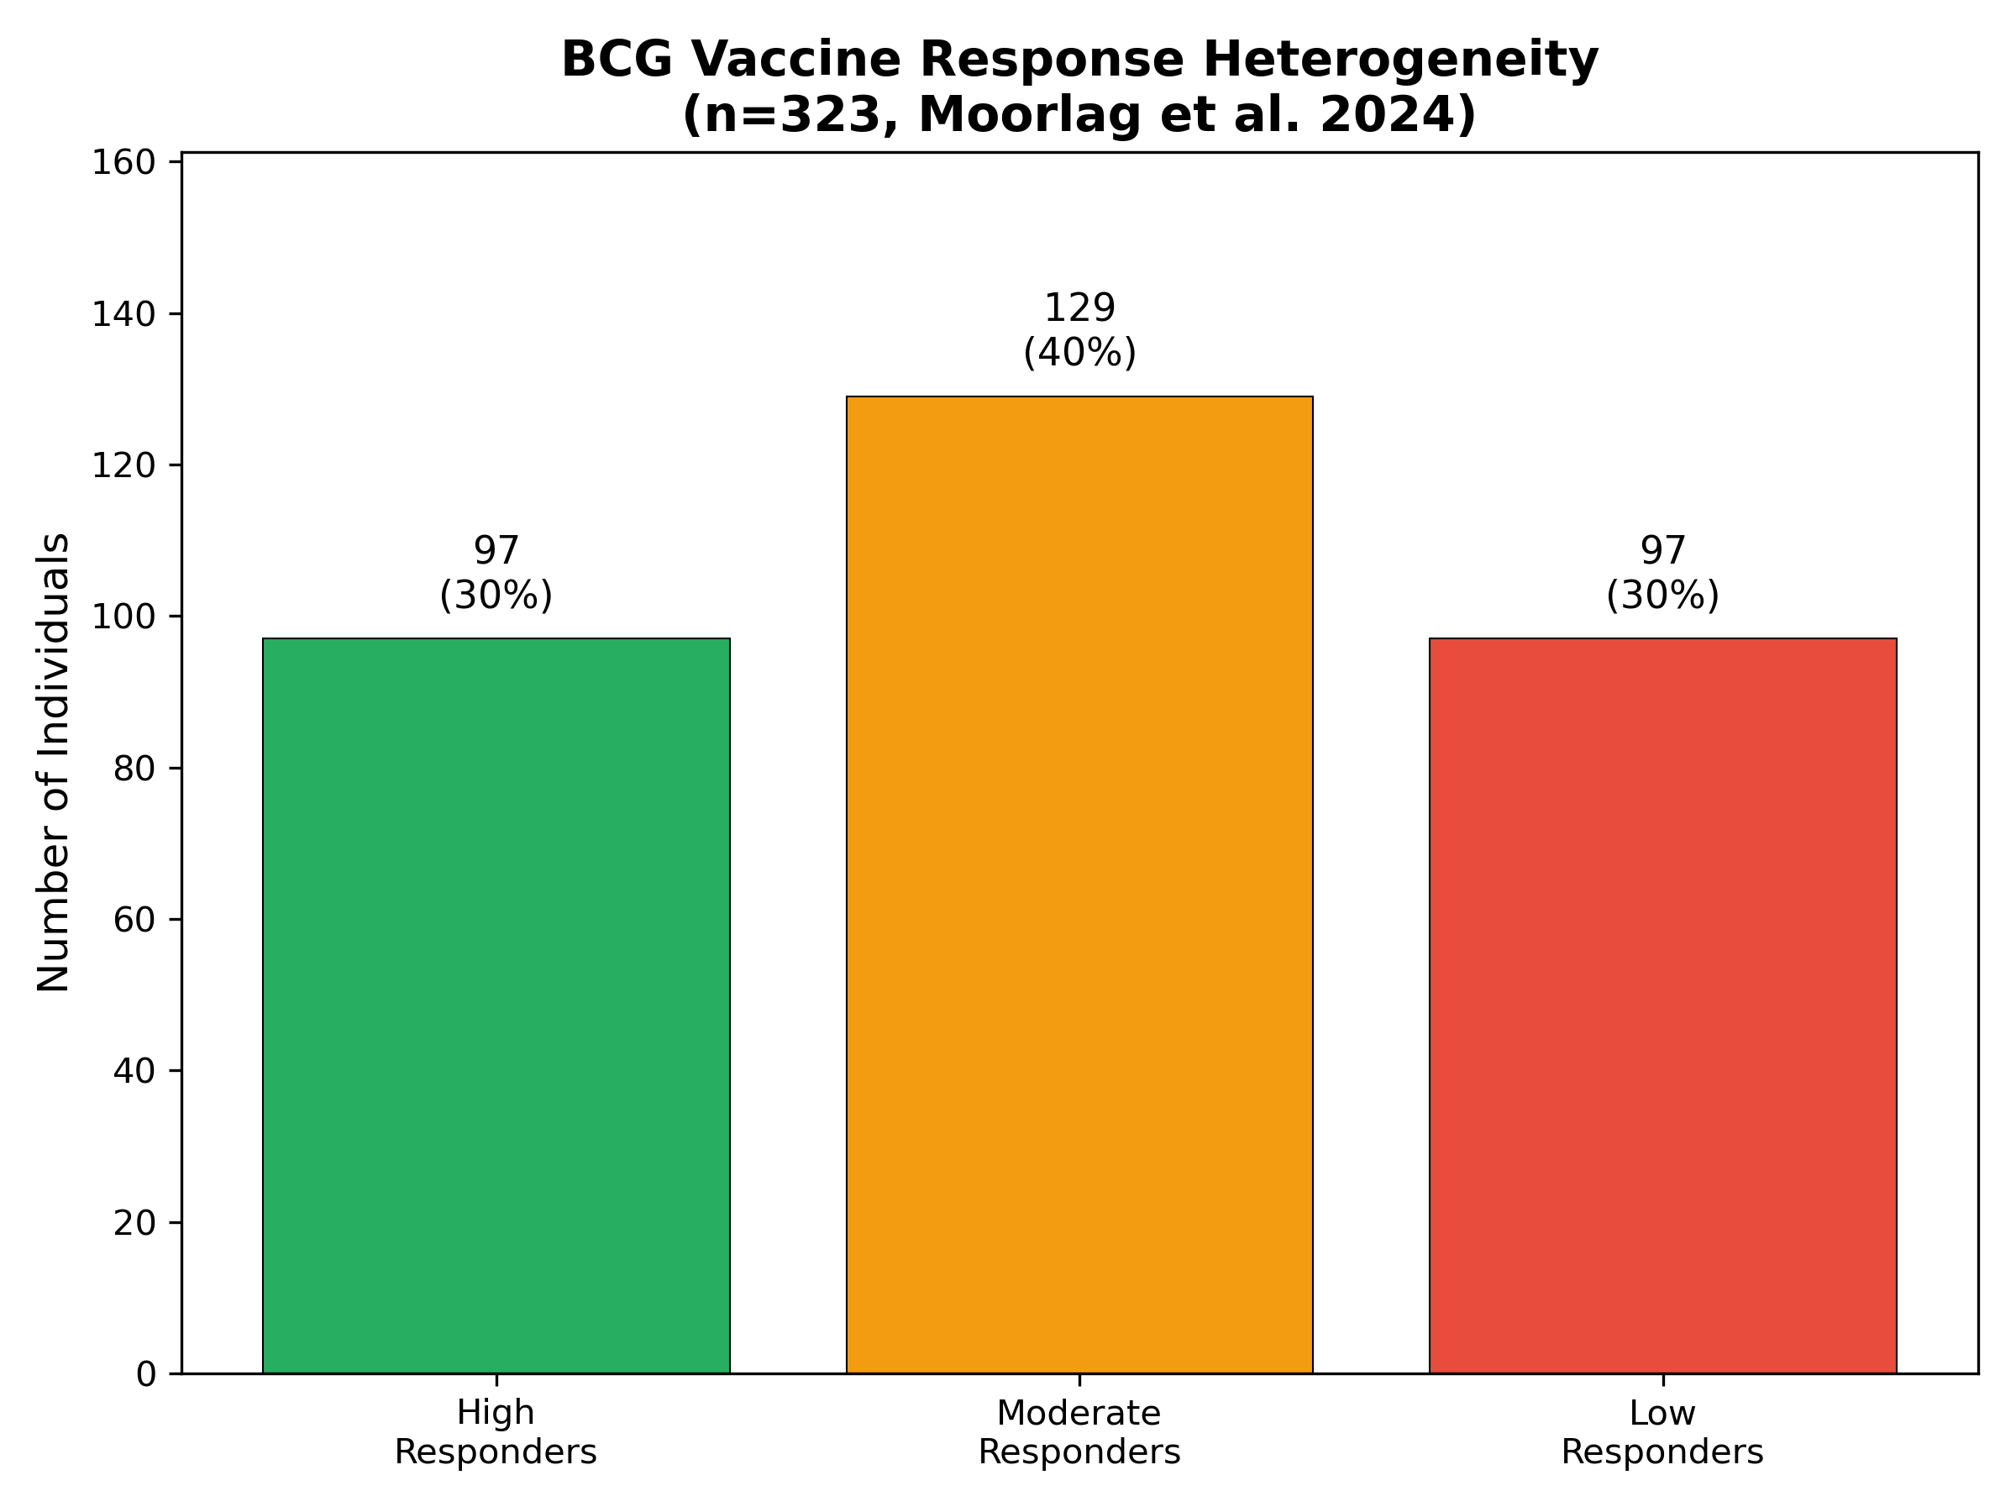
Figure 1. BCG vaccine response distribution

3.2 Epigenetic Mechanisms
BCG induces epigenetic reprogramming with 7,842 regions showing increased H3K4me3 marks.4 High responders had greater baseline H3K4me3 at TNF, IL1B loci.2 The NOD2 receptor mediates this epigenetic training.5
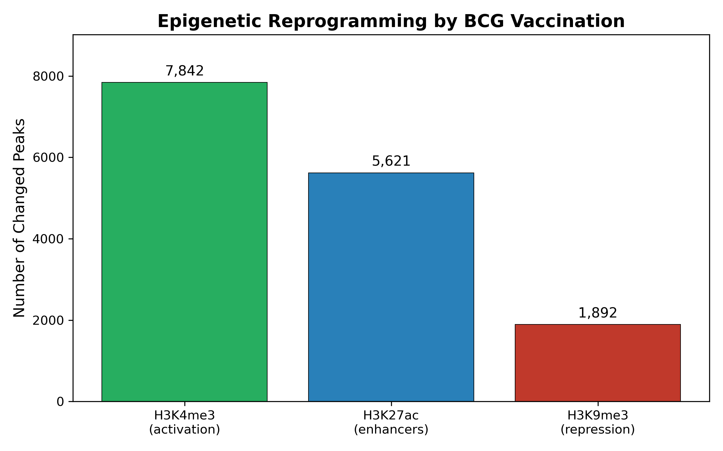
Figure 2. Epigenetic changes by BCG

3.3 Response Predictors
Key predictors: H3K4me3 at TNF (OR 2.8, p<0.001), IL-1beta production (OR 2.1), STAT1 expression (OR 1.9), glycolytic capacity (OR 1.7).2 Older age (OR 0.5) and prior TB exposure (OR 0.6) predicted low response.
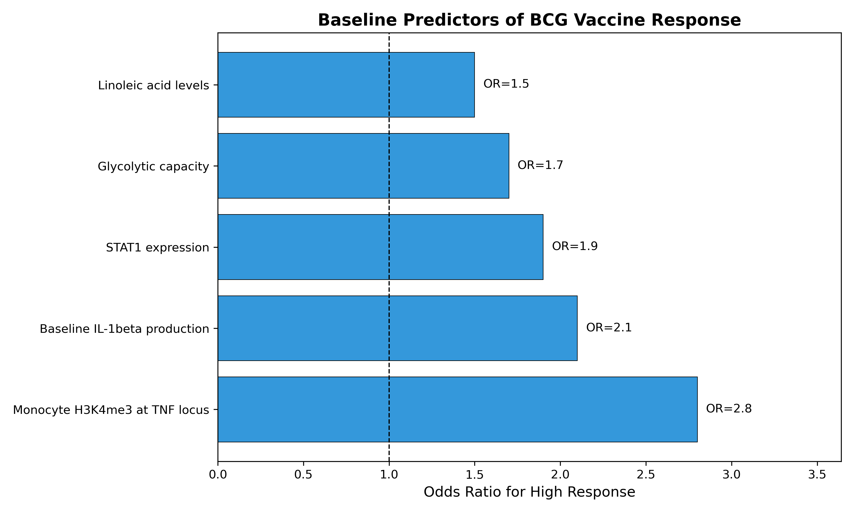
Figure 3. Response predictors

3.4 Hematopoietic Reprogramming
Cirovic et al. demonstrated BCG reprograms hematopoietic stem cells, not just circulating monocytes.6 This explains the persistence of trained immunity for months after vaccination.

4. Discussion
The trimodal response distribution has implications for vaccination. Baseline epigenetic states predict response, suggesting chromatin accessibility determines trainability. Metabolic fitness also influences response, with glycolytic capacity being a key predictor.
Limitations: Most studies in European populations. Long-term durability remains incompletely characterized.

5. Conclusions
BCG responses are highly heterogeneous (~30% high, 30% low). Baseline H3K4me3, STAT1, and glycolytic capacity predict response. These findings enable personalized vaccination approaches.

Funding
No specific funding received.

Conflict of Interest
None declared.

References
1. World Health Organization. BCG vaccines: WHO position paper. Wkly Epidemiol Rec 2018;93(8):73-96. PMID: 29474026
2. Moorlag SJCFM, Rodriguez-Rosales YA, Gillard J, et al. Multi-omics analysis of innate and adaptive responses to BCG vaccination reveals epigenetic cell states that predict trained immunity. Immunity 2024;57(1):171-187. doi: 10.1016/j.immuni.2023.12.005. PMID: 38176412
3. Koeken VACM, Qi C, Mourits VP, et al. BCG vaccination induces trained immunity through intergenerational epigenetic and metabolic rewiring. Science Advances 2024;10(15):eadl2648. doi: 10.1126/sciadv.adl2648. PMID: 38608012
4. Arts RJW, Moorlag SJCFM, Novakovic B, et al. BCG vaccination protects against experimental viral infection in humans through the induction of cytokines associated with trained immunity. Cell Host Microbe 2018;23(1):89-100. doi: 10.1016/j.chom.2017.12.010. PMID: 29324233
5. Kleinnijenhuis J, Quintin J, Preijers F, et al. Bacille Calmette-Guerin induces NOD2-dependent nonspecific protection from reinfection via epigenetic reprogramming of monocytes. PNAS 2012;109(43):17537-42. doi: 10.1073/pnas.1202870109. PMID: 22988082
6. Cirovic B, de Bree LCJ, Groh L, et al. BCG vaccination in humans elicits trained immunity via the hematopoietic progenitor compartment. Cell Host Microbe 2020;28(2):322-334. doi: 10.1016/j.chom.2020.05.014. PMID: 32504575
7. Netea MG, Joosten LAB, Latz E, et al. Trained immunity: a program of innate immune memory in health and disease. Science 2016;352(6284):aaf1098. doi: 10.1126/science.aaf1098. PMID: 27102489
8. Arts RJW, Carvalho A, La Rocca C, et al. Immunometabolic pathways in BCG-induced trained immunity. Cell Reports 2016;17(10):2562-2571. doi: 10.1016/j.celrep.2016.11.011. PMID: 27926861

