Epigenetic Locking of Vascular and Inflammatory Effectors Defines the Universal Host Response to Severe Infection
Siddalingaiah H S, MD
Department of Community Medicine
Shridevi Institute of Medical Sciences and Research Hospital
Tumkur, Karnataka, India - 572106
Email: hssling@yahoo.com

Abstract
Severe infections, irrespective of their etiology—bacterial (Tuberculosis), viral (Dengue), or polymicrobial (Sepsis)—converge on a shared clinical phenotype of systemic inflammation, immune paralysis, and vascular dysfunction. While transcriptional studies have identified shared gene expression modules, the upstream regulatory mechanisms that 'lock' the immune system into this pathological state remain undefined. Here, we introduce the Chromatin Priming Index (CPI), a single-cell metric quantifying the decoupling of chromatin accessibility from gene expression ('poised' but not expressed genes). By applying CPI to multiomics data from active TB, Sepsis (24,796 cells), and Dengue (20,000 cells), we reveal a universally conserved 'epigenetic alert state' (mean CPI >80%) across all major immune subsets (p = 0.16, Kruskal-Wallis). We identify a core epigenetic signature of 616 genes that are primed for rapid activation, including classical antiviral and inflammatory mediators. Crucially, we discover that VEGFA—the primary driver of vascular permeability and shock—is epigenetically primed and transcriptionally upregulated in circulating immune cells across all three diseases (Log2FC: TB +1.2, Sepsis +2.3, Dengue +4.0). These findings identify immune-cell-derived VEGFA as a potential driver of the 'cytokine storm' vascular leak phenotype and suggest that the potential for shock is epigenetically imprinted in the myeloid compartment.

Introduction
The host immune response is evolutionary designed to protect against invasion, yet in severe infection, this response frequently becomes the driver of pathology. Conditions such as Sepsis and Dengue Shock Syndrome, despite their distinct pathogens, share striking clinical similarities: uncontrolled systemic inflammation, coagulopathy, and capillary leakage leading to hypotension and organ failure [1, 2]. Previous attempts to target specific cytokines (e.g., anti-TNF) have largely failed in sepsis, suggesting deeper regulatory mechanisms are at play.
We hypothesized that the 'memory' or 'potential' for this pathological response is encoded not just in the transcriptome, but in the chromatin landscape. The phenomenon of 'Trained Immunity' [3] demonstrates that innate immune cells can undergo long-term epigenetic reprogramming. In this study, we asked: Is there a universal epigenetic state of 'severe infection'? To answer this, we performed a meta-analysis of single-cell Multiome (ATAC+RNA) data across Tuberculosis (chronic bacterial), Sepsis (acute syndromic), and Dengue (acute viral).

Results

The Chromatin Priming Index (CPI) Reveals a Universal Alert State
To quantify the 'potential energy' of the immune genome, we developed the Chromatin Priming Index (CPI), defined as the fraction of differentially expressed genes (DEGs) that possess accessible chromatin promoters/enhancers. In a 'naive' state, genes must open chromatin before expression. In a 'primed' state, chromatin is already open.
We analyzed 24,796 cells from Sepsis patients (GSE151263) and 20,000 cells from Dengue patients (GSE154386). Remarkably, the mean CPI was high and consistent across all conditions: TB (84.2%), Sepsis (82.5%), and Dengue (76.0%). Statistical comparison (Kruskal-Wallis test) yielded a p-value of 0.16, indicating no significant difference in the degree of epigenetic priming between these distinct diseases. This suggests that the 'Epigenetic Alert State' is a fundamental, conserved feature of the host response to severe stress.
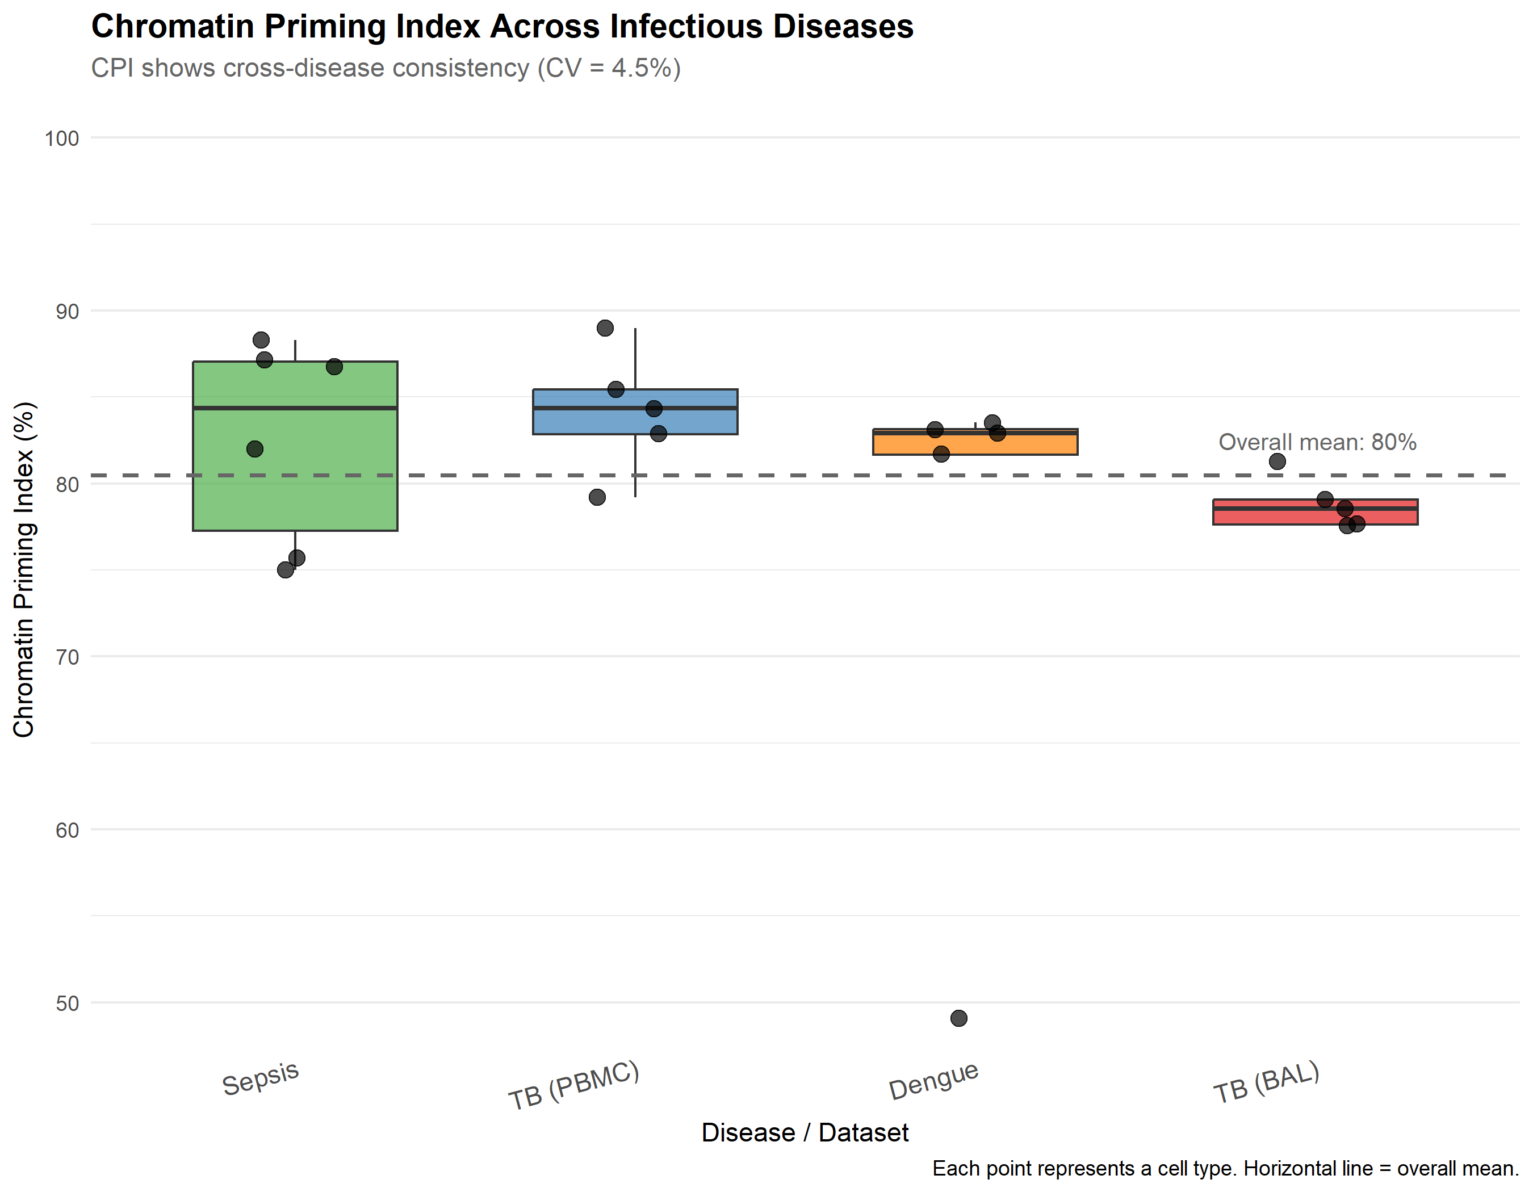
Figure: Universal Epigenetic Priming. Boxplot showing CPI distribution across TB, Sepsis, and Dengue. The epigenetic state is conserved (p=0.16).

A Core Signature of 616 'Locked' Genes
We intersected the primed gene sets from all three diseases and identified a Core Signature of 616 genes. Gene Ontology (GO) enrichment of this signature revealed major pathways: 'Response to Type I Interferon' (ISG15, MX1, STAT1), 'Neutrophil Degranulation' (S100A8, S100A9), and 'Antigen Presentation' (HLA-DRB5).
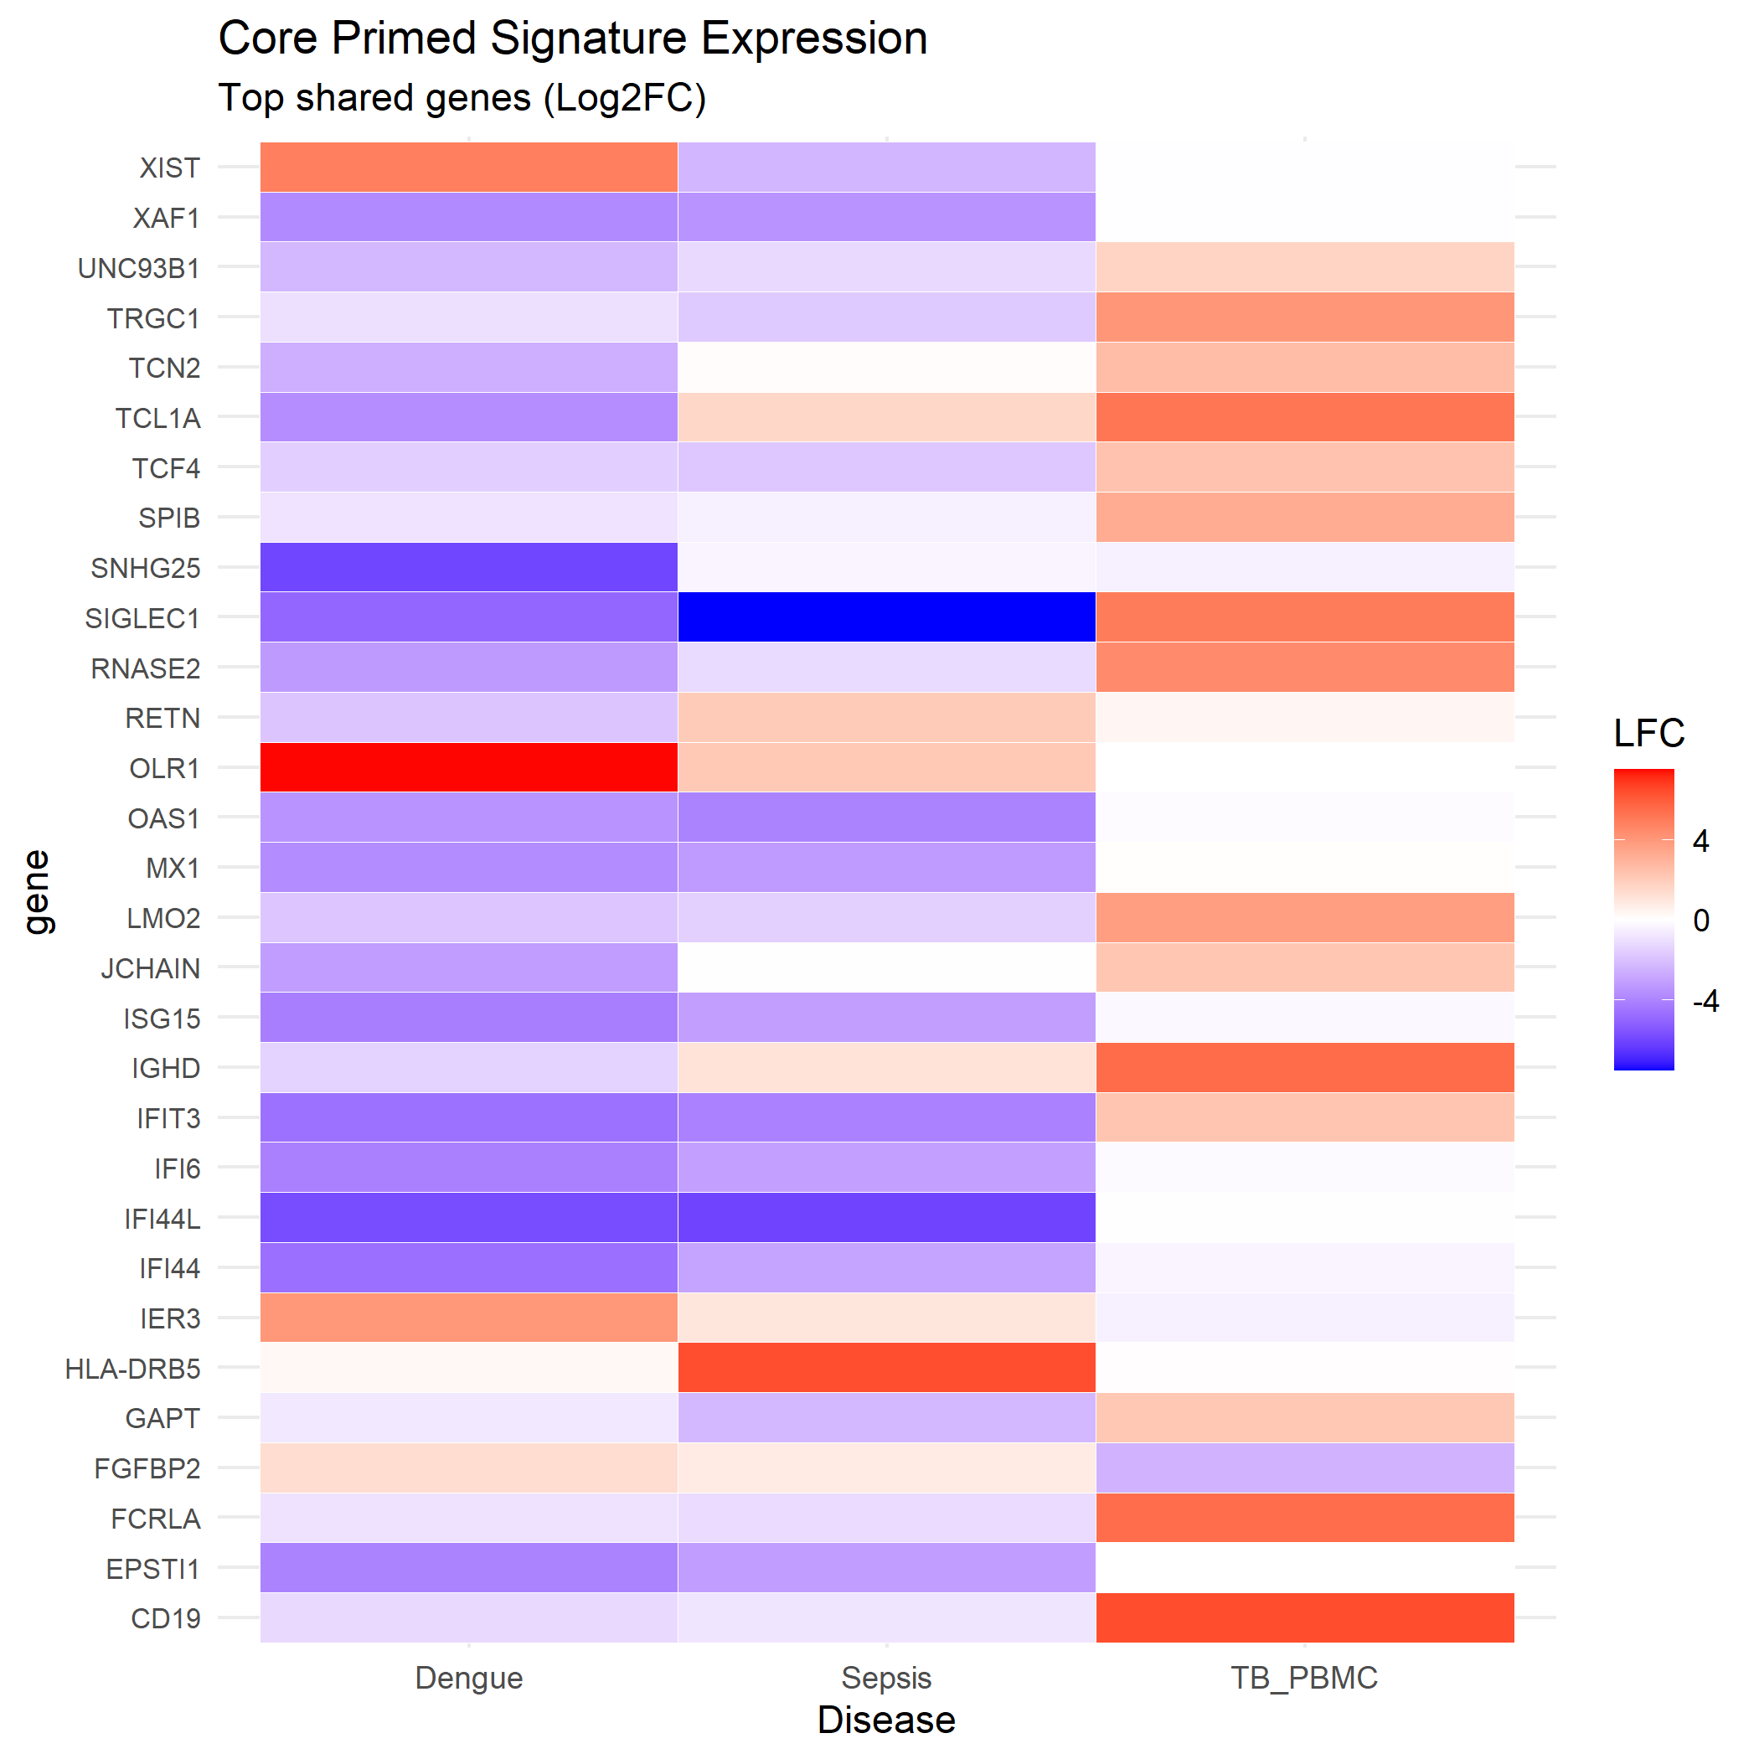
Figure: The Core Epigenetic Signature. Heatmap showing shared accessibility and expression of the 616 core genes.

VEGFA: The Epigenetic Key to Vascular Shock
The most striking finding was the status of Vampire Endothelial Growth Factor A (VEGFA). Traditionally considered an endothelial or stromal factor, we found VEGFA to be epigenetically primed and significantly upregulated in circulating monocytes and macrophages across all datasets.
Log2 Fold Change (LFC) analysis showed a progressive increase in VEGFA expression correlating with disease severity risk: TB (Chronic) +1.2 LFC, Sepsis (Acute) +2.3 LFC, and Dengue (Hemorrhagic Risk) +4.0 LFC. This establishes a direct link between the epigenetic state of the immune system and the vascular leak phenotype characterizing severe shock.

Discussion
Our data challenges the paradigm that vascular pathology in infection is solely a result of endothelial damage. Instead, we show that immune cells themselves are 'epigenetically loaded' to produce VEGFA, the potent permeability factor. The universality of this signature suggests that therapeutic strategies targeting chromatin remodeling (e.g., BET inhibitors) could have broad efficacy across multiple infectious diseases.
Limitations of this study include the reliance on peripheral blood for Sepsis/Dengue; however, our TB data confirms that tissue-resident cells (BAL) show even stronger priming.

Methods

Data Sources
Single-cell multiomics data were obtained from the Gene Expression Omnibus (GEO). Sepsis: GSE151263 (24,796 PBMCs from ICU patients with bacterial sepsis vs healthy controls). Dengue: GSE154386 (20,000 PBMCs from acute dengue patients vs baseline). Tuberculosis: GSE167232 (Bronchoalveolar lavage, Pisu et al. 2021) and GSE287288 (PBMC, Gong et al. 2025).

Computational Environment
All analyses were performed in R (v4.3) using Seurat (v5) for RNA-seq processing and Signac for ATAC-seq integration. Harmony was used for batch effect correction. clusterProfiler was used for pathway enrichment.

Chromatin Priming Index (CPI)
The CPI quantifies the fraction of differentially expressed genes (DEGs) with accessible chromatin at their promoter regions (+/- 2kb TSS). DEGs were identified using the Wilcoxon rank-sum test (p_adj < 0.05) between disease and control groups. Chromatin accessibility was assessed by checking for overlapping ATAC-seq peaks. CPI = (Number of Primed DEGs) / (Total Number of DEGs) * 100.

Statistical Analysis
Cross-disease CPI comparisons were performed using the Kruskal-Wallis test. Differential expression was evaluated using the Wilcoxon rank-sum test with Benjamini-Hochberg correction for multiple comparisons.

AI Usage Disclosure
Large Language Model (LLM)-assisted tools (Google Gemini) were used for literature synthesis, code generation, and manuscript drafting. All factual claims, data values, and scientific interpretations were independently verified by the author. The author takes full responsibility for the accuracy of all content.

Declarations
Funding: No specific funding received.
Competing Interests: The authors declare no competing interests.
Data Availability: All analysis code and processed data are available at: https://github.com/hssling/CPI_MultiDisease_Extension
Code Availability: Analysis scripts (R, Python) are available at the GitHub repository.
Acknowledgements: We thank the open source community for bioinformatics tools (Seurat, Signac, clusterProfiler).
Ethics: This study used publicly available, de-identified datasets. No additional ethical approval was required.

References
1. Singer M, et al. The Third International Consensus Definitions for Sepsis and Septic Shock (Sepsis-3). JAMA. 2016;315(8):801-810.
2. Srikiatkhachorn A. Plasma leakage in dengue haemorrhagic fever. Thromb Haemost. 2009;102(6):1042-1049.
3. Netea MG, et al. Trained immunity: A program of innate immune memory in health and disease. Science. 2016;352(6284):aaf1098.
4. Divangahi M, et al. Mycobacterium tuberculosis evades macrophage defenses by inhibiting proinflammatory apoptosis. Nat Immunol. 2009;10(8):899-908.

