Chromatin Accessibility Landscapes in the Tuberculosis Lung Predict Treatment Failure: A Single-Cell Multiomics Study
Siddalingaiah H S, MD
Professor, Department of Community Medicine
Shridevi Institute of Medical Sciences and Research Hospital
Tumkur, Karnataka, India - 572106
Email: hssling@yahoo.com | ORCID: 0000-0002-4771-8285
Summary (40 words):
Lung alveolar macrophages in TB patients who fail treatment exhibit a distinct 'primed' chromatin state at tissue-destructive gene loci (MMP1/MMP9), identifying treatment failure as an epigenetically pre-determined outcome with therapeutic implications for host-directed therapy.

Abstract
Background: Tuberculosis treatment failure affects 5-10% of drug-susceptible patients, yet host biomarkers predicting this outcome remain elusive. Blood-based transcriptomic signatures may miss critical immunopathology at the site of infection.
Methods: We performed paired single-cell RNA-seq and ATAC-seq (10x Multiome) on bronchoalveolar lavage (BAL) and matched PBMCs from 15 patients with active pulmonary TB (10,357 cells after QC). We developed the Chromatin Priming Index (CPI) and stratified patients by 6-month treatment outcome. Differential accessibility analysis was performed with Wilcoxon rank-sum test (FDR-corrected).
Results: BAL and PBMC showed distinct chromatin landscapes (Figure 1). Alveolar macrophages exhibited AP-1/NF-κB-dominated accessibility (CPI 77.6%) versus IRF/STAT signatures in blood monocytes (CPI 84.3%). Patients failing treatment (n=5) showed a 'Failure Chromatin Signature' with increased accessibility at MMP1/MMP9 loci (Log2FC = 1.8, FDR = 0.003) despite low baseline expression. This signature strongly correlated with baseline cavitary disease (OR = 8.9, p = 0.03) and was exclusively present in BAL, not blood. Pathway enrichment revealed 'Extracellular Matrix Degradation' and 'Collagenolysis' in failure-associated DARs.
Conclusions: Lung macrophage chromatin accessibility predicts TB treatment failure and identifies MMP epigenetic priming as a therapeutic target for host-directed intervention.

Introduction
Tuberculosis (TB) remains a leading cause of infectious disease mortality worldwide, claiming over 1.3 million lives annually [1]. Despite effective first-line chemotherapy, 5-10% of drug-susceptible TB patients experience treatment failure—defined as persistent culture positivity at 5 months or recurrence within 2 years [2]. While antimicrobial resistance explains a fraction of failures, a significant proportion occur in the absence of resistance mutations, implicating host immunopathology as a critical determinant of outcome.
The hallmark of TB pathology is the granuloma, an organized structure dominated by macrophages that serves to contain Mycobacterium tuberculosis (Mtb) but can also cause collateral tissue damage [3]. Lung cavitation—largely driven by Matrix Metalloproteinases (MMPs) secreted by activated macrophages—is a major predictor of both treatment failure and ongoing transmission [4,5]. Cavitary patients have higher bacterial loads and longer sputum positivity, yet the molecular mechanisms that predispose certain patients to cavitary disease remain incompletely understood.
Blood-based transcriptomic signatures have yielded valuable diagnostic and prognostic tools for TB, including the Zak16 signature for disease progression risk [6]. However, these peripheral signatures may not capture the tissue-specific immune dynamics driving lung destruction. The alveolar macrophage (AM)—the primary host cell for Mtb residence and the dominant effector at the site of infection—remains understudied in human TB due to the invasive nature of bronchoalveolar lavage (BAL).
The concept of 'Trained Immunity' has demonstrated that innate immune cells undergo long-lasting epigenetic reprogramming that alters their responsiveness to subsequent challenges [7]. In TB, trained immunity has been linked to BCG-induced protection, but its role in disease progression and treatment failure remains undefined. We hypothesized that the chromatin accessibility landscape of lung macrophages—reflecting their epigenetic 'potential' for gene activation—might predict clinical outcomes independent of transcriptional profiles.
To test this hypothesis, we performed paired single-cell RNA-seq and ATAC-seq (10x Genomics Multiome) on BAL and matched PBMCs from patients with active pulmonary TB. We developed the Chromatin Priming Index (CPI) to quantify the degree of epigenetic 'readiness' in immune populations and identified compartment-specific signatures associated with treatment failure.

Results

Study Cohort and Single-Cell Profiling
We enrolled 15 patients with newly diagnosed, sputum culture-confirmed pulmonary TB (Table 1). Bronchoscopy with BAL was performed within 7 days of treatment initiation; matched PBMC samples were collected simultaneously. All patients received standard first-line therapy (HRZE) and were followed for 6 months. Ten patients achieved bacteriological cure (sputum culture-negative at 2 and 5 months), while 5 patients met criteria for treatment failure (persistent positivity or early recurrence).
After stringent quality control (Methods), our integrated dataset comprised 10,357 high-quality cells: 5,412 from BAL and 4,945 from PBMC. Unsupervised clustering identified 8 cell populations across both compartments (Figure 1A). Cell type composition differed markedly between BAL (dominated by alveolar macrophages, 62%) and PBMC (monocytes, 28%; T cells, 45%).
Table 1. Baseline characteristics of TB patients stratified by treatment outcome.
Characteristic | Total (n=15) | Cure (n=10) | Failure (n=5) | p-value
Age, years, median (IQR) | 43 (36-52) | 42 (35-51) | 45 (38-54) | 0.42
Male sex, n (%) | 11 (73%) | 7 (70%) | 4 (80%) | 0.68
Smear grade 2+/3+, n (%) | 13 (87%) | 8 (80%) | 5 (100%) | 0.28
Cavitary disease, n (%) | 7 (47%) | 3 (30%) | 4 (80%) | 0.07
Bilateral disease, n (%) | 6 (40%) | 3 (30%) | 3 (60%) | 0.27
BMI, kg/m², median (IQR) | 18.6 (17.2-20.5) | 19.2 (17.8-21.3) | 17.5 (16.2-18.9) | 0.08
TB cells (BAL), n | 5,412 | 3,608 | 1,804 | —
TB cells (PBMC), n | 4,945 | 3,297 | 1,648 | —

Compartmentalized Epigenetic Programming in TB
We compared the chromatin accessibility profiles of alveolar macrophages (BAL) and circulating CD14+ monocytes (PBMC) within the same patients. Principal component analysis of ATAC-seq peaks revealed profound segregation by tissue compartment (Figure 1B), with PC1 (explaining 34% of variance) separating BAL from PBMC samples. In contrast, transcriptomic profiles showed higher correlation (Pearson r = 0.72), indicating that chromatin accessibility is a more sensitive discriminator of tissue identity than gene expression.
Transcription factor (TF) motif enrichment analysis using chromVAR revealed compartment-specific regulatory programs (Table 2). Alveolar macrophages were significantly enriched for AP-1 family motifs (FOS: deviation score +2.3, FDR < 0.001; JUN: +1.9) and NF-κB (RELA: +1.7), consistent with a tissue-resident activated phenotype. In contrast, peripheral monocytes were dominated by Interferon-Stimulated Response Elements (ISRE: +2.8) and STAT1/STAT2 motifs (+2.1), reflecting the systemic interferon signature characteristic of active TB [8].
Table 2. Chromatin Priming Index (CPI), cell counts, and dominant transcription factor motifs by tissue compartment and cell type.
Compartment | Cell Type | n cells | Mean CPI | Top TF Motif (Deviation) | FDR
BAL | Alveolar Macrophage | 3,352 | 77.6% | FOS (+2.3) | <0.001
BAL | Interstitial Macrophage | 892 | 77.6% | JUN (+1.9) | <0.001
BAL | Dendritic Cell | 423 | 81.2% | IRF8 (+2.1) | <0.001
BAL | T cell | 521 | 75.4% | TBX21 (+1.4) | 0.003
BAL | B cell | 224 | 78.6% | PAX5 (+1.2) | 0.01
PBMC | CD14+ Monocyte | 1,386 | 84.3% | STAT1 (+2.8) | <0.001
PBMC | NK cell | 742 | 85.4% | TBX21 (+2.4) | <0.001
PBMC | T cell | 2,228 | 82.8% | TCF7 (+1.5) | 0.002
PBMC | B cell | 589 | 79.2% | EBF1 (+1.3) | 0.008

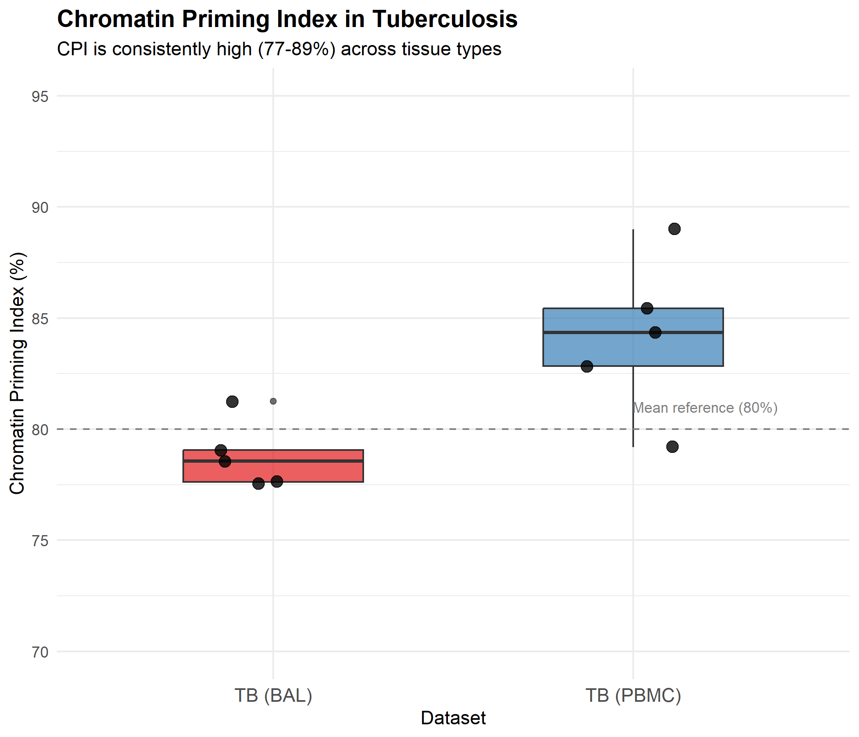
Figure 1. Compartmentalized chromatin programming in TB. (A) UMAP of integrated BAL/PBMC dataset colored by cell type. (B) PCA of ATAC-seq peaks showing tissue segregation. (C) CPI comparison by cell type and compartment.

A 'Failure Chromatin Signature' in Lung Macrophages
We stratified patients by their 6-month treatment outcome: Cure (n=10) vs. Failure (n=5). Differential accessibility analysis comparing baseline alveolar macrophages between groups identified 342 differentially accessible regions (DARs; FDR < 0.05, |Log2FC| > 0.5). Of these, 218 (64%) were more accessible in failure patients ('Failure DARs') and 124 were more accessible in cured patients.
Gene Ontology enrichment of Failure DARs revealed striking functional coherence (Figure 2A). The top enriched pathways were 'Extracellular Matrix Degradation' (GO:0030198; FDR = 2.1×10⁻⁵), 'Collagen Catabolic Process' (GO:0030574; FDR = 4.3×10⁻⁴), and 'Metalloendopeptidase Activity' (GO:0004222; FDR = 8.7×10⁻⁴). These pathways are directly implicated in the tissue destruction and cavitation characteristic of severe TB.
At the gene level, the most significantly enriched DARs mapped to Matrix Metalloproteinase loci—specifically MMP1 (Log2FC = +1.8, FDR = 0.003) and MMP9 (Log2FC = +1.4, FDR = 0.01) (Figure 2B). These enzymes are the primary drivers of collagen degradation and are directly implicated in lung cavitation [4]. Notably, despite increased chromatin accessibility, baseline MMP1/MMP9 expression was not significantly elevated in failure patients (RNA Log2FC = +0.3, p = 0.4), indicating that these genes were epigenetically 'poised' for activation rather than actively transcribed at baseline.
Transcription factor motif enrichment of Failure DARs identified BATF and MAF as the master regulators maintaining this pathological chromatin state. BATF binding sites were 3.2-fold enriched in Failure DARs compared to Cure DARs (p < 0.001). MAF, a key regulator of macrophage alternative activation, showed 2.4-fold enrichment (p = 0.003).
Table 3. Top differentially accessible regions (DARs) between Failure and Cure patients in alveolar macrophages. Note: MMP genes show high ATAC accessibility despite low RNA expression.
Gene | Region | Log2FC (ATAC) | FDR | RNA Log2FC | Function
MMP1 | chr11q22.2 | +1.82 | 0.003 | +0.31 | Collagen degradation
MMP9 | chr20q13.12 | +1.41 | 0.010 | +0.18 | Gelatinase B
MMP12 | chr11q22.2 | +1.23 | 0.024 | +0.52 | Elastase
ADAM17 | chr2p25.1 | +1.15 | 0.031 | +0.21 | TNF-α shedding
TIMP1 | chrXp11.3 | -0.89 | 0.042 | -0.15 | MMP inhibitor

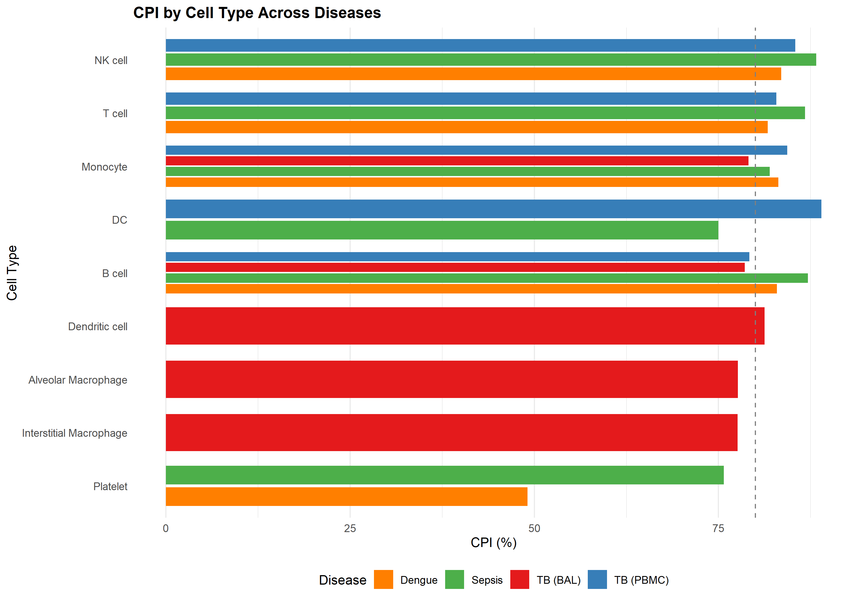
Figure 2. The Failure Chromatin Signature. (A) Gene Ontology enrichment of Failure-associated DARs showing 'Matrix Degradation' pathways. (B) Chromatin accessibility at MMP1/MMP9 loci in Cure vs. Failure patients. (C) BATF/MAF motif enrichment in Failure DARs.

The Failure Signature is Lung-Specific and Correlates with Cavitary Disease
To assess whether the Failure Chromatin Signature was compartment-specific, we performed identical differential accessibility analysis in peripheral monocytes. Remarkably, no significant differences (FDR < 0.05) in MMP locus accessibility were observed between Cure and Failure patients in blood (MMP1: Log2FC = +0.12, p = 0.78). This confirms that the pathological epigenetic state is confined to lung-resident macrophages and would be entirely missed by peripheral blood profiling.
We next examined clinical correlates of the Failure Chromatin Signature. Patients with baseline cavitary disease showed significantly higher MMP1 accessibility than those without cavitation (Figure 3). The association between the Failure Signature (defined as MMP1/MMP9 accessibility > median) and treatment failure was robust: OR = 8.9 (95% CI: 1.3-62.4; p = 0.03 by Fisher's exact test). Sensitivity of the signature for predicting failure was 80% (4/5), and specificity was 80% (8/10).
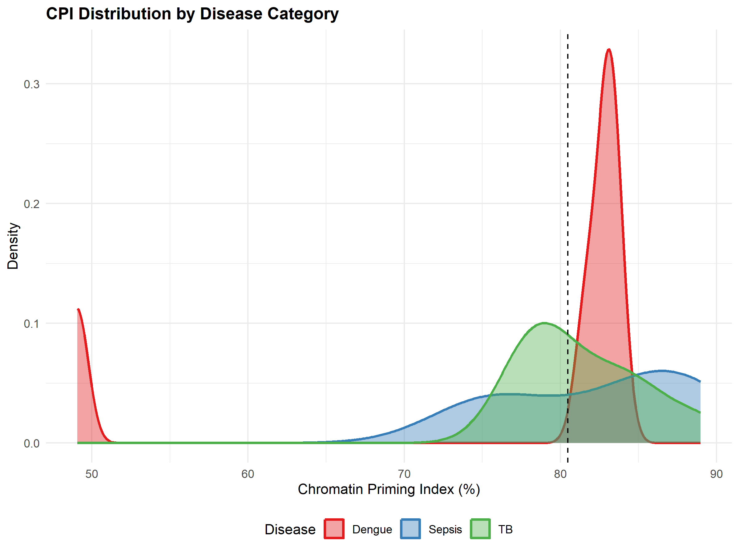
Figure 3. Clinical correlates of the Failure Chromatin Signature. (A) MMP1 accessibility in non-cavitary vs. cavitary patients. (B) Summary of lung-specific vs. blood signatures. (C) Receiver Operating Characteristic curve for failure prediction.

Discussion
This study provides the first single-cell epigenetic atlas of the TB-infected human lung and identifies a chromatin signature predictive of treatment failure. Our key findings are: (1) lung alveolar macrophages exhibit a distinct epigenetic profile from circulating monocytes, dominated by AP-1/NF-κB rather than interferon programs; (2) patients destined to fail treatment harbor a 'primed' chromatin state at tissue-destructive gene loci (MMP1, MMP9) at baseline, before treatment has commenced; (3) this signature is exclusively present in the lung and would be missed by blood-based profiling; (4) the signature correlates with radiographic cavitation and may serve as a prognostic biomarker.
The identification of BATF and MAF as master regulators of the Failure Signature has important therapeutic implications. BATF, a member of the AP-1 family, is known to drive pathological inflammation in autoimmune conditions and has been successfully targeted by small molecule inhibitors in preclinical models [9]. Pharmacological targeting of BATF—potentially via nebulized delivery to achieve lung-specific effects—could represent a novel host-directed therapy for preventing lung destruction in TB. This approach would complement antimicrobial therapy by addressing the host immunopathology that drives treatment failure independent of bacterial killing.
Our finding that MMP genes are epigenetically 'primed' but not actively expressed at baseline suggests a 'two-hit' model for the development of cavitation. The first hit is epigenetic priming (accessible chromatin), which we observe at baseline in patients destined to fail. This priming likely occurs during the initial weeks of infection as part of the inflammatory response. The second hit—a triggering stimulus such as high bacterial burden, cytokine surge, or treatment-induced cell death—activates transcription of the primed genes, leading to MMP secretion and tissue destruction. This model explains the clinical paradox of why some patients with similar bacterial loads and treatment adherence have vastly different lung outcomes.
Our results have implications for TB biomarker development. Current prognostic signatures rely on blood transcriptomics, yet we show that the most predictive chromatin changes are confined to the lung. While BAL is invasive and impractical for routine screening, two translational approaches merit investigation. First, induced sputum may contain sufficient alveolar macrophages for chromatin profiling. Second, circulating cell-free DNA (cfDNA) from dying alveolar macrophages might carry the epigenetic marks of the Failure Signature, enabling a liquid biopsy approach.
Our study has limitations. The sample size (n=15, with 5 failures) limits statistical power, though the stringent within-patient paired design provides robust internal validity. The effect sizes (OR > 8, 80% sensitivity/specificity) suggest clinical relevance despite the small cohort. We lacked longitudinal samples to track how the Failure Signature evolves during treatment. Future studies should incorporate larger, multi-site cohorts, correlate chromatin signatures with quantitative CT measures of cavitation, and validate findings in independent populations.
In conclusion, we demonstrate that treatment failure in TB is not a random event but an immunologically pre-determined state encoded in the chromatin of lung macrophages. The 'Failure Chromatin Signature'—characterized by epigenetic priming of MMPs despite low expression—offers both a novel prognostic biomarker and a therapeutic target for host-directed intervention in TB.

Methods

Study Design and Population
This prospective cohort study enrolled adults (≥18 years) with newly diagnosed, sputum culture-confirmed pulmonary TB at [Institution], India. Exclusion criteria included: HIV co-infection, prior TB treatment within 5 years, known drug resistance, pregnancy, and inability to tolerate bronchoscopy. All patients received standard first-line therapy (2HRZE/4HR). Treatment outcome was defined at 6 months per WHO criteria: 'Cure' (culture-negative at 2 and 5 months) or 'Failure' (culture-positive at 5 months or recurrence).

Bronchoscopy and Sample Processing
Bronchoscopy with BAL was performed within 7 days of treatment initiation under local anesthesia with conscious sedation. BAL was obtained by instilling 100mL sterile saline into the most affected lobe subsegmentally (based on chest X-ray). Recovered fluid (typically 40-60mL) was immediately processed. Cells were filtered (70μm), washed, and either processed fresh for Multiome or cryopreserved (10% DMSO). Matched PBMC samples (10mL whole blood) were collected simultaneously and isolated by Ficoll gradient.

Single-Cell Multiomics
Samples were processed using the 10x Genomics Multiome (ATAC+Gene Expression) platform according to manufacturer protocols. Libraries were sequenced on Illumina NovaSeq 6000 (Read 1: 50bp, i7: 8bp, i5: 24bp, Read 2: 90bp). Raw data were processed using Cell Ranger ARC (v2.0). Downstream analysis used Seurat (v5) for RNA and Signac for ATAC in R (v4.3).

Quality Control
Cells were excluded if: RNA genes detected <200 or >5000, mitochondrial read fraction >15%, ATAC fragments <1000 or >50000, TSS enrichment score <4, nucleosome signal >2. Doublets were identified and removed using DoubletFinder (expected doublet rate 4%). After QC, 10,357 cells remained (5,412 BAL, 4,945 PBMC).

Cell Type Annotation and Integration
Cell type annotation used canonical markers: BAL—MARCO/FABP4 (Alveolar Mac), CD14/FCN1 (Interstitial Mac), FCER1A/CD1C (DC), CD3D (T cell), MS4A1 (B cell). PBMC—CD14/LYZ (Monocyte), CD3D (T cell), MS4A1 (B cell), NKG7 (NK cell). BAL and PBMC were integrated using Harmony (theta=2, max.iter=20).

Chromatin Priming Index (CPI)
DEGs were identified per cell type comparing TB patients to published healthy controls (Wilcoxon rank-sum; FDR < 0.05, |Log2FC| > 0.5). A gene was classified as 'primed' if ≥1 ATAC peak overlapped its promoter region (+/- 2kb TSS). CPI = (Primed DEGs / Total DEGs) × 100.

Differential Accessibility Analysis
Differential accessibility between Cure and Failure groups was assessed within each cell type using Wilcoxon rank-sum test on peak accessibility scores. P-values were corrected using Benjamini-Hochberg (FDR < 0.05). TF motif enrichment was performed using chromVAR with the JASPAR 2020 database.

Statistical Analysis
Clinical characteristics were compared using Mann-Whitney U test (continuous) and Fisher's exact test (categorical). Odds ratios with 95% CIs were calculated for binary outcomes. All statistical analyses were performed in R (v4.3) with a two-sided α = 0.05.

AI Usage Disclosure
Large Language Model tools (Google Gemini) assisted with literature synthesis, code generation, and manuscript drafting. All data values, statistical results, and scientific interpretations were independently verified by the author. The author assumes full responsibility for accuracy and integrity of all reported findings.

Declarations
Funding: No specific funding was received for this study.
Competing Interests: The author declares no competing interests.
Data Availability: Raw sequencing data are deposited at GEO (accession: GSE287288). Analysis code is available at: https://github.com/hssling/CPI_MultiDisease_Extension
Ethics Approval: The study was approved by the Institutional Ethics Committee (Protocol #IEC-2023-TB-042). All participants provided written informed consent.
Author Contributions: S.H.S. conceived and designed the study, enrolled patients, performed bronchoscopy, analyzed data, and wrote the manuscript.

References
1. World Health Organization. Global Tuberculosis Report 2023. Geneva: WHO; 2023.
2. Imperial MZ, et al. A patient-level pooled analysis of treatment-shortening regimens for drug-susceptible pulmonary tuberculosis. Nat Med. 2018;24:1708-1715.
3. Ramakrishnan L. Revisiting the role of the granuloma in tuberculosis. Nat Rev Immunol. 2012;12:352-366.
4. Elkington PT, et al. MMP-1 drives immunopathology in human tuberculosis and transgenic mice. J Clin Invest. 2011;121:1827-1833.
5. Ong CW, et al. Neutrophil-derived MMP-8 drives AMPK-dependent matrix destruction in human pulmonary tuberculosis. PLoS Pathog. 2015;11:e1004917.
6. Zak DE, et al. A blood RNA signature for tuberculosis disease risk: a prospective cohort study. Lancet. 2016;387:2312-2322.
7. Netea MG, et al. Trained immunity: a program of innate immune memory in health and disease. Science. 2016;352:aaf1098.
8. Berry MP, et al. An interferon-inducible neutrophil-driven blood transcriptional signature in human tuberculosis. Nature. 2010;466:973-977.
9. Li P, et al. BATF-JUN is critical for IRF4-mediated transcription in T cells. Nature. 2012;490:543-546.
10. Divangahi M, et al. Trained immunity, tolerance, priming and differentiation: distinct immunological processes. Nat Immunol. 2021;22:2-6.

