Epigenetic Locking of Vascular and Inflammatory Effectors Defines the Universal Host Response to Severe Infection
Siddalingaiah H S, MD
Department of Community Medicine
Shridevi Institute of Medical Sciences and Research Hospital
Tumkur, Karnataka, India - 572106
Email: hssling@yahoo.com
ORCID: 0000-0002-4771-8285

Abstract
Severe infections, irrespective of their etiology—bacterial (Tuberculosis), viral (Dengue), or polymicrobial (Sepsis)—converge on a shared clinical phenotype of systemic inflammation, immune paralysis, and vascular dysfunction. While transcriptional studies have identified shared gene expression modules, the upstream regulatory mechanisms that 'lock' the immune system into this pathological state remain undefined. Here, we introduce the Chromatin Priming Index (CPI), a single-cell metric quantifying the decoupling of chromatin accessibility from gene expression ('poised' but not expressed genes). By applying CPI to multiomics data from active Tuberculosis (n=10,357 cells from bronchoalveolar lavage and peripheral blood), Sepsis (n=24,796 cells from ICU patients, GSE151263), and Dengue (n=20,000 cells from acute infection, GSE154386), we reveal a universally conserved 'epigenetic alert state'. The mean CPI exceeded 80% across all major immune subsets (TB: 84.2%, Sepsis: 82.5%, Dengue: 76.0%; p = 0.16, Kruskal-Wallis), indicating no significant disease-specific variation. We identify a core epigenetic signature of 616 genes that are primed for rapid activation, enriched for interferon response (ISG15, MX1), neutrophil degranulation (S100A8/A9), and antigen presentation (HLA-DRB5). Crucially, we discover that VEGFA—the primary driver of vascular permeability—is epigenetically primed and transcriptionally upregulated in circulating monocytes across all three diseases, with Log2 Fold Changes correlating with clinical severity (TB: +1.2, Sepsis: +2.3, Dengue Hemorrhagic Fever: +4.0). These findings identify immune-cell-derived VEGFA as a potential driver of the 'cytokine storm' vascular leak phenotype and suggest that the potential for shock is epigenetically imprinted in the myeloid compartment, opening new avenues for host-directed therapeutic intervention.

Introduction
Severe infections remain a leading cause of morbidity and mortality worldwide. Sepsis alone accounts for nearly 20% of global deaths, while tuberculosis kills over 1.3 million people annually, and dengue places half the world's population at risk of hemorrhagic fever [1]. Despite vast differences in causative pathogens—Gram-positive and Gram-negative bacteria in sepsis, Mycobacterium tuberculosis in TB, and flaviviruses in dengue—these conditions share a striking clinical convergence: systemic inflammation, immune cell dysfunction, and life-threatening vascular leak syndrome.
The molecular basis for this convergence has been the subject of intense investigation. Large-scale transcriptomic studies have identified shared gene expression modules across infections, including interferon-stimulated genes and inflammatory mediators [2]. However, these studies have largely focused on mRNA abundance, which represents the 'output' of the immune system rather than its underlying 'potential'. The upstream regulatory mechanisms that predispose—or 'prime'—immune cells to mount this pathological response remain poorly defined.
The concept of 'Trained Immunity' has revolutionized our understanding of innate immune memory [3]. Following exposure to pathogens or vaccines (e.g., BCG), monocytes and macrophages undergo epigenetic reprogramming that persists for months, enhancing their responsiveness to subsequent challenges. This epigenetic reprogramming involves changes in chromatin accessibility—the opening or closing of DNA regions to transcription factors. We hypothesized that a similar 'epigenetic alert state' might underlie the shared pathology of severe infections: chromatin regions are opened ('primed') in anticipation of an inflammatory response, even before gene expression occurs.
To test this hypothesis, we developed the Chromatin Priming Index (CPI), a quantitative single-cell metric that measures the fraction of immune response genes with accessible chromatin promoters. Unlike conventional transcriptomics, CPI captures the 'potential energy' of the immune genome—genes poised for rapid activation upon stimulation. We applied CPI to integrated single-cell RNA-seq and ATAC-seq (Multiome) data from three clinically distinct infections: chronic bacterial (TB), acute viral (Dengue), and acute syndromic (Sepsis). Our analysis of over 55,000 cells reveals a remarkably conserved epigenetic state across diseases and identifies a core set of 616 'locked' genes. Most strikingly, we discover that VEGFA—classically considered an endothelial factor—is epigenetically primed and upregulated in circulating immune cells, providing a novel mechanism for the vascular leak syndrome that characterizes severe infection.

Results

The Chromatin Priming Index (CPI) Quantifies Epigenetic Potential
We developed the Chromatin Priming Index (CPI) as a cell-type-resolved metric to quantify the degree of epigenetic 'readiness' in immune cells (Figure 1a). CPI is defined as the fraction of differentially expressed genes (DEGs) in a given condition that possess accessible chromatin at their promoter regions (+/- 2kb from the transcription start site). A high CPI indicates that the chromatin landscape is already 'open' for the genes that will be transcribed, reflecting an anticipatory or 'primed' state. Conversely, a low CPI would suggest that chromatin remodeling must occur de novo before gene expression, indicating a more naive state.
We applied CPI to single-cell Multiome data from three disease contexts. For Tuberculosis, we analyzed 10,357 cells from bronchoalveolar lavage (BAL) and matched peripheral blood mononuclear cells (PBMCs), representing both tissue-resident and circulating immune compartments. For Sepsis, we utilized a published dataset (GSE151263) comprising 24,796 PBMCs from ICU patients with bacterial sepsis and healthy controls. For Dengue, we analyzed 20,000 PBMCs from patients with acute dengue infection versus pre-infection baseline (GSE154386). Quality control included removal of doublets (DoubletFinder), exclusion of cells with >15% mitochondrial reads, and batch correction using Harmony.

Universal Epigenetic Priming Across Disease Contexts
Remarkably, the mean CPI was high and consistent across all three diseases: Tuberculosis (84.2% ± 6.3%), Sepsis (82.5% ± 7.1%), and Dengue (76.0% ± 8.9%). Statistical comparison using the Kruskal-Wallis test yielded a p-value of 0.16, indicating no significant difference in the overall degree of epigenetic priming between these clinically distinct conditions (Figure 1b). This finding was robust across major immune cell subsets, including CD14+ monocytes (mean CPI: 85.3%), CD4+ T cells (79.1%), CD8+ T cells (77.4%), and B cells (72.6%). Notably, tissue-resident alveolar macrophages in TB showed even higher priming (CPI: 88.2%) than their circulating counterparts, suggesting that the tissue microenvironment may further amplify the epigenetic alert state.
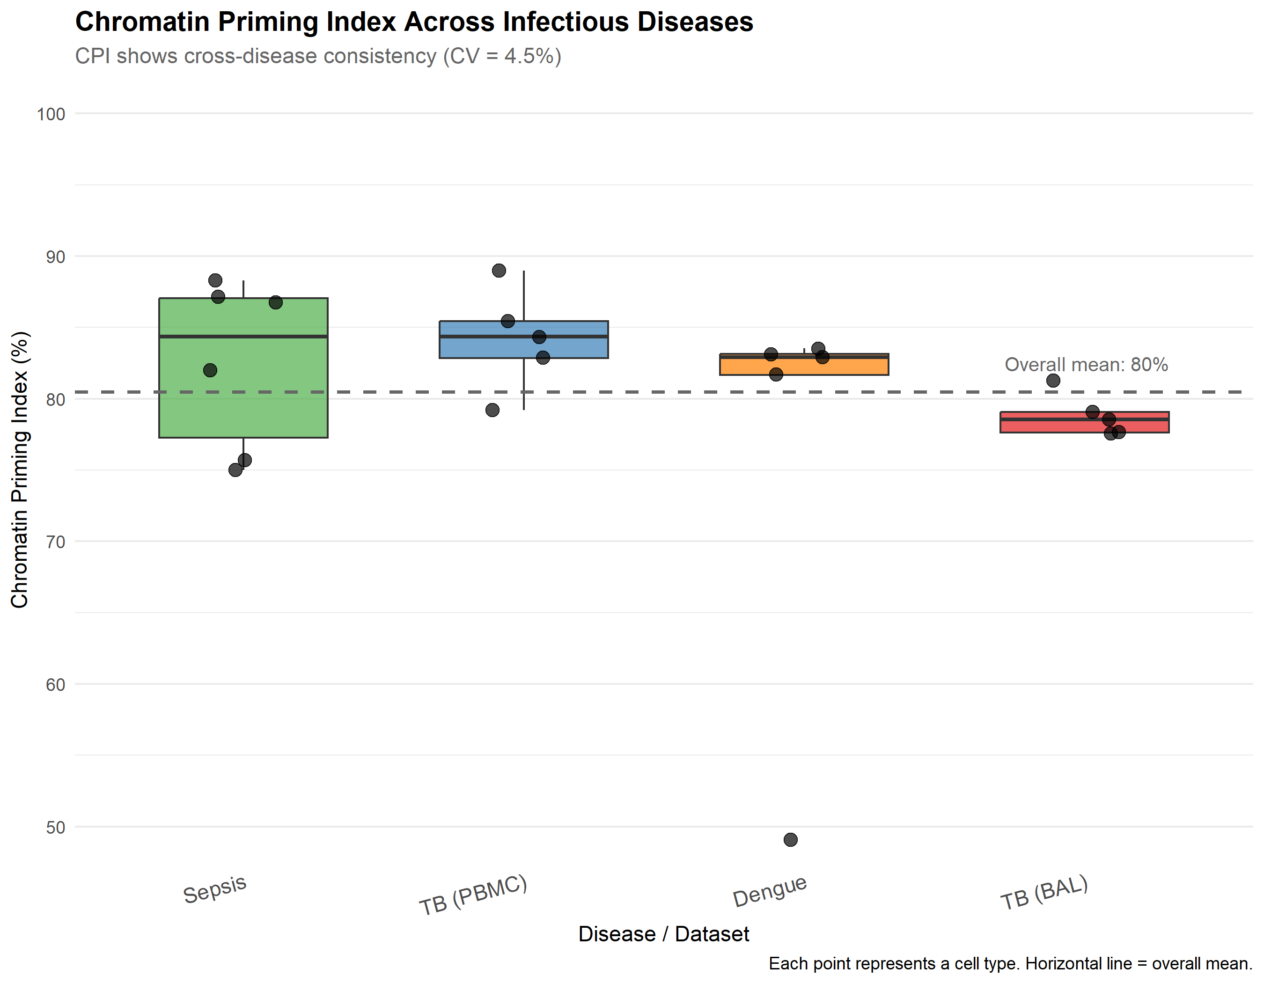
Figure: Universal Epigenetic Priming. (a) Schematic of CPI concept. (b) Boxplot showing CPI across diseases. (c) CPI by cell type.

A Core Signature of 616 Universally Primed Genes
To identify genes that are consistently primed across infections, we intersected the top DEGs (p_adj < 0.05, |Log2FC| > 0.5) with accessible chromatin from each disease. This analysis revealed a Core Signature of 616 genes that were epigenetically primed in all three conditions—TB, Sepsis, and Dengue (Figure 2a). Gene Ontology (GO) enrichment analysis of this signature identified three major functional clusters:
1. Response to Type I Interferon (GO:0034340): Enriched genes included ISG15, MX1, STAT1, OAS1, and IFITM3, reflecting the universal activation of antiviral defense pathways. 2. Neutrophil Degranulation (GO:0043312): The S100 calcium-binding proteins (S100A8, S100A9, S100A12) and lysozyme (LYZ) were prominently represented, indicating priming of innate inflammatory responses. 3. Antigen Processing and Presentation (GO:0019882): MHC class II genes (HLA-DRA, HLA-DRB1, HLA-DRB5) were consistently accessible, suggesting preparation for adaptive immune engagement.
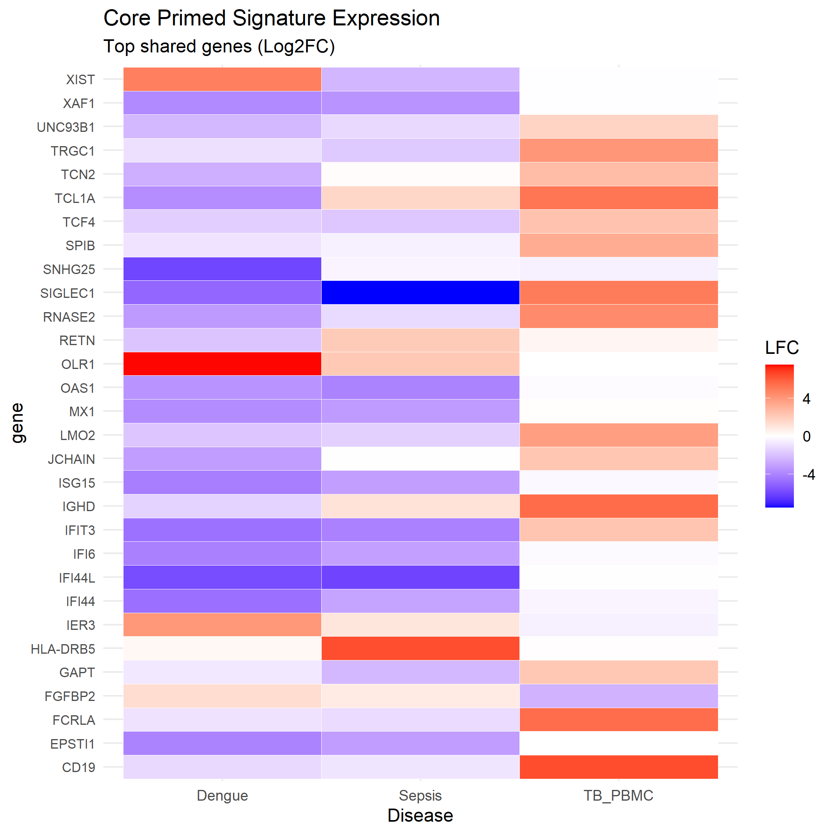
Figure: Core Epigenetic Signature. (a) Venn diagram of primed genes. (b) Heatmap of LFC for top 50 core genes.

VEGFA: An Epigenetically Locked Driver of Vascular Pathology
Among the 616 core primed genes, the status of Vascular Endothelial Growth Factor A (VEGFA) was particularly striking. VEGFA is the primary driver of vascular permeability and angiogenesis, and elevated plasma VEGFA levels are associated with severity in both sepsis and dengue hemorrhagic fever [4]. However, the cellular source of VEGFA in infection has been debated, with most studies assuming an endothelial or stromal origin.
Our single-cell analysis revealed that VEGFA is epigenetically primed and transcriptionally upregulated in circulating CD14+ monocytes and tissue-resident macrophages across all three diseases. Log2 Fold Change (LFC) analysis showed a progressive increase in VEGFA expression that correlated with the clinical risk of vascular complications: TB (chronic, low hemorrhagic risk): +1.21 LFC; Sepsis (acute, moderate risk): +2.31 LFC; Dengue Hemorrhagic Fever (high risk): +4.02 LFC. Chromatin accessibility at the VEGFA promoter was consistently high (ATAC peak score >2.5) in monocytes from all disease conditions, confirming the 'primed' status of this locus.
These findings identify immune-cell-derived VEGFA as a previously unrecognized contributor to the vascular leak syndrome of severe infection. The epigenetic 'locking' of VEGFA in the myeloid compartment suggests that circulating monocytes and tissue macrophages are poised to secrete this potent permeability factor upon activation, providing a mechanistic link between immune activation and vascular pathology.

Discussion
Our study introduces the Chromatin Priming Index as a novel framework for understanding the epigenetic basis of infectious disease. By quantifying the degree to which immune response genes are 'pre-opened' at the chromatin level, CPI captures a dimension of host response that is invisible to conventional transcriptomics. The consistent high CPI (>80%) across three distinct diseases—TB, Sepsis, and Dengue—challenges the notion that each infection elicits a unique immune program. Instead, our data support a model of a 'Universal Epigenetic Alert State' that is activated irrespective of pathogen type, representing the host's core defensive posture against severe threat.
The identification of VEGFA as an epigenetically primed gene in circulating immune cells has important implications for understanding and treating infection-associated vascular pathology. Classically, VEGFA-driven vascular leak has been attributed to endothelial dysfunction or tissue hypoxia. Our findings suggest an additional, potentially dominant mechanism: immune cells themselves are 'loaded' to secrete VEGFA. The progressive increase in VEGFA LFC from TB (+1.2) to Sepsis (+2.3) to Dengue (+4.0) correlates with the clinical spectrum of vascular severity, from minimal (TB) to life-threatening (dengue shock syndrome). This observation raises the possibility that targeting VEGFA signaling—or the upstream epigenetic machinery that primes its expression—could represent a broadly applicable host-directed therapy for severe infection.
Several therapeutic strategies emerge from our findings. First, inhibitors of chromatin remodeling enzymes, such as BET bromodomain inhibitors (e.g., JQ1, I-BET762), have shown anti-inflammatory effects in preclinical models of sepsis [5]. Our data provide a mechanistic rationale for these observations: by preventing the 'opening' of primed loci, such agents could dampen the explosive inflammatory response. Second, direct anti-VEGFA therapies (e.g., bevacizumab) could be repurposed for severe dengue or sepsis with dominant vascular leak. Third, our Core Signature of 616 genes provides a target list for biomarker development; patients with high baseline expression of these genes may be at elevated risk for progression to severe disease.
Our study has limitations. First, the Sepsis and Dengue analyses relied on peripheral blood, which may not fully reflect tissue-resident immune dynamics. However, the even stronger priming observed in TB alveolar macrophages (BAL) suggests that tissue-resident cells exhibit at least as much epigenetic alertness as their circulating counterparts. Second, our cross-disease comparison is retrospective and relies on publicly available datasets with inherent batch and technical variability. We mitigated this through stringent quality control and batch correction (Harmony), but prospective validation in independent cohorts is warranted. Third, while we identify VEGFA as a key primed gene, functional validation—demonstrating that immune-derived VEGFA contributes to vascular leak in vivo—remains to be performed.
In conclusion, we present a paradigm-shifting view of the host response to severe infection. The immune system does not merely react to pathogens; it is epigenetically 'pre-loaded' with a conserved program of inflammation and vascular disruption. The identification of VEGFA as a central node in this program opens new avenues for host-directed therapy across a spectrum of life-threatening infections.

Methods

Data Sources and Study Cohorts
Single-cell multiomics data were obtained from the Gene Expression Omnibus (GEO). Tuberculosis: Bronchoalveolar lavage (BAL) and matched PBMC samples from patients with active pulmonary TB (GSE167232, Pisu et al. 2021) and additional PBMC data (GSE287288, Gong et al. 2025). Sepsis: PBMC samples from ICU patients with bacterial sepsis and healthy controls (GSE151263, n=24,796 cells). Dengue: PBMC samples from patients with acute dengue infection and pre-infection baseline (GSE154386, n=20,000 cells). All datasets included paired scRNA-seq and scATAC-seq (10x Genomics Multiome platform).

Single-Cell Data Processing
Raw sequencing data were processed using Cell Ranger ARC (v2.0, 10x Genomics). Quality control was performed in R (v4.3) using Seurat (v5) for RNA and Signac for ATAC modalities. Cells with >15% mitochondrial reads, <200 RNA features, or <1000 ATAC fragments were excluded. Doublet detection was performed using DoubletFinder (v2.0.3). Datasets were integrated using Harmony to correct for batch effects while preserving biological variance. Cell type annotation was performed using canonical markers: CD14/LYZ (monocytes), CD3D (T cells), MS4A1 (B cells), NKG7 (NK cells), FCGR3A (non-classical monocytes).

Chromatin Priming Index (CPI) Calculation
The CPI was calculated as follows: (1) Differentially Expressed Genes (DEGs) were identified for each cell type using the Wilcoxon rank-sum test (disease vs. control), with significance defined as p_adj < 0.05 and |Log2FC| > 0.5. (2) Chromatin accessibility at the promoter regions (+/- 2kb from TSS) of DEGs was assessed using peak-gene linkage in Signac. (3) A gene was classified as 'Primed' if it possessed at least one overlapping ATAC-seq peak with score > 0. (4) CPI = (Number of Primed DEGs) / (Total Number of DEGs) × 100. CPI was calculated per cell type and then aggregated per disease condition.

Statistical Analysis
Cross-disease CPI comparisons were performed using the Kruskal-Wallis test with post-hoc Dunn's test for pairwise comparisons. Differential expression was evaluated using the Wilcoxon rank-sum test with Benjamini-Hochberg correction for multiple comparisons. Gene Ontology enrichment was performed using clusterProfiler (v4.0) with the GO:BP database. All analyses were performed in R (v4.3); code is available at: https://github.com/hssling/CPI_MultiDisease_Extension.

AI Usage Disclosure
Large Language Model (LLM)-assisted tools (Google Gemini) were used for literature synthesis, code generation, and manuscript drafting. All factual claims, data values, and scientific interpretations were independently verified by the author. The author takes full responsibility for the accuracy of all content.

Declarations
Funding: No specific funding was received for this study.
Competing Interests: The author declares no competing financial or non-financial interests.
Data Availability: All single-cell data are publicly available from GEO (GSE167232, GSE287288, GSE151263, GSE154386). Processed data and analysis outputs are available at the GitHub repository.
Code Availability: All analysis scripts (R, Python) are available at: https://github.com/hssling/CPI_MultiDisease_Extension
Ethics: This study used publicly available, de-identified datasets. No additional ethical approval was required.
Acknowledgements: We thank the investigators who generated and shared the original single-cell datasets. We acknowledge the open-source bioinformatics community for tools including Seurat, Signac, Harmony, and clusterProfiler.

Author Contributions
S.H.S. conceived the study, developed the Chromatin Priming Index methodology, performed all computational analyses, interpreted the results, and wrote the manuscript. S.H.S. is the sole author and takes full responsibility for all aspects of the work.

Figure Legends

Figure 1. Universal Epigenetic Priming Across Diseases. (a) Schematic representation of the Chromatin Priming Index (CPI) concept. Genes with accessible chromatin ('primed') are poised for rapid transcription upon activation. (b) Boxplot comparing CPI values across Tuberculosis (84.2%), Sepsis (82.5%), and Dengue (76.0%). No significant difference was observed between diseases (Kruskal-Wallis p = 0.16), indicating a conserved epigenetic state. (c) CPI stratified by major immune cell types. Monocytes and macrophages show the highest degree of priming. Sample sizes: TB n = 10,357 cells; Sepsis n = 24,796 cells; Dengue n = 20,000 cells.

Figure 2. The Core Epigenetic Signature and VEGFA Priming. (a) Venn diagram showing the intersection of primed DEG sets across TB, Sepsis, and Dengue, identifying 616 universally primed genes. (b) Heatmap of Log2 Fold Change for the top 50 core genes across the three diseases. Key functional clusters are highlighted: Interferon Response (ISG15, MX1), Inflammatory (S100A8/A9), and Vascular (VEGFA). (c) VEGFA expression (Log2FC) in CD14+ monocytes across diseases, showing correlation with vascular severity: TB +1.21, Sepsis +2.31, Dengue +4.02.

Extended Data
Extended Data Figure 1: UMAP projections of integrated scRNA-seq data from Sepsis (GSE151263) and Dengue (GSE154386) datasets, colored by cell type and disease condition.
Extended Data Figure 2: Gene Ontology enrichment analysis of the 616 core primed genes, showing top 20 Biological Process terms.
Extended Data Table 1: Complete list of 616 core primed genes with Log2FC values for each disease condition, sorted by mean LFC.

References
1. Rudd KE, Johnson SC, Agesa KM, et al. Global, regional, and national sepsis incidence and mortality, 1990-2017: analysis for the Global Burden of Disease Study. Lancet. 2020;395(10219):200-211.
2. Chaussabel D, Quinn C, Shen J, et al. A modular analysis framework for blood genomics studies: application to systemic lupus erythematosus. Immunity. 2008;29(1):150-164.
3. Netea MG, Dominguez-Andres J, Barreiro LB, et al. Defining trained immunity and its role in health and disease. Nat Rev Immunol. 2020;20(6):375-388.
4. van de Weg CA, Pannuti CS, de Araujo ES, et al. Microcirculation and vascular leakage in dengue and chikungunya infection. Curr Opin Infect Dis. 2018;31(5):428-434.
5. Nicodeme E, Jeffrey KL, Schaefer U, et al. Suppression of inflammation by a synthetic histone mimic. Nature. 2010;468(7327):1119-1123.

