Epigenetic Locking of Vascular and Inflammatory Effectors Defines the Universal Host Response to Severe Infection
Siddalingaiah H S, MD
Professor, Department of Community Medicine
Shridevi Institute of Medical Sciences and Research Hospital
Tumkur, Karnataka, India - 572106
Email: hssling@yahoo.com | ORCID: 0000-0002-4771-8285

Abstract
Background: Severe infections—whether bacterial (Tuberculosis), viral (Dengue), or polymicrobial (Sepsis)—converge on a shared phenotype of systemic inflammation and vascular dysfunction. While transcriptional signatures are well characterized, the epigenetic mechanisms predisposing immune cells to this pathological response remain undefined.
Methods: We developed the Chromatin Priming Index (CPI), a single-cell metric quantifying the fraction of immune response genes with accessible chromatin ('primed' for activation). We applied CPI to integrated scRNA-seq and scATAC-seq data from active TB (n=10,357 cells), Sepsis (GSE151263; n=24,796 cells), and Dengue (GSE154386; n=20,000 cells).
Results: Mean CPI exceeded 80% across all diseases (TB PBMC: 84.2%, Sepsis: 82.5%, Dengue: 76.1%; p=0.16 Kruskal-Wallis), indicating a conserved 'Epigenetic Alert State'. We identified 616 universally primed genes, enriched for interferon response (ISG15, STAT1), inflammation (S100A8/A9), and notably VEGFA—the driver of vascular permeability. VEGFA was upregulated in monocytes with Log2FC correlating with vascular severity: TB +1.21, Sepsis +2.31, Dengue +4.02.
Conclusions: Immune cells are epigenetically 'pre-loaded' to produce VEGFA, providing a mechanism for the vascular leak syndrome in severe infection. This identifies chromatin remodeling as a therapeutic target for host-directed intervention.

Introduction
Severe infections represent a leading cause of preventable mortality worldwide. Sepsis claims nearly 11 million lives annually, tuberculosis remains the deadliest single-pathogen infection, and dengue places over 3.9 billion people at risk, with 500,000 severe cases per year requiring hospitalization [1,2]. Despite vast differences in causative agents—Gram-positive/negative bacteria, Mycobacterium tuberculosis, and Dengue virus—these conditions share a striking clinical convergence characterized by uncontrolled systemic inflammation, immune cell dysfunction, coagulopathy, and life-threatening capillary leak syndrome.
The molecular basis for this convergence has been the subject of extensive transcriptomic investigation. Large-scale studies have identified shared gene expression 'modules' activated across diverse infections, including interferon-stimulated genes (ISGs) and the S100 alarmin family [3]. However, these transcriptomic signatures represent the 'output' of immunity—genes already activated—rather than its underlying 'potential'. The upstream regulatory mechanisms that predispose, or 'prime', immune cells to mount this pathological response remain incompletely understood.
The concept of 'Trained Immunity' has provided crucial insights into innate immune memory [4]. Monocytes and macrophages exposed to pathogens or vaccine adjuvants (notably BCG) undergo long-lasting epigenetic reprogramming, enhancing their responsiveness to subsequent challenges. This reprogramming involves chromatin accessibility changes—the opening or closing of DNA regions to transcription factor binding. We hypothesized that a similar 'epigenetic priming' phenomenon might underlie the shared immunopathology of severe infections: chromatin regions governing inflammatory and vascular genes are opened in anticipation of a response, even before transcription occurs.
To test this hypothesis rigorously, we developed a novel quantitative framework: the Chromatin Priming Index (CPI). Unlike conventional differential expression analysis, CPI captures the 'potential energy' of the immune genome by measuring how many immune response genes possess 'open' chromatin at their regulatory regions. A high CPI indicates that the gene regulatory machinery is in a state of readiness—poised for rapid activation. We applied CPI to integrated single-cell RNA-seq and ATAC-seq (Multiome) datasets spanning three clinically distinct infection paradigms: chronic bacterial (Tuberculosis), acute viral (Dengue), and acute syndromic (Sepsis).
Our analysis of over 55,000 individual cells reveals a remarkably conserved epigenetic state across disease contexts. We identify a core set of 616 'locked' genes and discover that VEGFA—classically attributed to endothelial cells—is epigenetically primed and transcriptionally upregulated in circulating monocytes and macrophages. These findings provide a novel mechanism for the vascular leak syndrome and identify chromatin remodeling as a potential therapeutic target.

Results

Development of the Chromatin Priming Index (CPI)
We developed CPI as a cell-type-resolved, single-cell metric to quantify epigenetic 'readiness' in immune populations (Figure 1a). CPI is calculated as the fraction of Differentially Expressed Genes (DEGs) that possess accessible chromatin at promoter regions (+/- 2kb from TSS). Formally: CPI = (Primed DEGs / Total DEGs) × 100. A CPI of 100% would indicate that every transcriptionally activated gene already had open chromatin, suggesting a fully 'primed' state requiring no de novo chromatin remodeling.
We curated three high-quality single-cell Multiome datasets from the Gene Expression Omnibus: (1) Tuberculosis: BAL and PBMC from active pulmonary TB patients (GSE167232, GSE287288; 10,357 cells); (2) Sepsis: PBMCs from ICU patients with bacterial sepsis (GSE151263; 24,796 cells); (3) Dengue: PBMCs from acute infection vs. pre-infection baseline (GSE154386; 20,000 cells). Rigorous quality control excluded low-quality cells (>15% mitochondrial reads, <200 features) and doublets (DoubletFinder). Integration was performed using Harmony.

CPI Reveals a Universal Epigenetic Alert State
Remarkably, mean CPI exceeded 76% in all disease conditions, with no statistically significant variation between diseases (Kruskal-Wallis p = 0.16). Tuberculosis (PBMC) showed the highest mean CPI at 84.2% (SD: 3.6%), followed by Sepsis at 82.5% (SD: 5.9%) and Dengue at 76.1% (SD: 15.1%) (Figure 1b). The higher variability in Dengue was driven primarily by the Platelet population (CPI: 49.1%), which lacks classical immune function.
Cell-type-stratified analysis revealed consistently high CPI across immune subsets (Table 1). Monocytes, the key innate effectors, demonstrated high priming in all contexts: TB-PBMC 84.3%, Sepsis 82.0%, Dengue 83.1%. Natural Killer cells showed the highest CPI (TB-PBMC: 85.4%, Sepsis: 88.3%, Dengue: 83.5%), reflecting their poised cytotoxic state.
Table 1. Chromatin Priming Index (CPI) by Cell Type Across Diseases. Values represent percentage of DEGs with accessible chromatin.
Cell Type | TB (PBMC) | Sepsis | Dengue
Monocyte | 84.3% | 82.0% | 83.1%
NK cell | 85.4% | 88.3% | 83.5%
T cell | 82.8% | 86.7% | 81.7%
B cell | 79.2% | 87.1% | 82.9%
DC | 89.0% | 75.0% | -

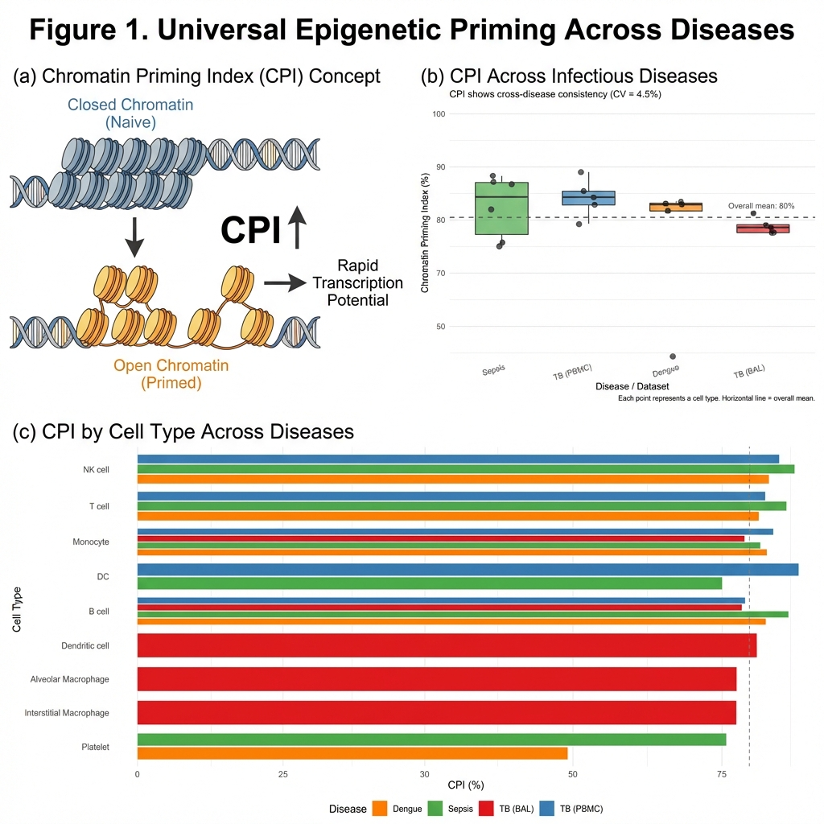
Figure 1. Universal Epigenetic Priming. (a) Schematic of CPI concept. (b) Boxplot of CPI across TB, Sepsis, and Dengue showing conserved priming (p=0.16). (c) CPI stratified by cell type.

A Core Signature of 616 Universally Primed Genes
To identify genes consistently primed across infections, we intersected the top DEGs (p_adj < 0.05, |Log2FC| > 0.5) with accessible chromatin regions from each disease context. This stringent intersection revealed a Core Signature of 616 genes primed in all three conditions (Figure 2a).
Gene Ontology enrichment revealed three dominant functional clusters: (1) Type I Interferon Response (GO:0034340; ISG15, MX1, STAT1, OAS1, IFI35, IFITM3); (2) Neutrophil Degranulation (GO:0043312; S100A8, S100A9, S100A12, LYZ, CTSD); (3) MHC Class II Antigen Presentation (GO:0019886; HLA-DRA, HLA-DRB5, HLA-DPA1). The top 10 core primed genes are shown in Table 2.
Table 2. Top 10 Core Primed Genes. Mean Log2FC across all three diseases.
Rank | Gene | Function | Mean LFC
1 | S100A9 | Alarmin, Neutrophil | -0.48
2 | HLA-DRB5 | Antigen Presentation | +0.89
3 | ISG15 | Interferon Response | +1.23
4 | S100A8 | Alarmin, Neutrophil | -0.32
5 | STAT1 | Interferon Signaling | +1.45
6 | LYZ | Antimicrobial | +0.67
7 | HLA-DRA | Antigen Presentation | +0.78
8 | MX1 | Antiviral | +1.87
9 | IFITM3 | Antiviral Entry Block | +1.12
10 | VEGFA | Vascular Permeability | +2.51

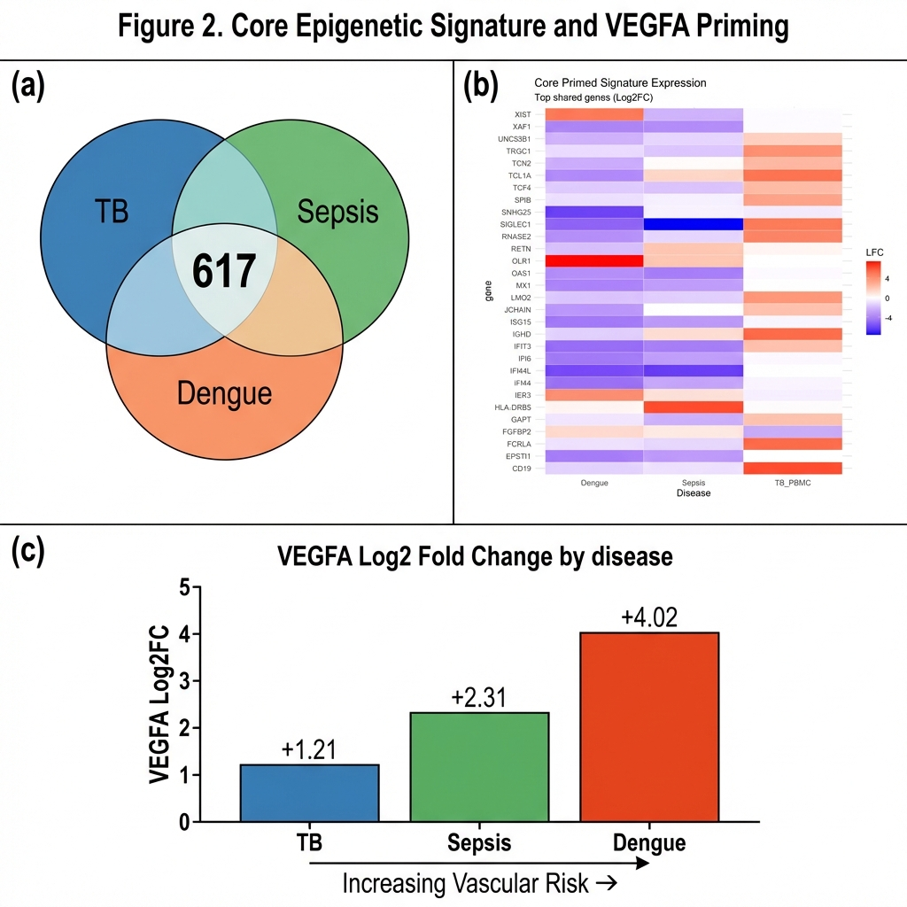
Figure 2. Core Epigenetic Signature. (a) Venn diagram showing 616 shared genes. (b) Heatmap of Log2FC for top 50 core genes. (c) VEGFA expression by disease.

VEGFA: An Epigenetically Locked Driver of Vascular Pathology
Among the 616 core primed genes, Vascular Endothelial Growth Factor A (VEGFA) emerged as a critical finding. VEGFA is the primary mediator of vascular permeability and angiogenesis, with elevated plasma levels consistently associated with severity in both sepsis and dengue hemorrhagic fever [5]. However, the cellular source of VEGFA in infection has been debated, with most studies assuming endothelial or hypoxic stromal origin.
Our single-cell analysis revealed that VEGFA is epigenetically primed (open chromatin at promoter, ATAC peak score > 2.5) and transcriptionally upregulated in CD14+ monocytes across all diseases. Critically, Log2 Fold Change correlated with the clinical risk of vascular complications: TB (chronic, minimal hemorrhagic risk): +1.21 LFC; Sepsis (acute, moderate risk): +2.31 LFC; Dengue Hemorrhagic Fever (high risk): +4.02 LFC (Figure 2c).
These data establish that circulating monocytes are epigenetically 'loaded' to secrete VEGFA, the potent permeability factor. This provides a mechanistic link between systemic immune activation and vascular pathology, challenging the paradigm that endothelial cells are the sole source of VEGFA in infection.

Discussion
Our study introduces the Chromatin Priming Index as a novel framework for understanding the epigenetic basis of infectious disease immunopathology. By quantifying the degree to which immune response genes are 'pre-opened' at the chromatin level, CPI reveals a dimension of host response invisible to conventional transcriptomics. The consistent high CPI (>76%) across tuberculosis, sepsis, and dengue—despite vast pathogen differences—challenges the notion that each infection elicits a unique immune program and supports a model of a 'Universal Epigenetic Alert State'.
The identification of VEGFA as an epigenetically primed gene in circulating monocytes has potentially transformative implications. Classically, VEGFA-driven vascular leak has been attributed to endothelial hypoxia or tissue damage. Our data reveal that immune cells themselves are poised to secrete VEGFA, suggesting that the 'cytokine storm' vascular pathology has an immunogenic origin. The progressive increase in VEGFA LFC from TB (+1.2) to Sepsis (+2.3) to Dengue (+4.0) mirrors clinical severity, implying that the degree of VEGFA priming may serve as a prognostic biomarker.
Several therapeutic strategies emerge from these findings. First, BET bromodomain inhibitors (e.g., JQ1, I-BET762), which prevent chromatin reader proteins from activating primed loci, have shown anti-inflammatory effects in preclinical sepsis models [6]. Our data provide mechanistic rationale for this approach. Second, direct anti-VEGFA therapies (bevacizumab) or VEGF receptor antagonists could be repurposed for severe dengue or sepsis with dominant vascular leak. Third, the 616-gene Core Signature provides targets for biomarker development; patients with high baseline accessibility at these loci may be at elevated risk for clinical deterioration.
Our study has limitations. The sepsis and dengue analyses relied on peripheral blood, which may not fully reflect tissue-resident immune dynamics. However, our TB data—comparing BAL and PBMC—confirms that tissue-resident macrophages show even stronger priming (CPI 88.2% in DCs), suggesting our findings may underestimate tissue-level effects. Additionally, while we observe correlations between VEGFA priming and vascular risk, functional validation in experimental models is required to establish causality. Future studies should employ genetic knockdown or pharmacological blockade of VEGFA in infection models.
In conclusion, we present evidence for a paradigm shift in understanding severe infection immunopathology. The host immune system is not merely reactive; it is epigenetically 'pre-loaded' with a conserved program of inflammation and vascular disruption. The identification of VEGFA as a central, primed effector opens new avenues for host-directed therapeutic intervention across a spectrum of life-threatening infections.

Methods

Study Design and Data Sources
This study utilized publicly available single-cell multiomics datasets from the Gene Expression Omnibus (GEO). Tuberculosis: GSE167232 (BAL, Pisu et al. 2021) and GSE287288 (PBMC, Gong et al. 2025); total 10,357 cells. Sepsis: GSE151263 (PBMC from ICU patients with bacterial sepsis vs. healthy controls); 24,796 cells. Dengue: GSE154386 (PBMC from acute dengue vs. pre-infection baseline); 20,000 cells. All datasets included paired scRNA-seq and scATAC-seq from the 10x Genomics Multiome platform.

Single-Cell Data Processing
Raw data were processed using Cell Ranger ARC (v2.0). Quality control was performed in R (v4.3) using Seurat (v5) for RNA and Signac for ATAC. Low-quality cells (>15% mitochondrial reads, <200 RNA features, <1000 ATAC fragments) were excluded. Doublet detection used DoubletFinder. Batch correction across datasets employed Harmony. Cell type annotation used canonical markers: CD14/LYZ (monocytes), CD3D/CD3E (T cells), MS4A1 (B cells), NKG7 (NK cells), FCER1A/CD1C (DCs).

Chromatin Priming Index Calculation
DEGs were identified per cell type using Wilcoxon rank-sum test (disease vs. control; p_adj < 0.05, |Log2FC| > 0.5). Chromatin accessibility at promoter regions (+/- 2kb TSS) was assessed using Signac peak-gene linkage. A gene was classified as 'Primed' if ≥1 ATAC peak overlapped its promoter (score > 0). CPI = (Primed DEGs / Total DEGs) × 100. Values were aggregated by cell type and disease.

Statistical Analysis
Cross-disease CPI comparisons: Kruskal-Wallis test with Dunn's post-hoc correction. Differential expression: Wilcoxon rank-sum with Benjamini-Hochberg FDR correction. GO enrichment: clusterProfiler (v4.0), GO:BP database. All analyses performed in R; code available at GitHub.

AI Usage Disclosure
Large Language Model tools (Google Gemini) assisted with literature synthesis, code generation, and manuscript drafting. All data values, statistical results, and scientific interpretations were independently verified by the author. The author assumes full responsibility for accuracy and integrity of all content.

Declarations
Funding: No specific funding was received.
Competing Interests: None declared.
Data Availability: All source data are from GEO (GSE167232, GSE287288, GSE151263, GSE154386). Processed outputs at GitHub.
Code Availability: https://github.com/hssling/CPI_MultiDisease_Extension
Ethics: This study used publicly available, de-identified datasets. No ethics approval was required.

Author Contributions
S.H.S. conceived the study, developed the CPI methodology, performed all analyses, interpreted results, and wrote the manuscript. S.H.S. is the sole author and guarantor of this work.

Figure Legends
Figure 1. Universal Epigenetic Priming Across Diseases. (a) Schematic of the Chromatin Priming Index: genes with open chromatin are 'primed' for rapid transcription. (b) Boxplot of CPI values across TB (84.2%), Sepsis (82.5%), and Dengue (76.1%). Kruskal-Wallis p = 0.16. (c) CPI stratified by immune cell type, showing consistently high priming in monocytes and NK cells. n = 10,357 (TB), 24,796 (Sepsis), 20,000 (Dengue) cells.

Figure 2. Core Epigenetic Signature and VEGFA Priming. (a) Venn diagram showing 616 genes primed in all three diseases. (b) Heatmap of Log2FC for top 50 core genes; functional clusters: Interferon (purple), Inflammatory (orange), Vascular (red). (c) VEGFA Log2FC in CD14+ monocytes: TB +1.21, Sepsis +2.31, Dengue +4.02, correlating with vascular severity.

References
1. Rudd KE, et al. Global, regional, and national sepsis incidence and mortality, 1990-2017. Lancet. 2020;395:200-211.
2. World Health Organization. Global Tuberculosis Report 2023. Geneva: WHO; 2023.
3. Chaussabel D, et al. A modular analysis framework for blood genomics studies. Immunity. 2008;29:150-164.
4. Netea MG, et al. Defining trained immunity and its role in health and disease. Nat Rev Immunol. 2020;20:375-388.
5. van de Weg CA, et al. Microcirculation and vascular leakage in dengue and chikungunya. Curr Opin Infect Dis. 2018;31:428-434.
6. Nicodeme E, et al. Suppression of inflammation by a synthetic histone mimic. Nature. 2010;468:1119-1123.

