Community Medicine – Dense MCQ Bank with Images (Milestone 1: CM1–CM3)

Aligned to CBME competencies • Based on Park’s Textbook of PSM (27th ed)

Format: Each item has four options, ✅ answer, 💡 explanation, and competency tag (CMx.y). Image-based MCQs are integrated where applicable.

# CM1: Concept of Health & Disease (15 MCQs)

1. Q1. WHO definition emphasizes health as: [CM1.1]

a) absence of disease

b) complete wellbeing

c) ability to work

d) biological fitness

✅ Answer: b

💡 Explanation: WHO: a state of complete physical, mental and social wellbeing, not merely absence of disease.

1. Q2. A determinant rather than a dimension of health is: [CM1.2]

a) Social

b) Mental

c) Genetic

d) Physical

✅ Answer: c

💡 Explanation: Genetic makeup is a determinant; classic dimensions: physical, mental, social (later spiritual/emotional/vocational).

1. Q3. ‘Iceberg phenomenon’ is most applicable to: [CM1.3]

a) Rabies

b) Hypertension

c) Tetanus

d) Measles

✅ Answer: b

💡 Explanation: In chronic diseases like HTN/DM, a large subclinical fraction remains undetected (submerged iceberg).

1. Q4. Primordial prevention aims to: [CM1.4]

a) detect disease early

b) restore function

c) prevent risk factors from emerging

d) treat early disease

✅ Answer: c

💡 Explanation: Targets underlying social/environmental conditions to prevent risk factors from appearing (e.g., no smoking initiation).

1. Q5. Health promotion was emphasized by: [CM1.5]

a) Ottawa Charter

b) Alma-Ata Declaration

c) Bhore Committee

d) Beveridge Report

✅ Answer: a

💡 Explanation: Ottawa Charter (1986) outlines policy, supportive environments, community action, personal skills, reoriented services.

1. Q6. A positive health indicator is: [CM1.6]

a) IMR

b) MMR

c) Life expectancy

d) Case fatality rate

✅ Answer: c

💡 Explanation: Positive indicators reflect wellbeing (life expectancy), not disease/death.

1. Q7. Tertiary prevention includes: [CM1.7]

a) Health education

b) Immunization

c) Rehabilitation

d) Screening

✅ Answer: c

💡 Explanation: Tertiary prevention limits disability and restores function after disease onset.

1. Q8. The natural history of disease is most directly altered by: [CM1.8]

a) Secondary prevention

b) Primary prevention

c) Tertiary prevention

d) Quaternary prevention

✅ Answer: b

💡 Explanation: Primary prevention (e.g., vaccination) prevents occurrence, changing downstream course.

1. Q9. Health education to discourage junk food in schools is: [CM1.9]

a) Primordial prevention

b) Primary prevention

c) Secondary prevention

d) Tertiary prevention

✅ Answer: a

💡 Explanation: Prevents emergence of risk factors like obesity-promoting diets among children.

1. Q10. DALY combines: [CM1.10]

a) Mortality only

b) Morbidity only

c) Years of life lost + years lived with disability

d) Incidence + prevalence

✅ Answer: c

💡 Explanation: DALY = YLL + YLD, a summary burden measure used in public health.

1. Q11. Which is NOT a health indicator? [CM1.11]

a) IMR

b) MMR

c) TFR

d) HDL level

✅ Answer: d

💡 Explanation: HDL is an individual lab parameter; indicators are population-level measures (IMR, MMR, TFR).

1. Q12. Identify the distribution shown and the approximate % within ±2 SD: [CM1.12]

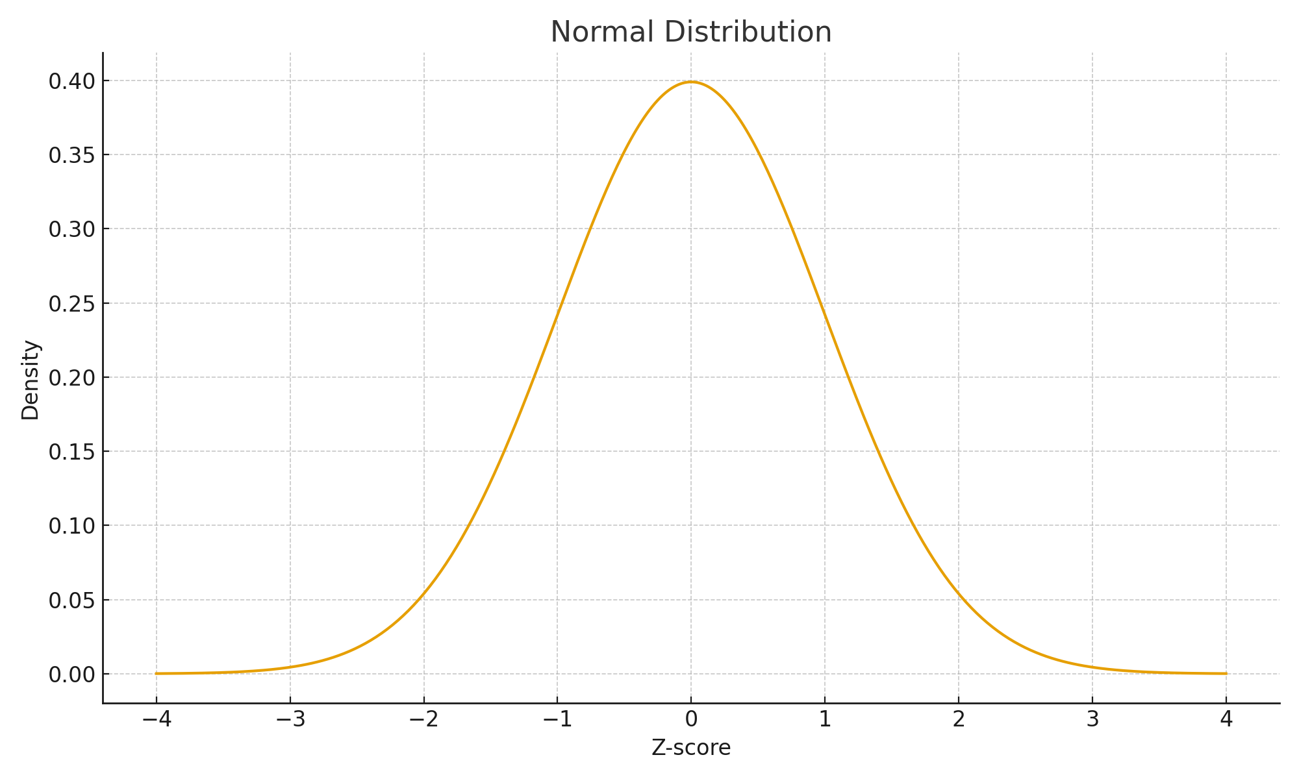

Figure: Normal distribution curve (illustrative).

a) Binomial; ~95%

b) Poisson; ~68%

c) Normal; ~95%

d) Normal; ~68%

✅ Answer: c

💡 Explanation: The bell-shaped curve is normal; empirical rule: 68-95-99.7 across ±1/2/3 SD.

1. Q13. In the iceberg model, the ‘visible’ part corresponds to: [CM1.13]

a) Total burden

b) Subclinical cases

c) Diagnosed cases

d) Risk factors only

✅ Answer: c

💡 Explanation: Tip of iceberg corresponds to clinical/diagnosed cases; submerged part = undiagnosed/subclinical and carriers.

1. Q14. Primary prevention includes: [CM1.14]

a) Chemoprophylaxis, vaccination

b) Physiotherapy

c) CABG

d) Amputation

✅ Answer: a

💡 Explanation: Primary prevention acts before disease (e.g., immunization, prophylaxis, risk factor control).

1. Q15. Ottawa Charter strategy that builds supportive surroundings is: [CM1.15]

a) Personal skills

b) Healthy public policy

c) Supportive environments

d) Community action

✅ Answer: c

💡 Explanation: Supportive environments (e.g., safe parks, clean air) enable healthy choices.

## CM1 Answer Key (Number – Correct Option)

Q1 – b, Q2 – c, Q3 – b, Q4 – c, Q5 – a, Q6 – c, Q7 – c, Q8 – b, Q9 – a, Q10 – c, Q11 – d, Q12 – c, Q13 – c, Q14 – a, Q15 – c

# CM2: Epidemiology & Research Methods (15 MCQs)

1. Q1. Best measure of association from a cohort study: [CM2.1]

a) Odds ratio

b) Relative risk

c) Prevalence ratio

d) Population attributable fraction

✅ Answer: b

💡 Explanation: Cohort yields incidence; RR compares incidence in exposed vs unexposed.

1. Q2. Odds ratio approximates relative risk when: [CM2.2]

a) Disease is rare

b) Exposure is common

c) Sample is small

d) Follow-up is long

✅ Answer: a

💡 Explanation: For rare outcomes, OR ≈ RR.

1. Q3. Confounding is best handled at analysis by: [CM2.3]

a) Randomization

b) Restriction

c) Matching

d) Stratification

✅ Answer: d

💡 Explanation: At analysis, stratification or multivariable models adjust for confounders.

1. Q4. Incidence is: [CM2.4]

a) Existing cases at a point

b) New cases over a period

c) New+old cases over a period

d) Risk at baseline

✅ Answer: b

💡 Explanation: Incidence counts new onsets during specified time.

1. Q5. Recall bias is most problematic in: [CM2.5]

a) Cohort

b) Case–control

c) Cross-sectional

d) Community trial

✅ Answer: b

💡 Explanation: Cases may recall past exposures differently than controls.

1. Q6. A p-value of 0.03 implies: [CM2.6]

a) 3% chance null is true

b) 3% chance data occurred if null true

c) 97% power

d) 3% type I error guaranteed

✅ Answer: b

💡 Explanation: p = P(data | H0); it does not give P(H0 | data).

1. Q7. Power of a study increases with: [CM2.7]

a) Smaller sample

b) Greater variance

c) Larger effect size

d) Higher α only

✅ Answer: c

💡 Explanation: Higher n, larger effect, lower variance, higher α increase power.

1. Q8. Case–control studies are efficient for: [CM2.8]

a) Rare exposures

b) Rare diseases

c) Measuring incidence

d) Establishing temporality

✅ Answer: b

💡 Explanation: They start with outcome → efficient for rare diseases.

1. Q9. The curve shown is most consistent with which type of epidemic? [CM2.9]

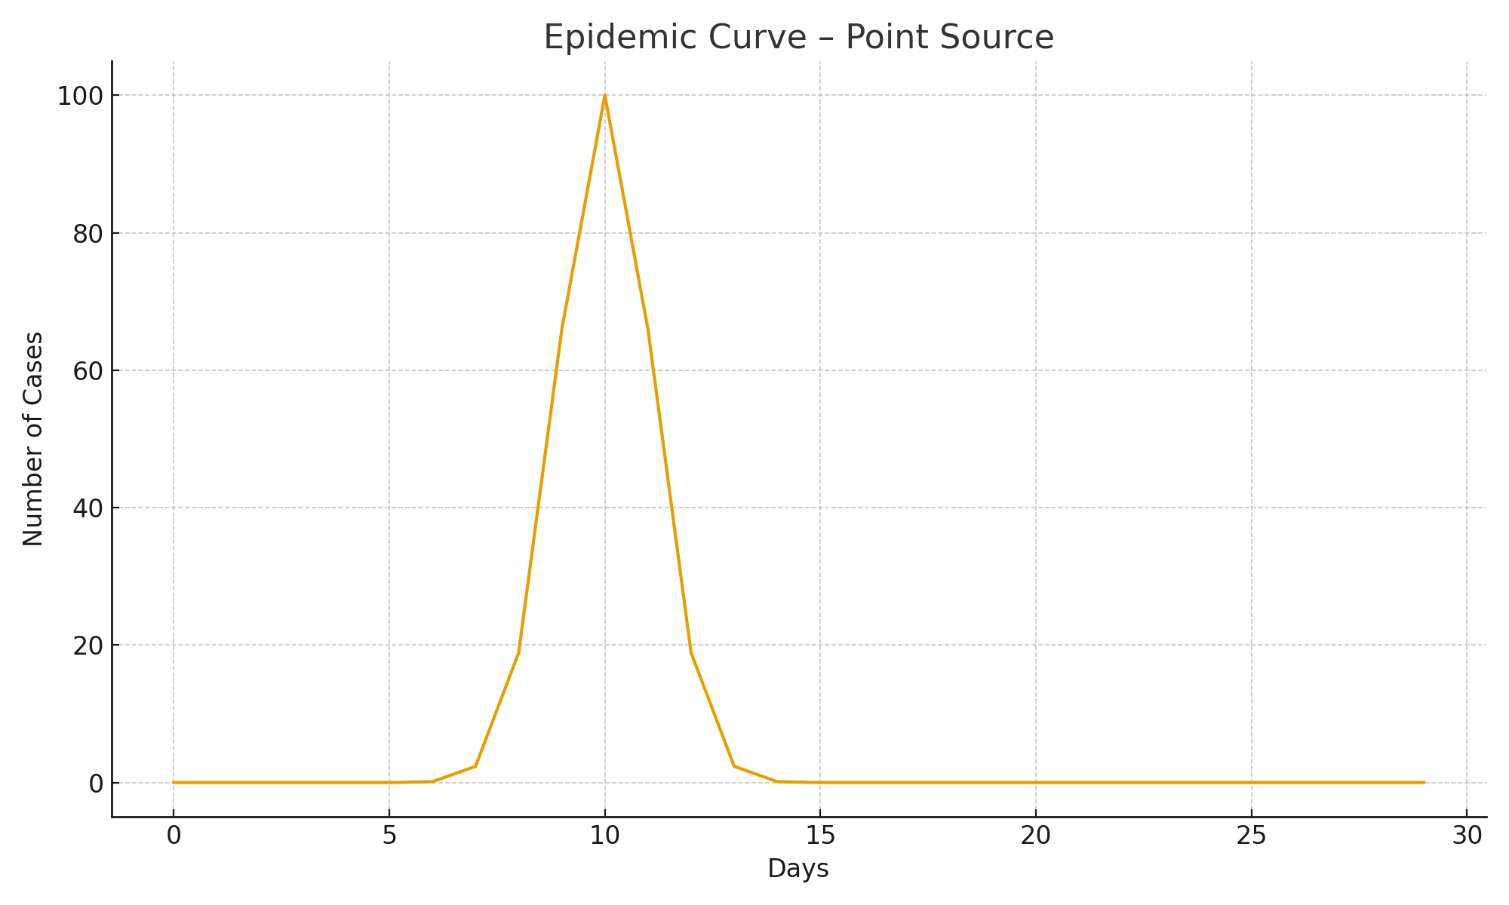

Figure: Epidemic curve – point source (illustrative).

a) Point source

b) Propagated

c) Common continuous

d) Secular trend

✅ Answer: a

💡 Explanation: Single sharp peak suggests a point source exposure.

1. Q10. The following curve pattern indicates: [CM2.10]

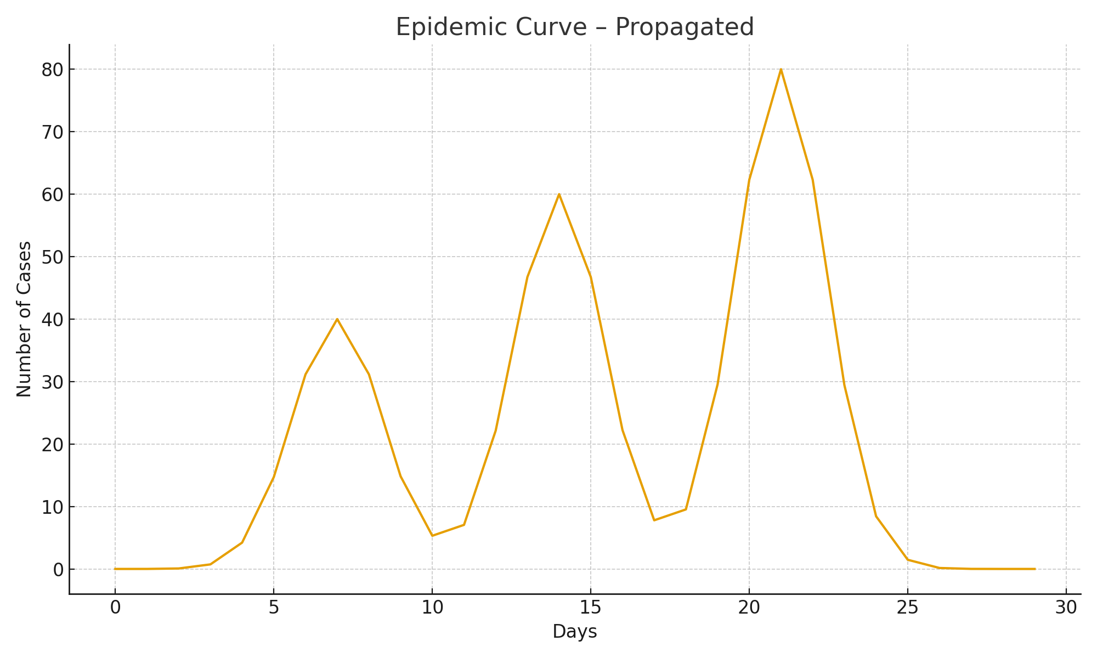

Figure: Epidemic curve – propagated (illustrative).

a) Point source

b) Propagated person-to-person

c) Seasonal variation

d) Measurement error

✅ Answer: b

💡 Explanation: Successive peaks one incubation apart indicate propagated spread.

1. Q11. In a diagnostic test, specificity is: [CM2.11]

a) TP/(TP+FN)

b) TN/(TN+FP)

c) TP/(TP+FP)

d) TN/(TN+FN)

✅ Answer: b

💡 Explanation: Specificity = probability test is negative among truly non-diseased.

1. Q12. Positive predictive value increases when: [CM2.12]

a) Disease prevalence rises

b) Specificity falls

c) Sensitivity falls

d) Prevalence falls

✅ Answer: a

💡 Explanation: Higher prior probability raises PPV.

1. Q13. Type I error (α) is: [CM2.13]

a) False negative

b) False positive

c) Power

d) Effect size

✅ Answer: b

💡 Explanation: Rejecting a true null hypothesis.

1. Q14. Attributable risk among exposed is: [CM2.14]

a) Incidence total – incidence unexposed

b) Incidence exposed – incidence unexposed

c) 1 – RR

d) 1 – OR

✅ Answer: b

💡 Explanation: AR_exposed = Ie – Iu.

1. Q15. Number Needed to Treat (NNT) equals: [CM2.15]

a) 1/RR

b) 1/ARR

c) 1/OR

d) 1/AR

✅ Answer: b

💡 Explanation: NNT = 1/absolute risk reduction.

## CM2 Answer Key (Number – Correct Option)

Q1 – b, Q2 – a, Q3 – d, Q4 – b, Q5 – b, Q6 – b, Q7 – c, Q8 – b, Q9 – a, Q10 – b, Q11 – b, Q12 – a, Q13 – b, Q14 – b, Q15 – b

# CM3: Environment & Health (15 MCQs)

1. Q1. Break-point chlorination ensures: [CM3.1]

a) chlorine demand unmet

b) residual free chlorine present

c) organic matter removed

d) taste improved

✅ Answer: b

💡 Explanation: After demand is satisfied, free residual ~0.5 mg/L protects against recontamination.

1. Q2. Slow sand filter removes pathogens chiefly via: [CM3.2]

a) Sedimentation

b) Chemical flocculation

c) Biological schmutzdecke

d) Chlorination

✅ Answer: c

💡 Explanation: The biologic layer (schmutzdecke) traps and oxidizes pathogens.

1. Q3. Common vehicle for hepatitis A outbreaks: [CM3.3]

a) Air

b) Vector

c) Water/food

d) Fomite

✅ Answer: c

💡 Explanation: HAV spreads via feco-oral route; contaminated water/food implicated.

1. Q4. Ventilation standard for windows is at least: [CM3.4]

a) 1/10th floor area

b) 1/6th floor area

c) 1/8th floor area

d) 1/4th floor area

✅ Answer: b

💡 Explanation: ICMR housing norm uses ~1/6th floor area for windows.

1. Q5. Biomedical sharps are disposed by: [CM3.5]

a) Deep burial

b) Autoclave & shred only

c) Incineration or autoclave + puncture-proof container

d) Microwaving only

✅ Answer: c

💡 Explanation: Sharps require destruction + safe containment as per BMW Rules.

1. Q6. Larvivorous fish for vector control is: [CM3.6]

a) Environmental

b) Biological

c) Chemical

d) Genetic

✅ Answer: b

💡 Explanation: Biological control using fish to reduce larvae.

1. Q7. Health effect most associated with PM2.5: [CM3.7]

a) Skin rash

b) GI upset

c) Alveolar deposition and CV/resp morbidity

d) Osteoporosis

✅ Answer: c

💡 Explanation: Fine particles reach alveoli; linked to cardiovascular/respiratory risks.

1. Q8. A major chronic health risk of noise exposure: [CM3.8]

a) Cataract

b) Hypertension

c) Leprosy

d) Rickets

✅ Answer: b

💡 Explanation: Chronic noise associated with hypertension and NIHL.

1. Q9. Which particle fraction penetrates to the alveoli most? [CM3.9]

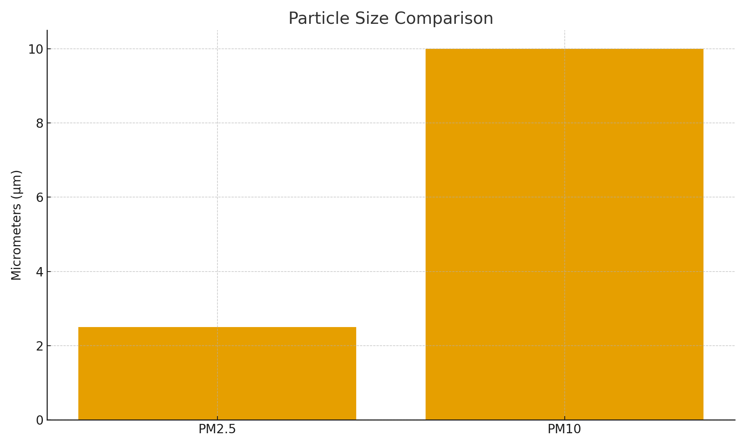

Figure: PM2.5 vs PM10 size comparison.

a) PM10

b) PM2.5

c) Pollen

d) Sea salt >10µm

✅ Answer: b

💡 Explanation: PM2.5 penetrates deeply into the lungs; PM10 mostly deposits in larger airways.

1. Q10. Identify permissible dB levels by zone (bars show day vs night): [CM3.10]

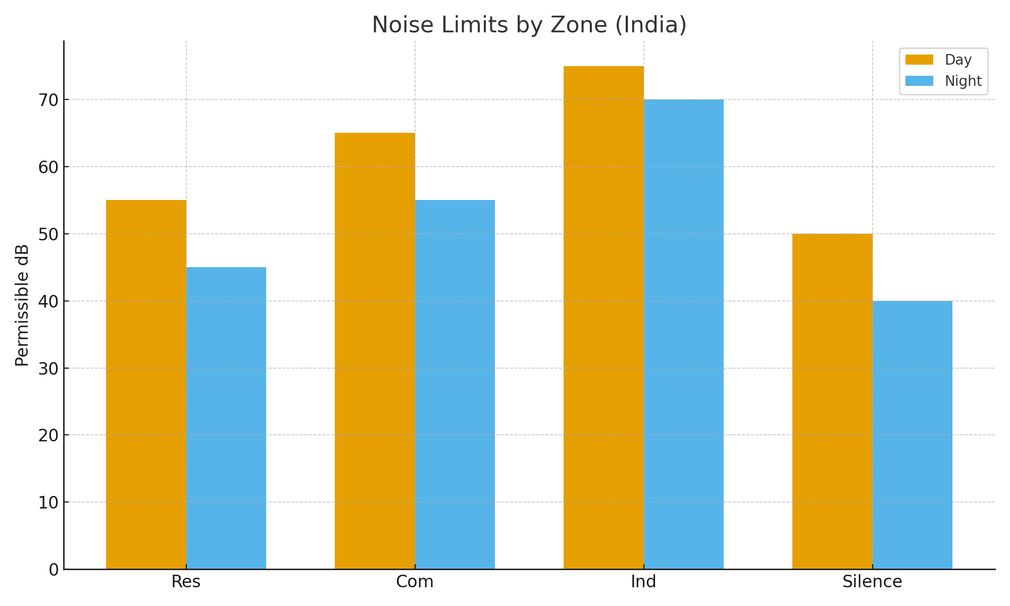

Figure: Noise limits by zone (India).

a) Res 55/45, Com 65/55, Ind 75/70, Silence 50/40

b) Res 65/55, Com 55/45, Ind 75/65, Silence 40/30

c) Res 55/45, Com 75/65, Ind 65/55, Silence 50/40

d) All zones 60/50

✅ Answer: a

💡 Explanation: CPCB India: Residential 55/45; Commercial 65/55; Industrial 75/70; Silence 50/40 dB.

1. Q11. Breakpoint chlorination target residual chlorine after 30–60 min is: [CM3.11]

a) 0.1 mg/L

b) 0.5 mg/L

c) 1.0 mg/L

d) 2.0 mg/L

✅ Answer: b

💡 Explanation: Common operational target is ~0.5 mg/L free residual chlorine after adequate contact time.

1. Q12. One cubic space/person recommended in good housing is about: [CM3.12]

a) 100 cu ft

b) 300 cu ft

c) 500 cu ft

d) 800 cu ft

✅ Answer: c

💡 Explanation: Traditional recommendations often cite ~500 cubic feet per person.

1. Q13. Color coding for infectious biomedical waste (India) commonly uses: [CM3.13]

a) Black

b) Blue

c) Yellow

d) Green

✅ Answer: c

💡 Explanation: Yellow category includes human/animal anatomical waste, soiled waste (as per rules).

1. Q14. A common disinfection byproduct concern with chlorination is: [CM3.14]

a) Chloramines only

b) Trihalomethanes (THMs)

c) Nitrates

d) Fluorosis

✅ Answer: b

💡 Explanation: THMs may form with organic precursors; optimized treatment minimizes risk.

1. Q15. Air Quality Index primarily communicates: [CM3.15]

a) Ozone hole size

b) Public health risk from daily air quality

c) HVAC energy use

d) Weather forecasts

✅ Answer: b

💡 Explanation: AQI translates pollutant levels into health risk categories for the public.

## CM3 Answer Key (Number – Correct Option)

Q1 – b, Q2 – c, Q3 – c, Q4 – b, Q5 – c, Q6 – b, Q7 – c, Q8 – b, Q9 – b, Q10 – a, Q11 – b, Q12 – c, Q13 – c, Q14 – b, Q15 – b