Community Medicine – Dense MCQ Bank (Milestone 2: CM4–CM8)

Aligned to CBME competencies • Based on Park’s Textbook of PSM (27th ed)

Each item has four options, ✅ answer, 💡 explanation, and competency tag (CMx.y). Images are integrated where relevant.

# CM4: Screening for Disease (Sample MCQs)

1. Q1. A highly sensitive test detects: [CM4.1]

a) Most true positives

b) Most true negatives

c) No false positives

d) Few true positives

✅ Answer: a

💡 Explanation: Sensitivity = true positive rate.

1. Q2. Specificity refers to: [CM4.2]

a) Probability test +ve in disease

b) Probability test -ve in healthy

c) PPV

d) NPV

✅ Answer: b

💡 Explanation: Specificity = TN/(TN+FP).

1. Q3. Lead-time bias causes: [CM4.3]

a) Real cure

b) Longer survival appearance

c) Lower incidence

d) Better prognosis

✅ Answer: b

💡 Explanation: Earlier detection makes survival appear longer without improving outcome.

1. Q4. Identify the curve shown: [CM4.4]

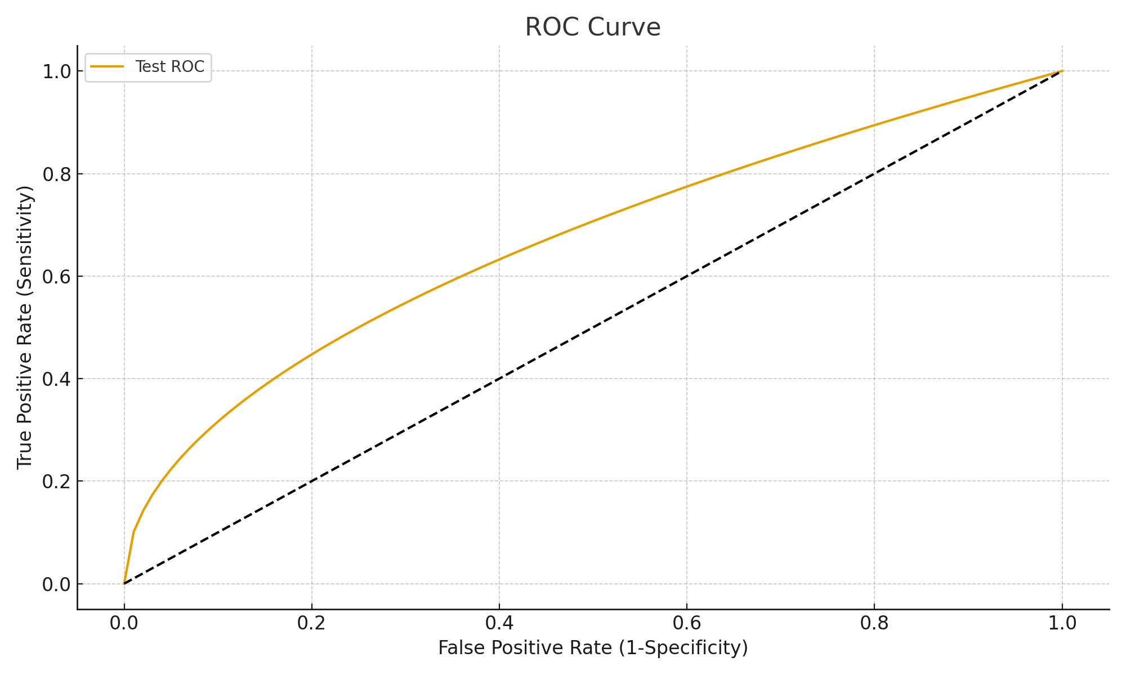

Figure: ROC curve

a) ROC curve

b) Normal curve

c) Epidemic curve

d) Demographic pyramid

✅ Answer: a

💡 Explanation: Graph of sensitivity vs 1-specificity.

## CM4 Answer Key

Q1 – a, Q2 – b, Q3 – b, Q4 – a

# CM5: Nutrition (Sample MCQs)

1. Q1. MUAC <11.5 cm indicates: [CM5.1]

a) Normal

b) MAM

c) SAM

d) Overnutrition

✅ Answer: c

💡 Explanation: <11.5 cm = Severe Acute Malnutrition.

1. Q2. Kwashiorkor due to: [CM5.2]

a) Protein deficiency

b) Energy deficiency

c) Vit A deficiency

d) Iodine deficiency

✅ Answer: a

💡 Explanation: Kwashiorkor is mainly protein deficiency.

1. Q3. The chart shows distribution of food groups in: [CM5.3]

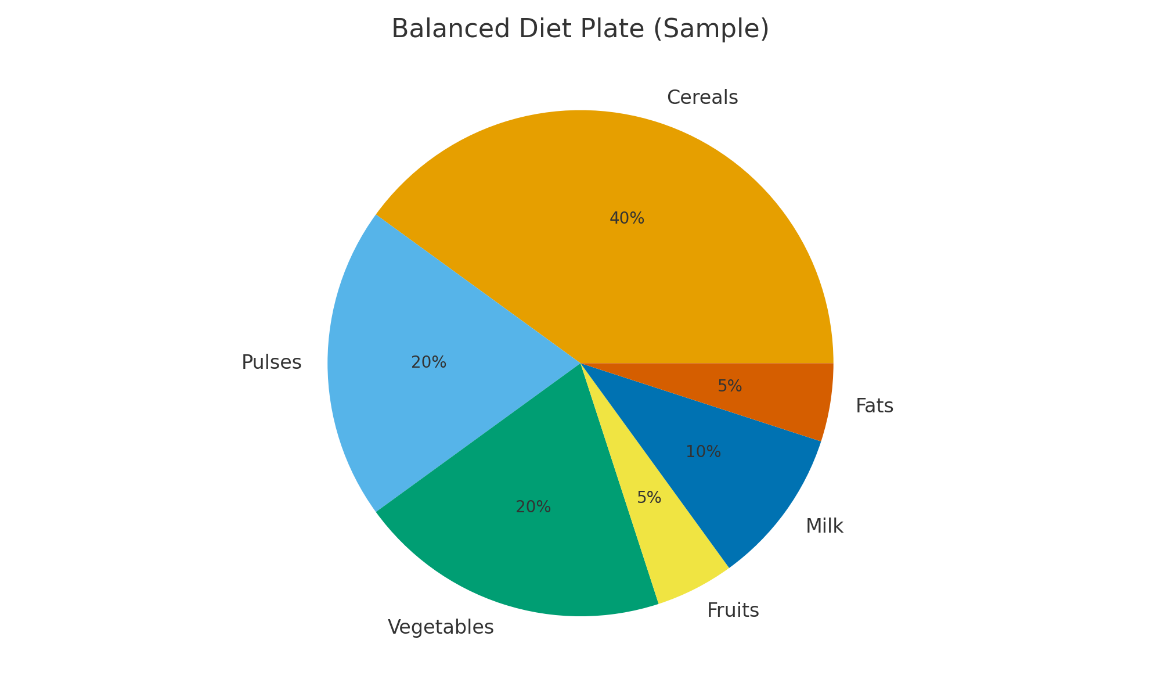

Figure: Balanced diet plate

a) Balanced diet plate

b) Epidemic curve

c) ROC curve

d) Food pyramid

✅ Answer: a

💡 Explanation: Proportions of cereals, pulses, vegetables etc.

## CM5 Answer Key

Q1 – c, Q2 – a, Q3 – a

# CM6–7: Demography & Family Planning (Sample MCQs)

1. Q1. India is in which demographic stage: [CM6.1]

a) Early expanding

b) Late expanding

c) Low stationary

d) High stationary

✅ Answer: b

💡 Explanation: India is late expanding.

1. Q2. CuT 380A effective for: [CM7.1]

a) 3 years

b) 5 years

c) 10 years

d) 15 years

✅ Answer: c

💡 Explanation: Copper-T 380A effective 10 years.

1. Q3. The figure represents: [CM6.2]

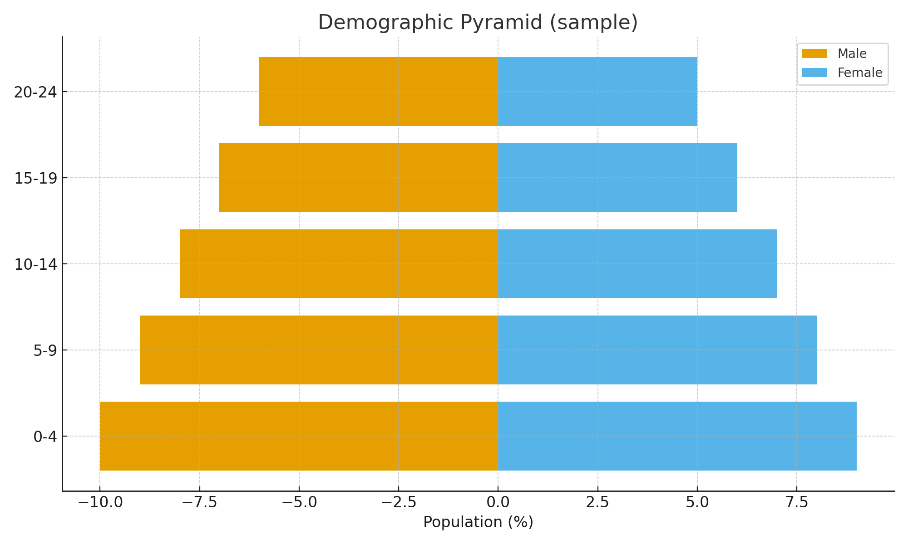

Figure: Demographic pyramid

a) Balanced diet

b) Demographic pyramid

c) ROC

d) Normal curve

✅ Answer: b

💡 Explanation: Pyramid shows age-sex distribution.

## CM6–7 Answer Key

Q1 – b, Q2 – c, Q3 – b

# CM8: Communicable Diseases (Sample MCQs)

1. Q1. Herd immunity not useful for: [CM8.1]

a) Measles

b) Tetanus

c) Polio

d) Rubella

✅ Answer: b

💡 Explanation: Tetanus is not person-to-person.

1. Q2. Incubation period of measles: [CM8.2]

a) 1–3 d

b) 5–7 d

c) 10 d

d) 30 d

✅ Answer: c

💡 Explanation: Average ~10 days.

## CM8 Answer Key

Q1 – b, Q2 – c