Community Medicine – Dense MCQ Bank (Milestone 3: CM9–CM13)

Aligned to CBME competencies • Based on Park’s Textbook of PSM (27th ed)

Each item has four options, ✅ answer, 💡 explanation, and competency tag (CMx.y). Images are integrated where relevant.

# CM9: Non-Communicable Diseases (Sample MCQs)

1. Q1. Primordial prevention in NCD aims at: [CM9.1]

a) Preventing risk factor emergence

b) Early detection

c) Treatment

d) Rehabilitation

✅ Answer: a

💡 Explanation: Primordial prevention keeps risk factors from emerging (e.g., anti-tobacco campaigns).

1. Q2. Most common cancer among Indian women is: [CM9.2]

a) Breast

b) Cervical

c) Ovarian

d) Lung

✅ Answer: a

💡 Explanation: Breast cancer has overtaken cervical cancer in incidence.

1. Q3. The chart shows trend of: [CM9.3]

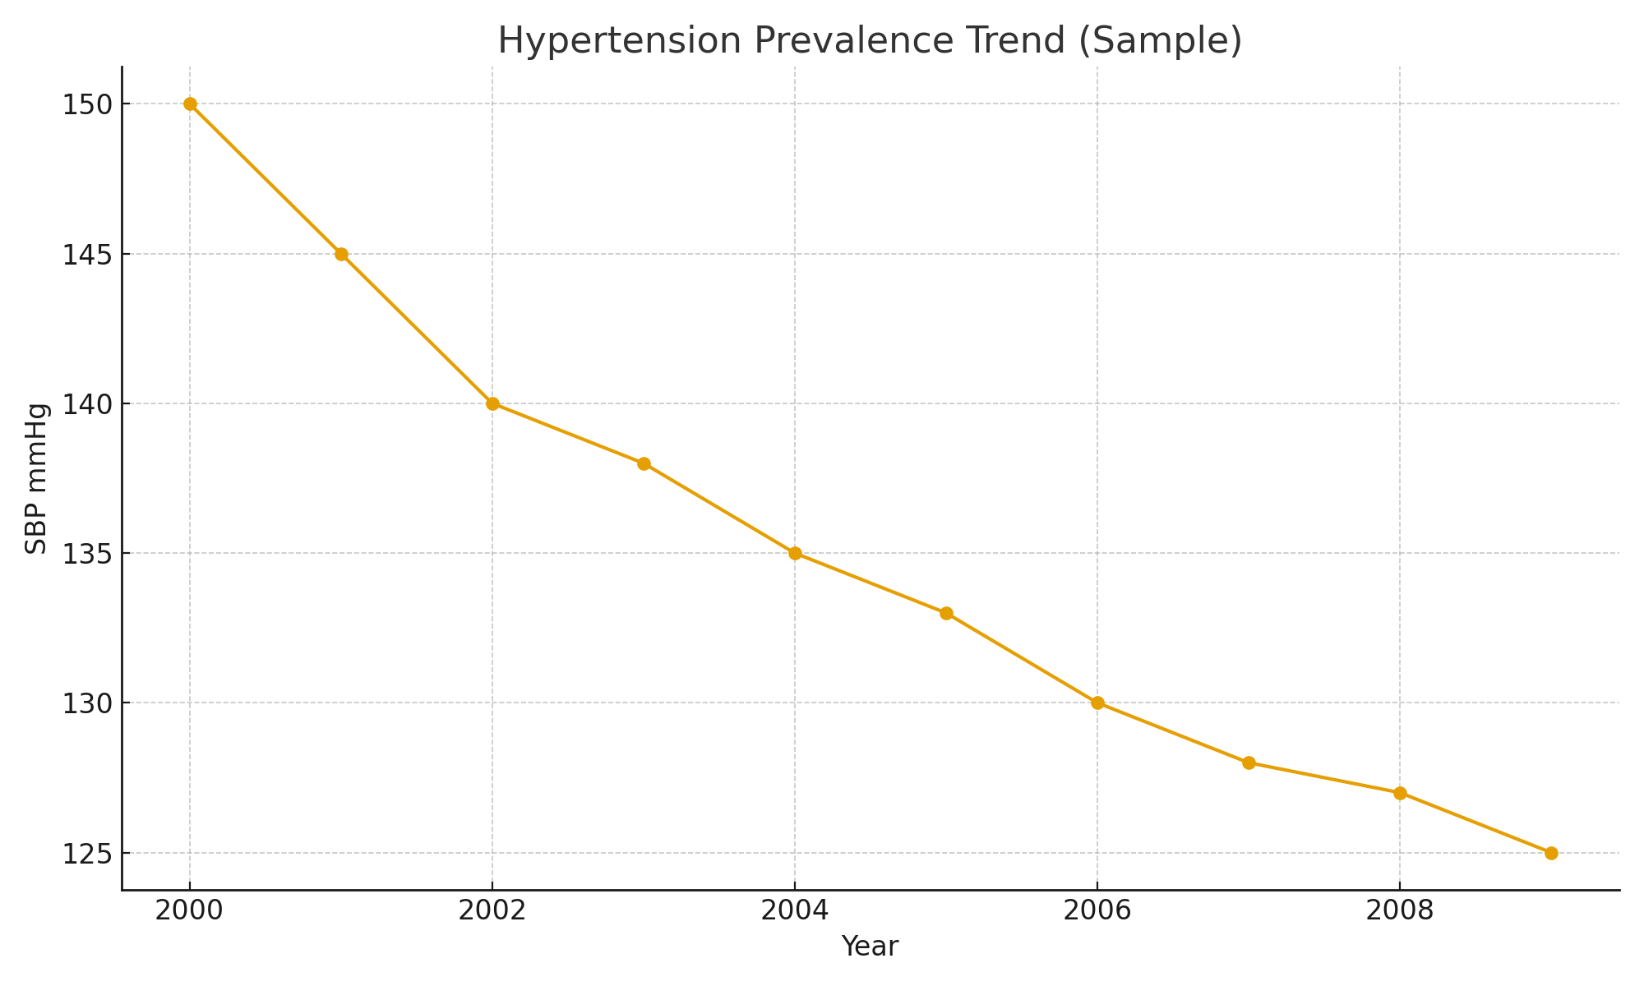

Figure: Hypertension trend

a) Malaria

b) Hypertension

c) Diabetes

d) COPD

✅ Answer: b

💡 Explanation: Graph indicates SBP decline trend in hypertension control.

## CM9 Answer Key

Q1 – a, Q2 – a, Q3 – b

# CM10: Biostatistics & Research Methods (Sample MCQs)

1. Q1. In normal distribution, 95% observations lie within: [CM10.1]

a) 1 SD

b) 2 SD

c) 3 SD

d) 4 SD

✅ Answer: b

💡 Explanation: 68-95-99.7 rule: 95% within 2 SD.

1. Q2. Chi-square test compares: [CM10.2]

a) Means

b) Proportions

c) Correlation

d) Regression

✅ Answer: b

💡 Explanation: Chi-square used for proportions/categorical data.

## CM10 Answer Key

Q1 – b, Q2 – b

# CM11: Occupational Health (Sample MCQs)

1. Q1. Byssinosis occurs in: [CM11.1]

a) Coal miners

b) Cotton workers

c) Asbestos workers

d) Silica workers

✅ Answer: b

💡 Explanation: Byssinosis due to cotton dust exposure.

1. Q2. Mesothelioma strongly linked with: [CM11.2]

a) Silica

b) Asbestos

c) Coal

d) Cotton

✅ Answer: b

💡 Explanation: Asbestos exposure causes mesothelioma.

## CM11 Answer Key

Q1 – b, Q2 – b

# CM12: Health System in India (Sample MCQs)

1. Q1. Population covered by Subcentre: [CM12.1]

a) 1000-2000

b) 3000-5000

c) 10,000

d) 20,000

✅ Answer: b

💡 Explanation: Subcentre: 3000 (tribal) to 5000 (plains).

1. Q2. PHC staffing includes: [CM12.2]

a) 1 MO + 14 staff

b) 2 MO + 20 staff

c) 4 Specialists

d) ASHA workers only

✅ Answer: a

💡 Explanation: PHC has 1 doctor and 14 staff.

## CM12 Answer Key

Q1 – b, Q2 – a

# CM13: National Health Programmes (Sample MCQs)

1. Q1. Under NVBDCP, filaria MDA includes: [CM13.1]

a) DEC+Albendazole

b) DEC+Ivermectin

c) Albendazole+Ivermectin

d) DEC only

✅ Answer: a

💡 Explanation: MDA includes DEC+Albendazole.

1. Q2. Anemia Mukt Bharat targets: [CM13.2]

a) Pregnant women only

b) Children only

c) 6 beneficiary groups

d) All adults

✅ Answer: c

💡 Explanation: AMB covers 6 groups: children, adolescents, women, pregnant, lactating, men.

## CM13 Answer Key

Q1 – a, Q2 – c