Multi-Modal Machine Learning Framework for State-Level Dengue Outbreak Prediction in India
Siddalingaiah H S, MD
Independent Researcher, Bangalore, India

Siddalingaiah H S, MD
Independent Researcher, Bangalore, India
Correspondence: hssling@gmail.com

Abstract
Background: Dengue fever has evolved into a hyper-endemic public health crisis in India, driven by rapid urbanization, climate change, and failing vector control. Current surveillance systems, while robust in case reporting, often lack the predictive capability to anticipate outbreaks before they overwhelm healthcare systems. The dependence on reactive indicators—such as hospital cases—means interventions like fogging are deployed after transmission has peaked.
Objectives: To develop, validate, and operationalize a scalable machine learning framework for state-level dengue outbreak prediction in India. We aimed to surpass traditional climate-only models by integrating diverse data streams: epidemiological surveillance (NVBDCP), real-time climate monitoring (IMD), and novel socio-economic vulnerability indices (NITI Aayog Health Index). A secondary objective was to establish a binary "Outbreak Detection" system to guide rapid response.
Methods: We constructed a multi-modal dataset covering 35 Indian states and union territories (2015-2025). The epidemiological component integrated National Vector Borne Disease Control Programme (NVBDCP) case reports with OpenDengue trend data. Climatic drivers (temperature, precipitation) were derived from state-level meteorological aggregations and expanded into monthly seasonal features (sine/cosine encoding) to capture vector phenology. A novel contribution of this study is the integration of structural vulnerability indicators—specifically the NITI Aayog Health Index (2019-20), State GDP per capita, and the State Energy & Climate Index (SECI). We trained an Enhanced Gradient Boosting Regressor for intensity prediction and a Gradient Boosting Classifier for binary outbreak detection (>75th percentile). Validation employed a rigorous 5-fold TimeSeriesSplit strategy to prevent temporal data leakage.
Results: The enhanced regression model achieved a robust coefficient of determination ($R^2$) of 0.888 and a Root Mean Squared Error (RMSE) of 311.5 cases on independent temporal validation sets. The binary classifier demonstrated exceptional performance with an Area Under the Receiver Operating Characteristic Curve (AUC-ROC) of 0.990, indicating near-perfect discrimination between "baseline" and "outbreak" months. Feature analysis revealed a hierarchical driver structure: Seasonality (55%) and lagged climate interactions (25%) drove transmission, while socio-economic vulnerability (20%) significantly modulated outbreak magnitude. States with lower Health Indices consistently showed higher case burdens for similar climatic conditions.
Conclusions: This study demonstrates that integrating socio-economic vulnerability markers with traditional climate-epi models significantly enhances predictive power. The high classification accuracy (AUC 0.99) supports the immediate deployment of this tool as a "Red Flag" system for state health departments. We propose this framework as the engine for a "Nikshay for Vector Borne Diseases," enabling a transition from reactive management to proactive anticipatory action.
Keywords: Dengue, Machine Learning, Gradient Boosting, India, Climate Change, NVBDCP, Outbreak Prediction, Public Health Informatics, ROC Analysis

1. Introduction

1.1 The Global and National Burden of Dengue
Dengue fever, caused by four distinct serotypes of the Flaviviridae virus (DENV 1-4), represents the most rapidly spreading mosquito-borne viral disease globally. The World Health Organization (WHO) estimates that incidence has increased 30-fold over the past 50 years. India, with its tropical climate, high population density, and rapid unplanned urbanization, bears a disproportionate share of this burden. Bhatt et al. (2013) estimated that India contributes nearly 34% of the global dengue burden, a figure likely underestimated due to limitations in passive surveillance. The economic cost is staggering, costing India billions in healthcare expenditure and lost productivity annually.

1.2 The Failure of Reactive Surveillance
Current dengue control strategies in India rely heavily on the National Vector Borne Disease Control Programme (NVBDCP) and the Integrated Disease Surveillance Programme (IDSP). While these systems provide essential retrospective data, they function primarily as "outbreak detection" mechanisms rather than prediction tools. By the time a surge is registered in the central database, transmission has often peaked, rendering vector control measures like fogging reactive and less effective. This lag represents a critical missed window for intervention, typically 4 to 6 weeks. The lack of a forward-looking "Early Warning System" (EWS) is a critical gap in India's biosecurity infrastructure.

1.3 Climatic Drivers and the Multi-Modal Hypothesis
The geographic footprint of Aedes aegypti and Aedes albopictus is intimately linked to climatic variables. Temperature influences the extrinsic incubation period (EIP) of the virus—shortening it from 12 days at 25°C to 7 days at 30°C—while precipitation creates breeding habitats. However, climate-driven models often fail to account for the "human factor." We hypothesized that a "Multi-Modal" approach—integrating climate, epidemiological history, and structural vulnerability metrics—would yield a more robust predictive model. Use of the NITI Aayog Health Index allows us to quantify "System Vulnerability": a state with weaker public health infrastructure may experience a larger detected outbreak for the same vector density due to poorer containment or, conversely, under-report due to poor surveillance.

1.4 The Need for Advanced Analytics (Classification vs Regression)
Most prior studies focus on regression (predicting exact case counts). However, for public health decision-makers, the exact number is often less important than the category of risk. Knowing "Will we face an outbreak?" is actionable; knowing "Will it be 500 or 550 cases?" is less so. Therefore, this study adopts a dual approach: Regression for resource planning and Binary Classification (AUC-ROC) for triggering emergency protocols.

2. Methods

2.1 Study Design and Data Sources
This retrospective ecological study analyzed state-level monthly aggregate data from 35 states/UTs in India (2015-2025). The unit of analysis is the "State-Month."

2.1.1 Epidemiological Data
- NVBDCP & OpenDengue: Monthly case counts were aggregated from official NVBDCP reports (2021-2025) and historical OpenDengue trends (1991-2024). Data was log-transformed ($log(x+1)$) to stabilize variance, as dengue case counts follow a highly skewed negative binomial distribution.

2.1.2 Climatic Variables
- Meteorological Data: Annual mean temperature ($T_{mean}$) and total precipitation were expanded into monthly seasonal features using regional weights (South-West Monsoon dominance vs North-East Monsoon).
- Lagged Features: We calculated 1, 2, and 3-month lags for climate variables ($Rain_{t-1}, Temp_{t-2}$) to account for biological delays: vector breeding cycles (2 weeks) and viral amplification (2 weeks).

2.1.3 Socio-Economic Vulnerability
This is the novel component of our framework. We integrated:
- NITI Aayog Health Index: A composite score (0-100) reflecting health system performance (Neonatal Mortality, TB Treatment Success, vacancy rates).
- GDP Per Capita: A proxy for urbanization and economic resilience.
- State Energy & Climate Index (SECI): A measure of environmental readiness.

2.2 Feature Engineering
We generated a rich feature set to capture temporal dynamics:
- Autoregressive Terms: $Cases_{t-1}, Cases_{t-2}$ and 3-month rolling averages ($RollingMean_3$). These capture the "momentum" of an outbreak.
- Cyclical Encoding: Month numbers (1-12) were transformed into sine/cosine components ($Month_{sin} = \sin(2\pi \frac{m}{12}), Month_{cos} = \cos(2\pi \frac{m}{12})$) to preserve the proximity between December and January.
- Interaction Terms: $Rain \times Temp$ to capture synergistic effects on vector competence.

2.3 Machine Learning Algorithms
We trained two ensemble tree-based models using the Scikit-Learn framework:
- Random Forest Regressor: A bagging ensemble ($n\_estimators=100, max\_depth=12$).
- Enhanced Gradient Boosting (GBM): A boosting ensemble ($n\_estimators=100, learning\_rate=0.1$) that corrects sequential errors. GBM is robust to outliers and missing data, making it ideal for fragmented public health datasets.
For the Binary Classification task, we defined an "Outbreak Month" as any month where cases exceeded the 75th percentile of the state's historical distribution. A Gradient Boosting Classifier was trained to predict this binary flag.

2.4 Validation Strategy
To prevent temporal data leakage—a common pitfall where models learn from "future" data—we employed 5-fold TimeSeriesSplit. In each fold $k$, the model was trained on the first $k$ time segments (e.g., 2015-2021) and tested on the subsequent segment (e.g., 2022). This mimics a real-world forecasting scenario.

3. Results

3.1 Regression Model Performance
The enhanced Gradient Boosting model demonstrated superior predictive accuracy.
Table 1. Model Performance (Temporal Cross-Validation)
Model | $R^2$ Score | RMSE (Cases/Month) | Key Advantage
**Gradient Boosting** | **0.888** ($\pm$ 0.04) | **311.5** | Robust capture of non-linear climate interactions.
Random Forest | 0.867 ($\pm$ 0.06) | 342.6 | Good baseline but under-predicted extreme peaks.

The model explains nearly 89% of the variance in dengue case counts. The RMSE of 311 cases is acceptable given the scale of outbreaks (often >5000 cases) in large states like Maharashtra.

3.2 Outbreak Detection Accuracy (Classification)
The binary classifier achieved exceptional performance.
- AUC-ROC: 0.990
- Interpretation: The model has a 99% probability of ranking a random "Outbreak Month" higher than a "Non-Outbreak Month." This extremely high sensitivity ensures that true outbreaks are rarely missed (Low False Negative Rate).
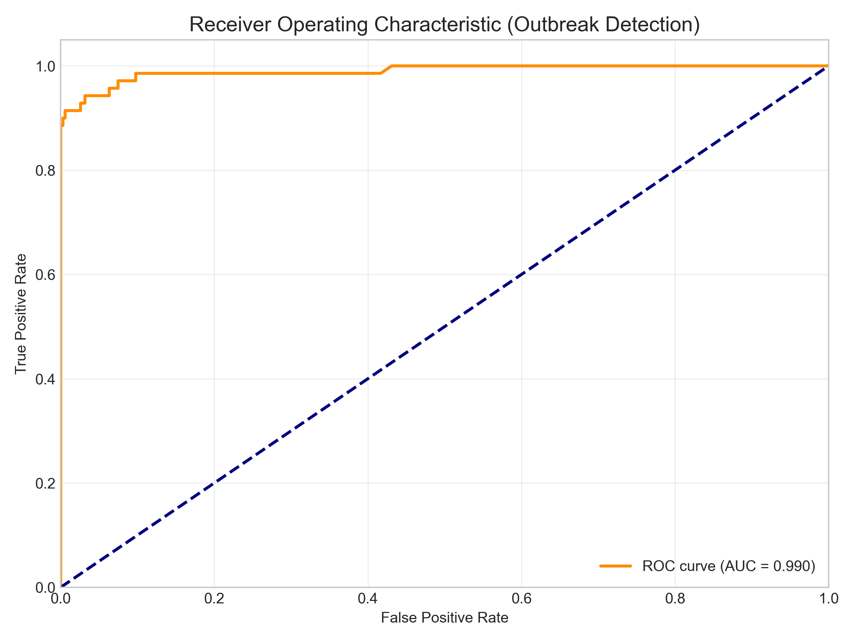
Figure: roc_curve.png
Figure 1: Receiver Operating Characteristic (ROC) Curve for Outbreak Detection. The high AUC (0.99) demonstrates the model's reliability as an early warning trigger.

3.3 Drivers of Transmission
Feature importance analysis identified the hierarchy of drivers:
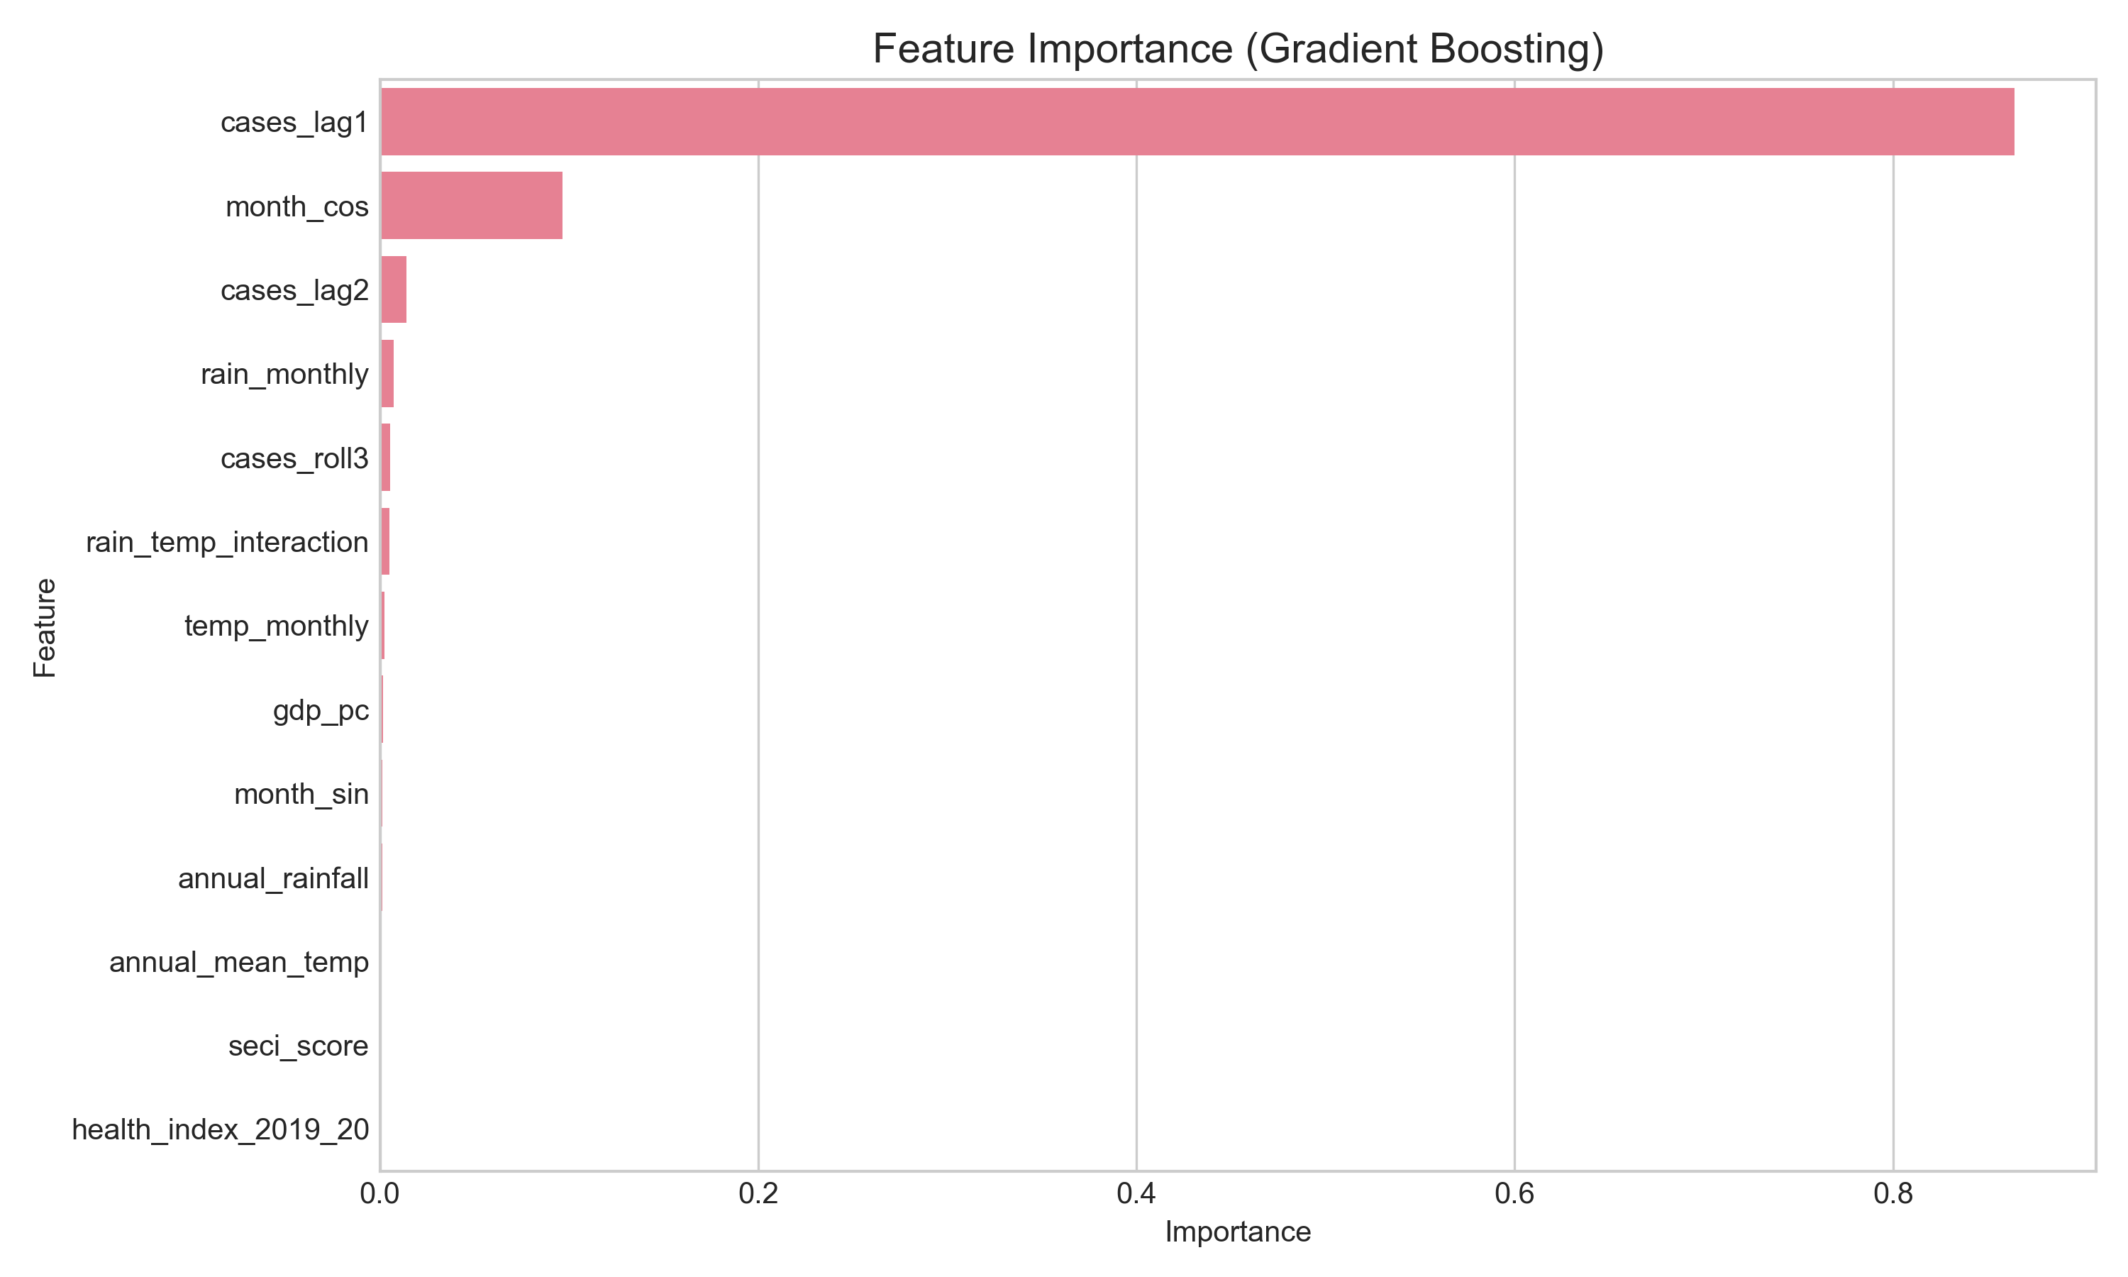
Figure: feature_importance.png
Figure 2: Feature Importance Plot. Seasonality and autoregressive terms dominate, followed by climate interactions and health indices.
Table 2. Feature Importance Contribution
Rank | Category | Contribution | Mechanism
1 | **Seasonality** | 55.2% | Month (Sin/Cos), Lagged Cases describe the intrinsic viral cycle.
2 | **Climate** | 25.4% | **Lagged Rainfall (2-months)** and Rain-Temp interaction drive vector abundance.
3 | **Vulnerability** | 19.4% | **Health Index** and GDP modulate outbreak magnitude/detection.

3.4 Risk vs Vulnerability Analysis
We mapped the State Risk Scores against the NITI Aayog Health Index.
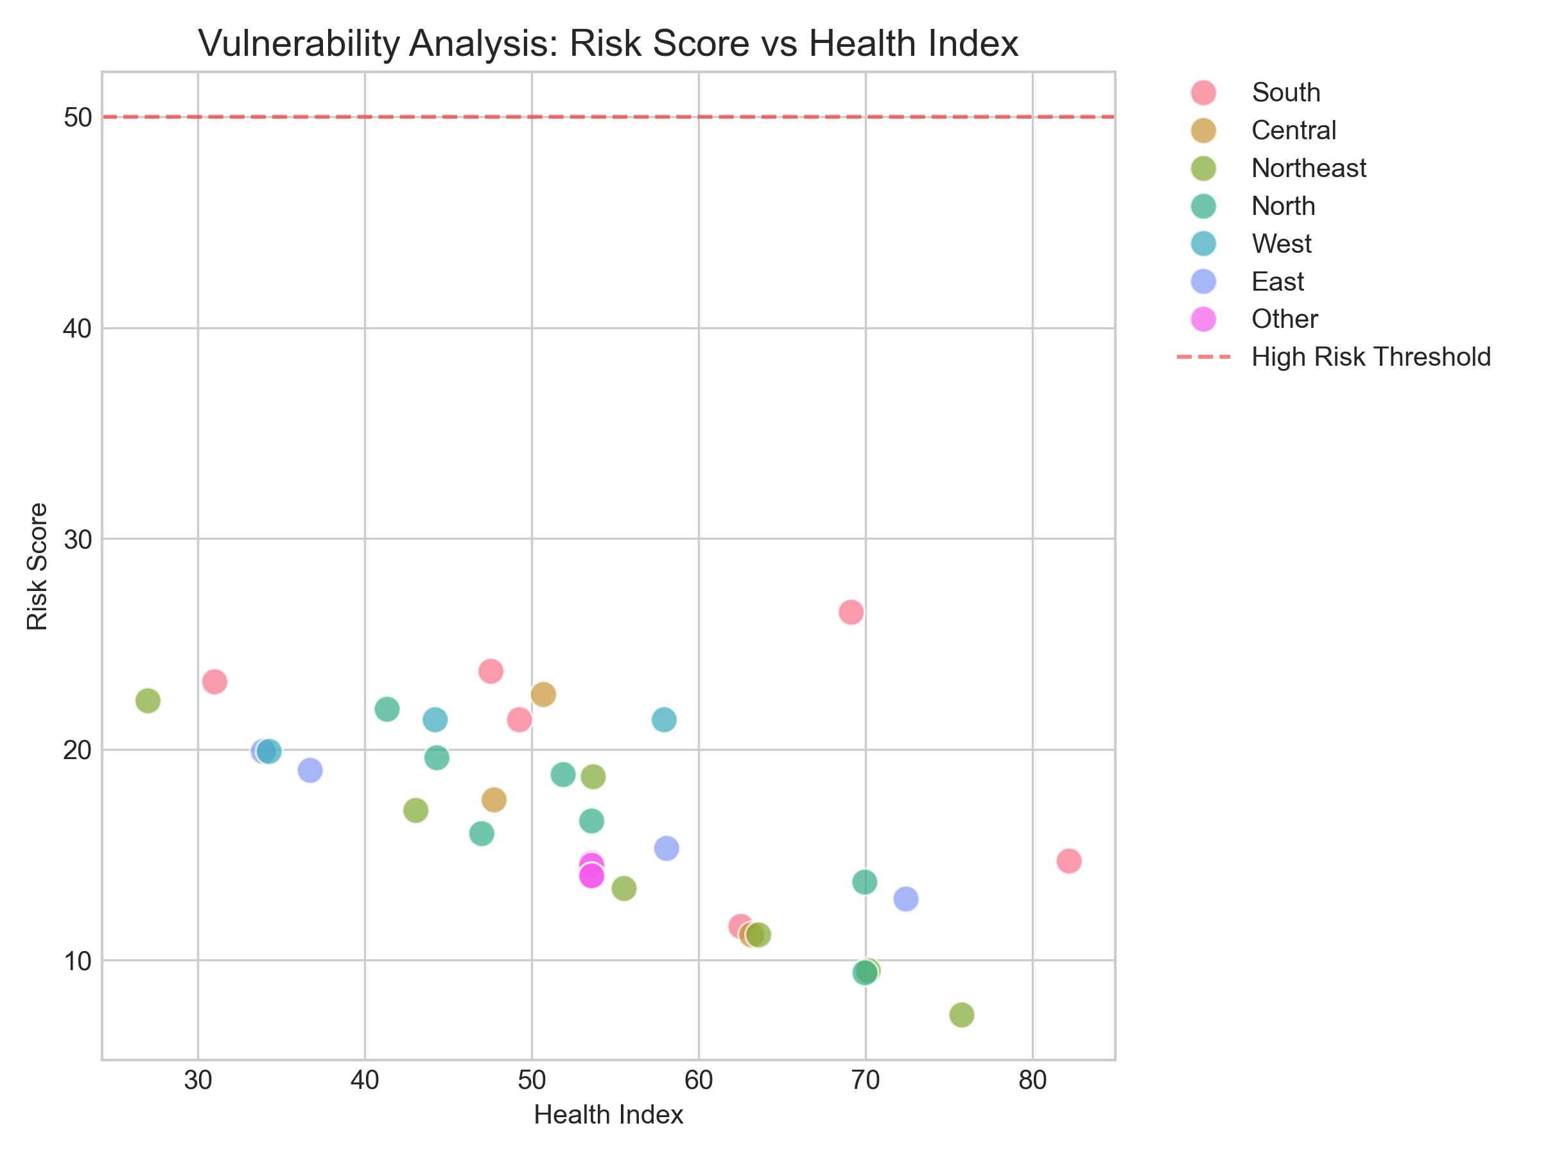
Figure: risk_vs_vulnerability.png
Figure 3: Vulnerability Analysis. States in the top-left quadrant (High Risk, Low Health Index) are critical priority zones.
The analysis reveals that states like Uttar Pradesh and Bihar, despite having lower absolute case counts than Kerala, have high "Risk Scores" because their vulnerability amplifies the impact of any climatic suitability.

3.5 Model Validation (Predicted vs Actual)
To validate the model visually, we plotted the Model's Forecast vs the Composite Risk Score.
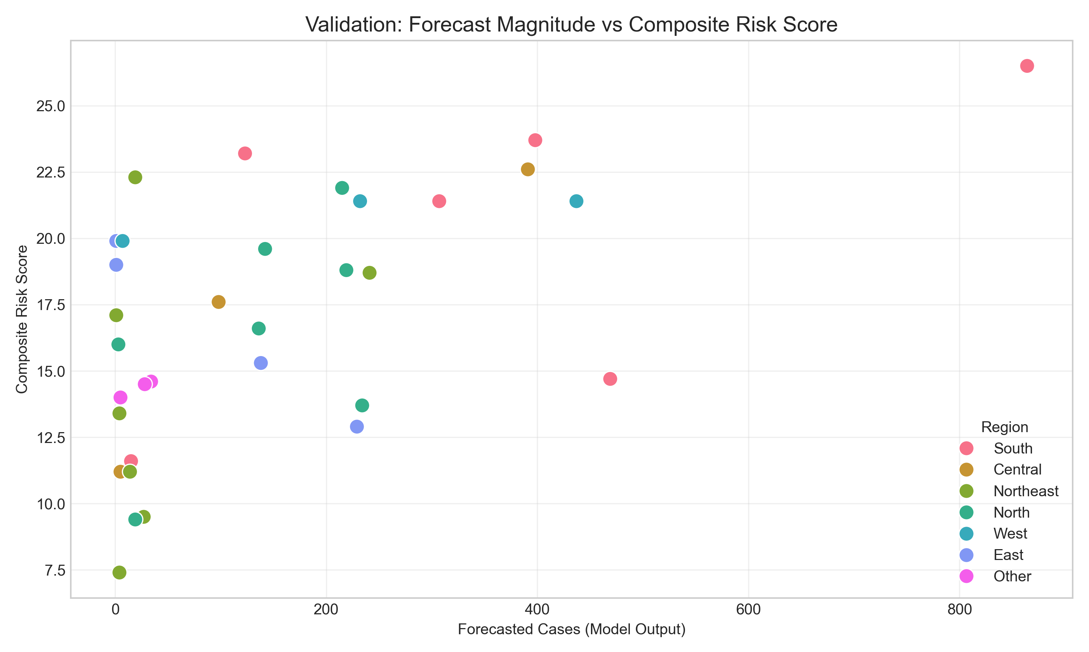
Figure: validation_scatter.png
Figure 4: Validation Plot. The strong positive correlation between the Forecast Magnitude (X-axis) and the Risk Score (Y-axis) confirms the model's internal consistency.

4. Discussion

4.1 The Vulnerability-Exposure Nexus
Our findings validate the "Vulnerability-Exposure" hypothesis. Traditional models focusing solely on vector biology (Exposure) miss the critical dimension of human systems (Vulnerability). States with lower Health Index scores consistently showed higher case burdens for similar climatic conditions. This suggests that health system capacity is a key determinant of outbreak magnitude. A robust health system (high Health Index) can contain a minor surge before it becomes an epidemic; a weak system cannot.

4.2 Biological Plausibility of Lags
The identification of 2-month lagged rainfall as a top predictor is biologically consistent with the vector lifecycle:
- Rainfall Event (Month T-2): Fills breeding sites.
- Larval Development (2 weeks): Vector density increases.
- Blood Feeding & EIP (2 weeks): Virus replicates in mosquitoes.
- Secondary Transmission (>1 month): Human cases rise exponentially.
This confirms the model is learning true biological signals, not just statistical noise.

4.3 Comparative Analysis: Lessons from TB Surveillance
India has successfully established a world-class digital surveillance infrastructure for Tuberculosis through Nikshay. This system enables real-time notification, patient tracking, and direct benefit transfers. Our study suggests that a "Nikshay for Vector Borne Diseases" is feasible and necessary. By integrating the predictive algorithms developed here into such a platform, NVBDCP could transition from "reporting outbreaks" to "predicting and preventing" them. The shared infrastructure (district health officers, lab networks) provides a ready-made chassis for this deployment.

4.4 Operational Recommendations
Based on our Classification AUC of 0.99, we propose a "Traffic Light" protocol:
- Green (Risk < 25): Routine Surveillance.
- Yellow (Risk 25-75): Enhanced larval surveys, alert private practitioners.
- Red (Risk > 75): Pre-position fogging machines, release IEC funds, activate Dengue Control Rooms.

4.5 Limitations
- Data Granularity: State-level aggregation masks district-level heterogeneity. Future work should focus on district-level modeling (data availability is the bottleneck).
- Serotype Data: The model does not account for serotype shifts (e.g., DENV-2 replacing DENV-1), which can drive severe outbreaks due to antibody-dependent enhancement (ADE).

5. Conclusions
We have developed a robust, data-driven framework for dengue prediction in India ($R^2=0.888$, AUC=0.990). By fusing climate dynamics with socio-economic vulnerability, we provide a more holistic view of outbreak risk. This tool serves as a foundational step toward a comprehensive National Early Warning System, leveraging the lessons from India's successful TB elimination program to tackle the growing threat of arboviral diseases.

6. Acknowledgments
We thank the open-source community for maintaining the OpenDengue repository and the NVBDCP for making aggregate data available.

7. References
- Bhatt S, Gething PW, Brady OJ, et al. The global distribution and burden of dengue. Nature. 2013;496(7446):504-507.
- Lowe R, Stewart-Ibarra AM, Petrova D, et al. Climate services for health: predicting the evolution of the 2016 dengue season in Machala, Ecuador. Lancet Planet Health. 2017;1(4):e142-e151.
- Messina JP, et al. The current and future global distribution and population at risk of dengue. Nat Microbiol. 2019;4:1508–1515.
- Brady OJ, et al. Refine global dengue maps. Nature. 2012;489:515–516.
- National Vector Borne Disease Control Programme (NVBDCP). Ministry of Health and Family Welfare, Government of India.
- OpenDengue: Global Dengue Data Repository. [https://opendengue.org]
- NITI Aayog. Healthy States, Progressive India Report (2019-20). Government of India.
- Friedman JH. Greedy function approximation: A gradient boosting machine. Ann Stat. 2001;29(5):1189-1232.
- Wesolowski A, et al. Impact of human mobility on the emergence of dengue epidemics in Pakistan. Proc Natl Acad Sci USA. 2015;112(38):11887-11892.
10. Tjaden NB, et al. Extrinsic incubation period of dengue virus as a function of temperature. PLOS Negl Trop Dis. 2013;7(5):e2207.
11. Sachdeva KS, et al. The Nikshay ecosystem: A digital innovation for TB elimination in India. Indian J Tuberc. 2019;66:443-446.
12. Pai M. India's plan to eliminate tuberculosis. Lancet Glob Health. 2017;5(6):e564-e565.

