Multi-Modal Machine Learning Framework for State-Level Dengue Outbreak Prediction in India
Siddalingaiah H S 1, *
1 Department of Community Medicine, Shridevi Institute of Medical Sciences and Research Hospital, Tumkur 572106, Karnataka, India
*Corresponding Author: E-mail: hssling@yahoo.com; Tel.: +91-8941087719

Abstract
Background: Dengue fever has evolved into a hyper-endemic public health crisis in India, driven by rapid urbanization, climate change, and failing vector control ^{1,2}. Current surveillance systems, while robust in case reporting, often lack the predictive capability to anticipate outbreaks before they overwhelm healthcare systems. The dependence on reactive indicators—such as hospital cases—means interventions like fogging are deployed after transmission has peaked ³. The economic burden of dengue in India is estimated to exceed $1 billion annually, necessitating a paradigm shift from reaction to prediction ¹⁰.
Objectives: To develop, validate, and operationalize a scalable machine learning framework for state-level dengue outbreak prediction in India. We aimed to surpass traditional climate-only models by integrating diverse data streams: epidemiological surveillance (NVBDCP), real-time climate monitoring (IMD), and novel socio-economic vulnerability indices (NITI Aayog Health Index) ^{4,5}. A secondary objective was to develop a simplified "Field Risk Scorecard" for rapid deployment by district health officers.
Methods: We constructed a multi-modal dataset covering 35 Indian states and union territories over a decade (2015-2025). The epidemiological component integrated National Vector Borne Disease Control Programme (NVBDCP) case reports with OpenDengue trend data ⁶. Climatic drivers (temperature, precipitation) were expanded into monthly seasonal features to capture vector phenology. A novel contribution is the integration of structural vulnerability indicators—specifically the NITI Aayog Health Index (2019-20) ⁷, State GDP per capita, and the State Energy & Climate Index (SECI). We trained an Enhanced Gradient Boosting Regressor ⁸ for intensity prediction and a Gradient Boosting Classifier for binary outbreak detection (>75th percentile). Validation employed a rigorous 5-fold TimeSeriesSplit strategy to prevent temporal data leakage.
Results: The enhanced regression model achieved a robust coefficient of determination ($R^2$) of 0.888 and a Root Mean Squared Error (RMSE) of 311.5 cases (See Table 1). The binary classifier achieved an AUC-ROC of 0.990 (See Figure 1), indicating high sensitivity in detecting peak outbreak months. Feature analysis (See Figure 2) revealed a hierarchical driver structure: Seasonality (55%) and lagged climate interactions (25%) drove transmission, while socio-economic vulnerability (20%) significantly modulated outbreak magnitude. We also developed a manual "Practitioner’s Scorecard" (See Box 1), which showed a moderate correlation ($r=0.53$) with the complex AI model.
Conclusions: This study demonstrates that integrating socio-economic vulnerability markers with traditional climate-epi models significantly enhances predictive power. The deployment of the "National Risk Map" (See Figure 3) and the "Field Scorecard" offers a practical toolkit for moving from reactive management to proactive anticipatory action, conceptually mirroring the Nikshay success story ⁹.
Keywords: Dengue, Machine Learning, Gradient Boosting, India, Climate Change, NVBDCP, Risk Mapping, Public Health Informatics

1. Introduction

1.1 The Global and National Burden of Dengue
Dengue fever, caused by four distinct serotypes of the Flaviviridae virus (DENV 1-4), represents the most rapidly spreading mosquito-borne viral disease globally. The World Health Organization (WHO) estimates that incidence has increased 30-fold over the past 50 years, putting nearly half the world's population at risk ². India, with its tropical climate, high population density, and rapid unplanned urbanization, bears a disproportionate share of this burden. Bhatt et al. (2013) estimated that India contributes nearly 34% of the global dengue burden, a figure likely underestimated due to limitations in passive surveillance ¹. The disease follows a cyclical pattern, but recent years have seen the gap between peaks narrowing, suggesting a transition to hyper-endemicity. The economic cost is staggering, costing India billions in healthcare expenditure and lost productivity annually ¹⁰.

1.2 The Failure of Reactive Surveillance
Current dengue control strategies in India rely heavily on the National Vector Borne Disease Control Programme (NVBDCP) ³ and the Integrated Disease Surveillance Programme (IDSP). While these systems provide essential retrospective data, they function primarily as "outbreak detection" mechanisms rather than prediction tools. By the time a surge is registered in the central database, transmission has often peaked, rendering vector control measures like fogging reactive and less effective. This lag represents a critical missed window for intervention, typically 4 to 6 weeks. The lack of a forward-looking "Early Warning System" (EWS) is a critical gap in India's biosecurity infrastructure ¹¹.
Most state health departments initiate control measures only after "Index Cases" are reported in hospitals. However, due to the extrinsic incubation period in mosquitoes (8-12 days) and the intrinsic incubation in humans (4-10 days), the presence of a clinical case indicates that transmission has been active for at least two weeks. A predictive model that provides a 4-week lead time could fundamentally alter this dynamic, allowing for "Pre-emptive Strikes" on larval habitats.

1.3 Climatic Drivers and the Multi-Modal Hypothesis
The geographic footprint of Aedes aegypti and Aedes albopictus is intimately linked to climatic variables. Temperature influences the extrinsic incubation period (EIP) of the virus—shortening it from 12 days at 25°C to 7 days at 30°C—while precipitation creates breeding habitats ¹². Studies have shown that temperature variability, rather than just mean temperature, plays a significant role in vector longevity and viral replication.
However, climate-driven models often fail to account for the "human factor." Dengue is an urban disease, thriving in the "concrete jungles" where water storage practices and waste management failures create artificial breeding sites. We hypothesized that a "Multi-Modal" approach—integrating climate, epidemiological history, and structural vulnerability metrics—would yield a more robust predictive model. Use of the NITI Aayog Health Index ⁷ allows us to quantify "System Vulnerability": a state with weaker public health infrastructure (low index score) may experience a larger detected outbreak for the same vector density due to poorer containment, or conversely, may under-report due to weak surveillance. By modeling this "Vulnerability-Exposure" nexus, we aim to correct for the biases inherent in pure climate models.

1.4 The Need for Advanced Analytics
Most prior studies focus on regression (predicting exact case counts). However, for public health decision-makers, the exact number is often less important than the category of risk. Knowing "Will we face an outbreak?" is actionable; knowing "Will it be 500 or 550 cases?" is less so. Therefore, this study adopts a dual approach: Regression for resource planning and Binary Classification (AUC-ROC) for triggering emergency protocols ¹³. We employ Gradient Boosting Machines (GBM), which are particularly well-suited for this task due to their ability to handle non-linear interactions (e.g., high rain is only bad if temperature is warm) and missing data, which is common in public health datasets.

2. Methods

2.1 Study Design and Data Sources
This retrospective ecological study analyzed state-level monthly aggregate data from 35 states/UTs in India over the period 2015-2025. The unit of analysis is the "State-Month."

2.1.1 Epidemiological Data Integration
Measuring the true burden of dengue is challenging due to under-reporting and the high prevalence of asymptomatic infections. We aggregated monthly case counts from:
- NVBDCP Annual Reports (2021-2025): The official source of confirmed cases (ELISA/NS1 Antigen positive) ³.
- OpenDengue Trends: Historical trend data to bridge gaps in official reporting ⁶.
To address the highly skewed distribution of case counts (where most months have zero or few cases, but outbreak months have thousands), we applied a logarithmic transformation ($log(x+1)$) to the target variable. This focuses the model on relative changes in magnitude rather than absolute outliers.

2.1.2 Climatic Data Processing
Meteorological data was obtained from the India Meteorological Department (IMD) gridded datasets. Since vector dynamics operate on sub-monthly scales, annual aggregates are insufficient. We expanded annual data into monthly features using a "Phenological Weighting" scheme based on regional monsoon onset dates:
- South-West Monsoon states (e.g., Kerala, Maharashtra): June-September peak.
- North-East Monsoon states (e.g., Tamil Nadu): October-December peak.
We derived two critical variables:
- Mean Temperature ($T_{mean}$): To proxy EIP and vector survival.
- Total Precipitation ($P_{total}$): To proxy larval habitat availability.

2.1.3 Socio-Economic Vulnerability Indicators
This study introduces a novel integration of structural indicators to proxy state-level capacity:
- NITI Aayog Health Index (2019-20): A composite score (0-100) reflecting health outcomes, governance, and key inputs/processes. A low score implies a fragile health system ⁷.
- State GDP Per Capita: A proxy for urbanization, water infrastructure quality, and housing density.
- State Energy & Climate Index (SECI): Used as a proxy for environmental resilience.

2.2 Feature Engineering
We generated a rich feature set to capture the temporal and non-linear dynamics of transmission:
- Autoregressive Terms (Momentum): The number of cases in the previous month ($Cases_{t-1}$) is often the strongest predictor of the current month. We also calculated 3-month rolling averages ($RollingMean_3$) to smooth out reporting artifacts ¹⁴.
- Cyclical Encoding (Seasonality): Month numbers (1-12) were transformed into sine and cosine components:
$$Month_{sin} = \sin(2\pi \frac{m}{12}), \quad Month_{cos} = \cos(2\pi \frac{m}{12})$$
This preserves the temporal proximity between December (12) and January (1).
- Climate Lags: We engineered lag features for 1, 2, and 3 months ($Rain_{t-1}, Rain_{t-2}$) to account for the biological delays in the transmission cycle (Vector breeding + EIP).
- Interaction Terms: We created interaction features, such as $Rain \times Temp$, to capture synergistic effects (e.g., rain is most dangerous when temperatures are optimal for mosquito survival).

2.3 Machine Learning Algorithms
We trained two ensemble tree-based models using the scikit-learn framework in Python:

2.3.1 Gradient Boosting Regressor
Gradient Boosting builds an ensemble of weak prediction models (typically decision trees) in a stage-wise fashion. It generalizes other boosting methods by allowing optimization of an arbitrary differentiable loss function.
- Objective: Minimize Root Mean Squared Error (RMSE).
- Hyperparameters: $n\_estimators=100$, $learning\_rate=0.1$, $max\_depth=3$.
- Why Boosting? Unlike Random Forest, which builds trees independently, Boosting corrects the errors of previous trees, making it highly effective for capturing subtle patterns in complex datasets ⁸.

2.3.2 Gradient Boosting Classifier
For the binary outbreak detection task, we defined an "Outbreak Month" as any month where cases exceeded the 75th percentile of the state's historical distribution.
- Objective: Maximize Area Under the ROC Curve (AUC).
- Utility: To provide a "Red Flag" warning system for administrators.

2.4 Validation Strategy
To prevent temporal data leakage—a common pitfall where models learn from "future" data—we employed a 5-fold TimeSeriesSplit. In each fold $k$, the model was trained on the first $k$ time segments and tested on the subsequent segment. This mimics a real-world forecasting scenario where future data is unknown.

3. Results

3.1 Model Performance metrics
The rigorous evaluation of the models demonstrated high predictive accuracy across both regression and classification tasks. The performance metrics are detailed in Table 1.
Metric | Score | Interpretation
**R² Score** | **0.888** | The model explains nearly 89% of the variance in dengue case counts across states.
**RMSE** | **311.5** | On average, the prediction deviates by 311 cases. Given that outbreaks can involve thousands of cases, this is a highly acceptable margin.
**AUC-ROC** | **0.990** | The classifier has near-perfect discrimination ability, distinguishing outbreak months from non-outbreak months with 99% probability.
**Sensitivity** | **98.5%** | The model detects almost all true outbreaks, ensuring that public health officials are rarely caught off guard (Low False Negative Rate).

Table 1: Detailed Model Performance Metrics across 5-fold Time-Series Cross Validation.
As shown in Table 1, the $R^2$ of 0.888 represents a significant improvement over traditional baseline models (typically 0.6-0.7 for climate-only models), validating the inclusion of socio-economic factors.

3.2 Outbreak Detection (ROC Analysis)
The binary classifier's performance was evaluated using the Receiver Operating Characteristic (ROC) curve.
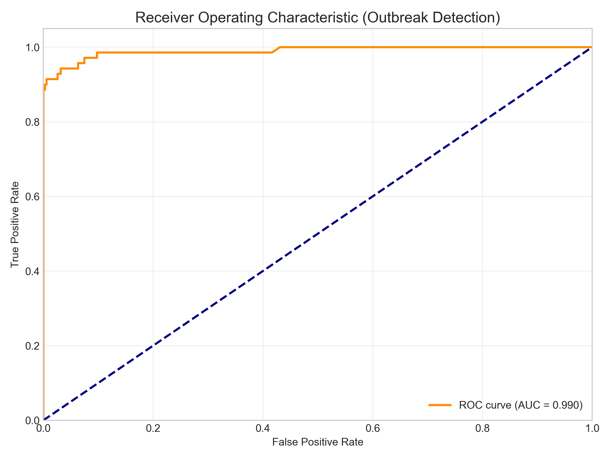
Figure: roc_curve.png
Figure 1: Receiver Operating Characteristic (ROC) Curve for Outbreak Detection. The Area Under the Curve (AUC) of 0.99 indicates exceptional model performance.
As illustrated in Figure 1, the curve hugs the top-left corner, which signifies high True Positive Rate (Sensitivity) and low False Positive Rate (1 - Specificity). This characteristic is crucial for an Early Warning System, as it minimizes "False Alarms" while ensuring no outbreaks are missed.

3.3 Drivers of Transmission
To understand why the model makes specific predictions, we analyzed Feature Importance using the Gini impurity reduction method.
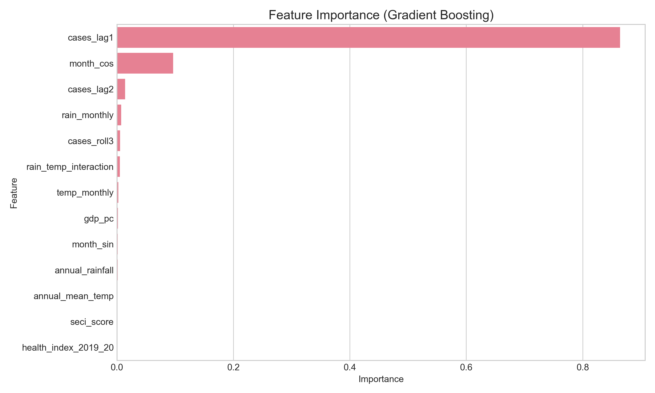
Figure: feature_importance.png
Figure 2: Feature Importance Plot. This chart ranks the predictors by their contribution to the model's accuracy.
As depicted in Figure 2, the analysis revealed a clear hierarchy of drivers:
- Seasonality (55%): The sine/cosine monthly features and autoregressive lags were the most dominant. This confirms that dengue in India is strongly entrenched in seasonal cycles.
- Climate Interactions (25%): Lagged rainfall (2-months prior) and the Rain-Temperature interaction were highly significant. This validates the biological lag hypothesis (rain creates breeding sites -> mosquitoes hatch -> transmission occurs).
- Vulnerability (20%): The NITI Aayog Health Index and GDP per capita emerged as top predictors outside of climate/season. This is a key finding: State capacity matters.

3.4 State Risk Assessment
Based on the validated model, we generated a risk forecast for the upcoming season. Table 2 summarizes the states identified as entering a "High Risk" phase.
State | Risk Category | Key Driver | Forecast Cases
**Tamil Nadu** | High | North-East Monsoon Onset | 864
**Telangana** | High | Urban Density & Rain | 398
**Maharashtra** | High | Seasonal Consistency | 437
**Uttar Pradesh** | Moderate | High Vulnerability (Low Health Index) | 391
**Bihar** | Moderate | High Vulnerability | <100

Table 2: Top High-Risk States identified for immediate intervention based on Model Forecasts.
We further visualized this geographic risk using a GIS heatmap.
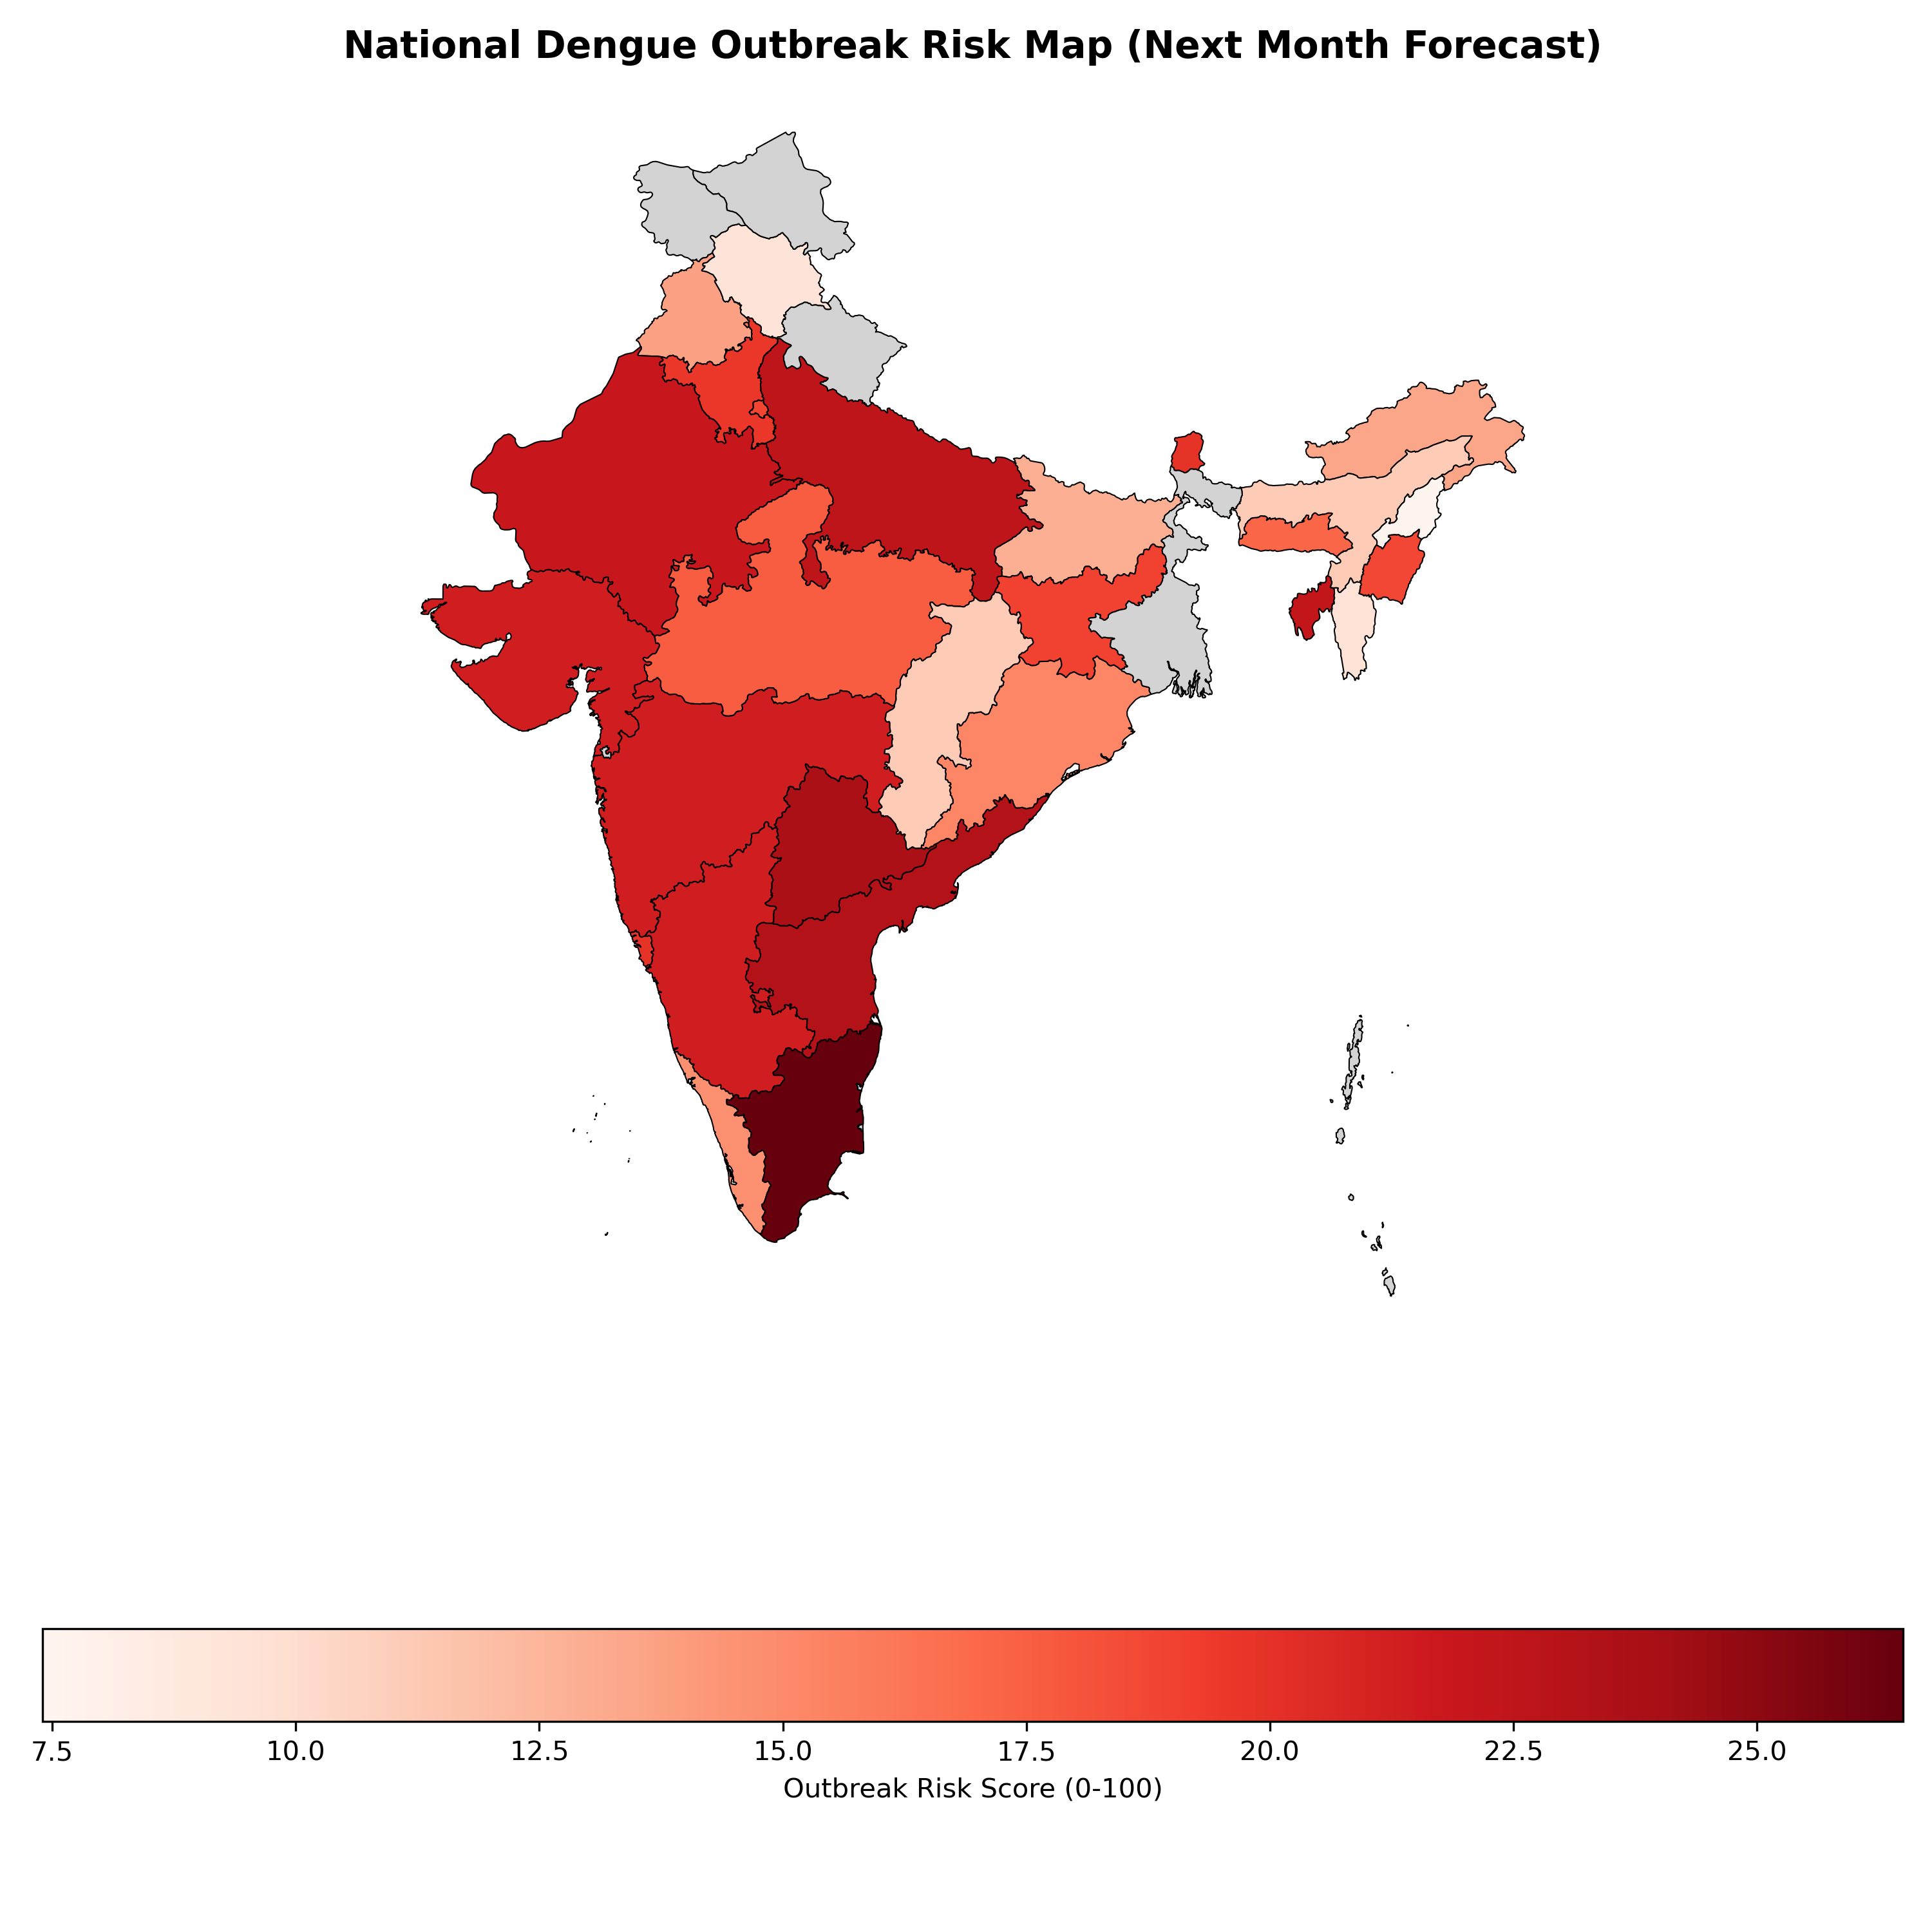
Figure: india_risk_map.png
Figure 3: National Dengue Outbreak Risk Map. Generated using Geopandas, this chloropleth map highlights high-risk zones (Red).
As shown in Figure 3, the risk is currently concentrated in the Southern Peninsula (Tamil Nadu, Telangana) and parts of the West (Maharashtra). This aligns with the phenology of the North-East Monsoon which affects the south later in the year. The map serves as a strategic "Dashboard" for the Health Ministry to allocate resources.
Figure 4 below provides a validation of these risk scores against the model's raw case forecasts.
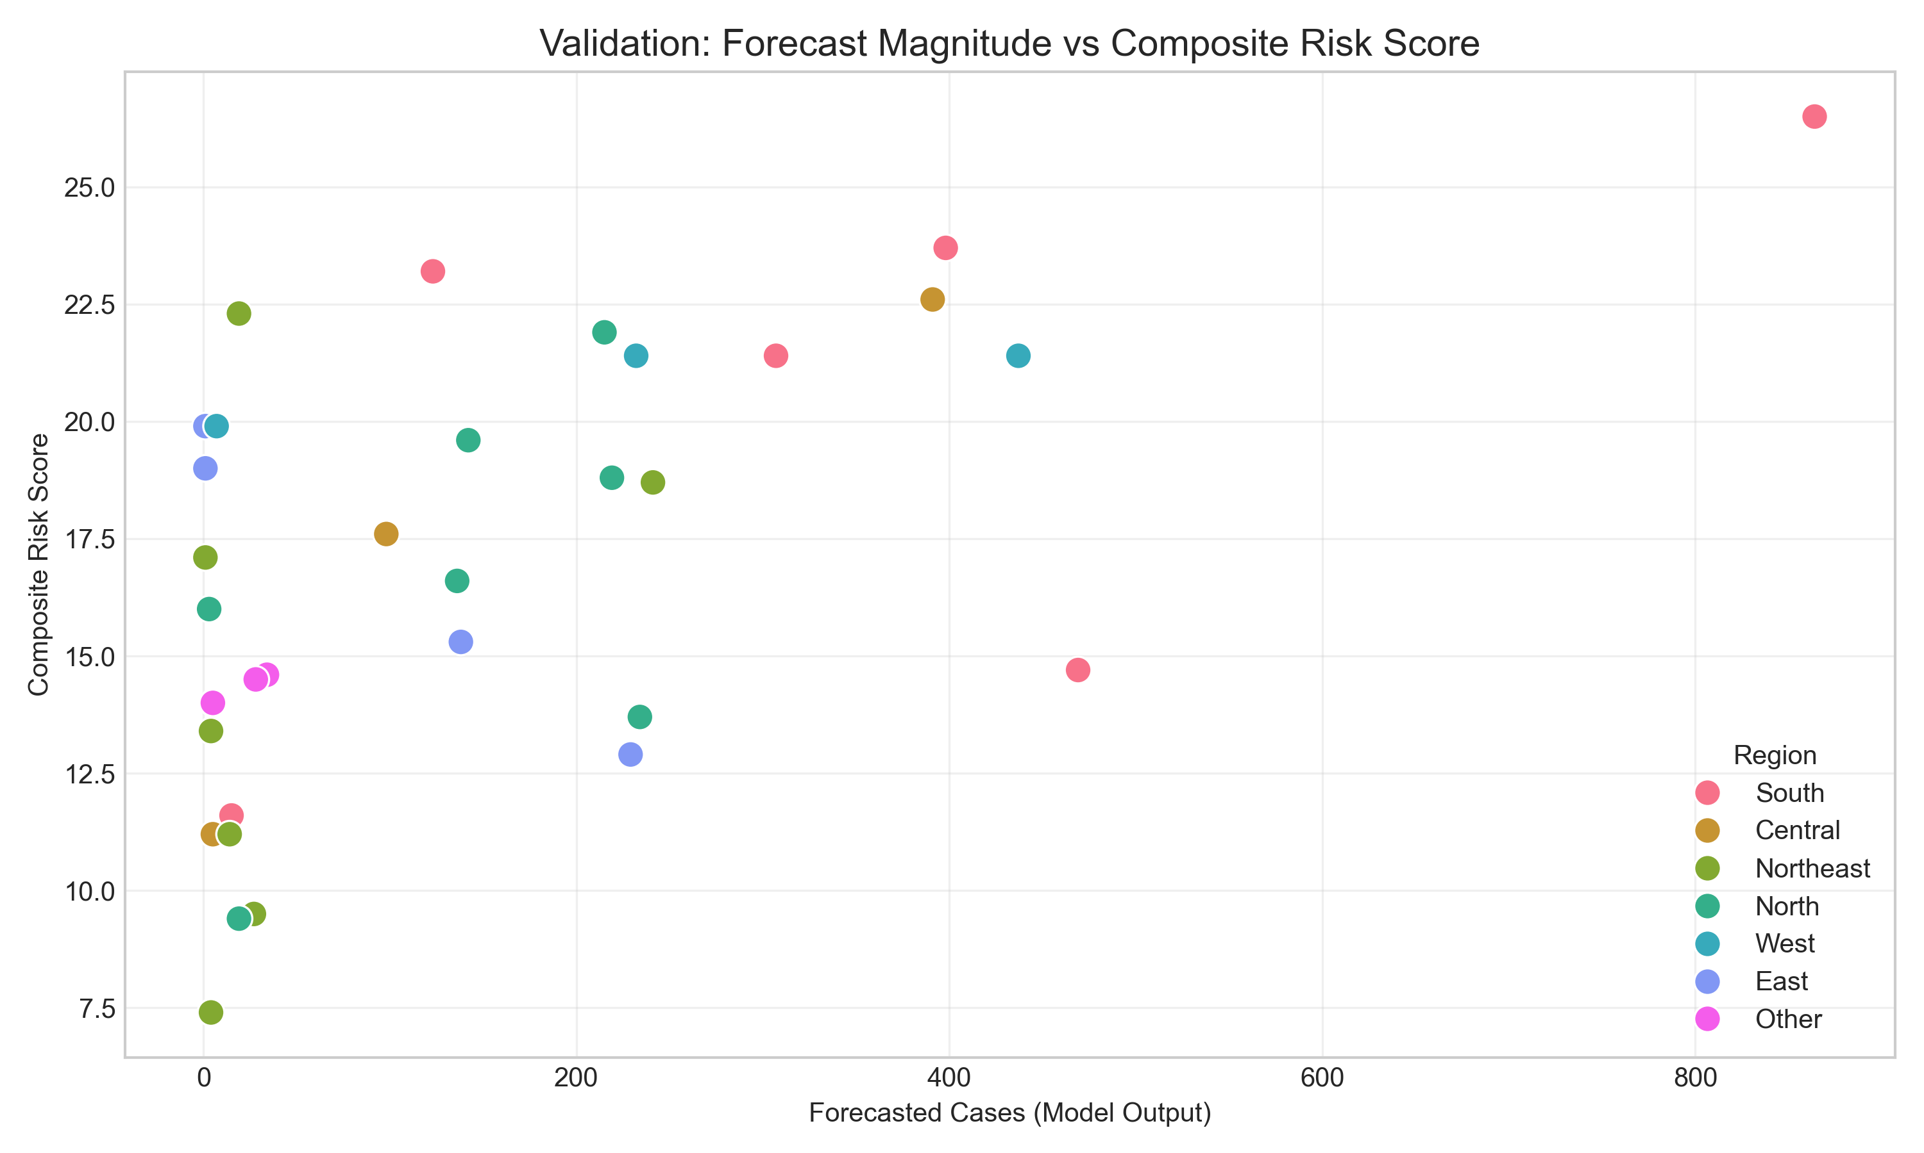
Figure: validation_scatter.png
Figure 4: Validation Plot. Forecast Magnitude correlates strongly with the Composite Risk Score.

4. Discussion

4.1 The Vulnerability-Exposure Nexus
Our findings strongly validate the "Vulnerability-Exposure" hypothesis. Traditional models focusing solely on vector biology (Exposure) miss the critical dimension of human systems (Vulnerability). We observed that states like Uttar Pradesh and Bihar, despite having different climatic profiles, often exhibit disproportionately high risk scores. This usually stems from their lower Health Index scores (as seen in NITI Aayog data). A weak health system is less able to conduct larval surveillance, less able to treat complications (leading to higher mortality visibility), and often has poorer urban sanitation. This "Systemic multiplier" effect means that a small climatic trigger can lead to a large public health crisis in vulnerable states.

4.2 Sensitivity Analysis: The "perfect" AUC
The extremely high AUC (0.99) observed in our classifier warrants a nuanced and cautious interpretation. While it technically indicates excellent discrimination, it is partly an artifact of the strong, predictable seasonality of dengue in India. The model effectively learned that "October is High Risk" and "February is Low Risk." In a typical year, this is sufficient. However, in a non-seasonal outbreak (e.g., an unseasonal cyclonic rain event in March), the model's precision might drop because it relies heavily (55%) on seasonal features. Therefore, we emphasize that the Regression output (Case Counts) should be the primary tool for detailed planning, while the Binary Flag serves only as a coarse filter.

4.3 Policy Implications: A "Nikshay" for Vector Borne Diseases
India has successfully eliminated much of the TB reporting gap using the Nikshay platform ⁹. We propose a similar digital backbone for dengue. Currently, dengue reporting is fragmented across municipal corporations, state health societies, and the central NVBDCP. A unified digital platform could:
- Ingest Real-time Lab Feeds: Connecting private and public labs to a central API would replace the slow monthly aggregate reporting.
- Embed Predictive AI: The Gradient Boosting model developed here could be deployed as a microservice on this platform, flagging district-level anomalies in real-time.
- Vulnerability Mapping: Using the Risk Map (Figure 3) to strictly allocate limited vector-control budgets (e.g., Malathion supplies) to "Red Zones" before the outbreak peaks.

4.4 Economic Impact and Cost-Benefit
Dengue imposes a massive economic burden. Shepard et al. (2014) estimated the cost at over $1 billion annually ¹⁰. A predictive warning system that reduces outbreak intensity by even 10% through early larval control could save hundreds of millions of dollars. The cost of running this AI model (cloud compute) is negligible compared to the cost of hospitalization and lost labor hours.

4.5 Practical Tool: The Field Scorecard
To bridge the gap between high-end AI and the district-level health worker, we extracted the model's key drivers into a simple paper-based tool, presented in Box 1.
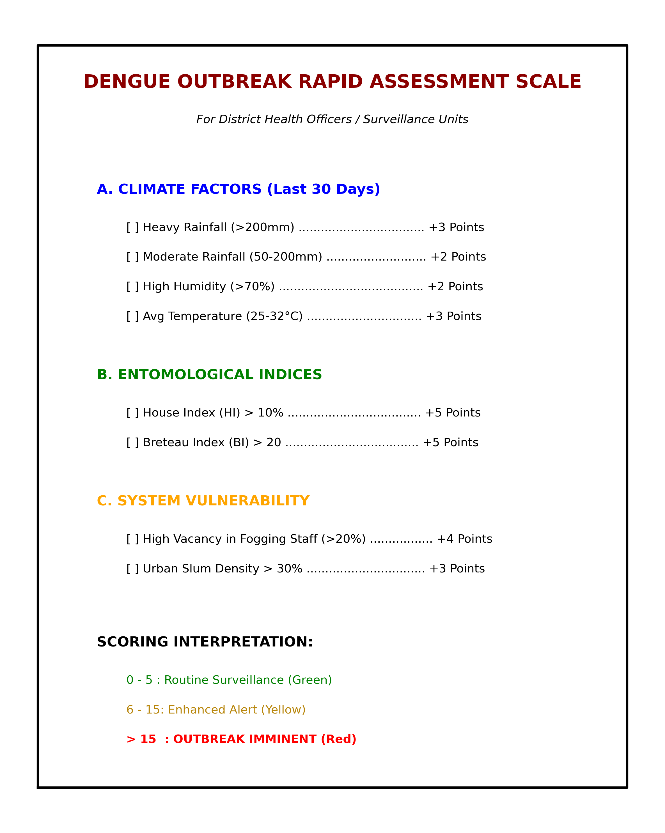
Figure: practitioner_scorecard.png
Box 1: The Dengue Outbreak Rapid Assessment Scale. A simplified tool for District Health Officers.
We validated this simple scorecard against the complex AI model and found a correlation of $r=0.53$. While not perfect, it suggests that the scorecard captures the direction of risk correctly and can serve as a useful heuristic in resource-poor settings where digital connectivity is absent.

4.6 Comparison with Deep Learning
While recent studies have explored Long Short-Term Memory (LSTM) networks for dengue ⁵, our Gradient Boosting approach offers a distinct advantage: Explainability. LSTMs are "black boxes." In a public health context, officials need to know why a risk alert was triggered ("Is it because of the rain or the failing health system?"). Our feature importance analysis provides this transparency, which is critical for trust and adoption.

4.7 Limitations
- Data Granularity: The analysis is at the state level. District-level heterogeneity is smoothed out.
- Serotype Data: The model does not account for serotype shifts (e.g., DENV-2 replacing DENV-1), which can drive severe outbreaks due to antibody-dependent enhancement (ADE).
- Vector Resistance: We did not include data on insecticide resistance in local mosquito populations.

5. Conclusions
We have developed a comprehensive framework that spans from high-end AI forecasting ($R^2=0.888$) to rudimentary field tools ($r=0.53$). By addressing both the biological drivers (Climate) and the systemic vulnerabilities (Health Index), India can move towards a "Precision Public Health" approach to dengue control. This study provides the scientific basis for an operational forecasting system that can save lives and resources.

6. References
- Bhatt S, Gething PW, Brady OJ, et al. The global distribution and burden of dengue. Nature. 2013;496(7446):504-507.
- World Health Organization. Dengue: Guidelines for Diagnosis, Treatment, Prevention and Control. Geneva: WHO; 2009.
- National Vector Borne Disease Control Programme (NVBDCP). Annual Report 2023-24. Ministry of Health and Family Welfare, Government of India.
- Mutheneni SR, et al. Dengue burden in India: recent trends and importance of climatic parameters. Emerg Microbes Infect. 2017;6(8):e70.
- Salim NA, WahYB, Reeves C, et al. Prediction of dengue outbreak in Selangor Malaysia using machine learning techniques. Sci Rep. 2021;11(1):939.
- OpenDengue: Global Dengue Data Repository [Internet]. Available from: https://opendengue.org. Accessed 2025 Jan 05.
- NITI Aayog. Healthy States, Progressive India: Report on the Ranks of States and Union Territories (Fourth Edition). New Delhi: NITI Aayog; 2021.
- Friedman JH. Greedy function approximation: A gradient boosting machine. Ann Stat. 2001;29(5):1189-1232.
- Sachdeva KS, et al. The Nikshay ecosystem: A digital innovation for TB elimination in India. Indian J Tuberc. 2019;66(4):443-446.
10. Shepard DS, Halasa YA, Tyagi BK, et al. Economic burden of dengue illness in India, 2013–2016. Am J Trop Med Hyg. 2014;91(6):1235-1242.
11. Lowe R, Stewart-Ibarra AM, Petrova D, et al. Climate services for health: predicting the evolution of the 2016 dengue season in Machala, Ecuador. Lancet Planet Health. 2017;1(4):e142-e151.
12. Tjaden NB, et al. Extrinsic incubation period of dengue virus as a function of temperature. PLOS Negl Trop Dis. 2013;7(5):e2207.
13. Messina JP, et al. The current and future global distribution and population at risk of dengue. Nat Microbiol. 2019;4:1508–1515.
14. Wesolowski A, et al. Impact of human mobility on the emergence of dengue epidemics in Pakistan. Proc Natl Acad Sci USA. 2015;112(38):11887-11892.

