Figures
A Cross-Flaviviral Transcriptomic Evidence and Mechanistic Prioritization Framework for Host-Directed Therapy in Kyasanur Forest Disease
Figure 1. Discovery cohorts used in the analysis.
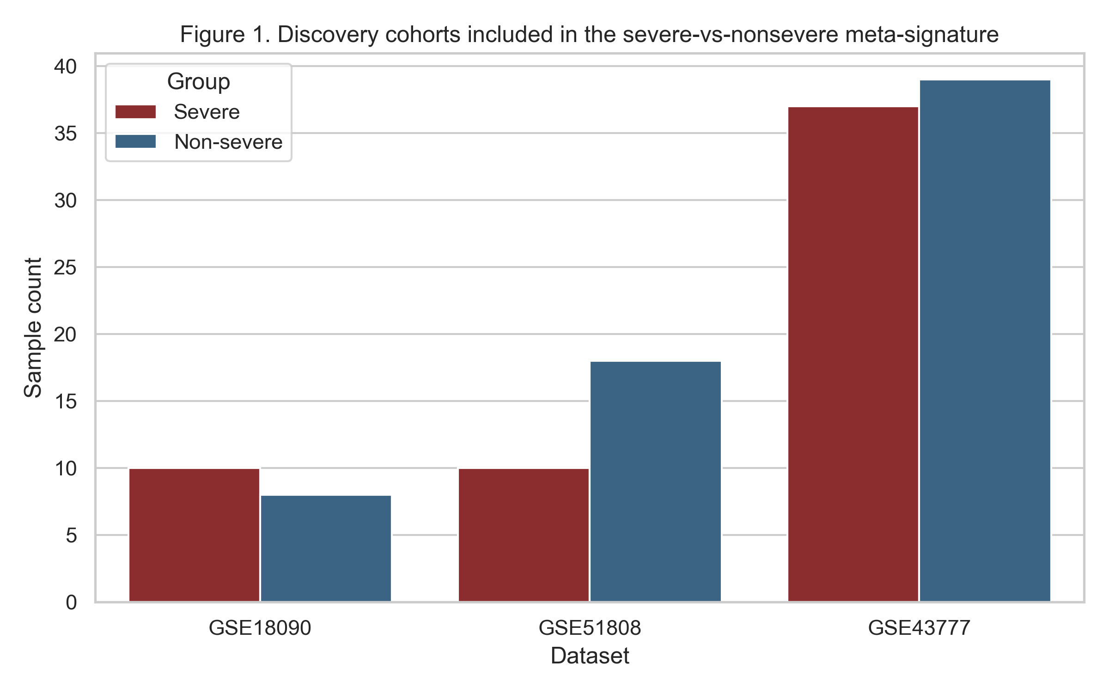

Figure 2. Meta-priority ranking after adding pooled effects and evidence tiers.
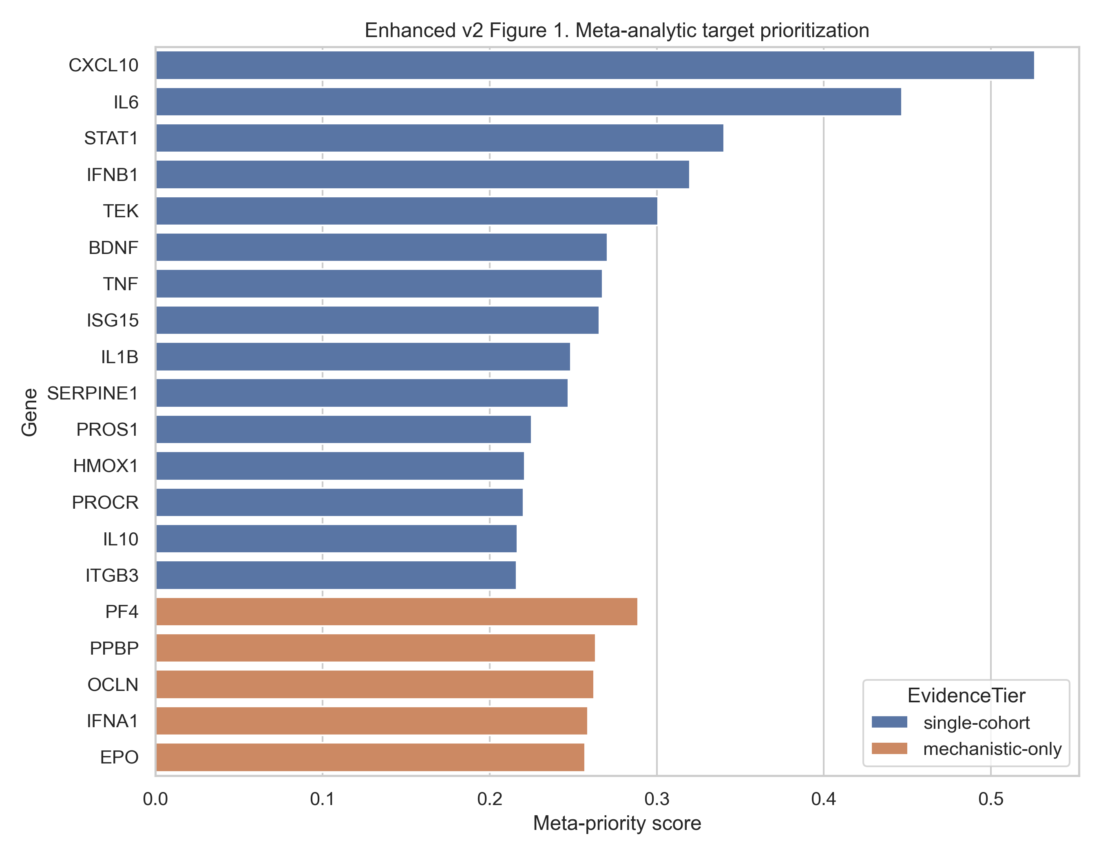

Figure 3. Pathway effect size versus heterogeneity.
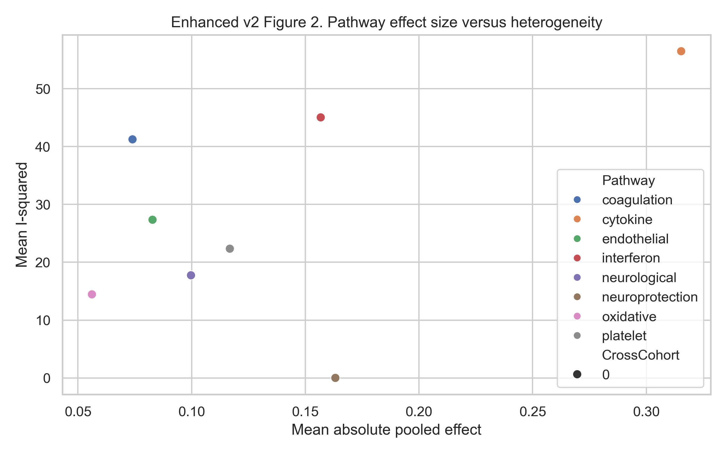

Figure 4. Original composite ranking retained for comparison with the meta-analytic ranking.
