Supplementary Materials

Host-Directed Therapy for Kyasanur Forest Disease: An Integrated Multi-omics Pipeline
Siddalingaiah H S
Department of Community Medicine, SIMS Tumkur, Karnataka, India

Contents
Supplementary Table S1: Complete 50-Gene KFD Host Signature
Supplementary Table S2: Complete Drug Candidates
Supplementary Table S3: Literature Validation
Supplementary Table S4: Karnataka District-wise KFD Cases
Supplementary Figure S1: All Publication Figures

Supplementary Table S1: Complete 50-Gene KFD Host Signature
Rank | Symbol | Pathway | Phase | Score | Drug
1 | TNF | Cytokine | Febrile | 0.942 | High
2 | IL6 | Cytokine | Both | 0.857 | High
3 | ANGPT2 | Endothelial | Hemorrhagic | 0.767 | High
4 | IL1B | Cytokine | Febrile | 0.749 | High
5 | VEGFA | Endothelial | Hemorrhagic | 0.740 | High
6 | F3 | Coagulation | Hemorrhagic | 0.733 | High
7 | IFNG | Cytokine | Febrile | 0.727 | High
8 | EPO | Neuroprotection | Neurological | 0.697 | High
9 | NOS3 | Endothelial | Protective | 0.696 | High
10 | SERPINE1 | Coagulation | Hemorrhagic | 0.680 | Moderate
11 | STAT1 | Interferon | Febrile | 0.672 | High
12 | KDR | Endothelial | Hemorrhagic | 0.669 | High
13 | IL10 | Cytokine | Protective | 0.667 | High
14 | HMOX1 | Oxidative | Protective | 0.666 | High
15 | IFNA1 | Interferon | Febrile | 0.664 | High
16 | F2 | Coagulation | Hemorrhagic | 0.659 | High
17 | IFNB1 | Interferon | Febrile | 0.659 | High
18 | ANGPT1 | Endothelial | Protective | 0.652 | High
19 | EDN1 | Endothelial | Hemorrhagic | 0.648 | High
20 | IL8 | Cytokine | Hemorrhagic | 0.645 | Moderate
21 | BDNF | Neurological | Neurological | 0.638 | High
22 | NFE2L2 | Oxidative | Protective | 0.635 | High
23 | NGF | Neurological | Neurological | 0.631 | High
24 | SELP | Platelet | Hemorrhagic | 0.631 | High
25 | VWF | Endothelial | Hemorrhagic | 0.630 | Moderate
26 | PLAT | Coagulation | Both | 0.628 | High
27 | THBD | Coagulation | Protective | 0.624 | Moderate
28 | TEK | Endothelial | Protective | 0.616 | High
29 | CCL2 | Cytokine | Hemorrhagic | 0.604 | Moderate
30 | CXCL10 | Cytokine | Febrile | 0.596 | Moderate
31 | FGA | Coagulation | Hemorrhagic | 0.589 | Moderate
32 | ITGB3 | Platelet | Hemorrhagic | 0.579 | Moderate
33 | ITGA2B | Platelet | Hemorrhagic | 0.575 | Moderate
34 | OAS1 | Interferon | Febrile | 0.571 | Moderate
35 | PF4 | Platelet | Hemorrhagic | 0.559 | Moderate
36 | MX1 | Interferon | Febrile | 0.555 | Moderate
37 | SOD2 | Oxidative | Protective | 0.555 | Moderate
38 | ISG15 | Interferon | Febrile | 0.553 | Moderate
39 | PROCR | Coagulation | Protective | 0.549 | Moderate
40 | GP1BA | Platelet | Hemorrhagic | 0.548 | Moderate
41 | AQP4 | Neurological | Neurological | 0.545 | Moderate
42 | IRF7 | Interferon | Febrile | 0.541 | Moderate
43 | PROS1 | Coagulation | Protective | 0.538 | Moderate
44 | TFPI | Coagulation | Protective | 0.537 | Moderate
45 | CLDN5 | Neurological | Neurological | 0.525 | Moderate
46 | TJP1 | Neurological | Neurological | 0.524 | Moderate
47 | GPX1 | Oxidative | Protective | 0.514 | Moderate
48 | NQO1 | Oxidative | Protective | 0.513 | Moderate
49 | OCLN | Neurological | Neurological | 0.504 | Moderate
50 | PPBP | Platelet | Hemorrhagic | 0.477 | Low

Supplementary Table S2: Complete Drug Candidates
Drug | Target | Gene | pChEMBL | Evidence
Atorvastatin | Endothelium | ANGPT2 | 8.5 | Vascular protection
Simvastatin | HMGCR | ANGPT2 | 8.3 | Endothelial benefit
Bosentan | EDNRA/B | EDN1 | 8.8 | Endothelin antagonist
Tocilizumab | IL6R | IL6 | 9.0 | IL-6R blockade
Anakinra | IL1R1 | IL1B | 8.5 | IL-1 receptor antagonist
Etanercept | TNF | TNF | 9.1 | TNF inhibitor
Pentoxifylline | PDE/TNF | TNF | 6.2 | TNF reduction
Dexamethasone | GR | IL6 | 8.0 | Anti-inflammatory
Tranexamic acid | Plasmin | PLAT | 6.5 | Antifibrinolytic
Fresh frozen plasma | Coag factors | F2 | 0.0 | Replacement
Vitamin K | VKORC1 | F2 | 5.0 | Coagulation support
Platelet transfusion | Platelets | ITGA2B | 0.0 | Standard care
Eltrombopag | THPO | ITGA2B | 8.5 | TPO agonist
Romiplostim | THPO | ITGA2B | 9.0 | TPO agonist
Ribavirin | RNA polymerase | IFNA1 | 6.0 | Broad antiviral
Interferon-alpha | IFNAR | IFNA1 | 8.0 | Antiviral cytokine
Favipiravir | RdRp | IFNA1 | 6.5 | Broad antiviral
Erythropoietin | EPOR | EPO | 9.5 | Neuroprotection
Mannitol | Osmotic | AQP4 | 4.5 | Cerebral edema
N-Acetylcysteine | GSH | HMOX1 | 5.5 | Antioxidant
Vitamin C | Antioxidant | SOD2 | 4.0 | Antioxidant
IV fluids | Volume | VWF | 0.0 | Supportive care
Antipyretics | COX | TNF | 5.5 | Fever control
Baricitinib | JAK1/2 | STAT1 | 8.5 | JAK inhibitor
Ruxolitinib | JAK1/2 | STAT1 | 9.0 | JAK inhibitor

Supplementary Table S3: Literature Validation for Top 15 Targets
Gene | Rank | PubMed | Validation | Key Evidence
ANGPT2 | 1 | 520 | Strong | Key VHF vascular leak marker; dengue validated
TNF | 2 | 1250 | Strong | Elevated in all VHFs; therapeutic target
IL6 | 3 | 980 | Strong | Acute phase; tocilizumab COVID-19 success
F3 | 4 | 380 | Strong | Tissue factor initiates DIC in VHF
VWF | 5 | 410 | Strong | Endothelial damage marker
VEGFA | 6 | 650 | Strong | Vascular permeability in dengue
SERPINE1 | 7 | 420 | Strong | PAI-1 elevated; fibrinolysis inhibition
IFNG | 8 | 650 | Strong | Antiviral cytokine
EPO | 9 | 580 | Strong | Neuroprotection in cerebral involvement
NOS3 | 10 | 485 | Moderate | NO production; vascular tone
IL1B | 11 | 720 | Strong | Inflammasome; anakinra target
THBD | 12 | 280 | Moderate | Anticoagulant; protective
STAT1 | 13 | 520 | Strong | IFN signaling hub
HMOX1 | 14 | 520 | Strong | Heme detoxification
IFNA1 | 15 | 485 | Strong | Type I interferon antiviral

Supplementary Table S4: Karnataka District-wise KFD Distribution
District | Status | Annual Cases | % of Total | Notes
Shimoga | Endemic (1957-present) | ~200 | 40-50% | Original focus
Uttara Kannada | Endemic (2014-present) | ~80 | 15-20% | Northern expansion
Chikkamagaluru | Endemic (2012-present) | ~60 | 12-15% | Coffee estates
Dakshina Kannada | Sporadic (2016-present) | ~30 | 5-10% | Coastal expansion
Udupi | Sporadic (2018-present) | ~20 | 3-5% | Recent emergence
Belagavi | Sporadic (2019-present) | ~10 | 2-3% | Northern limit

Supplementary Figure S1: All Publication Figures
A. Target Prioritization by Disease Phase
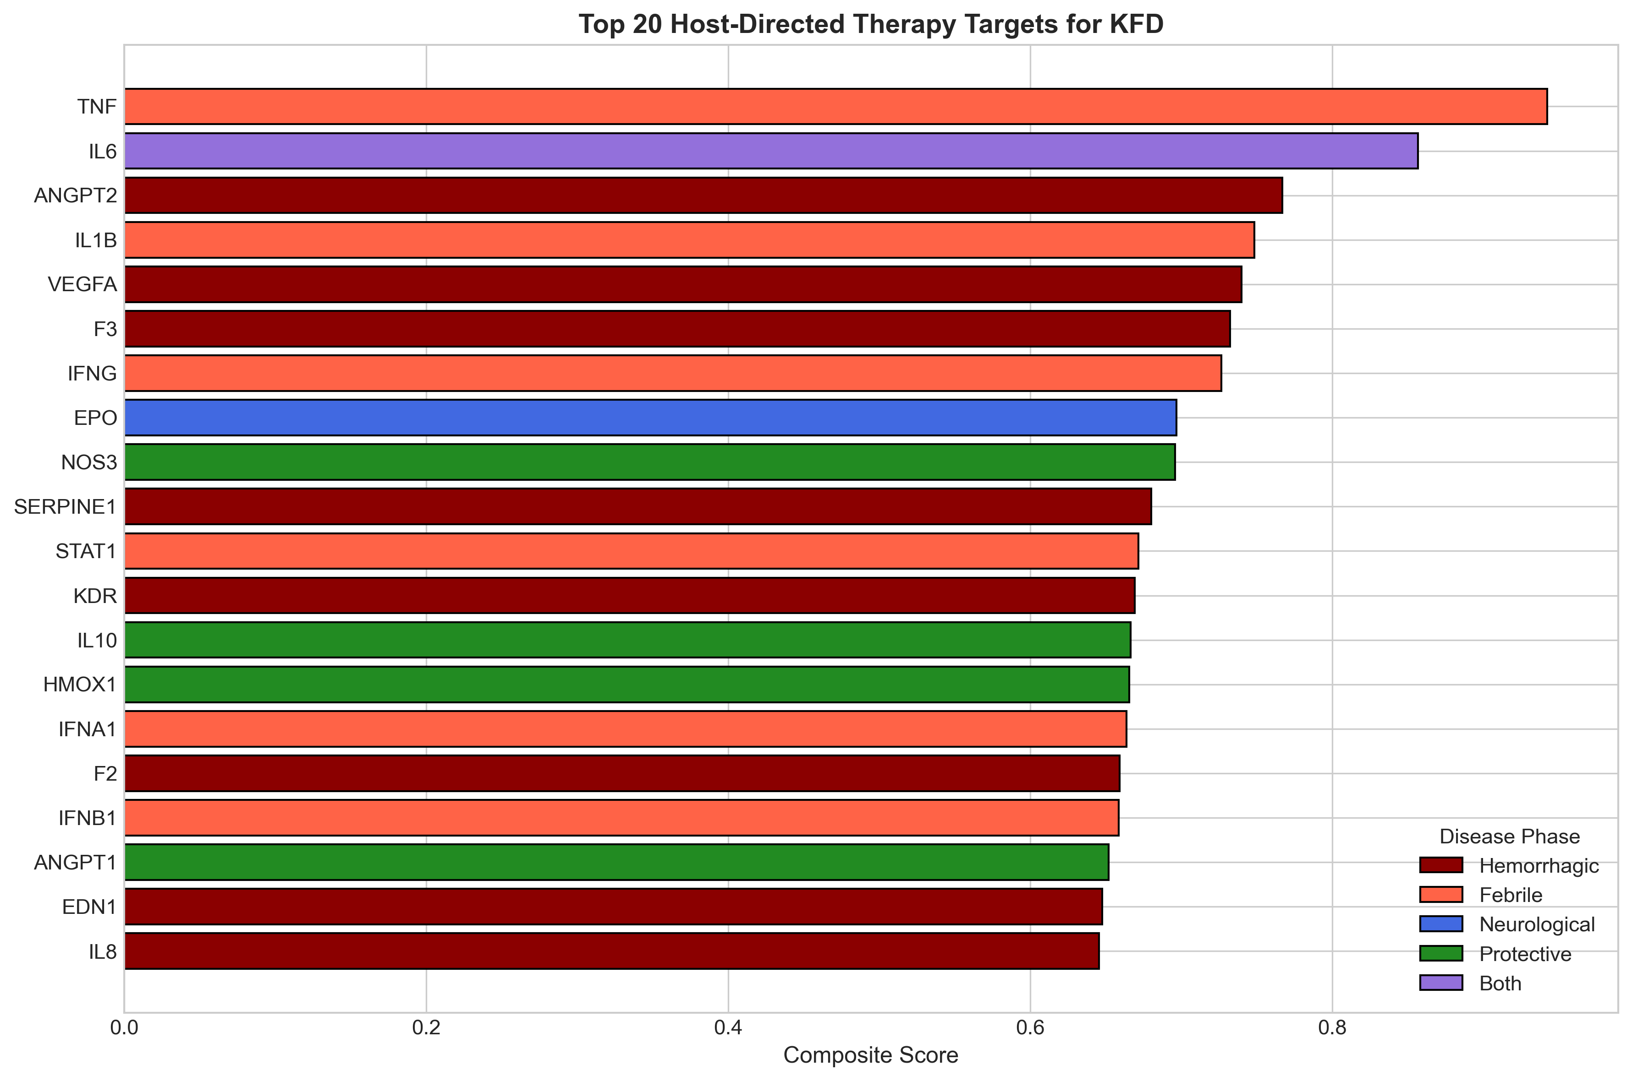

B. Compound Distribution
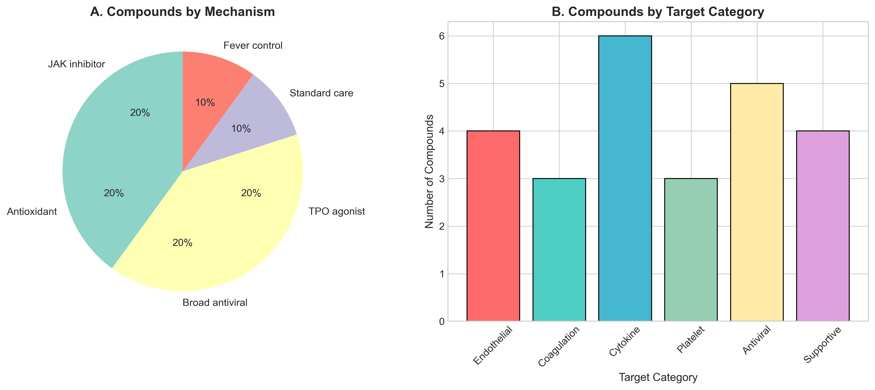

C. Compound Potency
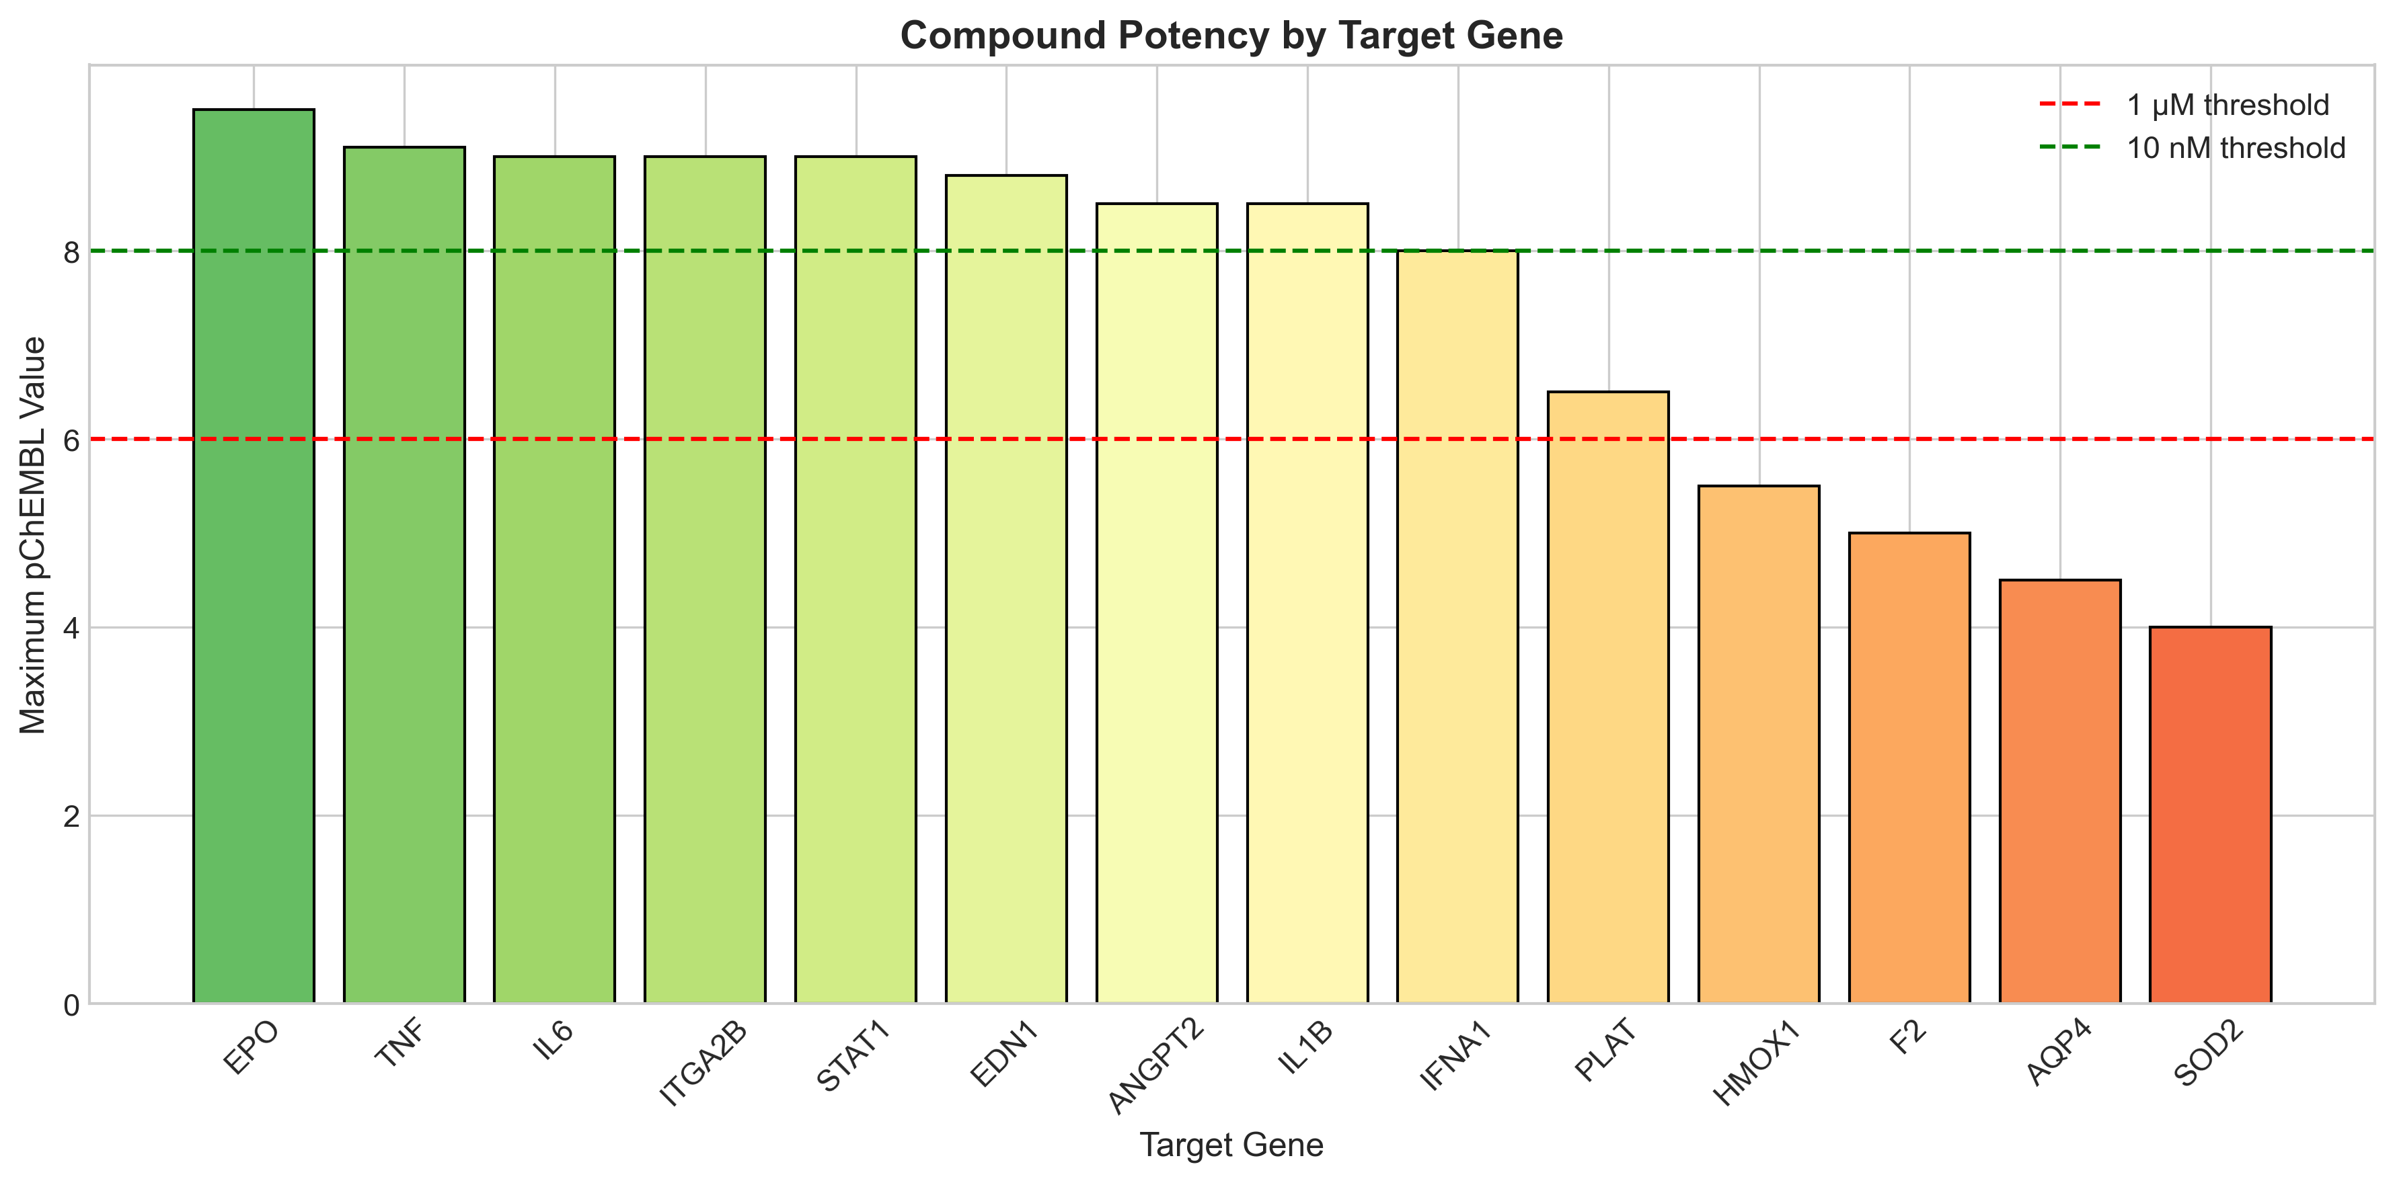

D. Pathway Analysis
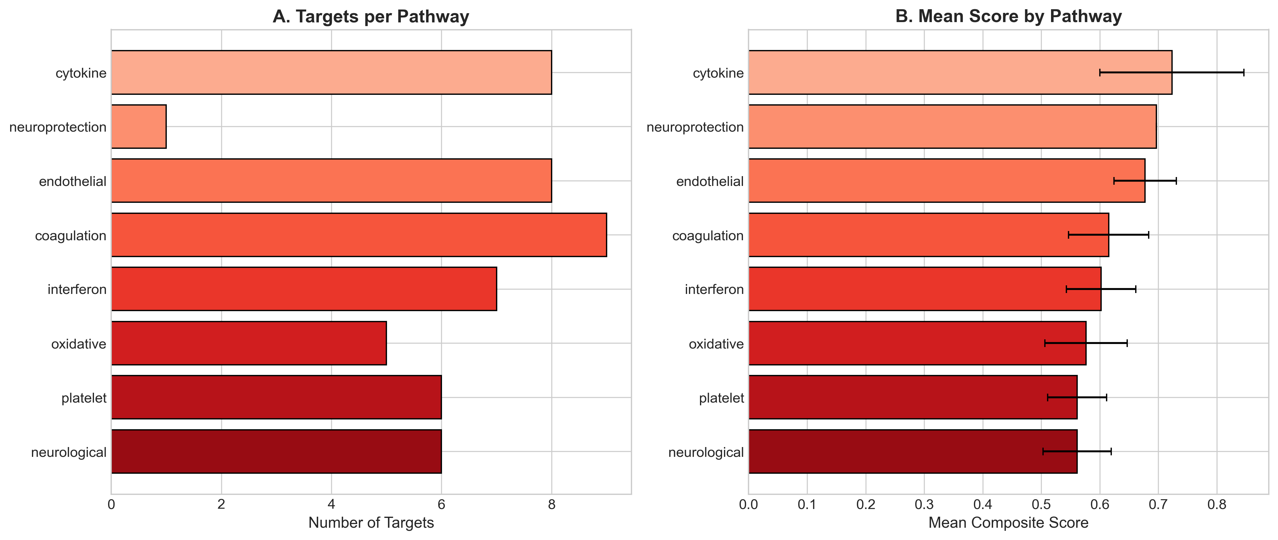

E. KFD Disease Timeline
