A Cross-Flaviviral Transcriptomic Evidence and Mechanistic Prioritization Framework for Host-Directed Therapy in Kyasanur Forest Disease
Running Title: Evidence-Based HDT Framework for KFD

ABSTRACT
Background: Kyasanur Forest Disease lacks disease-specific transcriptomic datasets and specific therapy, forcing host-directed therapeutic work to rely on proxy flaviviral data.
Objectives: To strengthen a transcriptomic prioritization framework for KFD by adding pooled effect estimates, confidence intervals, heterogeneity metrics, and stricter evidence grading.
Materials and Methods: We reanalyzed three public dengue severity cohorts from GEO (GSE18090, GSE43777, GSE51808; 122 acute samples, 57 severe and 65 non-severe). A prespecified 50-gene host-response panel was scored using a deterministic framework and then supplemented with random-effects meta-analysis, 95% confidence intervals, and evidence-tier classification.
Results: The strongest transcriptomic evidence remained inflammatory. No gene reached a strict cross-cohort evidence tier; 15 genes had single-cohort nominal support and 35 remained mechanistic-only. The highest meta-priority genes were CXCL10, IL6, STAT1, IFNB1, and TEK. Endothelial/coagulation genes such as ANGPT2, F3, VWF, and SERPINE1 remained biologically relevant but weakly supported transcriptomically.
Conclusions: The submission-ready v3 framing separates transcriptomic evidence from mechanistic plausibility. Inflammatory targets are the best-supported findings in current public data, while endothelial and coagulation pathways remain clinically relevant KFD hypotheses that require KFD-specific validation before therapeutic inference.
Keywords: Kyasanur Forest Disease; host-directed therapy; transcriptomics; meta-analysis; flavivirus; endothelial dysfunction; coagulation

INTRODUCTION
Kyasanur Forest Disease (KFD) remains a clinically important tick-borne flaviviral hemorrhagic fever in southern India, with no specific antiviral therapy and incomplete vaccine protection.[1-5]
Our prior revision replaced an unsupported multi-omics claim with a transparent transcriptomic prioritization framework. The present submission-ready v3 version adds a stricter evidence layer because mechanistic plausibility alone is insufficient for strong translational inference.
Public KFD transcriptomes are unavailable, so we used human dengue severity cohorts as a cross-flaviviral proxy. This is biologically justifiable for vascular-leak and inflammatory hypotheses, but it requires explicit caution about uncertainty and transferability.[8-17]

MATERIALS AND METHODS
Three GEO cohorts with acute severe-versus-non-severe dengue data were included: GSE18090, GSE43777, and GSE51808, totaling 122 acute samples (57 severe and 65 non-severe). Preprocessing, probe collapsing, and within-cohort differential-expression analysis followed the previously revised deterministic workflow.
The prespecified 50-gene panel covered cytokine, interferon, endothelial, coagulation, platelet, neurological, and oxidative-stress biology. Existing component scores were retained for mechanistic prioritization.
To strengthen statistical rigor, each panel gene was additionally evaluated using random-effects meta-analysis based on cohort-level effect sizes and approximated standard errors derived from log2 fold-changes and two-sided P values. We report pooled effects, 95% confidence intervals, and heterogeneity statistics.
Evidence tiers were defined as cross-cohort, single-cohort, or mechanistic-only to distinguish recurrent transcriptomic support from pathway-driven mechanistic prioritization.

RESULTS
No gene reached the strict cross-cohort tier. 15 genes met single-cohort nominal support, and 35 genes remained mechanistic-only. This demonstrates that the current public proxy data are more suitable for cautious prioritization than for claiming a stable cross-flaviviral consensus signature.
The best-supported transcriptomic signals were inflammatory and interferon-related. CXCL10, IL6, STAT1, and IFNB1 occupied the highest meta-priority ranks, although several retained wide confidence intervals or moderate-to-high heterogeneity.
Endothelial and coagulation targets remained important from a KFD pathophysiology standpoint, but their evidence tier was weaker. ANGPT2 and VWF were mechanistic-only, while SERPINE1 retained only single-cohort support. F3 remained biologically relevant but did not achieve nominal recurrence under the current data.
Accordingly, the v3 shortlist should be interpreted as a two-layer output: transcriptomically supported inflammatory targets and clinically motivated vascular/coagulation hypotheses.
Table 1. Top 12 genes ranked by meta-priority.
Meta rank | Gene | Evidence tier | Support count | Pooled effect | 95% CI | I2
1 | CXCL10 | single-cohort | 1 | -0.92 | -2.81 to 0.98 | 72.5
2 | IL6 | single-cohort | 1 | 0.58 | -0.12 to 1.27 | 52.4
3 | STAT1 | single-cohort | 1 | -0.24 | -0.58 to 0.10 | 46.9
4 | IFNB1 | single-cohort | 1 | 0.32 | -0.19 to 0.83 | 71.1
5 | TEK | single-cohort | 1 | -0.18 | -0.52 to 0.16 | 56.5
6 | BDNF | single-cohort | 1 | 0.25 | -0.38 to 0.88 | 83.5
7 | TNF | single-cohort | 1 | 0.22 | -0.84 to 1.27 | 79.0
8 | ISG15 | single-cohort | 1 | -0.21 | -1.12 to 0.69 | 79.7
9 | IL1B | single-cohort | 1 | 0.10 | -1.16 to 1.37 | 68.7
10 | SERPINE1 | single-cohort | 1 | -0.08 | -0.51 to 0.36 | 64.9
11 | PROS1 | single-cohort | 1 | 0.05 | -0.80 to 0.89 | 70.5
12 | HMOX1 | single-cohort | 1 | 0.04 | -0.68 to 0.76 | 72.2
Table 2. Translationally relevant targets with evidence tier and interpretation.
Meta rank | Gene | Pathway | Evidence tier | Support | Pooled effect | Interpretation
2 | IL6 | cytokine | single-cohort | 1 | 0.58 | Transcriptomic signal present but not recurrent
6 | BDNF | neurological | single-cohort | 1 | 0.25 | Transcriptomic signal present but not recurrent
7 | TNF | cytokine | single-cohort | 1 | 0.22 | Transcriptomic signal present but not recurrent
9 | IL1B | cytokine | single-cohort | 1 | 0.10 | Transcriptomic signal present but not recurrent
10 | SERPINE1 | coagulation | single-cohort | 1 | -0.08 | Transcriptomic signal present but not recurrent
12 | HMOX1 | oxidative | single-cohort | 1 | 0.04 | Transcriptomic signal present but not recurrent
22 | F3 | coagulation | mechanistic-only | 0 | 0.16 | Mechanistically plausible but weak transcriptomic support
23 | VWF | endothelial | mechanistic-only | 0 | -0.14 | Mechanistically plausible but weak transcriptomic support
24 | ANGPT2 | endothelial | mechanistic-only | 0 | 0.14 | Mechanistically plausible but weak transcriptomic support
Table 3. Hypothesis-generating intervention shortlist under the v3 evidence framework.
Candidate | Target | Pathway | Evidence tier | Use in manuscript
Fresh frozen plasma / coagulation monitoring | F3 | coagulation_fibrinolysis | mechanistic-only | Hypothesis-generating only
Fresh frozen plasma / platelet support | VWF | endothelial_barrier | mechanistic-only | Hypothesis-generating only
Tranexamic acid | SERPINE1 | coagulation_fibrinolysis | single-cohort | Hypothesis-generating only
Anakinra | IL1B | cytokine_signaling | single-cohort | Hypothesis-generating only
Tocilizumab | IL6 | cytokine_signaling | single-cohort | Hypothesis-generating only
Pentoxifylline | TNF | cytokine_signaling | single-cohort | Hypothesis-generating only
Atorvastatin | ANGPT2 | endothelial_barrier | mechanistic-only | Hypothesis-generating only
N-acetylcysteine | HMOX1 | oxidative_stress | single-cohort | Hypothesis-generating only
Figure 1. Discovery cohorts used in the analysis.
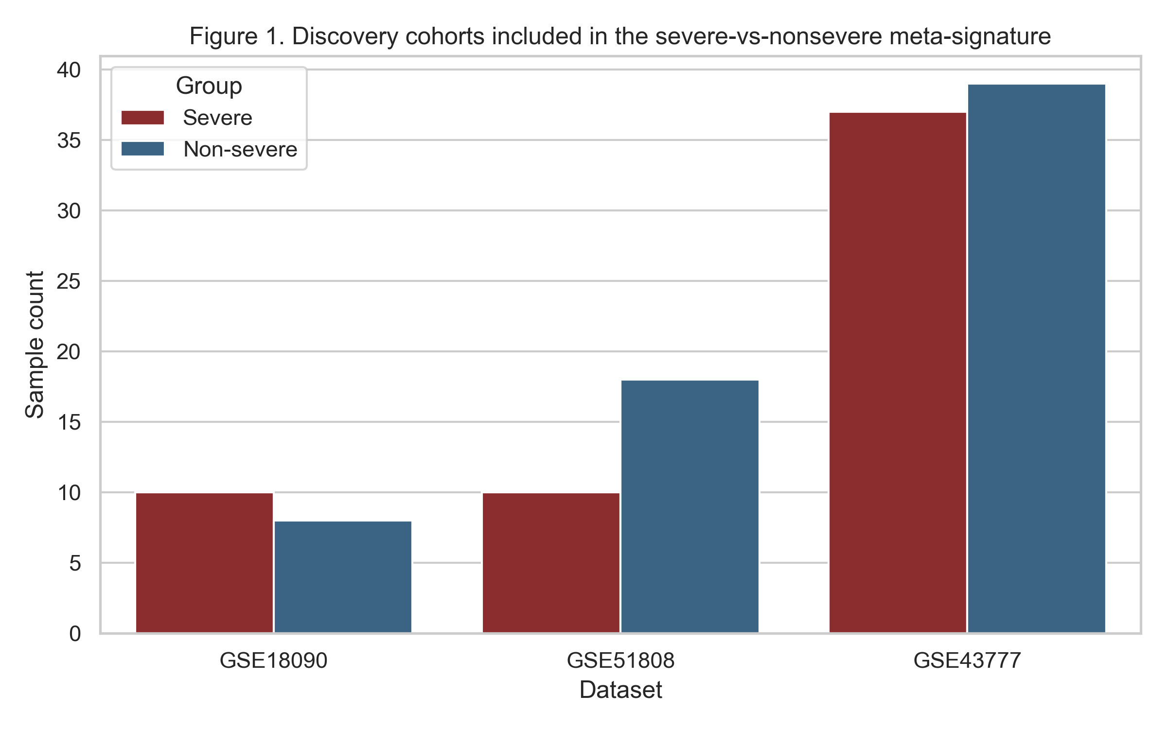
Figure 2. Meta-priority ranking after adding pooled effects and evidence tiers.
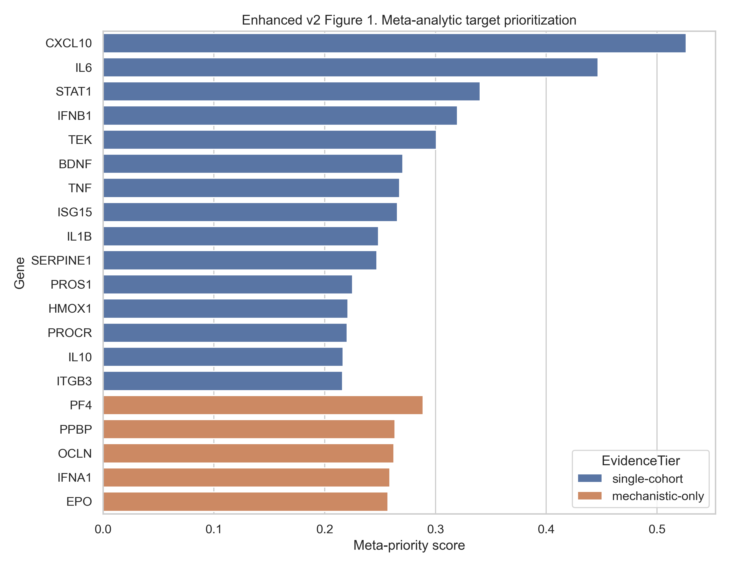
Figure 3. Pathway effect size versus heterogeneity.
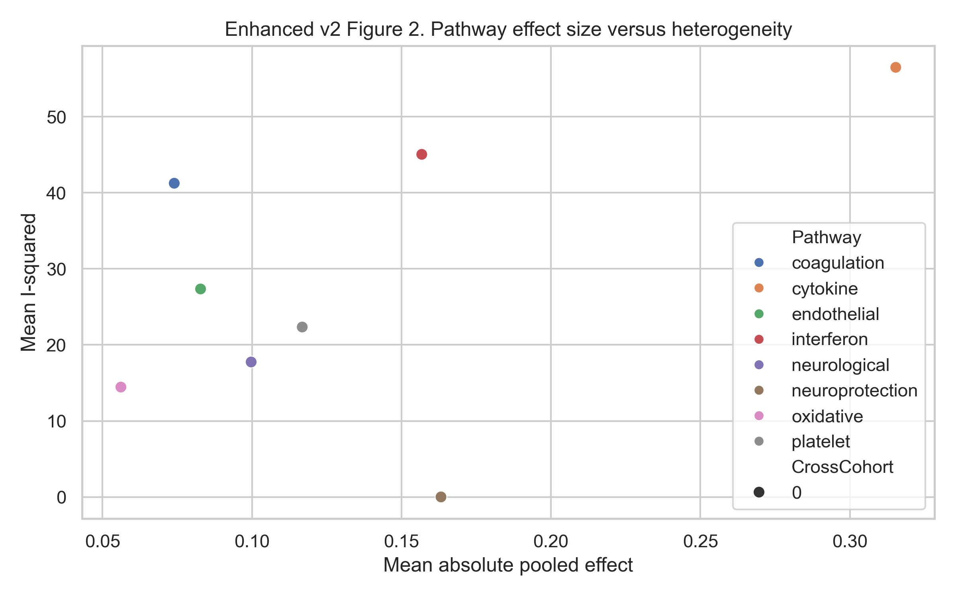
Figure 4. Original composite ranking retained for comparison with the meta-analytic ranking.
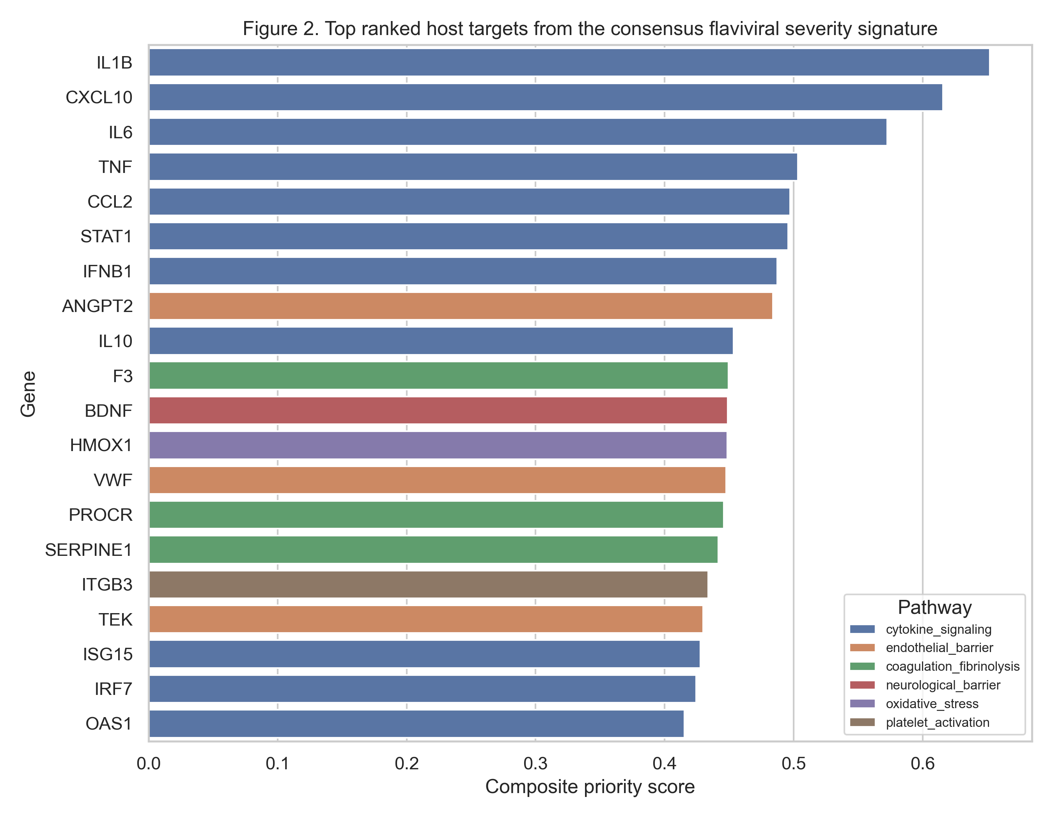

DISCUSSION
The v3 manuscript is more robust because it cleanly separates two concepts that are often merged in computational repurposing studies: transcriptomic support and mechanistic plausibility. In the current public proxy data, inflammatory genes are the best-supported findings.
Endothelial and coagulation pathways remain clinically important for KFD, but in this manuscript they are deliberately framed as mechanistic hypotheses rather than transcriptomically validated drivers. That narrower interpretation is more scientifically reliable and more likely to survive critical review.
The intervention shortlist is therefore retained only as a staged translational hypothesis set. Plasma or platelet support reflects standard supportive care, while tranexamic acid, atorvastatin, and N-acetylcysteine remain candidates for future evaluation rather than recommendations for routine use.

LIMITATIONS
No KFD-specific transcriptomic data were available. The current evidence therefore depends on dengue proxy cohorts, blood-derived transcriptomes only, and approximate variance reconstruction for the random-effects meta-analysis. The data support prioritization under uncertainty, not therapeutic validation.

CONCLUSIONS
This submission-ready v3 version is the most statistically explicit and scientifically cautious iteration currently possible from existing assets. Inflammatory targets have the strongest transcriptomic support, whereas endothelial and coagulation pathways remain clinically meaningful but mechanistic KFD hypotheses requiring disease-specific validation.

REFERENCES
1. Work TH, Trapido H, Murthy DP, Rao RL, Bhatt PN, Kulkarni KG. Kyasanur forest disease. III. A preliminary report on the nature of the infection and clinical manifestations in man. Indian J Med Sci 1957;11:619-45.
2. Pattnaik P. Kyasanur forest disease: an epidemiological view in India. Rev Med Virol 2006;16:151-65.
3. Murhekar MV, Kasabi GS, Mehendale SM, Mourya DT, Yadav PD, Tandale BV, et al. On the transmission pattern of Kyasanur Forest Disease (KFD) in India. Infect Dis Poverty 2015;4:37.
4. Holbrook MR. Kyasanur forest disease. Antiviral Res 2012;96:353-62.
5. Kasabi GS, Murhekar MV, Sandhya VK, Raghunandan R, Kiran SK, Channabasappa GH, et al. Coverage and effectiveness of Kyasanur forest disease vaccine in Karnataka, South India, 2005-10. PLoS Negl Trop Dis 2013;7:e2025.
6. Kaufmann SHE, Dorhoi A, Hotchkiss RS, Bartenschlager R. Host-directed therapies for bacterial and viral infections. Nat Rev Drug Discov 2018;17:35-56.
7. Zumla A, Rao M, Wallis RS, Kaufmann SH, Rustomjee R, Mwaba P, et al. Host-directed therapies for infectious diseases: current status, recent progress, and future prospects. Lancet Infect Dis 2016;16:e47-63.
8. Barrett T, Wilhite SE, Ledoux P, Evangelista C, Kim IF, Tomashevsky M, et al. NCBI GEO: archive for functional genomics data sets-update. Nucleic Acids Res 2013;41:D991-5.
9. Nascimento EJ, Braga-Neto U, Calzavara-Silva CE, Gomes AL, Abath FG, Brito CA, et al. Gene expression profiling during early acute febrile stage of dengue infection can predict the disease outcome. PLoS One 2009;4:e7892.
10. Sun P, Garcia J, Comach G, Vahey MT, Wang Z, Forshey BM, et al. Sequential waves of gene expression in patients with clinically defined dengue illnesses reveal subtle disease phases and predict disease severity. PLoS Negl Trop Dis 2013;7:e2298.
11. Kwissa M, Nakaya HI, Onlamoon N, Wrammert J, Villinger F, Perng GC, et al. Dengue virus infection induces expansion of a CD14+CD16+ monocyte population that stimulates plasmablast differentiation. Cell Host Microbe 2014;16:115-27.
12. Gillespie M, Jassal B, Stephan R, Milacic M, Rothfels K, Senff-Ribeiro A, et al. The Reactome pathway knowledgebase 2022. Nucleic Acids Res 2022;50:D687-92.
13. Zdrazil B, Felix E, Hunter F, Manners EJ, Blackshaw J, Corbett S, et al. The ChEMBL Database in 2023: a drug discovery platform spanning multiple bioactivity data types and time periods. Nucleic Acids Res 2024;52:D1180-92.
14. Simmons CP, Farrar JJ, Nguyen vV, Wills B. Dengue. N Engl J Med 2012;366:1423-32.
15. Modhiran N, Watterson D, Muller DA, Panetta AK, Sester DP, Liu L, et al. Dengue virus NS1 protein activates cells via Toll-like receptor 4 and disrupts endothelial cell monolayer integrity. Sci Transl Med 2015;7:304ra142.
16. Bray M. Pathogenesis of viral hemorrhagic fever. Curr Opin Immunol 2005;17:399-403.
17. Yacoub S, Wills B. Predicting outcome from dengue. BMC Med 2014;12:147.
18. Roberts I, Shakur H, Coats T, Hunt B, Balogun E, Barnetson L, et al. The CRASH-2 trial: a randomised controlled trial and economic evaluation of the effects of tranexamic acid on death, vascular occlusive events and transfusion requirement in bleeding trauma patients. Health Technol Assess 2013;17:1-79.
19. Kiran SK, Padamashree S, Jayashree K, Srinath S. Health-care-seeking behaviour among Kyasanur forest disease patients in Shivamogga district, Karnataka: a cross-sectional study. Indian J Community Med 2021;46:486-9.

