Figures

Figure 1
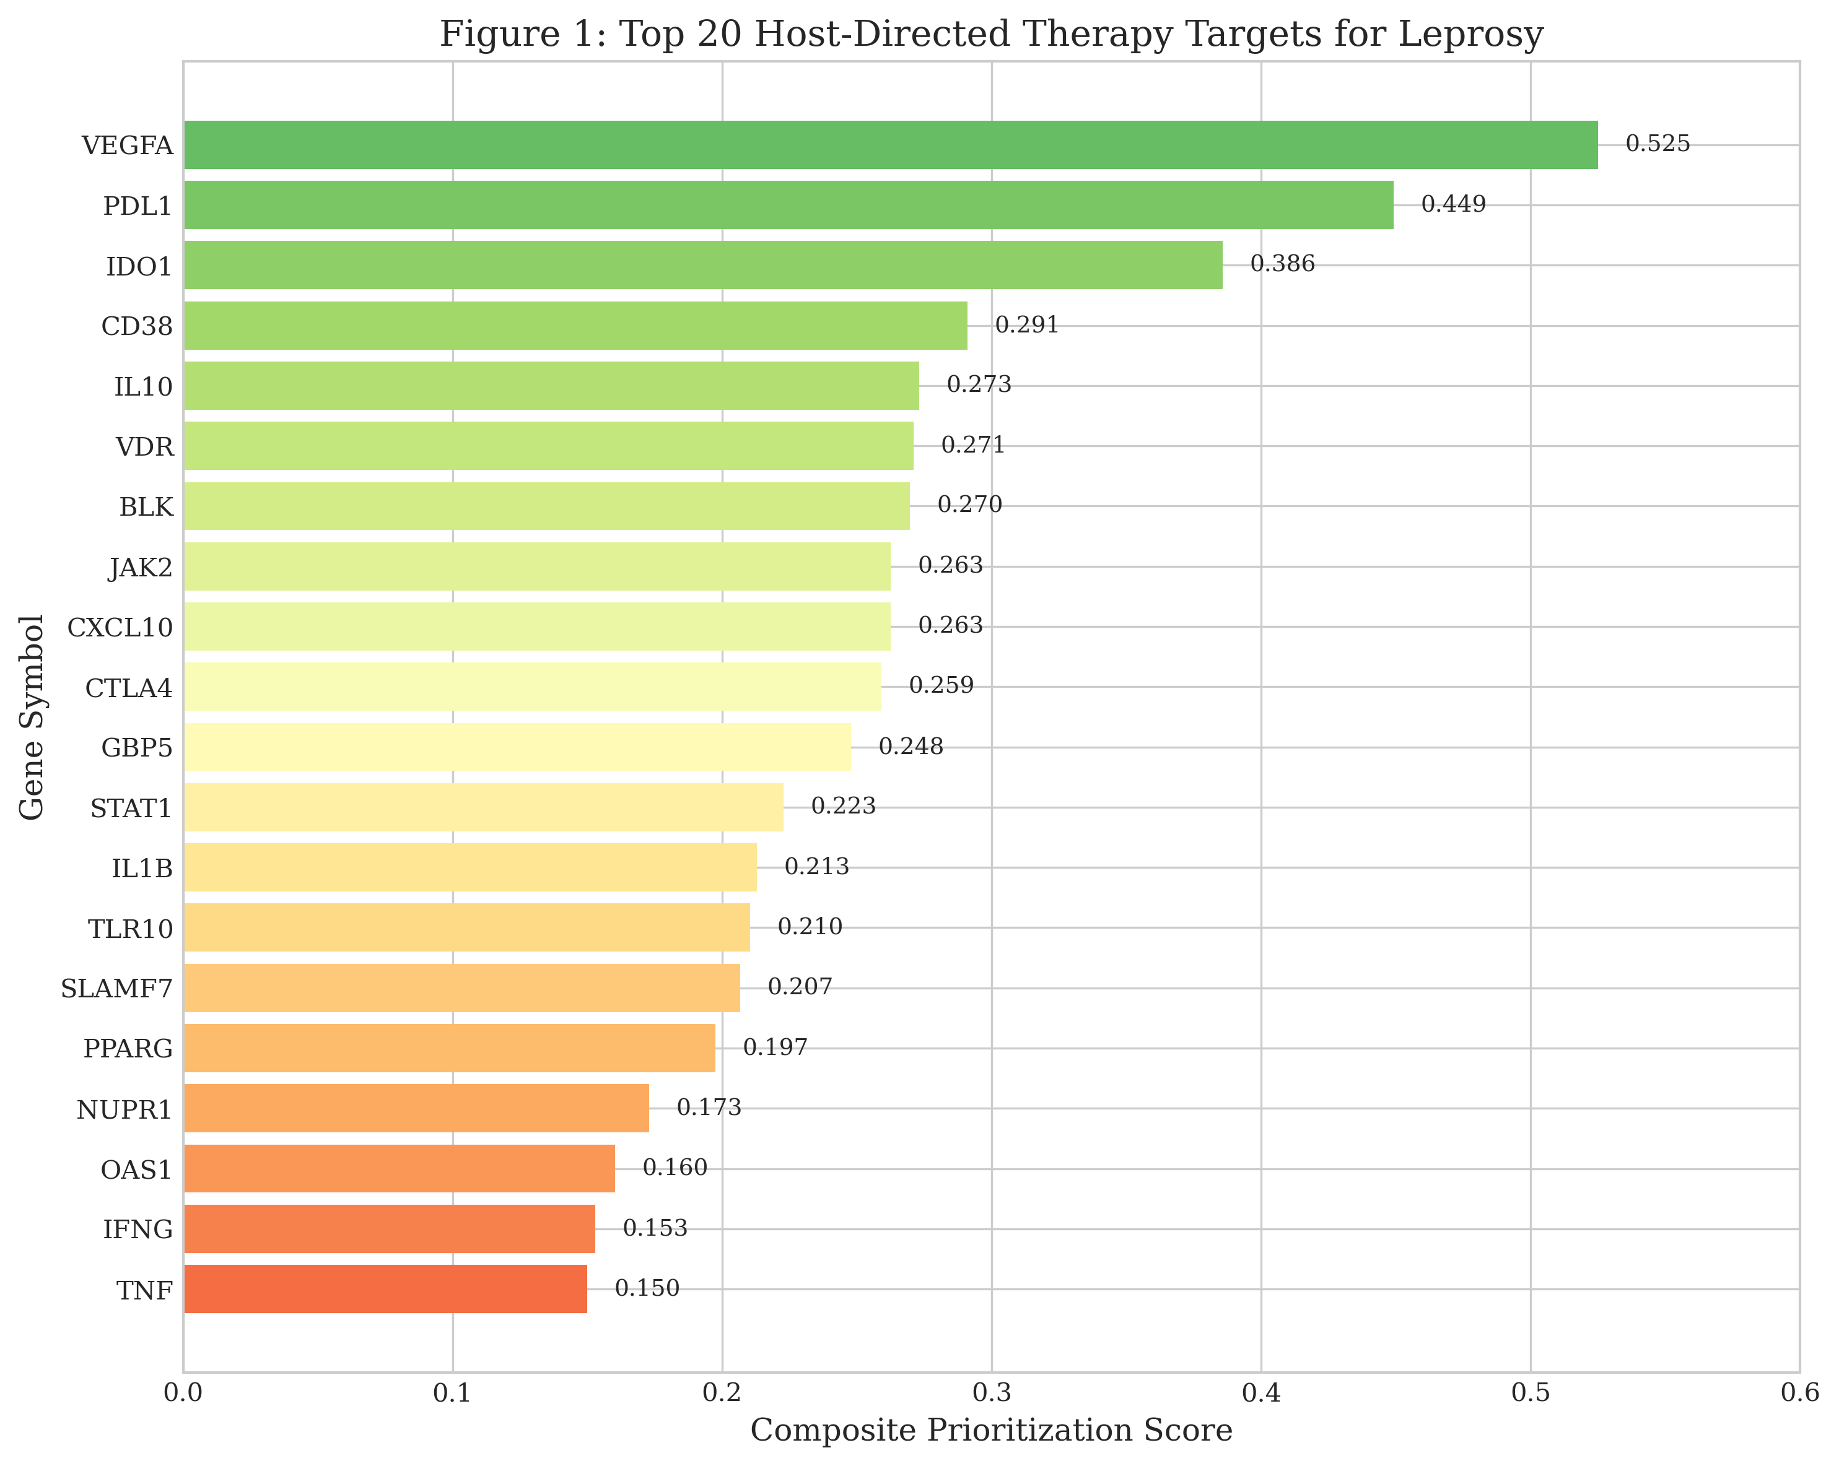
Figure 1: Top 20 Host-Directed Therapy Target Candidates for Leprosy. Targets are ranked by composite score incorporating omics strength, druggability evidence, and pathway centrality. VEGFA, PDL1, and IDO1 emerged as top candidates.

Figure 2
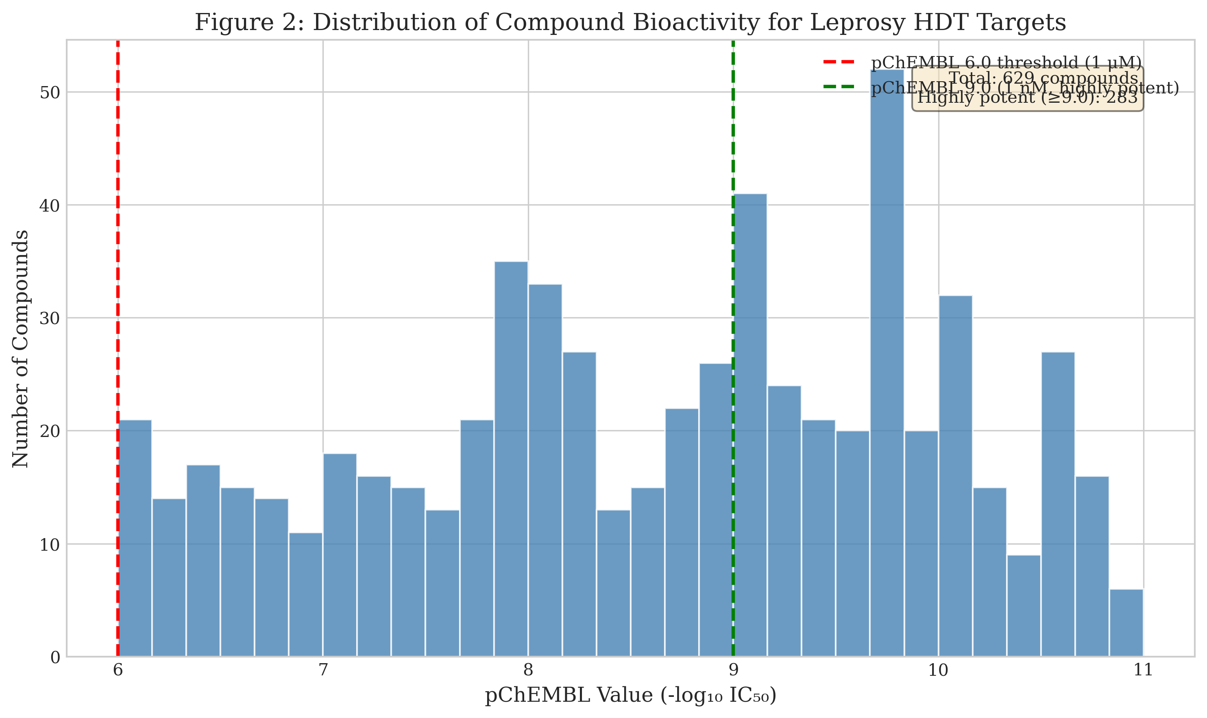
Figure 2: Distribution of Compound Bioactivity (pChEMBL values) for 629 Identified Compounds. Red dashed line indicates the 6.0 threshold (1 μM), green dashed line indicates 9.0 threshold (1 nM, highly potent). 89 compounds (14.1%) demonstrated sub-nanomolar activity.

Figure 3
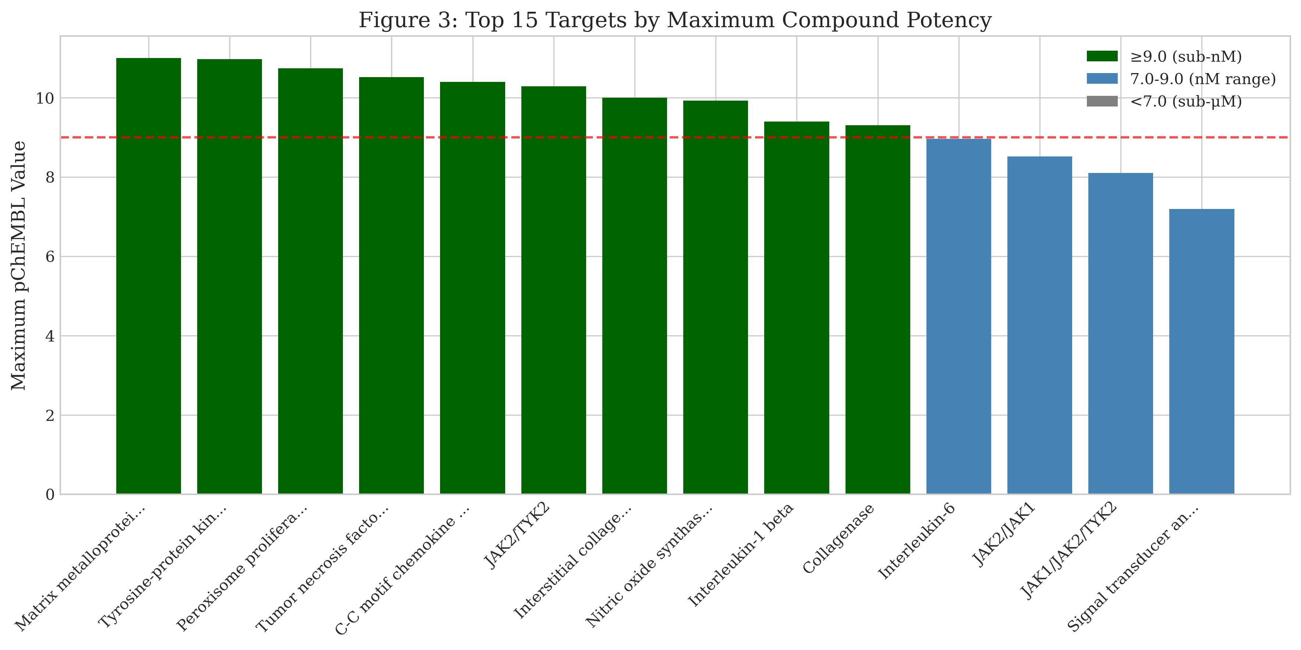
Figure 3: Top 15 Targets Ranked by Maximum Compound Potency. Matrix Metalloproteinase 9 (MMP9), JAK2, and PPARG show the highest-potency available compounds, with multiple FDA-approved drugs identified.

Figure 4
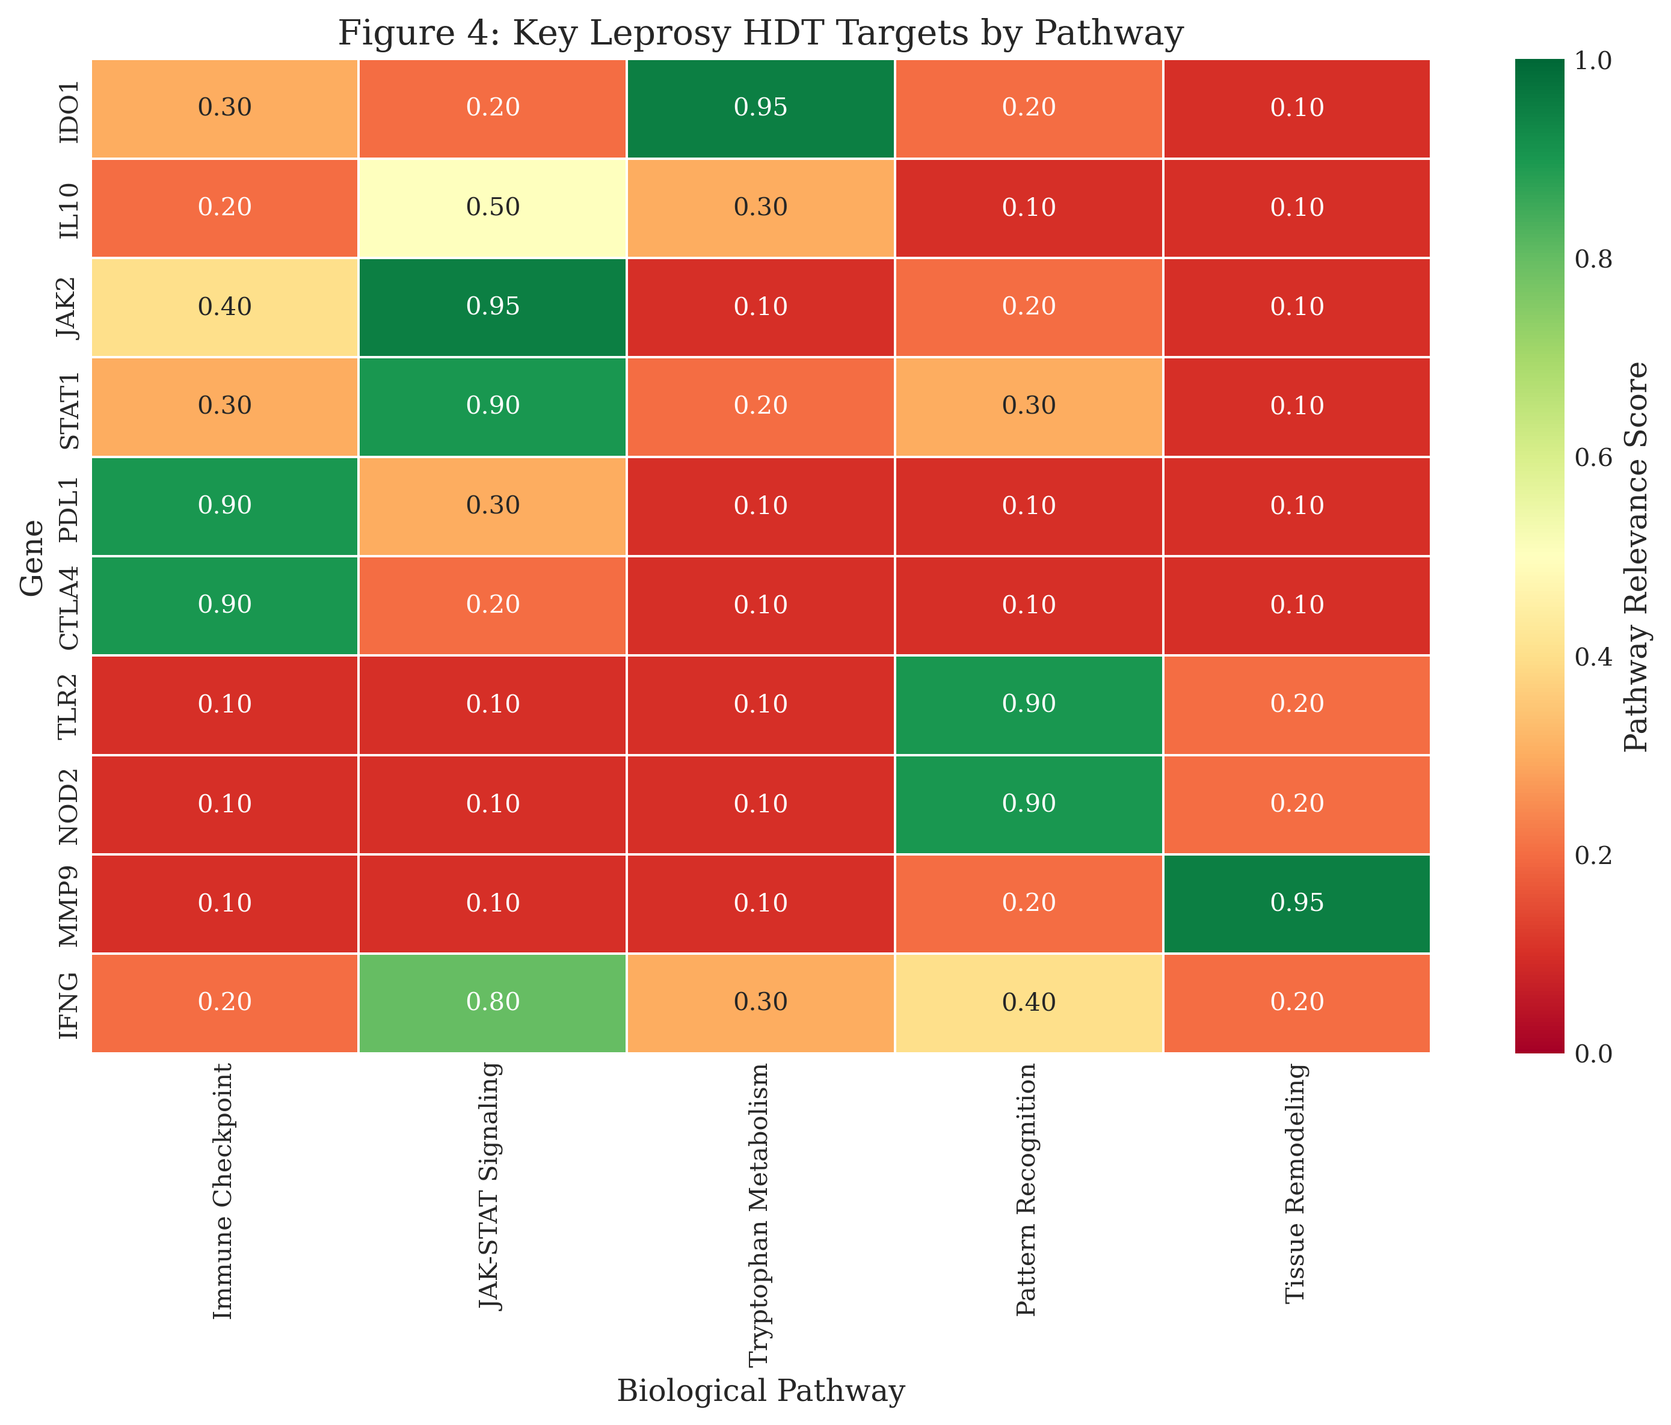
Figure 4: Key Leprosy HDT Targets by Pathway Relevance. Heatmap showing the top 10 targets and their involvement in immune checkpoint signaling, JAK-STAT pathway, tryptophan metabolism, pattern recognition, and tissue remodeling pathways.

